Reservoir-Specific Data Analysis Sections to be Inserted in Catawba Chlorophyll-a Document

Clifton Bell

2024-08-21

## 4.2 FISHING CREEK RESERVOIR

Fishing Creek Reservoir is a man-made lake located about 9 miles southeast of Lancaster, SC. Created in 1916 by damming Fishing Creek on the Catawba River, it covers approximately 3,400 acres and serves as a hydroelectric reservoir for Duke Energy through the Nitrolee Dam. The lake is known for its fishing opportunities, particularly for largemouth bass, crappie, catfish, and stocked striped bass. With 85 miles of shoreline, Fishing Creek Reservoir offers various recreational activities including boating, water skiing, and picnicking. The Chester Metropolitan District has a public drinking water supply intake in the upstream portion of the reservoir.

### 4.2.1 Assessment History

### 4.2.2 Chlorophyll-a Conditions

There are four stations on Fishing Creek Reservoir with 10 or more data over 2000-2023 for computing summary statistics (Table X). Considering only these stations, the growing season geometric mean varied from 10.9 ug/L at station LCR-01 (an mainstem station) to 25.8 ug/L at station LCR-05 (a lake arm station). The 90th percentile chlorophyll-a values varied from 21.2 ug/L at station LCR-01 to 39.9 ug/L at station LCR-05. Station RL-01012 had the highest chlorophyll-a value but only 6 data. Box-and whisker plots of stations with at least 5 data (Figure X) indicate that chlorophyll-a is lower in the upper stations than the mid and lower reservoir stations.

Table X - Chlorophyll-a Summary Statistics for Fishing Creek Reservoir, Apr-Oct data <= 1 m

|  | **Chla in FISHING CREEK RESERVOIR** | **Chla in FISHING CREEK RESERVOIR** | **Chla in FISHING CREEK RESERVOIR** | **Chla in FISHING CREEK RESERVOIR** | **Chla in FISHING CREEK RESERVOIR** | **Chla in FISHING CREEK RESERVOIR** | **Chla in FISHING CREEK RESERVOIR** | **Chla in FISHING CREEK RESERVOIR** | **Chla in FISHING CREEK RESERVOIR** | **Chla in FISHING CREEK RESERVOIR** |
| --- | --- | --- | --- | --- | --- | --- | --- | --- | --- | --- |
| **StationID** | **Count** | **Max** | **Perc_90th** | **Perc_75th** | **Arith_Mean** | **Geo_Mean** | **Median** | **Perc_25th** | **Perc_10th** | **Min** |
| CW-016F | 80 | 58.2 | 23.8 | 9.4 | 9.1 | 5.7 | 4.3 | 3.2 | 2.2 | 0.8 |
| RL-21226 | 6 | 17.5 | 11.6 | 5.7 | 6.8 | 5.8 | 5.2 | 4.0 | 3.8 | 3.8 |
| RL-21210 | 7 | 16.9 | 9.8 | 4.4 | 5.6 | 4.5 | 3.6 | 3.3 | 3.1 | 3.0 |
| LCR-01 | 12 | 26.8 | 21.2 | 17.3 | 12.9 | 10.9 | 11.4 | 7.6 | 4.4 | 3.6 |
| RL-01012 | 6 | 73.8 | 66.7 | 55.1 | 41.4 | 34.7 | 36.9 | 31.8 | 20.5 | 9.3 |
| RL-22013 | 6 | 50.2 | 38.6 | 26.9 | 23.8 | 20.1 | 22.9 | 13.6 | 9.8 | 8.0 |
| LCR-05 | 12 | 51.7 | 39.9 | 36.4 | 27.8 | 25.8 | 25.9 | 17.6 | 16.9 | 16.7 |
| LCR-04 | 44 | 44.8 | 32.5 | 26.2 | 21.0 | 19.0 | 19.0 | 14.8 | 11.5 | 4.6 |
| CW-057 | 139 | 75.7 | 38.5 | 28.4 | 21.5 | 17.9 | 19.8 | 13.3 | 6.6 | 2.5 |

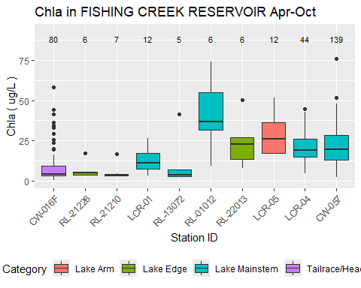

Figure X - Spatial pattern in chl-a in Fishing Creek Reservoir. Apr-Oct data <= 1 m

The growing season geometric mean is a candidate metric for expression of site-specific criteria. Table X shows the Apr-Oct geometric mean chlorophyll-a values for individual years and stations in Fishing Creek, and presents value only for year-station combinations with at least 5 data. The table also presents the minimum, median, maximum, and standard deviation of the geometric means. The maximum growing season geometric mean (28.8 ug/L) occurred at station CW-057 in 2002.

Table X - Chlorophyll-a Annual Geometric Means for Fishing Creek Reservoir, Apr-Oct data <= 1 m

| **Year** | **CW-016F** | **RL-21226** | **RL-21210** | **LCR-01** | **RL-13072** | **RL-01012** | **RL-15023** | **RL-22013** | **LCR-05** | **LCR-04** | **CW-057** |
| --- | --- | --- | --- | --- | --- | --- | --- | --- | --- | --- | --- |
| 2000 |  |  |  |  |  |  |  |  |  |  |  |
| 2001 |  |  |  |  |  | 34.7 |  |  |  |  | 26.4 |
| 2002 | 13.5 |  |  |  |  |  |  |  |  |  | 28.8 |
| 2003 |  |  |  |  |  |  |  |  |  |  |  |
| 2004 |  |  |  |  |  |  |  |  |  |  | 16.3 |
| 2005 |  |  |  |  |  |  |  |  |  |  | 19.4 |
| 2006 |  |  |  |  |  |  |  |  |  |  | 28.4 |
| 2007 |  |  |  |  |  |  |  |  |  |  |  |
| 2008 |  |  |  |  |  |  |  |  |  |  |  |
| 2009 |  |  |  |  |  |  |  |  |  |  |  |
| 2010 |  |  |  |  |  |  |  |  |  |  |  |
| 2011 |  |  |  |  |  |  |  |  |  |  |  |
| 2012 |  |  |  |  |  |  |  |  |  |  |  |
| 2013 |  |  |  |  | 6.1 |  |  |  |  |  |  |
| 2014 |  |  |  |  |  |  |  |  |  |  |  |
| 2015 |  |  |  |  |  |  |  |  |  |  |  |
| 2016 |  |  |  |  |  |  |  |  |  |  | 18.7 |
| 2017 | 5.5 |  |  |  |  |  |  |  |  |  | 27.5 |
| 2018 | 2.9 |  |  |  |  |  |  |  |  |  | 11.5 |
| 2019 | 6.6 |  |  | 10.9 |  |  |  |  | 25.8 | 24.1 | 17.9 |
| 2020 | 3.0 |  |  |  |  |  |  |  |  | 16.0 | 12.7 |
| 2021 | 4.4 | 5.8 | 4.5 |  |  |  |  |  |  | 18.2 | 19.5 |
| 2022 | 8.9 |  |  |  |  |  |  | 20.1 |  |  | 19.5 |
| 2023 | 7.0 |  |  |  |  |  |  |  |  |  | 23.5 |
| Years with ≥ 5 values | 8.0 | 1.0 | 1.0 | 1.0 | 1.0 | 1.0 | 0 | 1.0 | 1.0 | 3.0 | 13.0 |
| Min Geom Mean | 2.9 | 5.8 | 4.5 | 10.9 | 6.1 | 34.7 |  | 20.1 | 25.8 | 16.0 | 11.5 |
| Median Geom Mean | 6.1 | 5.8 | 4.5 | 10.9 | 6.1 | 34.7 |  | 20.1 | 25.8 | 18.2 | 19.5 |
| Max Geom Mean | 13.5 | 5.8 | 4.5 | 10.9 | 6.1 | 34.7 |  | 20.1 | 25.8 | 24.1 | 28.8 |
| SD Geom Mean | 3.5 |  |  |  |  |  |  |  |  | 4.2 | 5.7 |

Time series plots (Figure X) do not show marked trends in chlorophyll-a in Fishing Creek since 2000. Seasonal plots show a relatively muted season pattern in mid- and lower reservoir station, with the highest chlorophyll-a values in July or August.

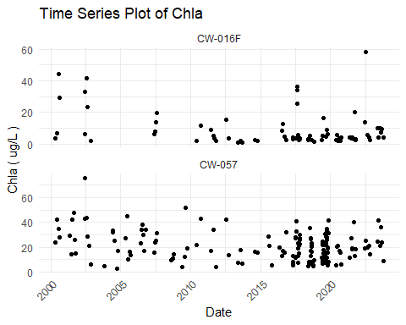

Figure X - Chl-a over time at Fishing Creek Reservoir stations. Data <= 1 m

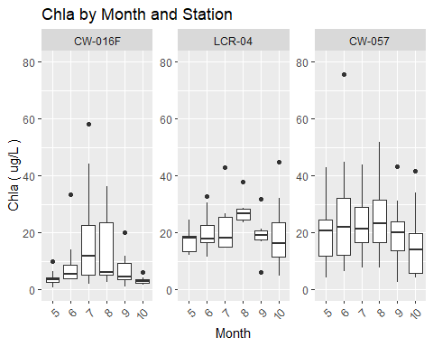

Figure X - Seasonal pattern in chl-a at Fishing Creek Reservoir stations. Data < 1 m

### 4.2.3 Water Quality Indicators

Apart from chlorophyll-a, other important water quality indicators include dissolved oxygen (DO), pH, water clarity, and cyanotoxins. Exceedances of related criteria or thresholds might or might not be related to eutrophication or high chlorophyll-a values. However, these water quality indicators provide insights into the overall use status of a reservoir, and relations of these indicators with chlorophyll-a (or lack thereof) can inform site-specific chlorophyll-a criteria.

#### 4.2.3.1 Dissolved Oxygen

The applicable DO water quality criteria for Fishing Creek Reservoir include a daily average not less than 5.0 mg/L with a low of 4.0 mg/L. For water quality assessment purposes, measurements are made at the surface. With the exception of a single outlier at station CW-057, no Fishing Creek Reservoir stations had surface DO observed below 4 mg/L, and the 10th percentile DO was greater than 5.5 mg/L at all stations (Table X). Hence it appears that the reservoir has relatively well oxygenated conditions at the surface. A plot of DO vs depth (Figure X) indicates that DO is not highly stratified in the reservoir, and most DO measurements were 6 mg/L or higher even at depths of 2-8 m.

Table X - Dissolved Oxygen Summary Statistics for Fishing Creek Reservoir, Apr-Oct data <= 1 m

|  | **DO in FISHING CREEK RESERVOIR** | **DO in FISHING CREEK RESERVOIR** | **DO in FISHING CREEK RESERVOIR** | **DO in FISHING CREEK RESERVOIR** | **DO in FISHING CREEK RESERVOIR** | **DO in FISHING CREEK RESERVOIR** | **DO in FISHING CREEK RESERVOIR** | **DO in FISHING CREEK RESERVOIR** | **DO in FISHING CREEK RESERVOIR** | **DO in FISHING CREEK RESERVOIR** |
| --- | --- | --- | --- | --- | --- | --- | --- | --- | --- | --- |
| **StationID** | **Count** | **Max** | **Perc_90th** | **Perc_75th** | **Arith_Mean** | **Geo_Mean** | **Median** | **Perc_25th** | **Perc_10th** | **Min** |
| CW-016F | 101 | 10.8 | 8.8 | 8.0 | 7.4 | 7.3 | 7.3 | 6.8 | 6.1 | 4.8 |
| RL-21226 | 7 | 9.0 | 8.6 | 8.0 | 7.2 | 7.2 | 6.8 | 6.5 | 6.2 | 5.8 |
| RL-17071 | 7 | 7.9 | 7.6 | 7.3 | 6.8 | 6.7 | 7.0 | 6.4 | 5.7 | 5.2 |
| RL-21210 | 7 | 8.4 | 8.2 | 8.0 | 7.3 | 7.2 | 7.7 | 6.5 | 6.1 | 5.9 |
| LCR-01 | 11 | 10.1 | 8.8 | 8.5 | 8.2 | 8.1 | 8.0 | 7.7 | 7.4 | 7.2 |
| RL-13072 | 7 | 9.2 | 9.0 | 8.4 | 7.8 | 7.7 | 7.5 | 7.3 | 6.9 | 6.5 |
| RL-01012 | 6 | 12.7 | 11.9 | 11.0 | 9.4 | 9.2 | 9.5 | 7.4 | 6.9 | 6.6 |
| RL-15023 | 7 | 10.2 | 9.0 | 8.1 | 8.0 | 8.0 | 7.7 | 7.4 | 7.3 | 7.3 |
| RL-22013 | 7 | 11.0 | 9.7 | 8.7 | 8.7 | 8.6 | 8.5 | 8.0 | 7.7 | 7.7 |
| LCR-05 | 11 | 11.7 | 10.6 | 9.7 | 8.8 | 8.7 | 8.8 | 7.6 | 6.8 | 6.7 |
| LCR-04 | 42 | 12.0 | 11.1 | 9.6 | 9.0 | 8.9 | 8.9 | 7.9 | 7.5 | 6.6 |
| CW-057 | 168 | 15.2 | 10.9 | 9.7 | 8.8 | 8.6 | 8.6 | 7.6 | 6.7 | 2.0 |

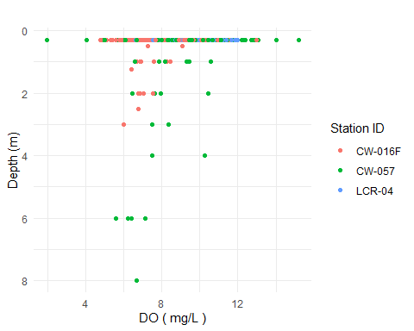

Figure X - Dissolved Oxygen v Depth at Fishing Creek Reservoir stations.

A plot of DO vs chlorophyll-a (Figure X) indicates a positive relation between the two parameters, as expected due to algal photosynthesis at the surface.

## `geom_smooth()` using formula = 'y ~ x'

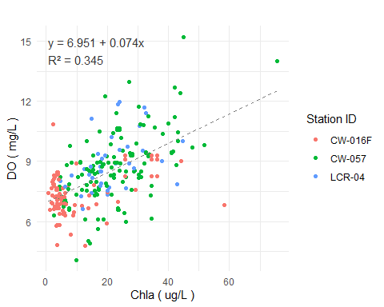

Figure X - Dissolved Oxygen v Chlorophyll-a at Fishing Creek Reservoir stations.

#### 4.2.3.2 pH

The applicable water quality criterion for pH for SC freshwaters is a range between 6.0 and 8.5. Several stations on Fishing Creek reservoir have 90th percentile pH values that exceed the upper limit of this range (Table X). A scatterplot of pH vs chlorophyll-a (Figure X) demonstrate a great deal of variance but a positive relation between the parameters. The pH was likely to exceed 8.5 when chlorophyll-a exceeded 40 ug/L, and a significant proportion of samples exceeded pH of 8.5 at chlorophyll-a values of 20 ug/L and higher.

Table X - pH Summary Statistics for Fishing Creek Reservoir, Apr-Oct data <= 1 m

|  | **pH in FISHING CREEK RESERVOIR** | **pH in FISHING CREEK RESERVOIR** | **pH in FISHING CREEK RESERVOIR** | **pH in FISHING CREEK RESERVOIR** | **pH in FISHING CREEK RESERVOIR** | **pH in FISHING CREEK RESERVOIR** | **pH in FISHING CREEK RESERVOIR** | **pH in FISHING CREEK RESERVOIR** | **pH in FISHING CREEK RESERVOIR** | **pH in FISHING CREEK RESERVOIR** |
| --- | --- | --- | --- | --- | --- | --- | --- | --- | --- | --- |
| **StationID** | **Count** | **Max** | **Perc_90th** | **Perc_75th** | **Arith_Mean** | **Geo_Mean** | **Median** | **Perc_25th** | **Perc_10th** | **Min** |
| CW-016F | 102 | 8.3 | 7.5 | 7.3 | 7.0 | 7.0 | 7.0 | 6.6 | 6.3 | 5.6 |
| RL-21226 | 7 | 7.1 | 7.1 | 7.0 | 6.9 | 6.9 | 6.9 | 6.8 | 6.7 | 6.6 |
| RL-17071 | 7 | 7.6 | 7.2 | 6.9 | 6.5 | 6.5 | 6.3 | 6.0 | 5.8 | 5.6 |
| RL-21210 | 7 | 7.5 | 7.4 | 7.2 | 7.0 | 7.0 | 7.0 | 6.9 | 6.8 | 6.7 |
| LCR-01 | 11 | 8.7 | 8.2 | 8.1 | 7.8 | 7.8 | 7.8 | 7.5 | 7.4 | 6.8 |
| RL-13072 | 7 | 7.8 | 7.6 | 7.1 | 6.8 | 6.8 | 6.5 | 6.5 | 6.3 | 6.1 |
| RL-01012 | 6 | 9.0 | 8.7 | 8.1 | 7.6 | 7.5 | 7.3 | 7.0 | 6.7 | 6.4 |
| RL-15023 | 7 | 7.7 | 7.4 | 6.8 | 6.5 | 6.5 | 6.3 | 6.2 | 5.9 | 5.7 |
| RL-22013 | 7 | 9.3 | 8.9 | 8.5 | 8.0 | 8.0 | 7.5 | 7.4 | 7.3 | 7.3 |
| LCR-05 | 11 | 9.4 | 9.1 | 8.9 | 8.5 | 8.5 | 8.5 | 8.4 | 7.4 | 7.3 |
| LCR-04 | 43 | 9.4 | 9.2 | 8.8 | 8.1 | 8.0 | 8.1 | 7.5 | 7.1 | 6.7 |
| CW-057 | 169 | 9.9 | 9.1 | 8.3 | 7.7 | 7.6 | 7.6 | 7.0 | 6.6 | 5.6 |

## `geom_smooth()` using formula = 'y ~ x'

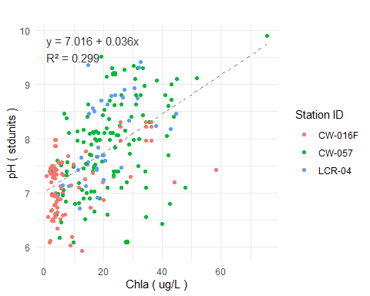

Figure X - pH v Chlorophyll-a at Fishing Creek Reservoir stations.

There are relatively few station-year combinations that have sufficient data (>= 10) to calculate the 90th percentile pH. Those that are available demonstrate that the seasonal (Apr-Oct) 90th percentile pH has a positive relation with the seasonal geometric mean chlorophyll-a concentration as expected (Figure X). No stations had a 90th percentile pH greater than 9.5. The seasonal 90th percentile pH was less than 9.0 when the seasonal geometric mean chlorophyll-a was less than about 20-22 ug/L.

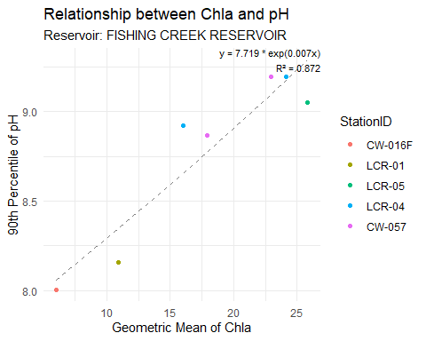

Figure X - Seasonal 90th percentile pH v seasonal geoemetric mean chlorophyll-a at Fishing Creek Reservoir stations.

The South Carolina upper pH limit of 8.5 is more stringent than the USEPA criterion of 9.0. The USEPA upper limit was primarily derived for salmonid protection, and most warmwater fish species do not experience adverse effects at pH values less than 9.5 or higher (reference). Hence, the pH exceedances in Fishing Creek Reservoir are not necessarily associated with aquatic life impacts.

#### 4.2.3.3 Water Clarity

Water clarity in reservoirs is typically measured by Secchi depth. South Carolina does not have a recreationally-based criterion for Secchi depth. As discussed in section X, a Secchi depth of <= 1 m has sometimes been cited in reservoir management literature as threshold for recreational . The median Secchi depth is between 0.5 and 0.75 m at most Fishing Creek Reservoir stations (Figure X), and there most stations have similar Secchi depth values. There was no significant relation between Secchi depth and chlorophyll-a (R2 = 0.01) (Figure X). Secchi depth had slightly stronger (inverse) relations with turbidity (Figure X) and total suspended solids (TSS) (Figure X).

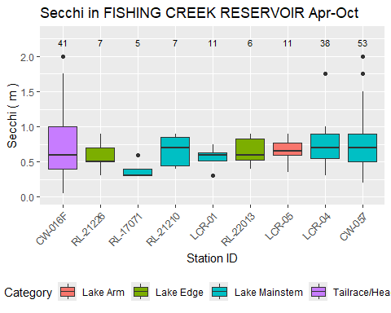

Figure X - Spatial pattern in Secchi depth in Fishing Creek Reservoir.

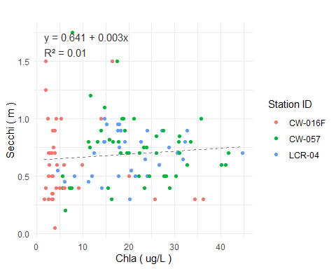

Figure X - Secchi depth v Chlorophyll-a at Fishing Creek Reservoir stations.

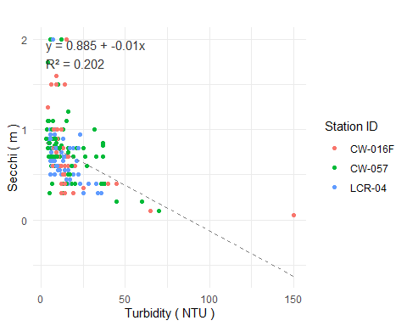

Figure X - Secchi depth v Turbidity at Fishing Creek Reservoir stations.

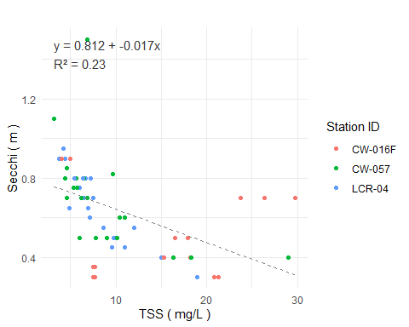

Figure X - Secchi depth v TSS at Fishing Creek Reservoir stations.

#### 4.2.3.4 Cyanotoxins

SCDES has monitored microcystin at three Fishing Creek reservoir stations since 2017. No samples have exceed SC recreational water quality criteria of 8.0 ug/L, nor any drinking water advisory level (Table X).

Table X - Microcystin Summary Statistics for Fishing Creek Reservoir

|  | **Microcystin in FISHING CREEK RESERVOIR** | **Microcystin in FISHING CREEK RESERVOIR** | **Microcystin in FISHING CREEK RESERVOIR** | **Microcystin in FISHING CREEK RESERVOIR** | **Microcystin in FISHING CREEK RESERVOIR** | **Microcystin in FISHING CREEK RESERVOIR** | **Microcystin in FISHING CREEK RESERVOIR** | **Microcystin in FISHING CREEK RESERVOIR** | **Microcystin in FISHING CREEK RESERVOIR** | **Microcystin in FISHING CREEK RESERVOIR** |
| --- | --- | --- | --- | --- | --- | --- | --- | --- | --- | --- |
| **StationID** | **Count** | **Max** | **Perc_90th** | **Perc_75th** | **Arith_Mean** | **Geo_Mean** | **Median** | **Perc_25th** | **Perc_10th** | **Min** |
| CW-016F | 29 | 0.2 | 0.1 | 0.1 | 0.1 | 0.1 | 0.1 | 0.1 | 0 | 0 |
| LCR-04 | 23 | 0.2 | 0.1 | 0.1 | 0.1 | 0.0 | 0.1 | 0.0 | 0 | 0 |
| CW-057 | 33 | 0.2 | 0.2 | 0.1 | 0.1 | 0.1 | 0.1 | 0.0 | 0 | 0 |

#### 4.2.3.5 Other Algal Indicators

SCDES has monitored algal taxa at two station on Fishing Creek reservoir:

* CW-016F, Fishing Creek Lake, upper reservoir
* CW-057, Fishing Creek Lake, near dam

Both were sampled sampled five times in 2017 between late June and mid October. Algal taxa were identified to the genus level and also categorized by major algal group (diatoms, green algae, cyanobacteria, etc.). Algae were quantified with regard to density (cells per mL) and biovolume (um3 per mL).

The data from 2017 indicate different proportions of major algal groups in the upper reservoir (CW-016F) and near the dam (CW-057). The upper reservoir had lower algal density and volume, consistent with lower chloropyll-a values. Green algae, cyanobacteria, and diatoms were the dominant groups by cell density (Figure X). However, cyanobacteria biovolume was proportionally very low even under higher chlorophyll-a concentrations (Figure X), due to the much smaller volume of cyanobacteria cells relative to other taxa. Near the dam, cyanobacteria were the dominant taxa by density (Figure X), but once again a relatively small component by biovolume (Figure X).

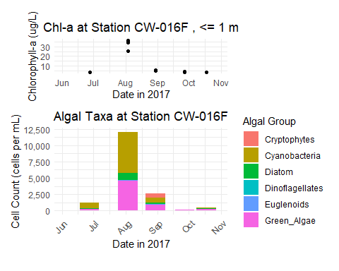

Figure X: CW-016F (Fishing Creek Res.) Chlorophyll-a and Algae Density

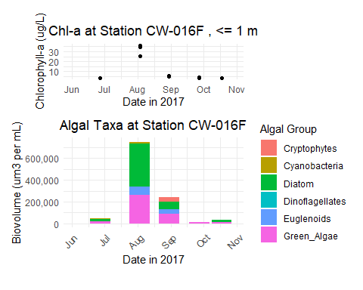

Figure X: CW-016F (Fishing Creek Res.) Chlorophyll-a and Algae Biovolume

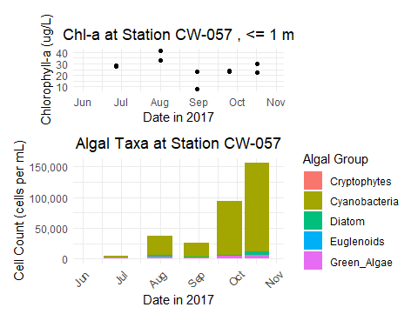

Figure X: CW-057 (Fishing Creek Res.) Chlorophyll-a and Algae Density

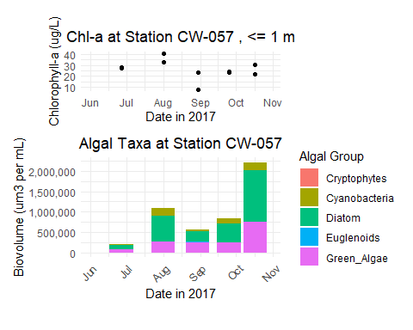

Figure X: CW-057 (Fishing Creek Res.) Chlorophyll-a and Algae Biovolume

A strong relationship between chlorophyll-a and cyanobacterial cell counts was not apparent from the relatively few data available (Figure X). No samples from the upper reservoir (CW-016F) exceeded the WHO threshold for moderate risk of cyanobacteria impacts in recreational waters (20,000 cells/mL) (Figure X). Two from the lower reservoir (CW-057) exceeded that threshold, and one exceeded the WHO threshold for high risk of cyanobacterial impacts in recreational waters (100,000 cells/mL). These thresholds are indirect measures of the potential for cyanotoxin impacts. The low concentrations of microcystin in Fishing Creek reservoir (as discussed ion section x.x.x.x) indicates the WHO thresholds may not be useful risk thresholds for this water body.

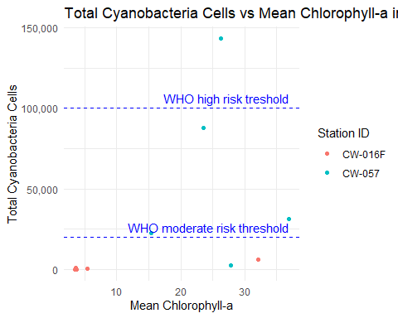

Figure X: Cyanobacteria count vs. chla, Fishing Creek Reservoir

## 4.3 Other Status Indicators

The previous section explored water quality indicators and their relation with chlorophyll-a. Some indicators are less quantitative but still informative regarding the use status of the reservoir. This subsection discusses three such indicators: fishery quality, potable water supply, and aesthetics.

## 4.3.1 Fishery Quality

## 4.3.2 Potable Water Supply

The Chester Metropolitan District (Chester Metro) operates a potable water supply intake on the upper part of Fishing Creek Reservoir. Water from the intake is treated at the Fort Lawn Water Treatment Plant, which has a typical treatment rate of 3 MGD and a permitted capacity of 7.6 MGD. Chester Metro reports no taste and odor (T&O) problems or issues with treatability related to chlorophyll-a or algae levels (pers. comm., Andy Litten, Chester Metro Manager of Engineering and Operations, July 8, 2024).

## 4.3.3 Reports of Algal Blooms

In addition to routine monitoring for microcystin, SCDES performs sampling associated with algal bloom complaints. The associated database includes only one such sampling event for Fishing Creek Reservoir, with a sample collected on June 17, 2024. The event was described as “Green (non toxin producing) algal bloom on entire reservoir- Carteria sp”. The associated microcystin concentration was 0.17 ug/L, well below any effects-based threshold.