B1. Creating the Tables

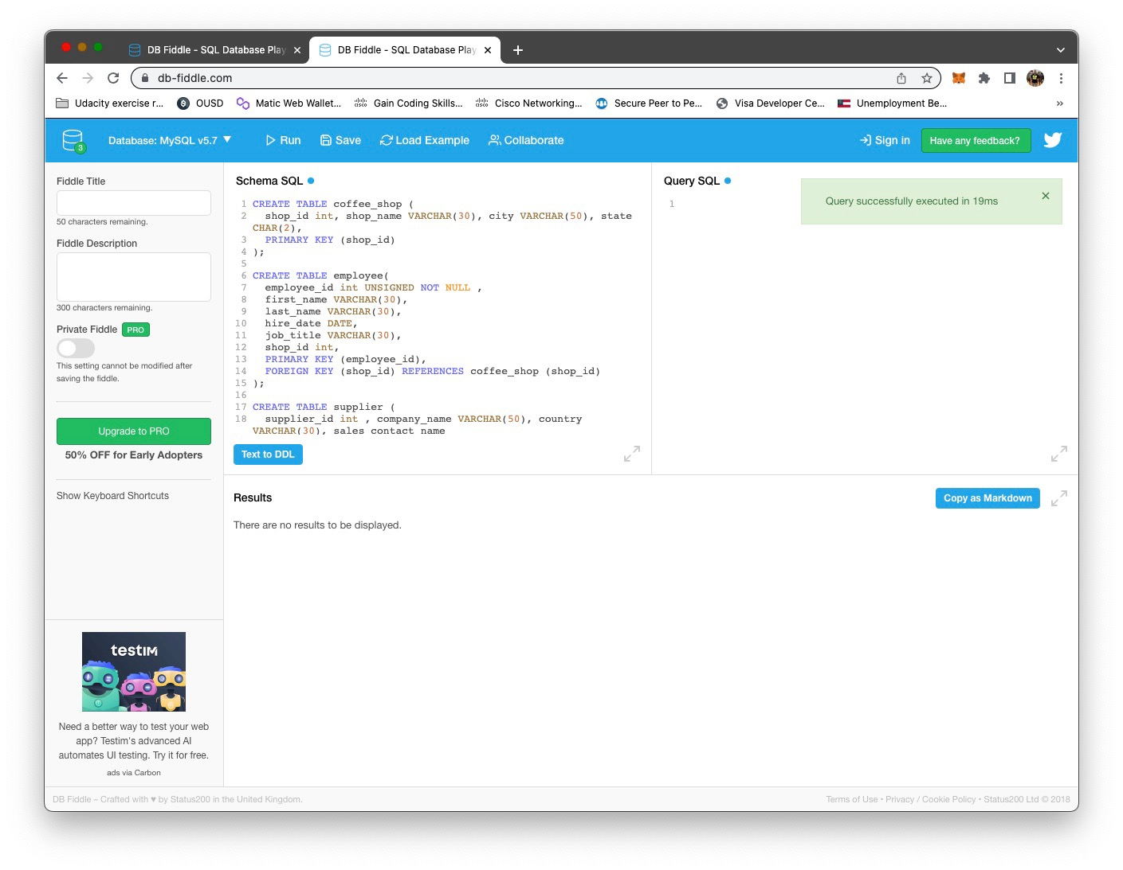

B2. SQL code to populate each table

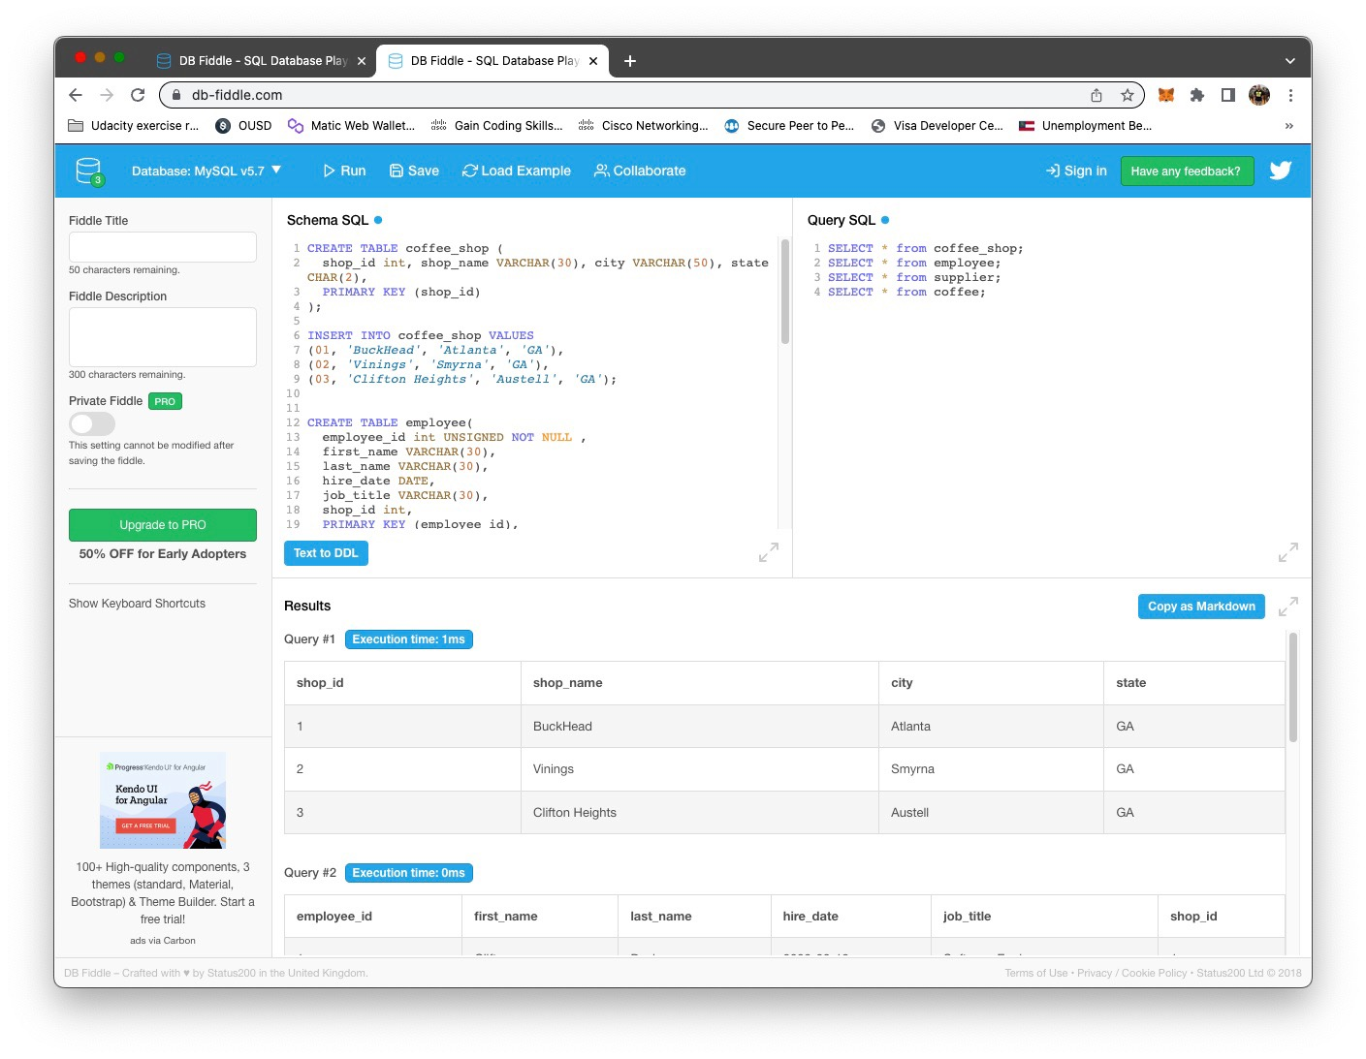

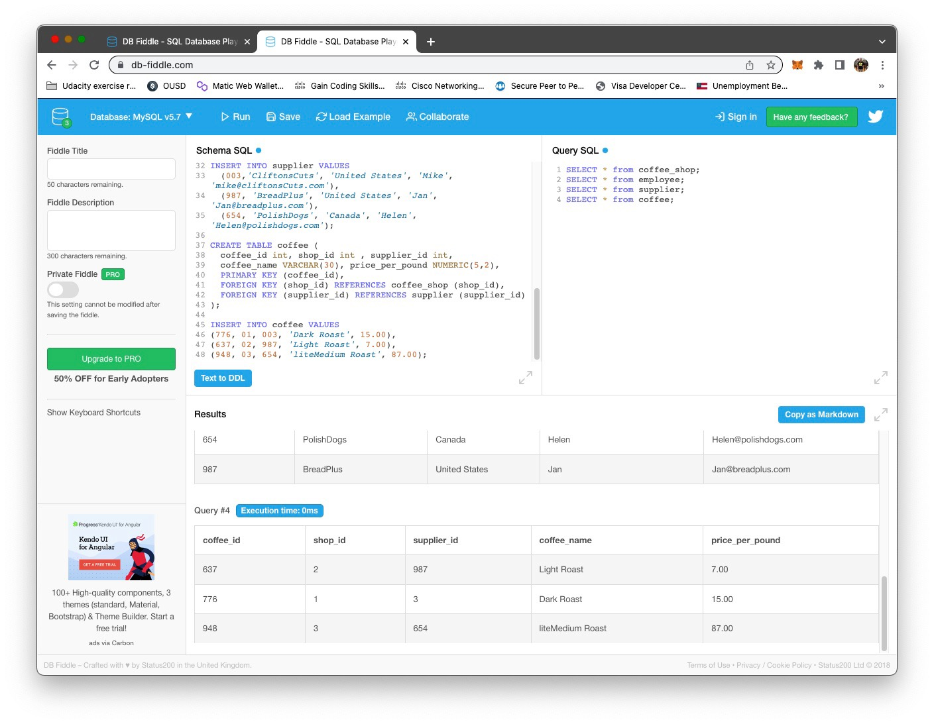

B3. Develop SQL code to create a View

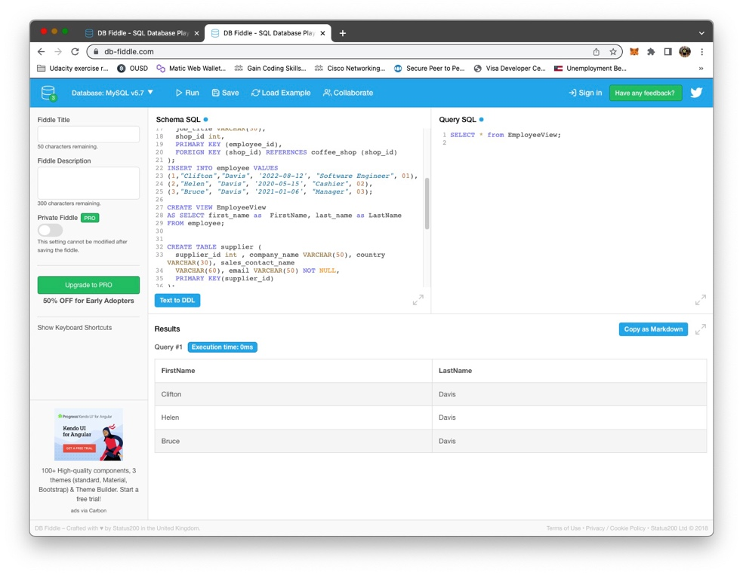

B4. SQL code to create an index on the coffee_name field

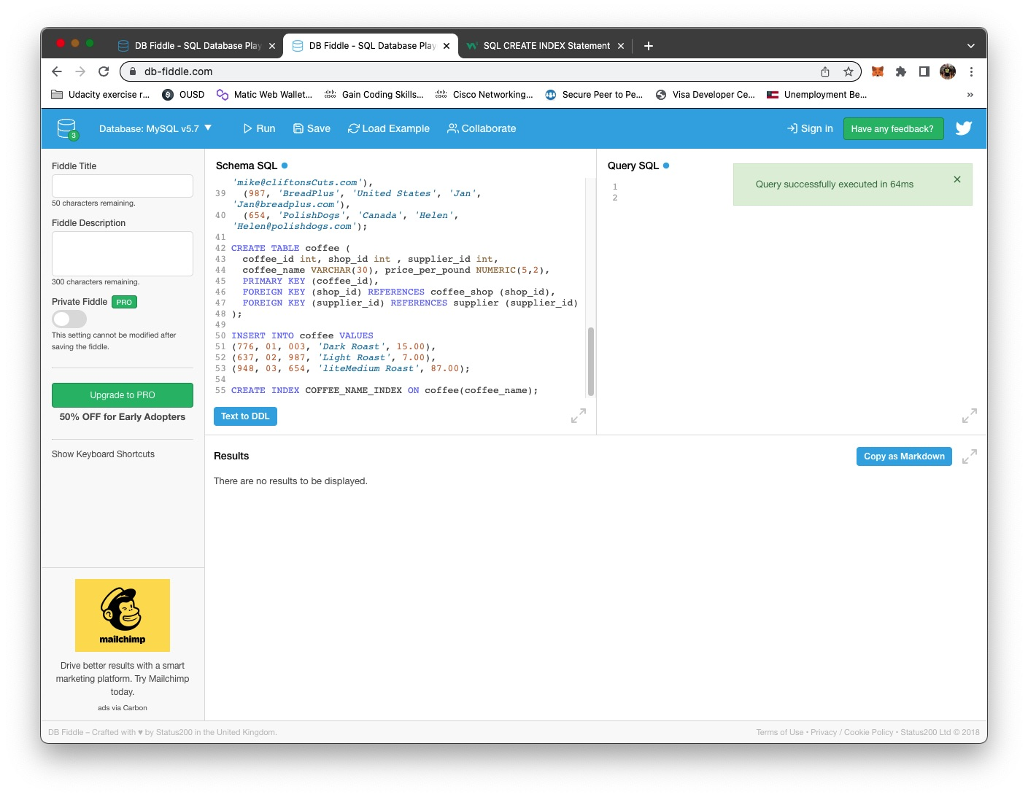

B5. SQL code to create an SFW query

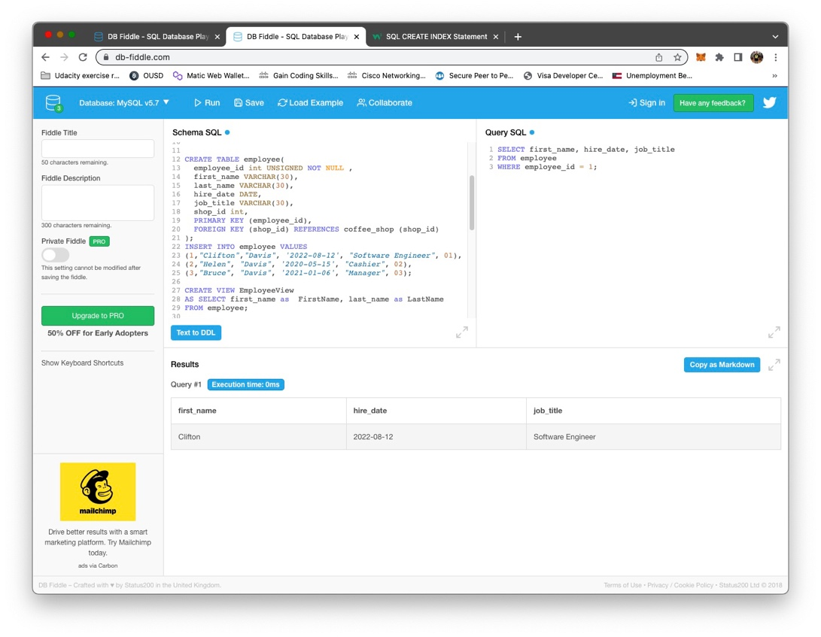

B6. SQL code to create a JOIN of 3 Tables

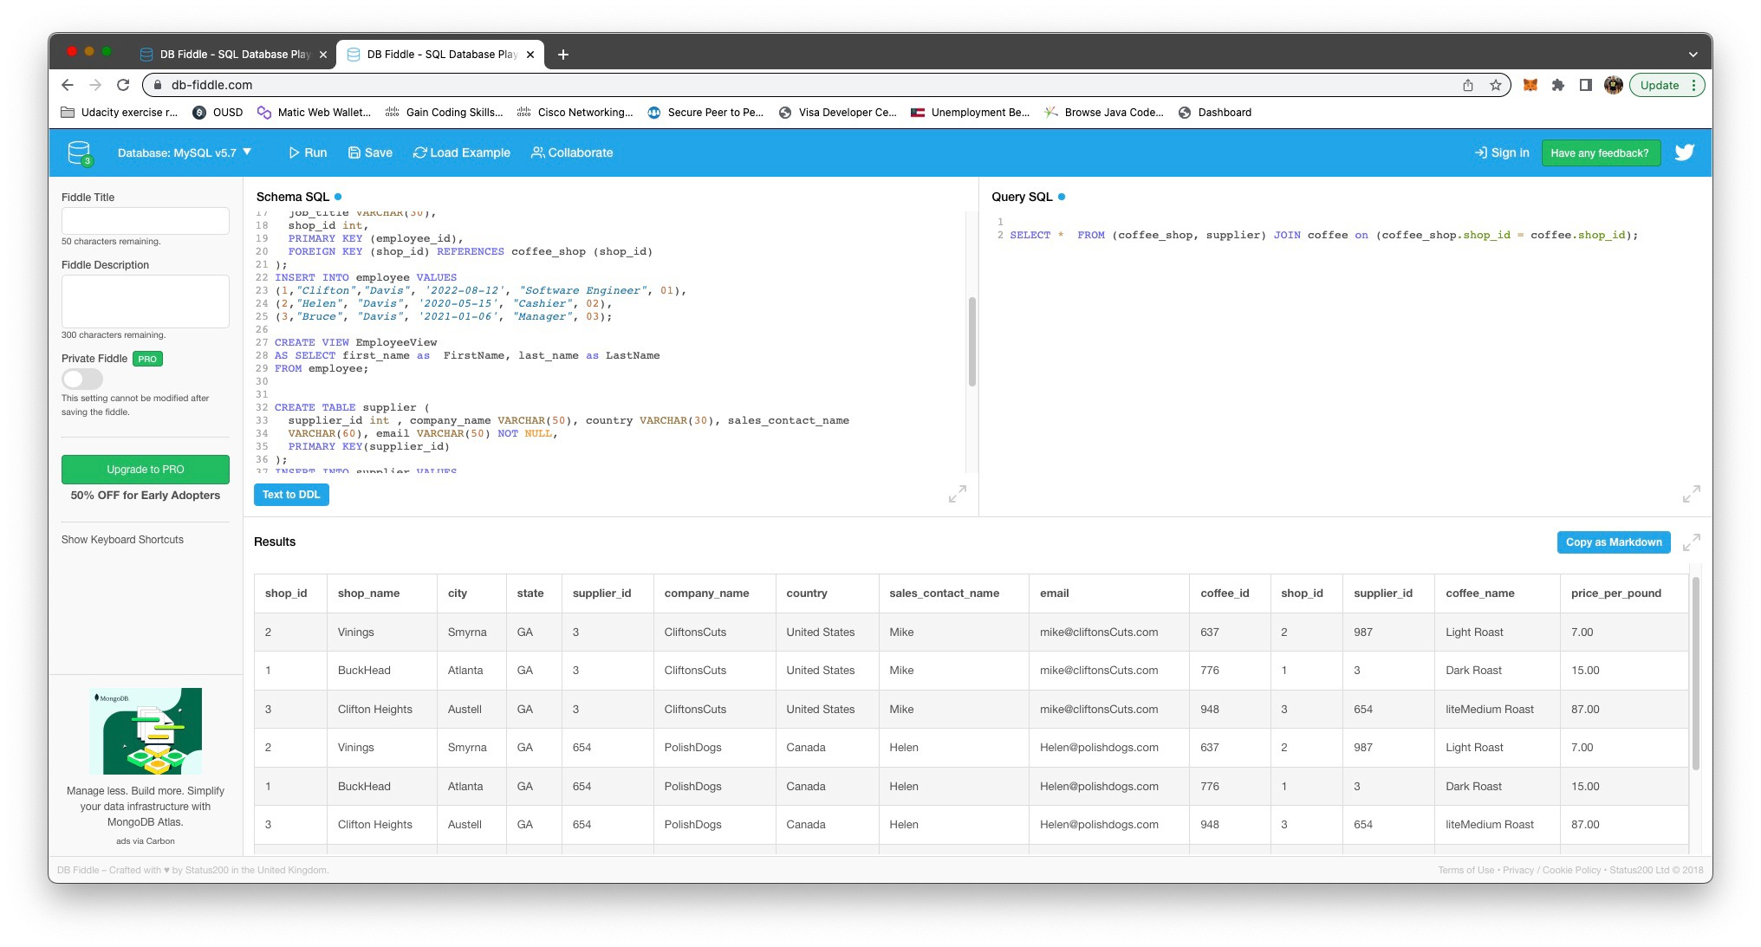

CREATE TABLE coffee_shop (

shop_id int, shop_name VARCHAR(30), city VARCHAR(50), state CHAR(2),

PRIMARY KEY (shop_id)

);

INSERT INTO coffee_shop VALUES

(01, 'BuckHead', 'Atlanta', 'GA'),

(02, 'Vinings', 'Smyrna', 'GA'),

(03, 'Clifton Heights', 'Austell', 'GA');

CREATE TABLE employee(

employee_id int UNSIGNED NOT NULL ,

first_name VARCHAR(30),

last_name VARCHAR(30),

hire_date DATE,

job_title VARCHAR(30),

shop_id int,

PRIMARY KEY (employee_id),

FOREIGN KEY (shop_id) REFERENCES coffee_shop (shop_id)

);

INSERT INTO employee VALUES

(1,"Clifton","Davis", '2022-08-12', "Software Engineer", 01),

(2,"Helen", "Davis", '2020-05-15', "Cashier", 02),

(3,"Bruce", "Davis", '2021-01-06', "Manager", 03);

CREATE VIEW EmployeeView

AS SELECT first_name as FirstName, last_name as LastName

FROM employee;

CREATE TABLE supplier (

supplier_id int , company_name VARCHAR(50), country VARCHAR(30), sales_contact_name

VARCHAR(60), email VARCHAR(50) NOT NULL,

PRIMARY KEY(supplier_id)

);

INSERT INTO supplier VALUES

(003,'CliftonsCuts', 'United States', 'Mike', 'mike@cliftonsCuts.com'),

(987, 'BreadPlus', 'United States', 'Jan', 'Jan@breadplus.com'),

(654, 'PolishDogs', 'Canada', 'Helen', 'Helen@polishdogs.com');

CREATE TABLE coffee (

coffee_id int, shop_id int , supplier_id int,

coffee_name VARCHAR(30), price_per_pound NUMERIC(5,2),

PRIMARY KEY (coffee_id),

FOREIGN KEY (shop_id) REFERENCES coffee_shop (shop_id),

FOREIGN KEY (supplier_id) REFERENCES supplier (supplier_id)

);

INSERT INTO coffee VALUES

(776, 01, 003, 'Dark Roast', 15.00),

(637, 02, 987, 'Light Roast', 7.00),

(948, 03, 654, 'liteMedium Roast', 87.00);

CREATE INDEX COFFEE_NAME_INDEX ON coffee(coffee_name);