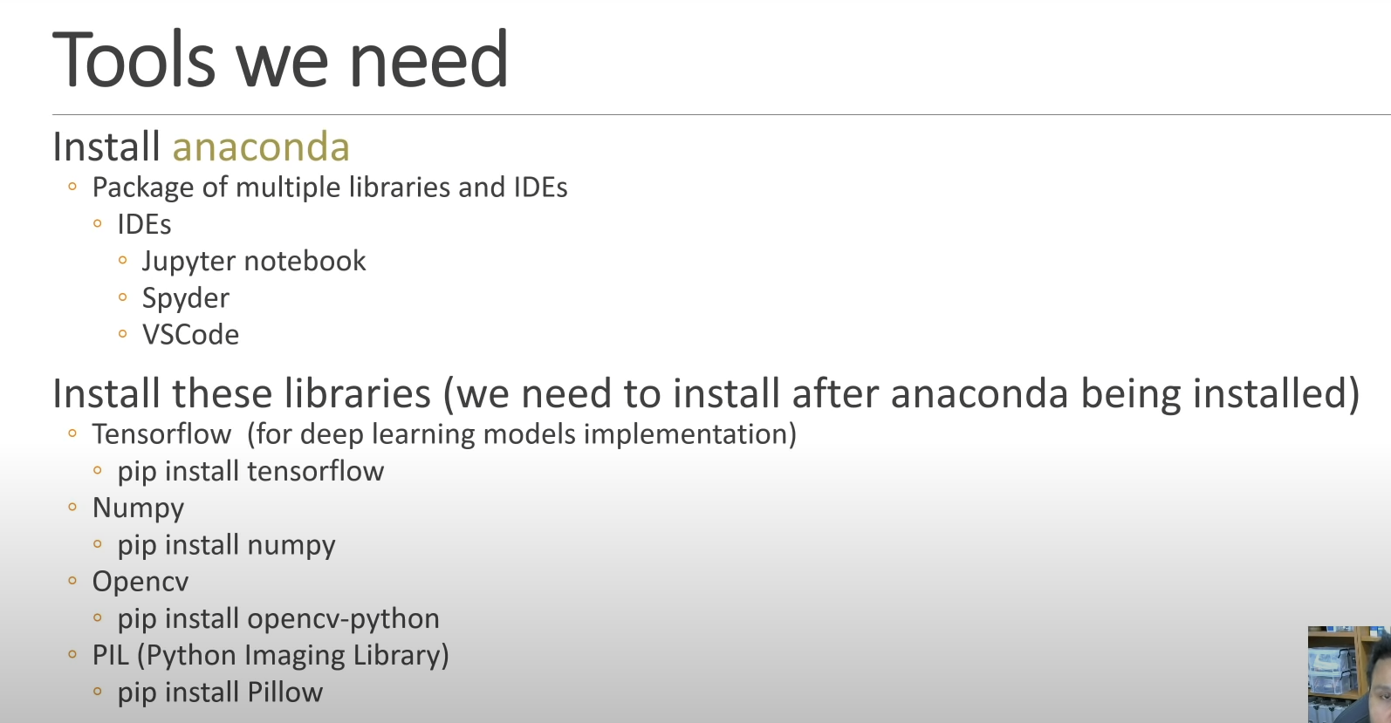

# DHT 11 Installation Guide at Raspberry Pi 3B+

URL: https://www.circuitbasics.com/how-to-set-up-the-dht11-humidity-sensor-on-the-raspberry-pi/

To install the Adafruit DHT11 library:  
1. Enter this at the command prompt to download the library:  
git clone <https://github.com/adafruit/Adafruit_Python_DHT.git>  
  
2. Change directories with:  
cd Adafruit_Python_DHT

3. Now enter this:  
sudo apt-get install build-essential python-dev

4. Then install the library with:  
sudo python3 setup.py install

TKINTER Installation Guide

http://www.pibits.net/programming/getting-started-with-tkinter-on-the-raspberry-pi.php

sudo apt-get install python-tk

Using GUI Icon

Ensure GUI image is at the desktop

Change file path accordingly