# Examples of data analysis with Grocer

**Senhua Zhu**

**2013.5.3**

**fMRI Grocer has been distributed online for free. You can download it from both of the SPM and NITRC (Neuroimaging Tools and Resources) websites. The links are as below.**

SPM: [www.fil.ion.ucl.ac.uk/spm/ext/#Grocer](http://www.fil.ion.ucl.ac.uk/spm/ext/#Grocer) (<http://code.google.com/p/fmrigrocer/>)

NITRC: [www.nitrc.org/projects/fmri_grocer/](http://www.nitrc.org/projects/fmri_grocer/)

## Start Grocer

After adding the path of Grocer toolbox into Matlab, you can start Grocer by typing “grocer” in the Matlab command window as below.

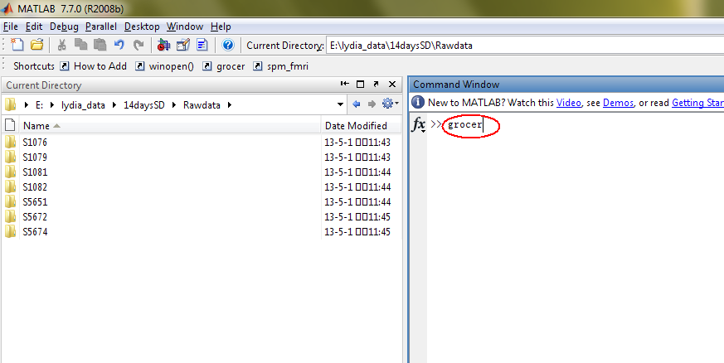

Press “Enter” and then the Grocer panel will pop up as below.

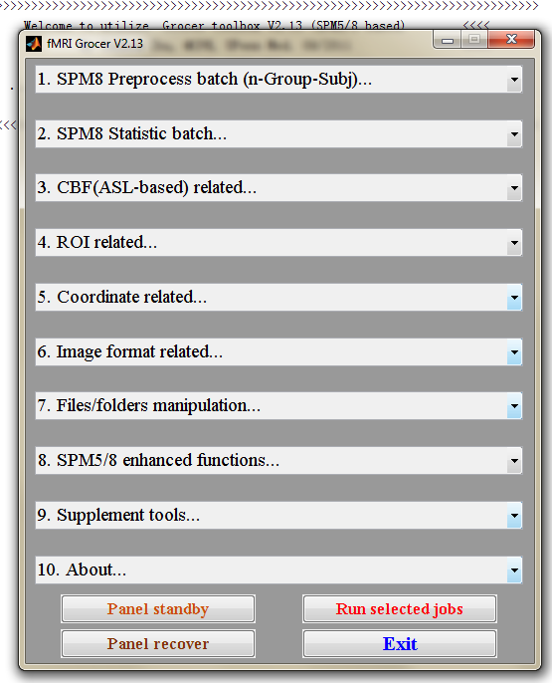

You can always find the brief manual and examples of using Grocer in the menu 10.

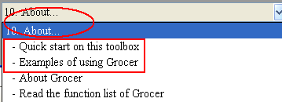

## 1. CBF reconstruction with Grocer 2.13

* **Data:** pCASL scans of a 14 days’ sleep deprivation study
* **Scans:** All Subjects had rest1, PVT, and rest2 three scans
* **Aim:** The aim of this example is to reconstruct the CBF maps from original perfusion scans (pCASL, DICOM formate) with fMRI Grocer 2.13.

### Manage and convert DICOM images

After MRI scans, you need to copy the DICOM data of each subject to the hard disk from CDs. The data was firstly organized as below.

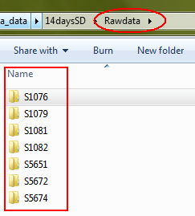

The functions for cleaning DICOM folders, categorizing DICOM images and converting DICOMs to Niftis in Grocer can be referred to as below.

The related functions in menu 6 can be used both under the Windows and Linux OS.

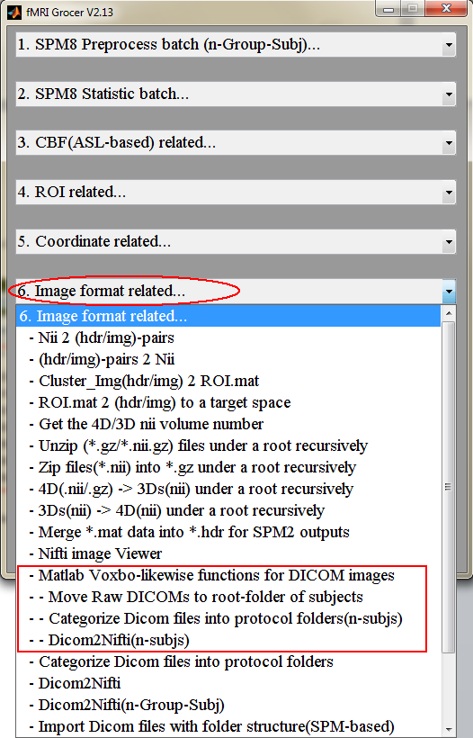

Alternatively, you can use the related functions in menu 9 under the Linux OS that has installed Voxbo tools (<http://www.voxbo.org/>).

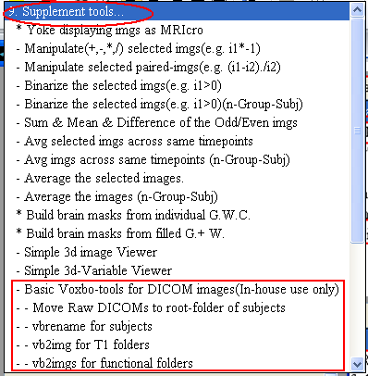

At last, no matter which kind of functions you use (even you can do it manually), finally you should organize your data as below:

* The subject folders (e.g. S1039, S1068) are all under a root folder (“Imgdata”).
* Under each subject folder, there are three pCASL scan folders and one T1 image. **Please make sure all the names of scan folders are same across subjects.** This would much help to reorginaze folder structure and running data analysis in a batch way.
* The Nifti images are under each scan folder (the rules of renaming the images is not that important for batch processing )

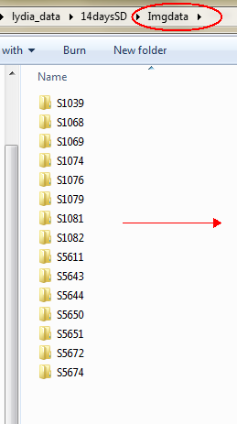 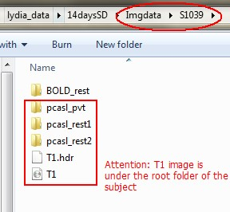 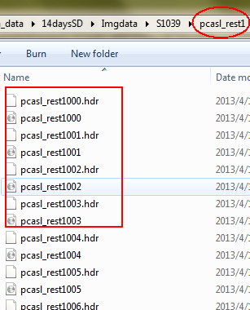

### Convert the Folder structure for doing batch propressing

In order to run CBF reconstruction in a batch way with Grocer, you need to reconstruct the original folder structure into a more common folder structure.

First, create a new folder named “reorginazed_Imgdata” as a target folder to hold the new outputs.

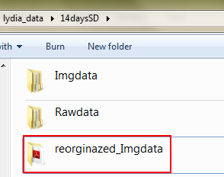

Then run the specific folder reconstruction function in the menu 7 of Grocer as below.

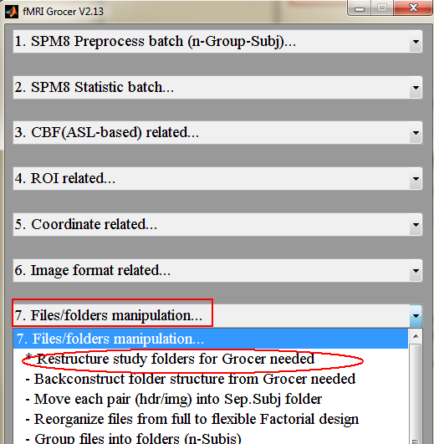

First, select the source root folder “Imgdata”. **(For using the functions in Grocer, just follow the instructions on the tile of the pop-up windows)**

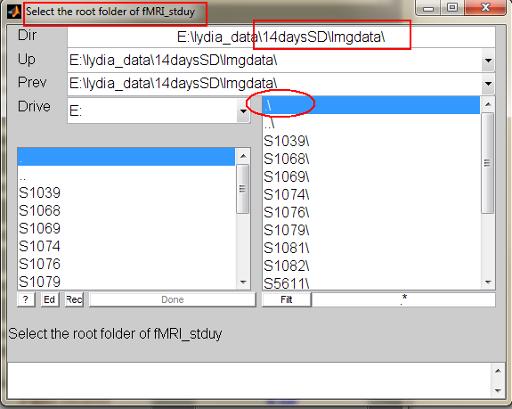

Then, select all the subject folders under the root folder.

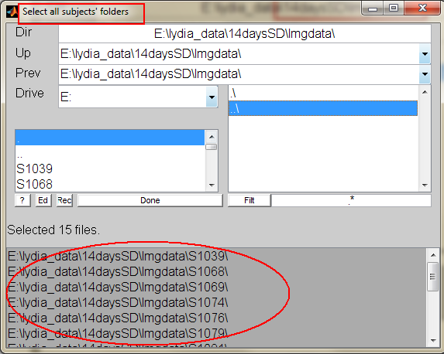

Then select all the pCASL functional groups under a subject folder **(The folder names of this selection will be applied for all the other subjects. That is why you need to make sure that the names of these scan folders should be the same across subjects)**.

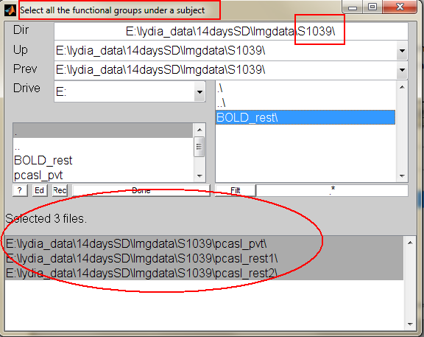

After that, a window pops up asking whether you need to deal with T1 images. If you don’t want to (or just not ready to) reorganize T1 images, you can click 【No】 to skip. Here we click 【Yes】to continue.

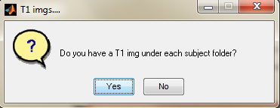

Then a window pops up asking where your T1 image is. It is either under the root folder of each subject or in a separated folder under the root folder of each subject. As you see the data organization before, we choose 【RootFolder】in this case.

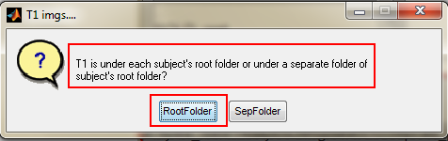

Next you can select the T1 image under the root folder of a subject **(Make sure the names of T1 image across subjects are same)**

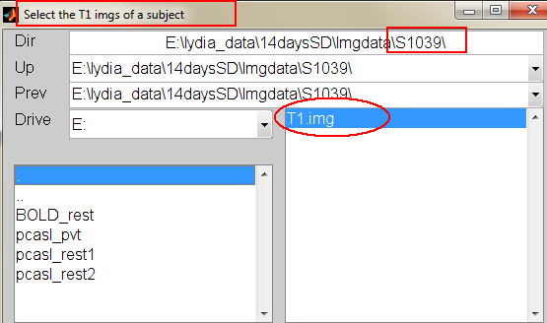

At last, a window pops up asking to select the target folder to hold the output.

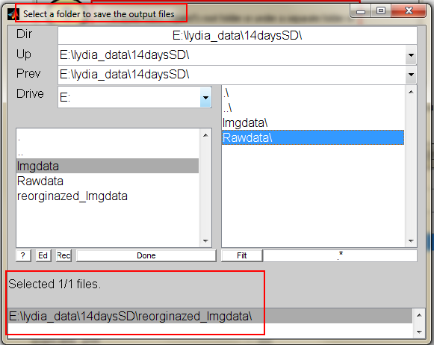

After that, a window pops up to confirm whether you really want to dealing with the functional groups **(Sometimes you rerun this function just want to deal with the T1 images, then you can skip dealing with the images of functional groups)**.

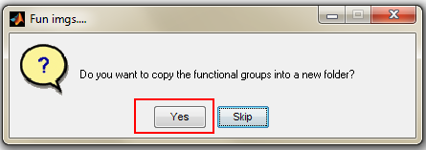

After clicking 【Yes】above, just wait. After it finishs, you can find the files with new folder structure in the target folder “reorginazed_Imgdata” as below.

* Three scan folders are under the new root folder “reorginazed_Imgdata”
* The corresponding images of each subject are all organized separately under the scan folders

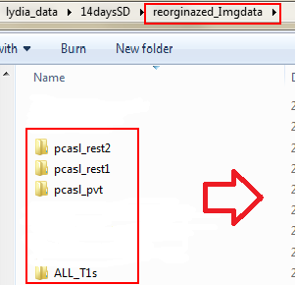 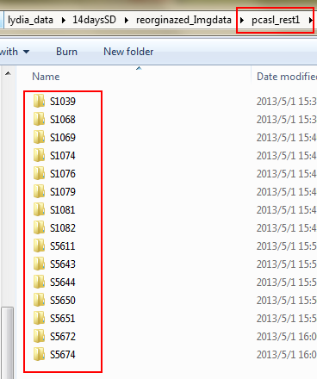

* An “ALL_T1s” folder holds all the T1 images of each subject. The T1 images has been renamed as starting with the name of subject folder.

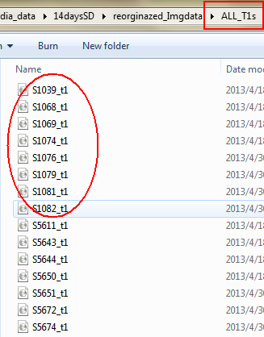

### 1.3 Run preprocessing & CBF reconstruction in a batch way

Before running any data analysis, the first is to make sure that the origins of your images are correct. If not, use the function in menu 8 to reset the origin of functional images and T1 images with specific requirement.

**In this case, the following batch processing of reconstructing CBF maps will reset the origins of functional images automatically. However, you should always check your T1 images manually.**

Most of the time, as the way for functional images, just reset the origin of T1 images into the center of the map. Practice has proved that this works quite well.

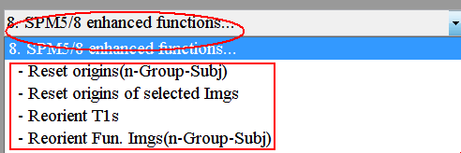

When all are set, you can use the function below to run image preprocessing and CBF reconstruction just with few clicks.

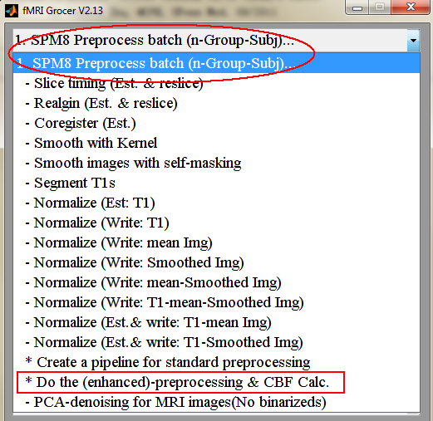

After clicking the command above, the first window is asking what kind of data you are going to deal with.

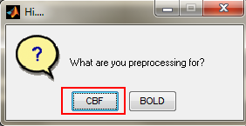

For perfusion images, no need to do slice-timing

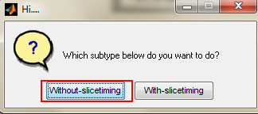

Don’t do the enhanced de-noising except you know what you are doing for.

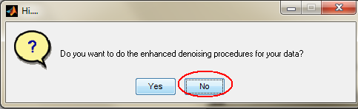

Suggest to do self-masking images before smoothing though it takes much more time.

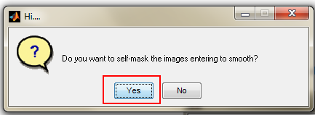

For doing self-masking, you just want to define the whole brain mask by removing the skull from the T1 image of each subject.

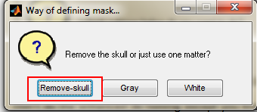

Then a window pops up to tell you what steps will be run for the image preprocessing

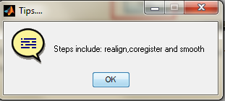

Of course, you want to reconstruct CBF maps in this example.

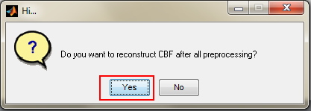

#### 1.3.1 Ways of giving parameters

There are **two ways of giving parameters of ASL-based CBF calculation for Grocer**.

If you have run CBF calculation with this function in Grocer before, you may have an “ASL_paras.mat” file somewhere you saved.

If you are going to run this CBF reconstruction with completely same parameters, then you can choose 【Yes】to select the old “ASL_paras.mat” file to feed the Grocer. Otherwise, choose 【No】 to input the parameters as the indications of the pop-up window.

**First way:** Here we choose 【Yes】and select the existed “ASL_paras.mat”.

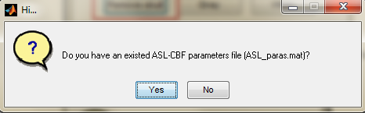

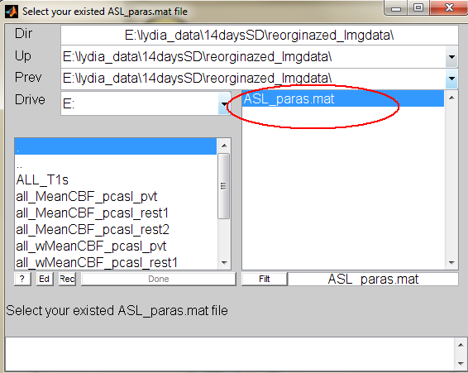

**Second way:** If you choose 【No】, the next window will be presented as below.

In this window, if you chose to do self-masking images before smoothing in the several steps before, then you can get the same CBF maps no matter which option you select. Otherwise, select 【CBF-selfmasked】to get relatively accurate CBF maps but takes much more time.

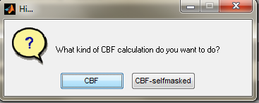

Then you will be asked to input the parameters for CBF calculation. All the parameters you need to adjust are framed by the red rectangle as below.

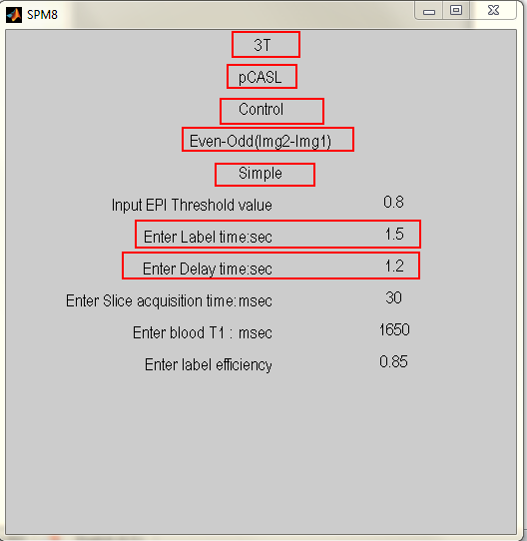

After that, you will be asked to select a folder to save your CBF calculation parameters. The file it created is the “ASL_paras.mat” that can be used in the next time.

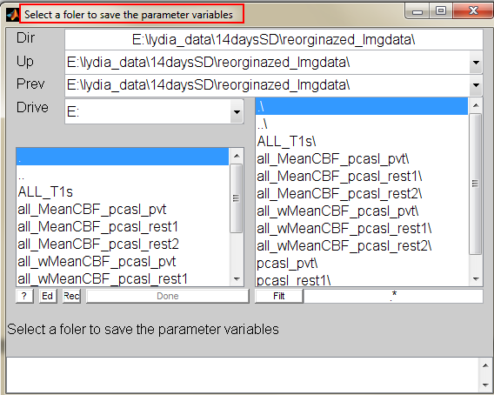

After the parameters settings are done, finally, you are going to choose the image files for dealing with.

#### 1.3.2 Image file choosing system of Grocer

First, choose the “reorginazed_Imgdata” as the root folder for this case.

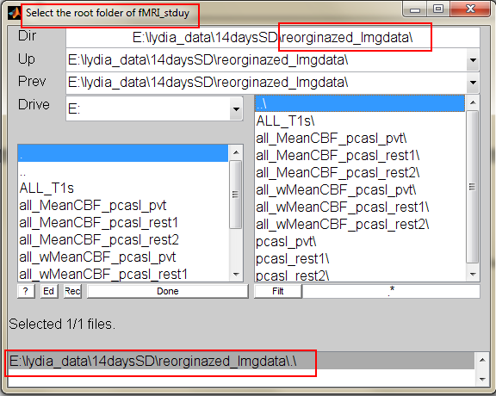

Then select the three functional groups of your data.

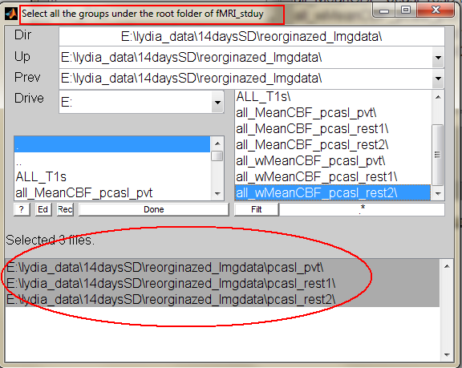

Choose the last option to ask Grocer to select all subject folders under each group automatically.

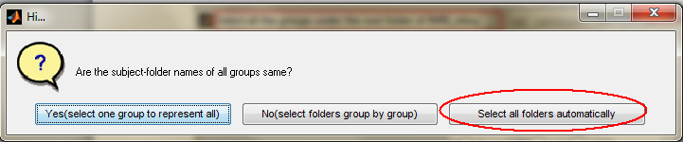

And you can also give a folder filter for selecting subject folders. If no special requirement, just leave the star in the dialogue widow alone to select all subject folders.

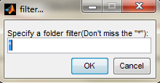

Next, also use the last option to ask Grocer to select all image files under each subject folder of each group automatically.

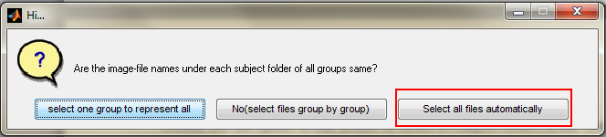

Also, you can also give a image file filter for selecting images. If no special requirement, just leave the predefined image filters in the dialogue widow alone to select all files under each subject folder.

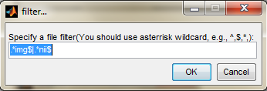

The next window is going to dealing with the T1 images.

In this study, as each subject of three functional groups use the same T1 image, so just choose the first option to apply the T1 images with the same order for the subjects of all groups.

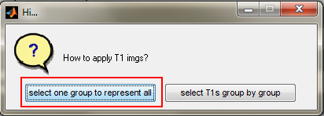

Then select all the T1 images under the “ALL_T1s” folder

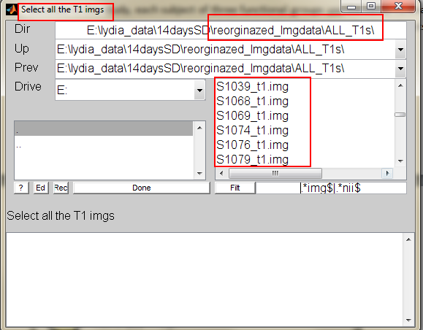

Finally, set the smoothing kernel size as you want. [8 8 8] is always used in our studies.

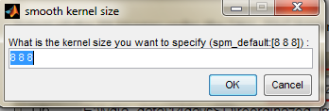

After clicking【OK】above, all you need to do is just to wait for your results.

Grocer will output the normalized and pre-normalized Mean-CBF of each subject of each group in independent folders under the target root folder separately. Usually, you can use the normalized Mean-CBFs to do the group statistics.

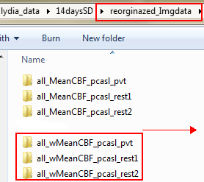 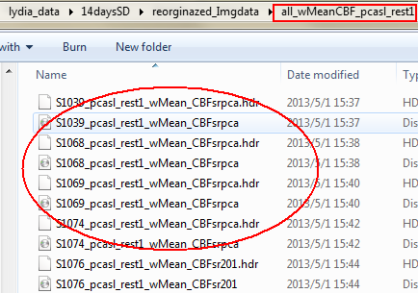

The pre-normalized CBF time series of each subject are also generated under each subject folder of each groups as below.

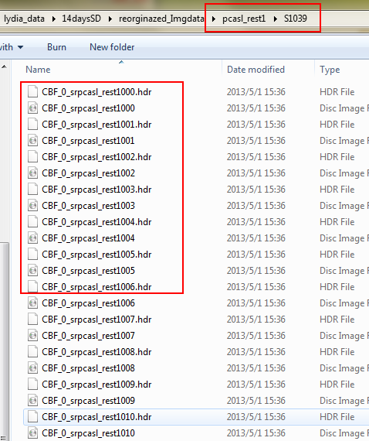

### Run preprocessing & CBF reconstruction separately

If you want to run image preprocessing independently, please refer to the functions shown as below. You can either use the separate functions to do the conventional preprocessing step by step or create a pipeline for standard preprocessing for the images.

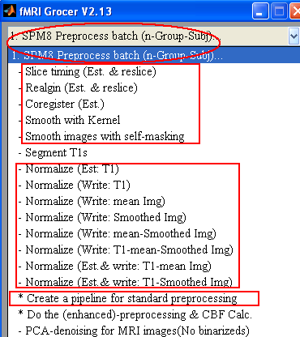

Once your preprocessing is done, use the independent CBF calculation function to reconstruct CBF maps from the preprocessed image files. After CBF reconstruction, first, you need to normalize the CBF or mean-CBF maps manually. Then you also need to copy out specific CBF maps manually with the help of “Copy (w)MeanCBF into a folder” function.

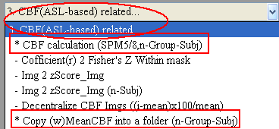

### 1.5 Functions for doing GLM analysis and ROI analysis

After you get your CBF maps ready, you are going to do the GLM statistical analysis or ROI analysis.

For the GLM analysis, just refer to the functions in menu 2.

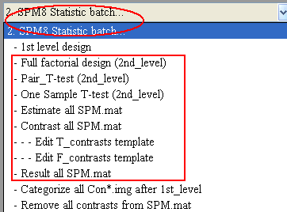

For the ROI analysis, just refer to the functions in menu 4.

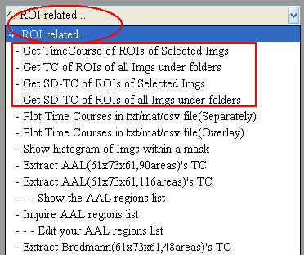

## 2. CBF reconstruction for a single subject

After you get the Nifti perfusion maps ready, you are going to do conventional preprocessing, including Realignment, Coregistration, Smoothing. Then you can use Grocer to reconstruct CBF maps from the smoothed perfusion maps. Once you get your CBF maps, you need to normalize them with coregistration parameters.

**\*\*\* Attention: the way of how to run conventional preprocessing is out of our topic. It is suggested to learn SPM before using Grocer. Otherwise, you can’t understand some concepts mentioned by Grocer \*\*\***

Now we assume you have succeeded in finishing the conventional preprocessing for perfusion images, and you have got the smoothed data which is shown as below.

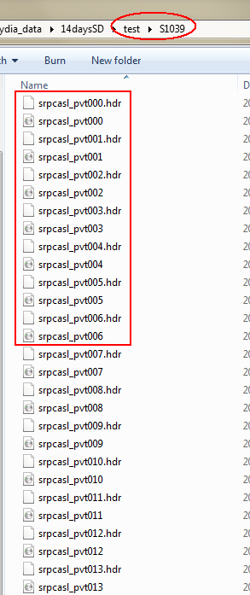

Now we’ll show you how to reconstruct CBF maps from these smoothed perfusion images. Locate the CBF calculation function in menu 3 as below.

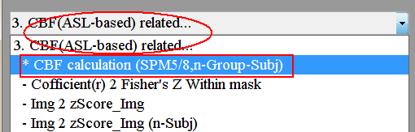

Now we’ll show you how to reconstruct CBF maps from these smoothed perfusion images. Locate the CBF calculation function in menu 3 as below.

Choose “CBF” option to do the most conventional CBF calculation method.

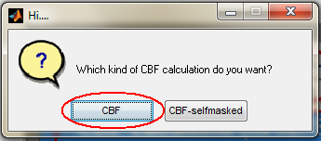

And then follow the instructions to select all the smoothed data mentioned above. Once you are done, the parameter selection panel pops up.

Choose the right options in the following pull-down menus according to your exact scan parameters.

We scan subjects in a 3T whole body scanner.

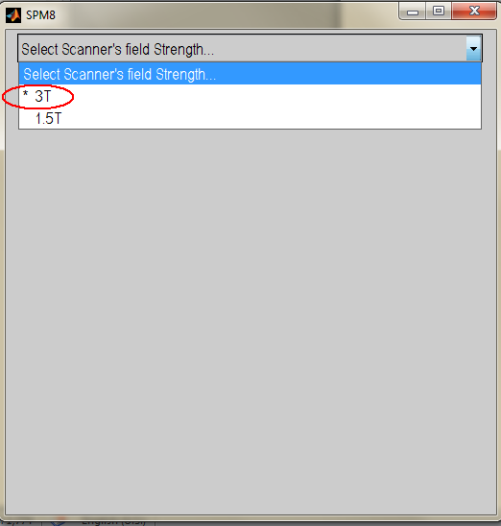

We are doing the pCASL scans.

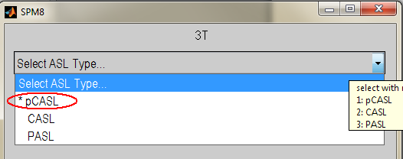

In our pCASL scans, the first image was predefined as the “control” image

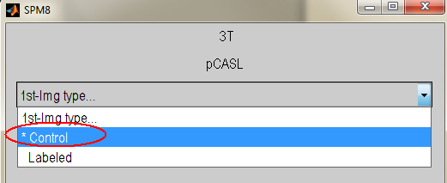

As the first image (odd) is a control, the CBF map then can be acquired from the subtraction of (even - odd).

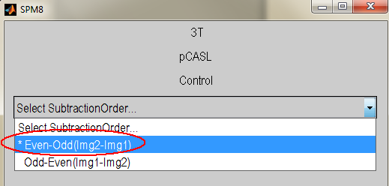

Usually, we choose to use “Simple” subtraction method to reconstruct the CBF maps from perfusion images.

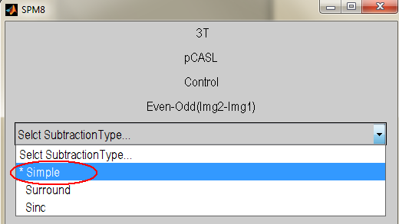

All the rest is to set up the label time and delay time of your pCASL sequence. You can know that from your sequence designer.

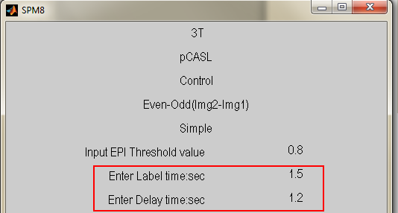

After setting up these parameters shown above, hopefully you can get a series of CBF maps and a Mean-CBF map under the subject folder after several minutes.

The following figure shows the output files you may get after above session.

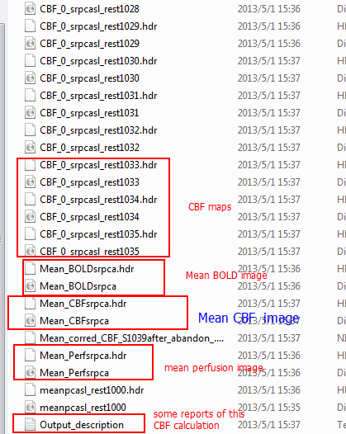

At last, before going into the group statistical analysis, use the normalization function to normalize either your CBF*.* maps or your Mean_CBF*.* map as below.

