Grocer V2.1 Quick Start
Senhua Zhu
Updated: 2013.8.13

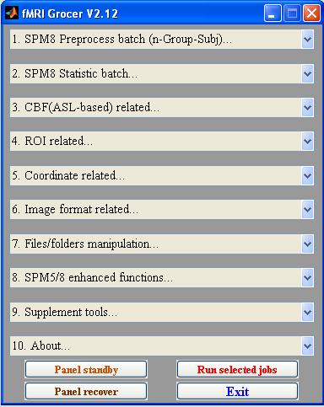
fMRI Grocer has been distributed online for free. You can download it from both of the SPM and NITRC (Neuroimaging Tools and Resources) websites. The links are as below.
SPM: www.fil.ion.ucl.ac.uk/spm/ext/#Grocer (http://code.google.com/p/fmrigrocer/)
NITRC: www.nitrc.org/projects/fmri_grocer/

1. Welcome
Welcome to use <Grocer> toolbox.
This toolbox contains many kinds of kits that you may be interested in during fMRI data analysis. These kits have been separated into many pull-down menus (So far, 9 menus) as above.
This toolbox is a homebrew tool that I wrote during my own whole years’ experience on ASL (arterial spin labeling)-based CBF (Cerebral Blood Flow) data analysis. However, this toolbox is also compatible with BOLD data analysis. Just as its name says, Grocer, everyone should find something useful for their own data analysis!
This toolbox is run and tested on SPM8 with MATLAB 7.6.0(R2008a) under the Linux OS. Theoretically, most of the functions (except the menu1 & 2 which are specially designed for the Batch Editor of SPM8) of this toolbox should be compatible with SPM5 and should also work smoothly under the Windows OS.
Since its birth, it has been published for quite a few versions. Now it should be very stable now. However, along with update from time to time, it may always have some bugs that haven’t been checked out. If you encounter some bugs or have any suggestions during utilizing these kits, please feel free to contact me via e-mail: zshtom@gmail.com.

2. Disclaimer
I wrote and modified all of these kits in this toolbox mainly based on SPM8. I also took use of some functions of some other toolboxes, such as Marsbar (http://marsbar.sourceforge.net/) and REST (http://www.restfmri.net/forum/) just for convenience. Actually, this is a second-development product based on open-source fMRI-tools. Some functions of which I took advantage were acquired from public resources online.
However, just as I mentioned above, at first, I just created these codes for in house utility. Today, when I am trying to share these kits for public, I concern about the problem of copyright. If someone find some codes here may infringe on your copyright, just tell me and I will remove them and then try to find some other substitutes.
Most of these scripts are generated during my CBF data analysis, so I add a session about CBF analysis in this toolbox. The main CBF reconstruction codes are modified from my advisor’s original codes (http://cfn.upenn.edu/perfusion/software.htm) at University of Pennsylvania.
At last, I want to thank many amazing people on the SPM mail list who answer many principle questions for SPM users. I integrated and updated some functions they provided online to make them work much more efficiently. Thanks a lot!

3. About this toolbox
To run this toolbox smoothly, at least you need to add SPM5(or SPM8) into your MATLAB path. If you want to use some functions about ROI stuff, you also need to add MarsBar (http://marsbar.sourceforge.net/) into your MATLAB path. Apart from these two main packages, I think I have integrated all other necessary functions int my own package.
This toolbox was designed to liberate data analysts from the boring and repeating setup stuffs in SPM. This toolbox can facilitate your data analysis with SPM, and avoid some intentioned mistakes during your repeating setup progress. Some batch generator here may just be able to produce some basic specification of the model, if you want to specify some other complicated settings, you can modify the produced batch scripts manually or modify them in SPM8 Batch Editor directly after importing them into it.

4. How to run this toolbox
You can enter ‘fmri_grocer’ or ‘grocer’ or ‘fmrigrocer’ in the MATLB Command window to start this toolbox!

5. How to organize data for Grocer
Important: it is recommended to organize your data directories as below which are the most efficient way to organize data for this toolbox.
% - fMRI study root path
% - - functional_group1_Data
% - - subj_1
% - - vol_001.nii
% - - vol_002.nii
% - - ...
% - - subj_2
% - - vol_001.nii
% - - vol_002.nii
% - - ...
% - - subj_n
% - - ...
% - - functional_group2_Data
% - - subj_1
% - - vol_001.nii
% - - vol_002.nii
% - - ...
% - - subj_2
% - - vol_001.nii
% - - vol_002.nii
% - - ...
% - - subj_n
% - - ...
% - - functional_group3_Data
% - - ...
% - - Anatomy-data
% - - t1_subj_001.nii
% - - t1_subj_002.nii
% - - ...

The snap and the cartoon below show an example of how to organize folders for <Grocer>. However, you can treat some other kinds of folder structures as the corresponding structure level in this example. For instance, if you don’t exactly have a “Root folder of fmri_study”, you can just select the parent folder of the “Group folders” as their root folder. Also, if you don’t have a group folder, you can just treat your subject folders’ parent folder as the group folder.
This batch toolbox is easy to use. After you understand what the specific folder means, you can create a batch job easily following the instructions of the Popup windows step by step.
Since V2.04, it is much more flexible to select folders and files when you are using functions in menu 1 (no limited). It provides much more options than before when you are dealing with the multiple groups and multiple subjects’ datasets. Try it yourself, you will like it!

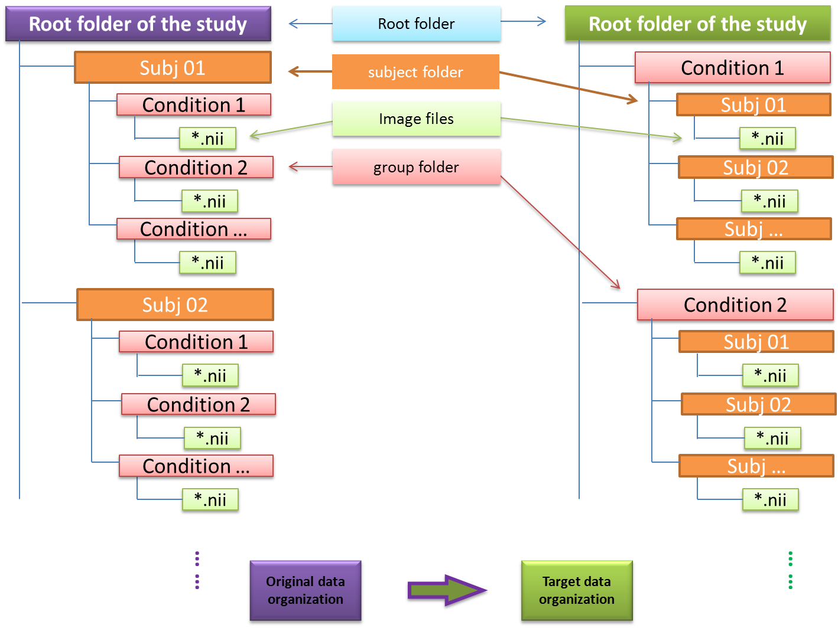

-----------------------

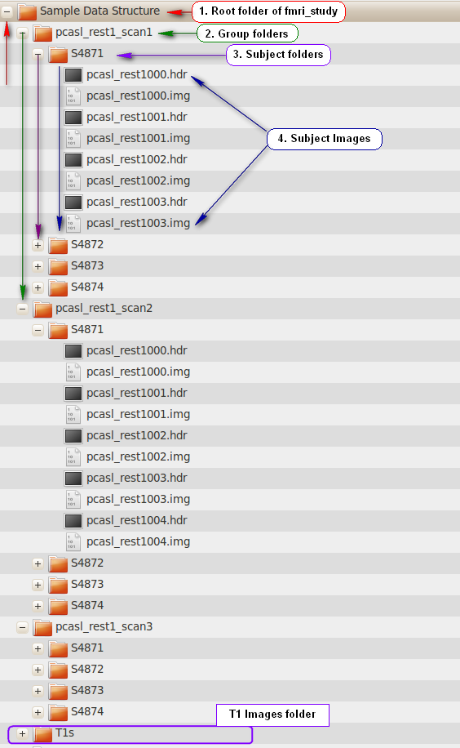

For a dataset of multiple groups and multiple subjects, the standard procedure of selecting data within a batch creating program is just to select fodders from the top level (root folder) to the lowest level (functional images) in the folder structure shown above. These procedures are illustrated as below.

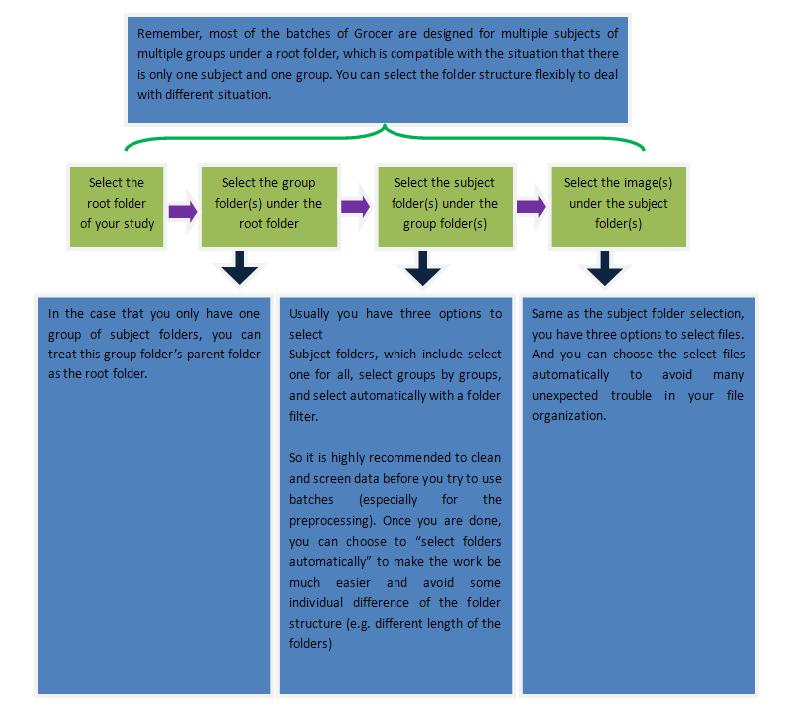

6. Function list of <Grocer> & the brief description of these functions:
Some functions listed in the menus are not limited to do the only thing named as their names. After you read some notes about some functions, you can use them in a much more flexibe way by changing the pre-existing file filters in the file selecting windows and then select the files you really want to deal with.

Menu 1 & 2 are specially designed for the Batch Editor of SPM8.

Some notes in labeling the functions:
- n-Group-Subj: classical “root -> group -> subjects” folder structure
- n-Subj: “one-group -> subjects” folder structure(It means the root folder is the group folder)
- ‘| - - -*’ functions are the sub-functions for the function (‘| - *’) above them
- If no special announcement, functions in menu1 & 2 will create a SPM-job file that need to be run manually
----------------------------------------------
- SPM8 Preprocess batch (n-Group-Subj)...
| - Slice timing (Est. & reslice)'...
[Note]: Slice timing for multiple subjects in multiple groups under the root folder
| - Realgin (Est. & reslice)'...
[Note]: Realignment for multiple subjects in multiple groups under the root folder
| - Coregister (Est.)'...
[Note]: Coregisteration for multiple subjects in multiple groups under the root folder
| - Smooth with Kernel
[Note]: Smoothing for multiple subjects in multiple groups under the root folder
| - Smooth images with self-masking
[Note]: Enhanced smoothing for multiple subjects in multiple groups under the root folder [No job file is created. It’ll run directly!]
| - Segment T1s
[Note]: Segment for multiple T1 images under a root folder
| - Normalize (Est: T1)
[Note]: Estimate normalization parameters file (*_sn.mat) for multiple T1 images under a root folder
| - Normalize (Write: T1)
[Note]: Normalize T1s by writing the parameters file (*_sn.mat) for multiple T1 images under a root folder
| - Normalize (Write: mean Img)
[Note]: Normalize one image (e.g. mean*.img) in each subject folder of a group folder under the root-folder by writing the parameters file (*_sn.mat) for multiple T1 images under a root folder
| - Normalize (Write: Smoothed Img)
[Note]: Normalize several images (e.g. sr*.img) in each subject folder of a group folder under the root-folder by writing the parameters file (*_sn.mat) for multiple T1 images under a root folder
| - Normalize (Write: mean-Smoothed Img)
[Note]: Normalize two types of images (e.g. sr*.img & mean*.img) in each subject folder of a group folder under the root-folder by writing the parameters file (*_sn.mat) for multiple T1 images under a root folder
| - Normalize (Write: T1-mean-Smoothed Img)
[Note]: Normalize two types of images (e.g. sr*.img & mean*.img) in each subject folder of a group folder under the root-folder and a third types of images (e.g. T1*.img) under a root folder by writing the parameters file (*_sn.mat) for multiple T1 images under a root folder
| - Normalize (Est.& write: T1-mean Img)
[Note]: Estimate T1 images and then Normalize both of the T1 images and an image (e.g. mean*.img) in each subject folder of a group folder under the root-folder.
| - Normalize (Est.& write: T1-Smoothed Img)
[Note]: Estimate T1 images and then Normalize both of the T1 images and the images (e.g. sr*.img) in each subject folder of a group folder under the root-folder
| * Create a pipeline for standard preprocessing
[Note]: Create a job file for a standard preprocessing of images in multiple subject folders of a group folder under the root-folder
| * Do the (enhanced)-preprocessing & CBF Calc.
[Note]: Do a standard or enhanced preprocessing of images in multiple subject folders of a group folder under the root-folder [No job file is created. It’ll run directly!]
| - PCA-denoising for MRI images(No binarizeds)
[Note]: Testing function: Do PCA denoising for a group of selected images [No job file is created. It’ll run directly!]

----------------------------------------
- SPM8 Statistic batch...
| - 1st level design
[Note]: Build up job file for 1st-level design in a batch way. In this function, you need to provide the program the condition names, also the corresponding variable names that you would like to import into the program.
| - Full factorial design (2nd_level)
[Note]: Build up job file that is used to do n-way ANOVA (full factorial design)in SPM 2nd-level
| - Pair_T-test (2nd_level)
[Note]: Build up job file that is used to do pair T-test in SPM 2nd-level
| - One Sample T-test (2nd_level)
[Note]: Build up job file that is used to do one sample T-test in SPM 2nd-level.
| - Estimate all SPM.mat
[Note]: Estimate all the SPM.mat files under folder(s) under a root folder.
| - Contrast all SPM.mat
[Note]: Build the contrasts for all the SPM.mat files under folder(s) under a root folder after estimation.
| - - - Edit T_contrasts template
| - - - Edit F_contrasts template
[Note]: The template file for building T/F contrasts for their root function(‘Contrast all SPM.mat’).
| - Result all SPM.mat
[Note]: Get the result of all contrasts in all the SPM.mat files under folder(s)
| - Categorize all Con*.img after 1st_level
[Note]: After you get the results of many contrasts in 1st-level, you can use this function to Categorize different contrast result file into different folder with their contrast names. [No job file is created. It’ll run directly!]
| - Remove all contrasts from SPM.mat',...

----------------------------------------
- CBF(ASL-based) related...
| * CBF calculation (SPM5/8,n-Group-Subj)
[Note]: Reconstruct CBF maps for the perfusion images in multiple subject folders of multiple groups under a root folder
| - Cofficient(r) 2 Fisher''s Z Within mask
[Note]: Do the Fisher’s Z transformation for a group of selected correlation coefficient maps.
| - Img 2 zScore_Img
[Note]: Do the z-score transformation for a group of selected correlation coefficient maps.
| - Img 2 zScore_Img (n-Subj)
[Note]: Do the z-score transformation for images of multiple subject folders under a group folder.
| - Decentralize CBF Imgs ((i-mean)x100/mean)
[Note]: Decentralize the selected images with the formula ((i-mean)x100/mean)
| * Copy (w)MeanCBF into a folder (n-Group-Subj)
[Note]: Copy the (w)Mean_CBF maps in multiple subject folders of multiple groups under a root folder into a target folder
| - Do PVE-correction for the MeanCBFs
[Note]: Do PVE-correction for a group of selected imgs.
| - Do PVE-correction for the CBFs (n-Group-Subj)
[Note]: Do PVE-correction for a group of subject folders.
| - Voxel-wise group variance (a groups of imgs)
| - Voxel-wise Pearson''s r (two groups of imgs)
| - Voxel-wise ICC across (n groups of imgs)
[Note]: Voxel-wise variance/correlation coefficient/ICC value calculation.
| - ICC calculation of multiple matrixes
[Note]: ICC value calculation for matrixes input rather than the Image imput.
| - - - z-test two imgs of r(corr. cofficient)
[Note]: Do z-test for two correlation coefficient maps.
| - - - z-test two vectors of r(corr. cofficient)
[Note]: Do z-test for two vectors input rather than the image input.
| - Regress Tag-Ctrl from perfusion imgs
| - Regress Tag-Ctrl from perfusion imgs (n-Group-Subj)

----------------------------------------
- ROI related ...
| - Get TimeCourse of ROIs of Selected Imgs
[Note]: Get time course of a group of selected images (Can deal with individual space images).
| - Get TC of ROIs of all Imgs under folders
[Note]: Get time course of images under a group of selected subject folders (Can deal with individual space images).
| - Get SD-TC of ROIs of Selected Imgs
[Note]: Get standard-deviation (SD) time course of a group of selected images (Can deal with individual space images).
| - Get SD-TC of ROIs of all Imgs under folders
[Note]: Get standard-deviation (SD) time course of images under a group of selected subject folders (Can deal with individual space images).
| - Plot Time Courses in txt/mat/csv file(Separately)
[Note]: Plot time courses in txt/mat/csv file separately by rows or by columns
| - Plot Time Courses in txt/mat/csv file(Overlay)
[Note]: Overlay time courses in txt/mat/csv file in a figure by rows or by columns. [You can even run this function several time and overlay different time courses in different files together.]
| - Extract AAL(61x73x61,90areas)''s TC
| - Extract AAL(61x73x61,116areas)''s TC
[Note]: Get time course of selected images in different AAL regions.
| - - - Show the AAL regions list
| - Inquire AAL regions list
[Note]: Inquire AAL regions by specifying a region number with some requirement; you can refer to its sub-function below.
| - - - Edit your AAL regions list
| - Extract Brodmann(61x73x61,48areas)''s TC
[Note]: Inquire Brodmann regions by specifying a region number (e.g. 1,4…).
| - BA/AAL multi. Labeling areas combination
[Note]: Combine some regions and output as a binary mask in a multiple labeling template (BA or AAL).
| - MNI Coordinate(*.txt) 2 Sphere_ROI
[Note]: Build specific MNI coordinate(s) which are stored in a txt file as a sphere ROI image in the standard MNI space.
| - Label clusters into different number
[Note]: Label different cluster as different integer number.
| - Binarize multiple labeling ROIs
[Note]: Combine all the multiple labeling areas into one area.
| - Get volumes of the selected images (ml)
[Note]: Get the image (e.g. gray/white matter and CSF) volume (ml) within the mask and threshold if any.
| - Evaluate overlay between two groups of ROIs

----------------------------------------
- Coordinate related...
| - Get the central Coordinate of a cluster
| - Find the peak voxels within a mask
| - MNI(ICBM) 2 Tal
| - MNI 2 Tal
| - MNI 2 Voxel Space
| - Tal 2 MNI(ICBM)
| - Tal 2 MNI
| - Voxel Space 2 MNI
| - Inquire Voxel Space Coord. in AAL
| - Inquire MNI Coord. in AAL
[Note]: Inquire the region names of Voxel-space/MNI coordinates in AAL template.

----------------------------------------
- Image format related...
| - Nii 2 (hdr/img)-pairs
| - (hdr/img)-pairs 2 Nii
| - Cluster_Img(hdr/img) 2 ROI.mat
| - ROI.mat 2 (hdr/img) to a target space
| - Get the 4D/3D nii volume number
| - Zip files(*.nii) into *.gz under a root recursively
| - Unzip (*.gz/*.nii.gz) files under a root recursively
| - 4D(.nii/.gz) -> 3Ds(nii) under a root recursively
| - 3Ds(nii) -> 4D(nii) under a root recursively
| - Merge *.mat data into *.hdr for SPM2 outputs
| - Nifti image Viewer
| - Matlab Voxbo-likewise functions for DICOM images
| - - Move Raw DICOMs to root-folder of subjects
| - - Categorize Dicom files into protocol folders(n-subjs)
| - - Dicom2Nifti(n-subjs)
| - Categorize Dicom files into protocol folders
| - Dicom2Nifti
| - Dicom2Nifti(n-Group-Subj)
| - Check header info of a DICOM img
| - FG_load_nii
| - FG_load_untouch_nii
| - FG_load_nii_ext
| - FG_load_untouch_header_only
[Note]: These functions are revised from “Tools for NIfTI and ANALYZE image in MATLAB (http://www.rotman-baycrest.on.ca/~jimmy/NIfTI/)”

----------------------------------------
- Files/folders manipulation...
| * Restructure study folders for Grocer needed
[Note]: Usually, this is the most of the first step before you use Grocer to do the preprocessing.
| - Backconstruct folder structure from GROCER-needed
| - Move Img(paired hdr/img & nii) into Sep.Subj folder
| - Reorganize files from full to flexible Factorial design
| - Group files into folders (n-Subjs)
[Note]: Group images in multiple folders into different folders by specific file identifiers that can be set up by its sub-function below.
| - - - Edit file identifiers
| - Group selected-files into folders based on labels
[Note]: Group images into multiple folders with predefined file labels that can be set up by its sub-function below.
| - - - Edit file labels
| - Rename specific files under folder(s) (n-Subj)
| - Rename selected folders
| - Rename selected files
| - Rename selected files to predefined names
| - Get all subdir names and folder sizes
| - Get all subdir names having specific folder sizes
| - List files of a selected folder
| - List files of a dir recursively
| - List file-related folders of a dir recursively
| - List files subdirectory by subdirectory
| - List one-level subfolders under a dir
| - List all folders under of dir recursively
| - List all subfolders with specific folder-size
| - Get and save selected filenames of a dir
| - Del Non-filtered files/folders of a dir recursively
| - Copy the folder structure under a foder
| - Copy/Move-out/Del-in files recursively
| - Copy/Move-out/Del-in subdirs with folder-size
| - Copy/Move-out/Del-in filtered folders
| - Copy/Move-out files in subdirs with their folder name
| - Move filtered subdirs up a level with parent folder name
| - Check string in txt/m files
| - Find and replace in txt files
| - Find and replace Multi. strs in txt files
| - - - Edit Search & Replace strs template
| - Find and replace (Windows Only)
| - Generate Excel Column letters
| - Randomly split selected files/folders to two groups
[Note]: These functions are created for dealing with folder structure and file names. Most of them are very flexible now.

----------------------------------------
- SPM5/8 enhanced functions...
| - Reset origins(n-Group-Subj)
[Note]: Reset image origins of images in multiple subjects of multiple groups under the root folder. If you just want to reset a group of images, you can use SPM’s reset function directly.
| - Reset origins of selected Imgs
| - Reorient T1s
[Note]: Reorient selected T1 images by entering specific parameters which you can read from SPM ‘display’ window. Be attention, this can just make a rough correction for different T1s. You should check one by one after this batch correction.
| - Reorient Fun. Imgs(n-Group-Subj)
[Note]: Reorient images in multiple subjects of multiple groups under the root folder by entering specific parameters which you can read from SPM ‘display’ window.
| * Reslice selected Imgs into a target space
[Note]: Reslice selected Imgs into a target space (this can also deal with individual space)
| * Reslice selected Imgs in original space
[Note]: Reslice selected Imgs in its original space by setting new image voxel-size
| - Reslice Multiple labeling template
[Note]: Reslice selected images into a target space (this can also deal with individual space)
| - Check-Reg up to 24 Imgs (paired-groups)
[Note]: An enhanced ‘Check’ function which can show 9 images more than traditional SPM-‘Check’ function. What is more, it offer an option to check paired-group images interleaving for improving checking-reg experience!
| - Enlarge the view of two Check-Reg Imgs
[Note]: Enlarge specific two images in the Check window.
| - Overlay SPM_T/F Img to T1 by XjView
[Note]: Use XjView to show SPM_T/F image on the brain template.
| - Plot the Realign_parameters(rp_*.txt)
| - Switch RedArrow ON/OFF in SPM Result Win.
| - Switch Crosshairs ON/OFF in SPM Result Win.
[Note]: Two shortcuts to switch on/off the arrow or crosshairs in the SPM graphic window
| - Flip images in original space
| - Overlay ROIs imgs on a Background img
| - Overlay three ROI imgs on a Background img
| - Make avi-movie of a sequence of MRI-images
| - Make avi-movie of a sequence of Media-images
[Note]: Make selected images into a movie at the specific slice

----------------------------------------
- Supplement tools...
| * Yoke displaying imgs as Mricro
[Note]: Take use of Rest slice-viewer of REST to display multiple images in a Yoke way. However, there is bug here that still can’t be fixed yet, which is that if you close one or some windows open by this function, it will get wrong if you try to run this function one more time. But if you don’t close any window before you run this function second time, everything goes well.
| - Manipulate(+,-,*,/) selected imgs(e.g. i1*-1)
| - Manipulate selected paired-imgs(e.g. (i1-i2)./i2)
| - Binarize the selected imgs(e.g. i1>0)
| - Binarize the selected imgs(e.g. i1>0)(n-Group-Subj)
| - Sum & Mean & Difference of the Odd/Even imgs
[Note]: Get the Sum, Average and Difference of the Odd and Even images of the selected images
| - Avg selected imgs across same timepoints
[Note]: Average selected images within a same time-point intervals. For example, average the 1-4, 5-8,9-12 into 3 mean-img.
| - Avg imgs across same timepoints (n-Group-Subj)
[Note]: Same function as above but this is used for images of multiple subjects of multiple groups under a root folder.
| - Average the selected images
| - Average the images (n-Group-Subj)
| * Build brain masks from individual G.W.C.
| * Build brain masks from filled G.+ W.
[Note]: Build individual brain masks from each subject’s C1,C2 & C3 segments (Gray/White matter and CSF).
| - Show histogram of Imgs within a mask
| - Simple 3d image Viewer
[Note]: A simple 3D image viewer which can help you check 3D image slice by slice.
| - Simple 3d-Variable Viewer
[Note]: A simple 3D variable viewer which can help you check 3D variable as an image.
| - Basic Voxbo-tools for DICOM images(In-house use only)
| - - Move Raw DICOMs to root-folder of subjects
| - - vbrename for subjects
| - - vb2img for T1 folders
| - - vb2imgs for functional folders
| - - - Edit Output-functional-group-names
[Note]: Run three most frequent using commands (vbrename/vb2img/vb2imgs) of Voxbo toolbox under Linux OS. It can be used when your linux operation system has installed Voxbo Toolbox.
| - Testing: PCA img-denoising OR Var-Dim-Reduction
[Note]: Testing function: this can be used to do PCA-denoising for images or variables
| - Linearly detrend the selected images
| - Linearly detrend for (n-Group-Subj)
[Note]: Remove the linear detrend in the image time-course(s)
| - Filter the selected images within the bandpass
| - Filter images of (n-Group-Subj) within the bandpass
[Note]: Filter the images within a specific band-pass range according their TR
| - Calculate the Dice similarity coefficient
[Note]: Calculate the dice similarity coefficient of a pair of images
| - Calculate the Dice similarity coefficient(two groups)
[Note]: Calculate the dice similarity coefficient of a pair of images of many subjects of two groups
| - Granger Causal Connectivity Analysis (n-Subj)
| - Granger Causal Connectivity Analysis for selected imgs
[Note]: Run Granger Causal Connectivity Analysis for fMRI images in time-domain.

----------------------------------------
- About...
| - Quick start on this toolbox
[Note]: You can read some instruction of using Grocer.
| - About Grocer
[Note]: Contact information of the author of Grocer.
| - Read the function list of Grocer
[Note]: List out all the functions in different menus you see.
| - - - >> Relax! Play Bomb game! <<- - - -
[Note]: A classical bomb game in MATLAB.

%%%%%%% Contact Information %%%%%%%%%%
Senhua Zhu
Visiting PhD student,
Center for functional Neuroimaging, Depts. of Neurology and Radiology, University of Pennsylvania
3 W.Gates Bldg, 3400, Philadelphia, PA (19104), United States
--------------------------------
PhD Candidate,
Department of Psychology, Sun Yat-sen University,
135 Xingang West Road, Haizhu District, Guangzhou (510275), P.R.China
--------------------------------
Email:
zshtom@gmail.com
senhua@mail.med.upenn.edu

QQ group #: 60524357

