A pvlib-Based Computational Model of a Multi-Inverter Rooftop Photovoltaic Plant Driven by Public Weather Data: Sensitivity Analysis and Field Validation
Cliff Nathanael Govino*, Wen-Ren Yang
International Master Program of Engineering, National Changhua University of Education,
Changhua, Taiwan
*Email: cliffgovin@gmail.com

Abstract
Rooftop PV energy is often estimated from datasheets and public weather data. We model a 139.5 kWp plant in Taiwan (372 modules; one 30 kW and two 50 kW inverters) with pvlib, rank nine uncertain factors with a converged Sobol analysis (45,056 runs), and compare the model with the AC power recorded at the common inverter output and with the lifetime energy counters of the inverters. DC loss and irradiation error explain 84% of the annual variance and the inverter model 7%; this inverter effect comes from the assumed efficiency (2.6%) and hardly from the model structure (0.4–0.6%). On clear autumn and winter days the plant delivered 80–89% of the modeled energy (nMBE up to +24%), although the hourly profile is reproduced (r ≥ 0.97); the budget reaches this only when all factors are at their lowest ends together. Over 3.5 years, however, the inverter counters agree with the model within 3%. The model is thus suitable for annual energy but biased on clear days at hourly scale, and separating the causes requires irradiance measured on site.
Keywords: Photovoltaic; Inverter modeling; pvlib; Uncertainty budget; Field validation
1. Introduction
The energy of a PV plant can be estimated from module and inverter datasheets and public weather data with pvlib [1], [2], but the result depends on the assumption made at each step. For the inverter, a constant efficiency is the simplest choice, PVWatts [3] adds a load-dependent efficiency, and the Sandia [4] and ADR [5] models need test data that datasheets rarely give; hourly data also underestimate clipping [6]. Uncertainty studies point to plane-of-array modeling [7], 2–6% annual uncertainty of satellite irradiation [8] and derate assumptions [9], but seldom treat a single rooftop plant whose weather data come from a distant station.
For the 139.5 kWp rooftop plant of National Changhua University of Education (NCUE), Taiwan, we ask: (i) how large the effect of the inverter model is compared with other factors, and whether it stems from model structure or assumed efficiency; (ii) how much the weather source (a station 21 km away or ERA5 [10]) matters; and (iii) whether the variance-based uncertainty budget [11], [12] encloses the energy the plant delivers.
2. Plant, Data and Model
2.1 Plant
The plant (24.066°N, 120.559°E) has 372 AJP-S672-375 modules [13] on open racks, facing south at 23° tilt, and feeds one 30 kW and two 50 kW inverters [14] without storage (Fig. 1, Table 1). The as-built layout found in October 2026 differs from the drawings (144/144/84 modules): 145, 140 and 87 modules in strings of 16 to 21 (Fig. 1b), which changes the annual energy by only +0.02%. Two blocks of the left inverter stand on a 7 m tower next to an empty frame of the same height, the middle inverter logs fan faults with de-rating, and the counter of the 30 kW inverter is faulty.

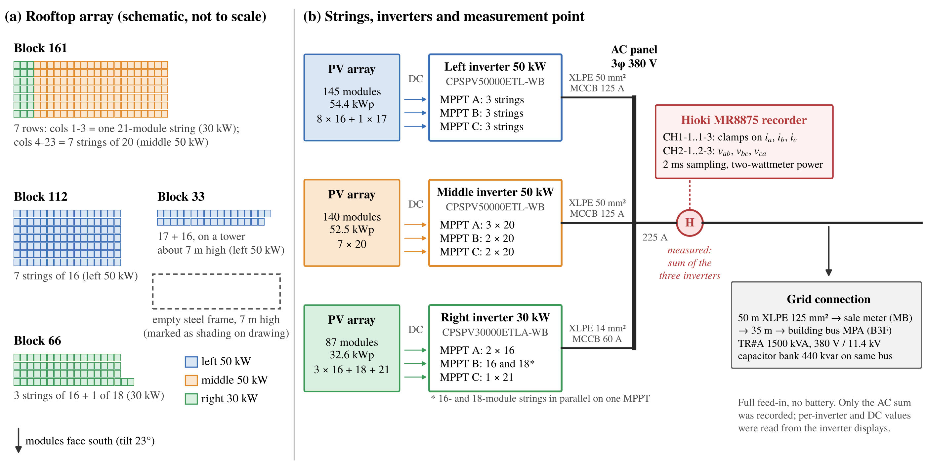
Fig. 1 Plant layout. (a) Roof blocks and their inverter (positions schematic). (b) Strings per MPPT, AC connection and the recorder at the common AC output of the three inverters.

Table 1 Plant data (as built).
Item | Value
Module | 375 W, γ = −0.44 %/°C, NOCT 46 ± 2 °C
Inverter 30 / 50 kW | η_{max} 98.6 / 98.5%
Modules (left / middle / right) | 145 / 140 / 87
Capacity (kWp) | 54.4 / 52.5 / 32.6
DC/AC ratio | 1.09 / 1.05 / 1.09
2.2 Weather data
Hourly irradiation and air temperature come from the CWA Tianzhong station (467270) [15], 21.4 km from the site (1626 kWh/m² in 2023), and hourly ERA5 data from PVGIS [16], [17]. No irradiance sensor exists on the roof.
2.3 Power measurement
A Hioki MR8875 [18] records the three line currents and line-to-line voltages at the common AC output (Fig. 1b). The bus voltages are three sinusoids displaced by 120° (Fig. 2); for balanced conditions the active power is
P = √3 V_{LL} I_{L} cos φ (1)
with rms values. With three wires and no neutral, the instantaneous power follows from two products (two-wattmeter method), which also holds under unbalance and distortion [28]:
P = ⟨v_{ab} i_{a} − v_{bc} i_{c}⟩ (2)
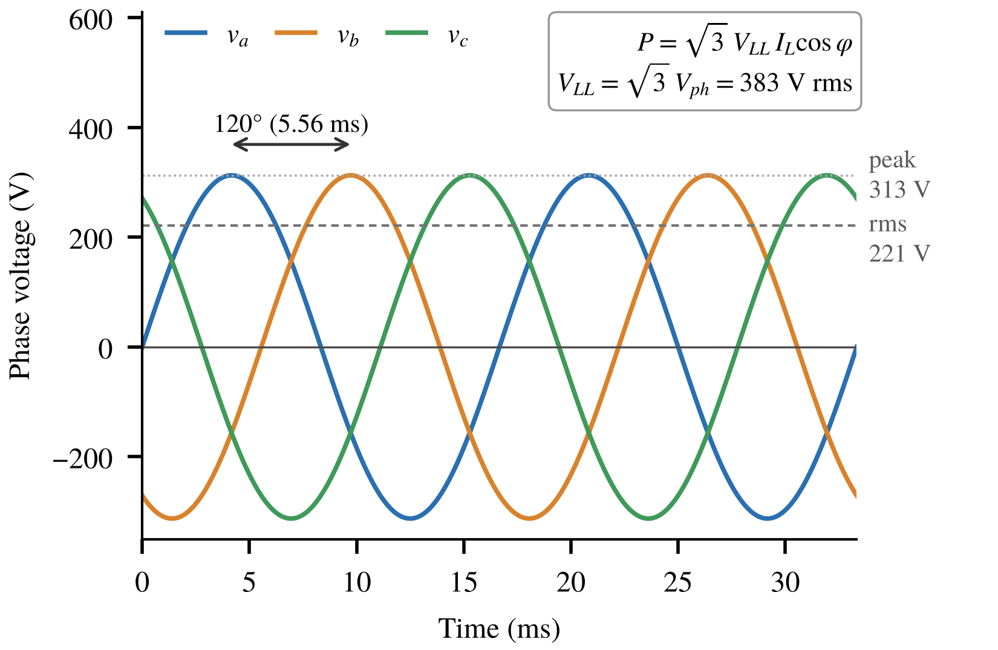
Fig. 2 Phase voltages of the AC bus (60 Hz): equal amplitude, displaced by 120°; 221 V rms per phase, 383 V rms line-to-line.
Because v_{ab} = v_{a} − v_{b}, a line-to-line voltage is √3 times the phase voltage and leads it by 30°; multiplying each current by its own line-to-line voltage would therefore overstate the power by 3 cos 30°/√3 = 1.5. The records show voltages 120° ± 1.5° apart, currents lagging by 0.5–4.3°, unbalance below 3.8% and a power factor of 0.995, and Eq. (1) applied to the fundamentals agrees with Eq. (2) within 0.13% (median).
The main record (16–19 October 2026) was sampled at 2 ms, thinned to 10 ms and averaged to 4,201 one-minute values; seven two-hour records (2025–2026) were thinned to 20 ms. Fig. 3 tests whether thinning biases the power, with 400 synthetic minutes carrying the measured unbalance, harmonics and ±30% power changes. At 10 and 20 ms the samples fall on five points of the cycle and the error stays below 0.12%; intervals of whole cycles such as 200 ms err by up to 12% and were avoided. The chain was not calibrated; on 18 October the inverter displays showed 3.0% more energy than the recorder.
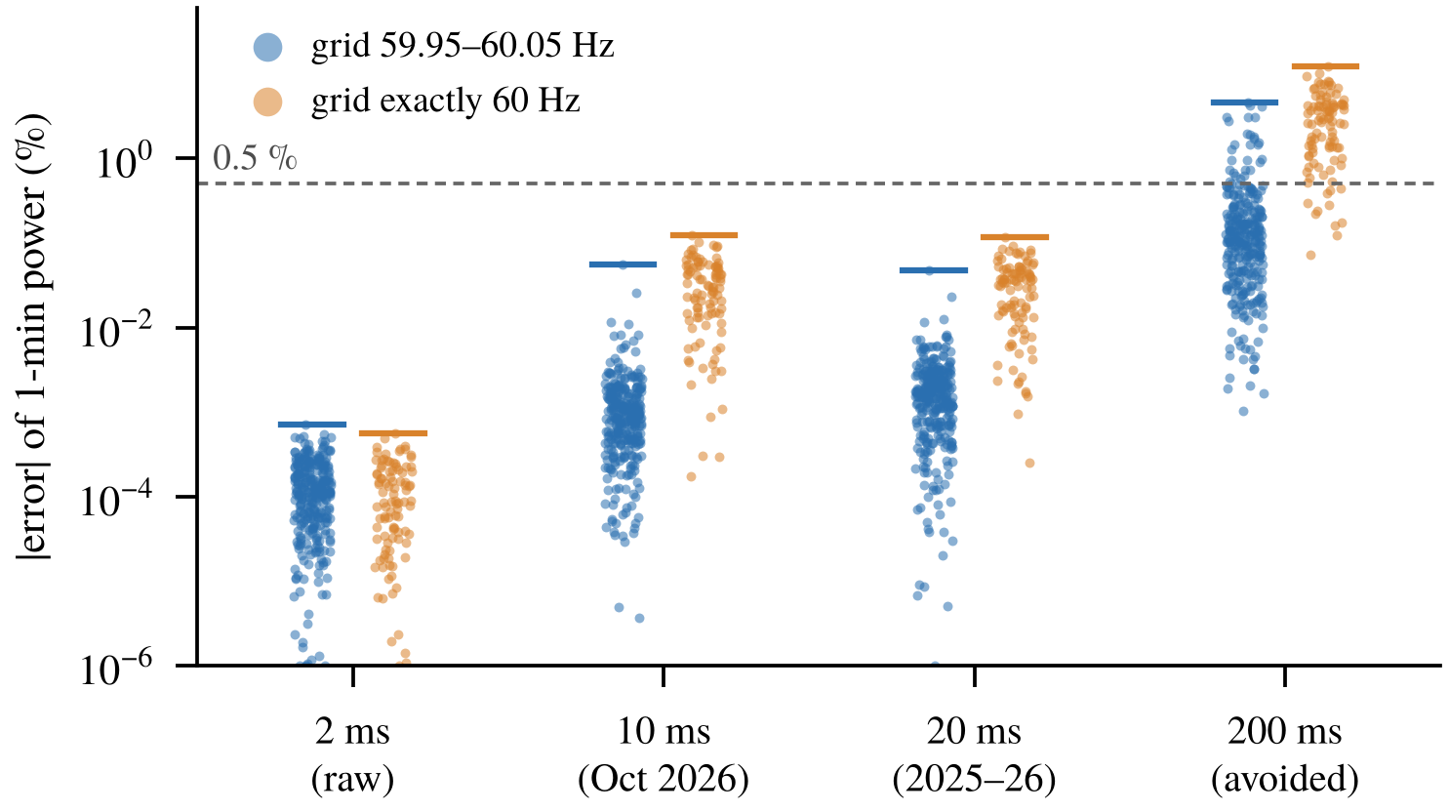
Fig. 3 Error of the one-minute two-wattmeter power after thinning (synthetic minutes; bars: maximum).
2.4 Model chain
Fig. 4 shows the chain: Erbs decomposition [19], Perez transposition [20] (albedo 0.25), Ross cell temperature [21] and PVWatts DC power [3],
P_{dc} = P₀(G/1000)[1 + γ(T_{c} − 25)](1 − f_{dc}) (3)
with f_{dc} = 8.7%. Each inverter is modeled with constant efficiency, PVWatts-DS (datasheet peak η as nominal, an upper bound) or PVWatts-G (η 0.96); our code equals pvlib.inverter.pvwatts to 0 W. A variant adds the Martin–Ruiz incidence-angle loss [22]; the performance ratio follows IEC 61724-1 [23].
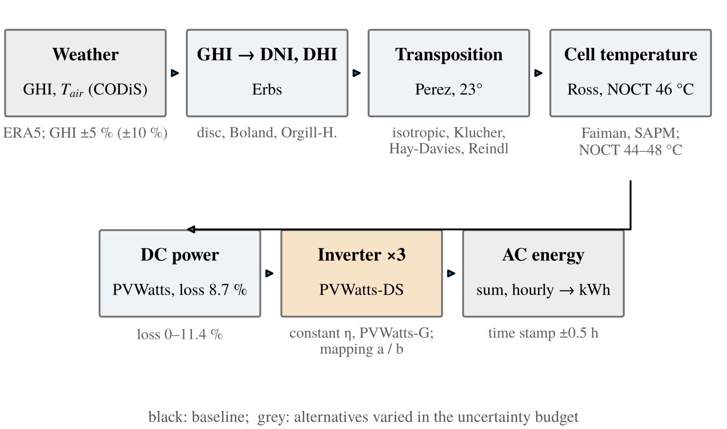
Fig. 4 Model chain. Grey: alternatives varied in Section 3 (e.g. Faiman [24] and SAPM [25] cell temperature).
3. Annual Uncertainty Budget
Nine factors were varied with SALib [26] (Table 2): continuous factors uniformly over the stated ranges, model options with equal weight. The ranges are assumptions with the given basis, and the ranking depends on them, as the ±5% and ±10% GHI cases show.

Table 2 Factors, ranges and Sobol total index S_{T} (4,096 base samples, 95% bootstrap interval).
Factor | Range, distribution and basis | S_{T} (±5% GHI) | S_{T} (±10% GHI)
DC loss | 0–11.4%, uniform; PVWatts total loss without / with shading [3] | 0.495 ± 0.020 | 0.243 ± 0.010
GHI error | ±5% (±10%), uniform; pyranometer class and 21 km distance [8] | 0.344 ± 0.014 | 0.678 ± 0.025
Inverter model | constant η, PVWatts-DS, PVWatts-G; equal weight | 0.071 ± 0.003 | 0.035 ± 0.001
Transposition | Perez, isotropic, Klucher, Hay-Davies, Reindl; equal weight | 0.058 ± 0.003 | 0.028 ± 0.001
Cell temperature | Ross, Faiman, SAPM; equal weight | 0.029 ± 0.001 | 0.015 ± 0.001
Decomposition | Erbs, disc, Boland, Orgill-Hollands; equal weight | 0.003 ± 0.000 | 0.001 ± 0.000
NOCT | 44–48 °C, uniform; datasheet 46 ± 2 °C | 0.002 ± 0.000 | 0.001 ± 0.000
Time shift | −0.5, 0, +0.5 h; meaning of the hour label | 0.001 ± 0.000 | 0.000 ± 0.000
Mapping | two layouts that satisfy the inverter limits | 0.000 ± 0.000 | 0.000 ± 0.000

3.1 Results and convergence
The baseline gives 195 MWh AC (1399 kWh/kWp), and the 5th–95th percentile spans −5.5% to +11.4%. DC loss (−3.0% to +9.6%) and GHI error (±5%) explain 84% of the variance and the inverter model ranks third (Fig. 5a). The total indices change by less than 0.003 between 1,024 and 4,096 base samples, five other seeds differ by at most 0.002, and the ranking is stable from 64 samples (Fig. 5b); the intervals of the first five factors do not overlap. Interactions are negligible (ΣS_{T} − ΣS₁ = 0.005), and no inverter clips at the baseline loss.
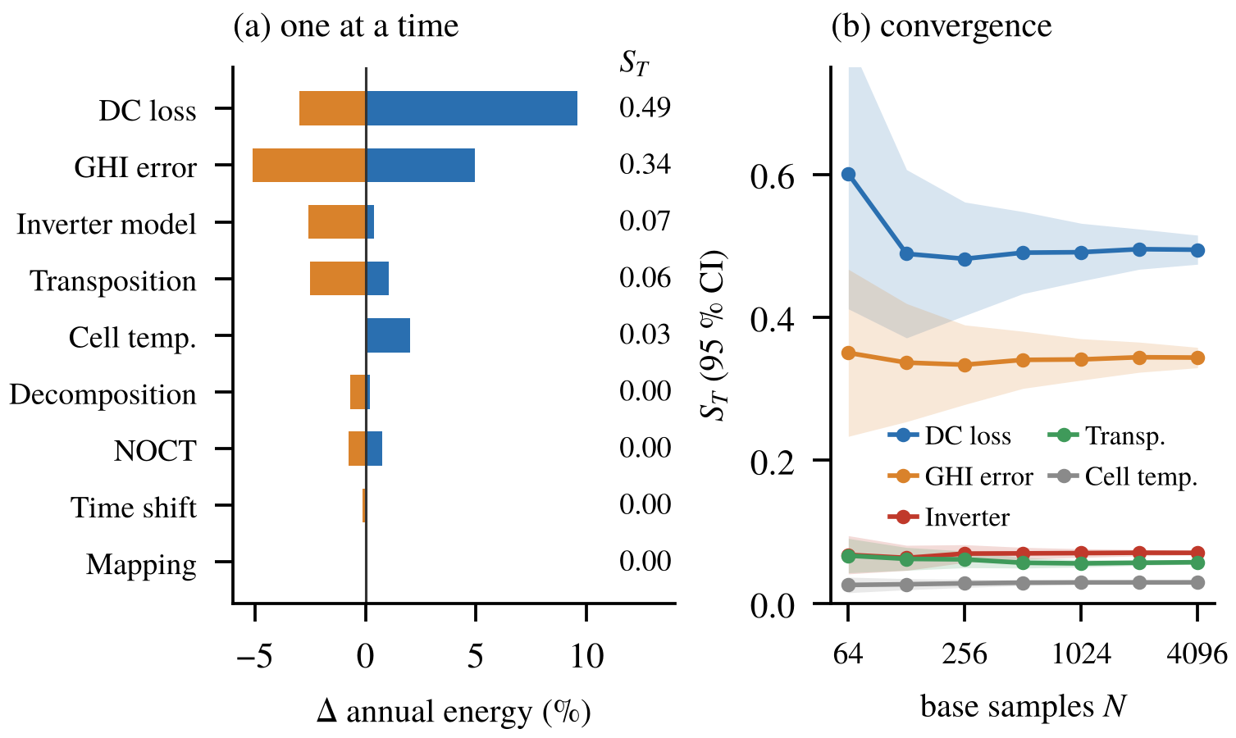
Fig. 5 (a) Change in annual energy when one factor moves within its range (orange: lowest, blue: highest) and S_{T}. (b) S_{T} against base samples with 95% interval.
3.2 Inverter: structure or efficiency
The formulations differ in curve shape and in assumed efficiency at once. Fig. 6 separates the two: at equal η, constant efficiency and PVWatts differ by 0.36–0.63%, whereas lowering η from 0.985 to 0.96 removes 2.6%. The inverter share of the budget is therefore an efficiency assumption, not a structural effect.
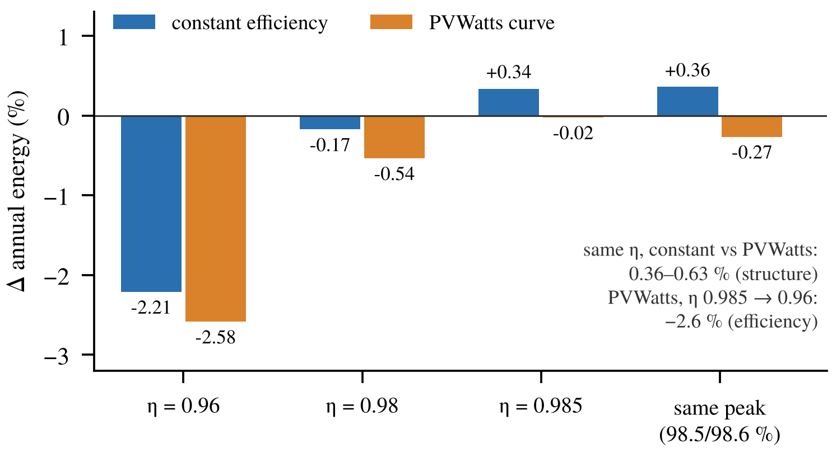
Fig. 6 Annual energy relative to PVWatts-DS for both structures at equal efficiency (as-built layout, 2023).
3.3 Weather source
Station and ERA5 irradiation differ by +2.6% mean bias and 37% RMSE (r = 0.83). The annual energy changes by +3.4%, but the monthly energy by −12% to +19% (Fig. 7), so at monthly scale the weather source outweighs the inverter model.
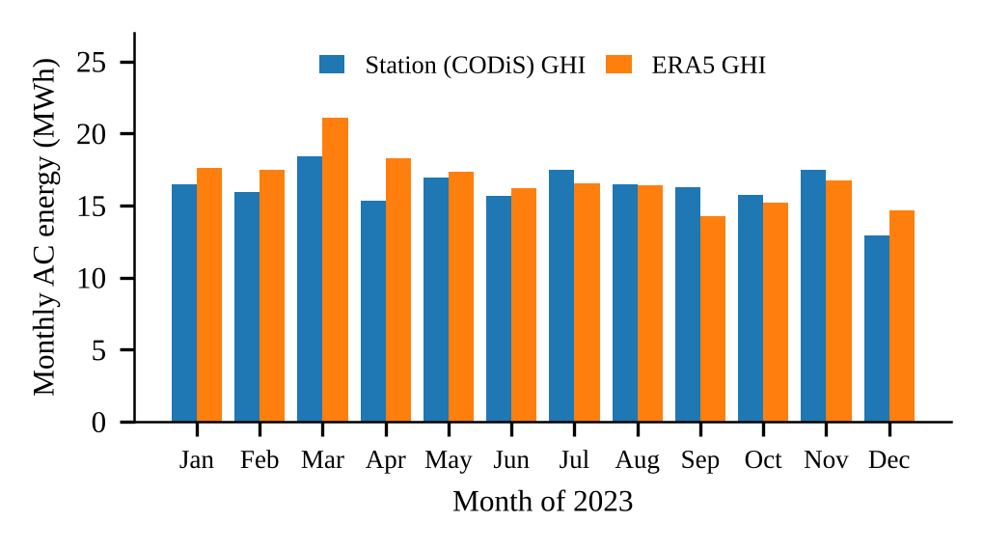
Fig. 7 Monthly AC energy driven by station or ERA5 irradiation (2023).
4. Field Validation
4.1 Measured output
On 17 and 18 October, with 97% and 94% of clear-sky irradiation at the station, the plant produced 585 and 557 kWh (4.20 and 3.99 kWh/kWp), with a peak of 100.5 kW against the 130 kW rating (Fig. 8). The one-minute power still shows dips (variability 0.06 and 0.13 of the mean between 10:00 and 14:00, against 0.003 on a clear February day) that AC data alone cannot attribute.
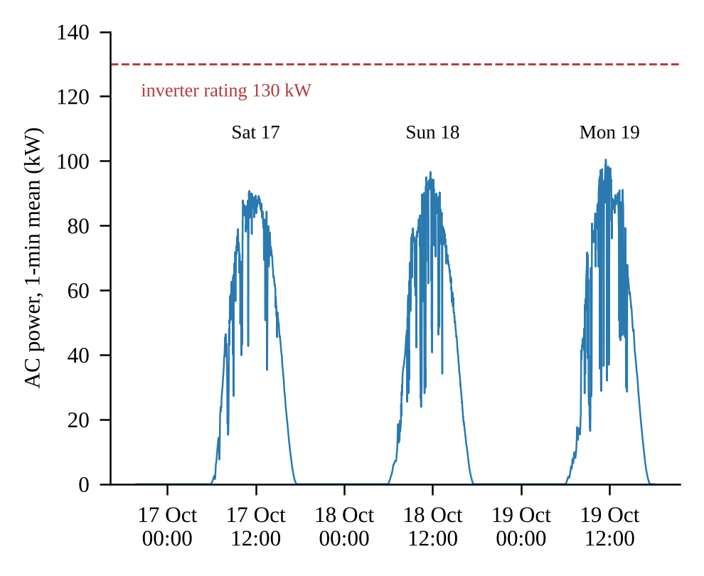
Fig. 8 Measured AC power, 16–19 October 2026 (one-minute means).
4.2 Model against measurement
Agreement is expressed by the ratio
R = ΣP_{actual} / ΣP_{model} (4)
over the hours of a record (R < 1: model too high) and by the mean bias and RMS errors normalized by the mean measured power (Table 3). The hourly shape is reproduced, but the model is higher in almost every hour (Fig. 9): R = 0.81 with nMBE +23% and +24% on 17 and 18 October, and 0.80 on 19 October; the performance ratio is 0.63 measured against 0.78 modeled. The hourly ratio stays near 0.8 from morning to afternoon (morning/afternoon 0.82/0.80 and 0.76/0.86; Fig. 10), so a one-sided obstruction is unlikely. A factor fitted on 17 October leaves biases of −8.6% and −19.7% on 10 February and 7 August, so R must not be used as a correction.
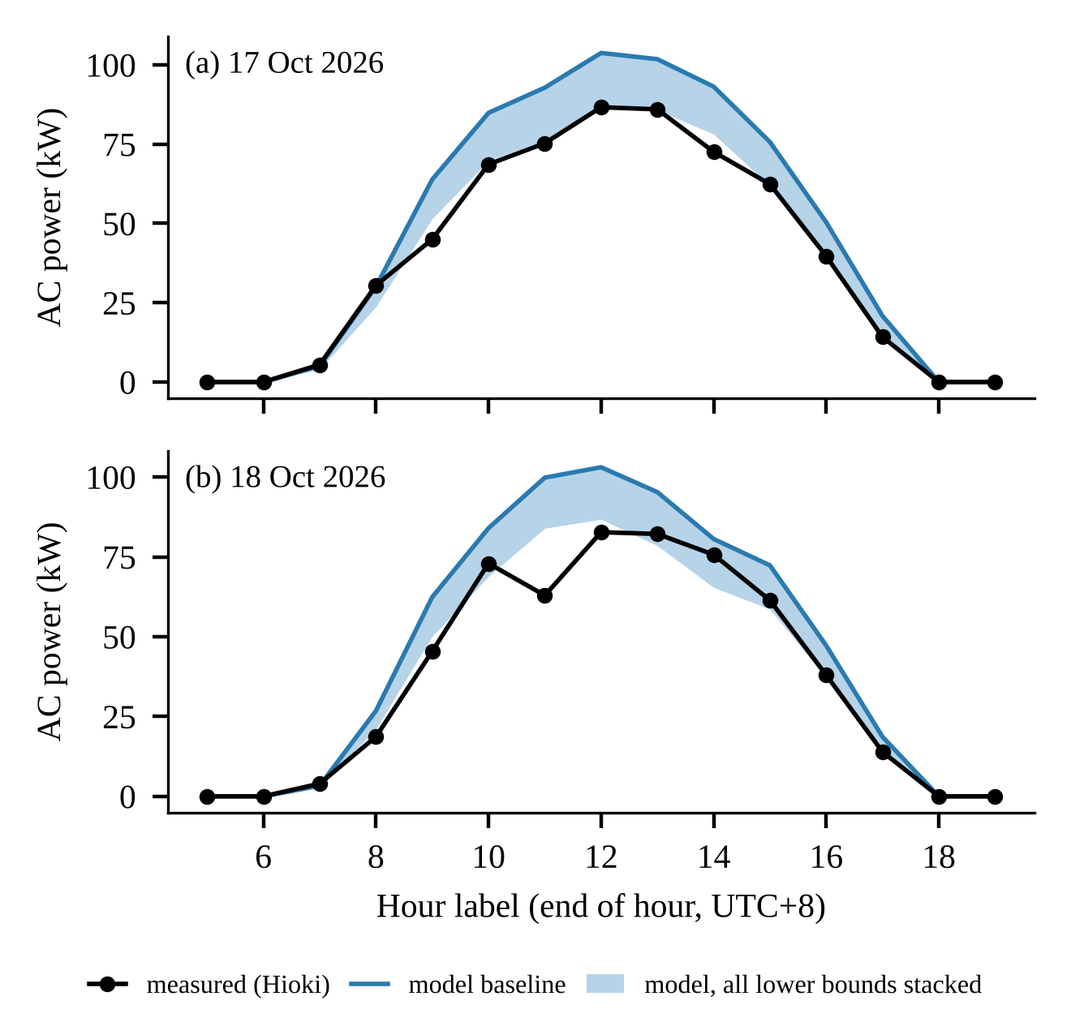
Fig. 9 Hourly AC power, measured and modeled; the band reaches the stacked lower bounds of Section 4.4.
Table 3 Error metrics on clear-sky records (hours ≥ 20 min, weighted; r for full days).
Record | h | R | MBE (kW) | nMBE (%) | RMSE (kW) | nRMSE (%) | r
17 Oct 26 | 11 | 0.81 | +12.3 | +23 | 14.2 | 26.7 | 0.99
18 Oct 26 | 11 | 0.80 | +12.3 | +24 | 15.6 | 30.8 | 0.97
10 Feb 26 | 3 | 0.89 | +11.9 | +13 | 12.0 | 12.7 | –
21 Dec 25 | 2 | 0.82 | +16.9 | +22 | 17.5 | 23.2 | –
7 Aug 25 | 3 | 1.01 | −0.9 | −1 | 11.2 | 14.6 | –
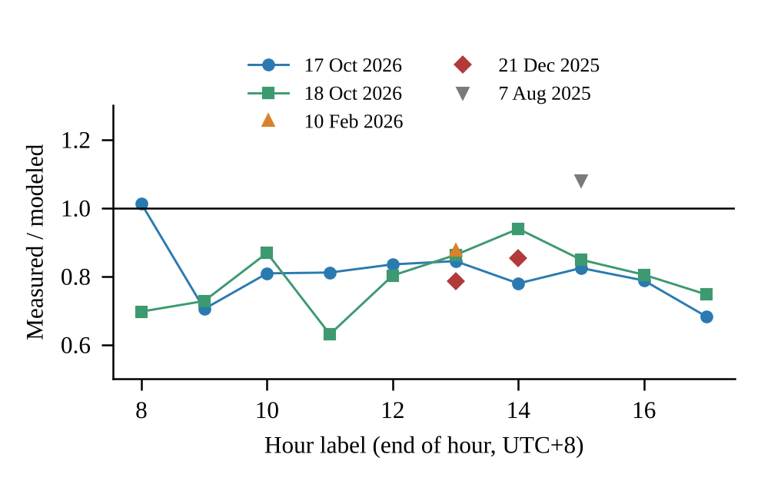
Fig. 10 Measured over modeled hourly power on the clear-sky records.
4.3 Other records
Across the nine days with station data, R lies between 0.65 and 1.01 (Fig. 11). Only the five days above 0.9 of clear-sky irradiation are used for the bias, because a station 21 km away does not follow the clouds over the roof; with so few records a seasonal pattern cannot be separated from day-to-day differences.
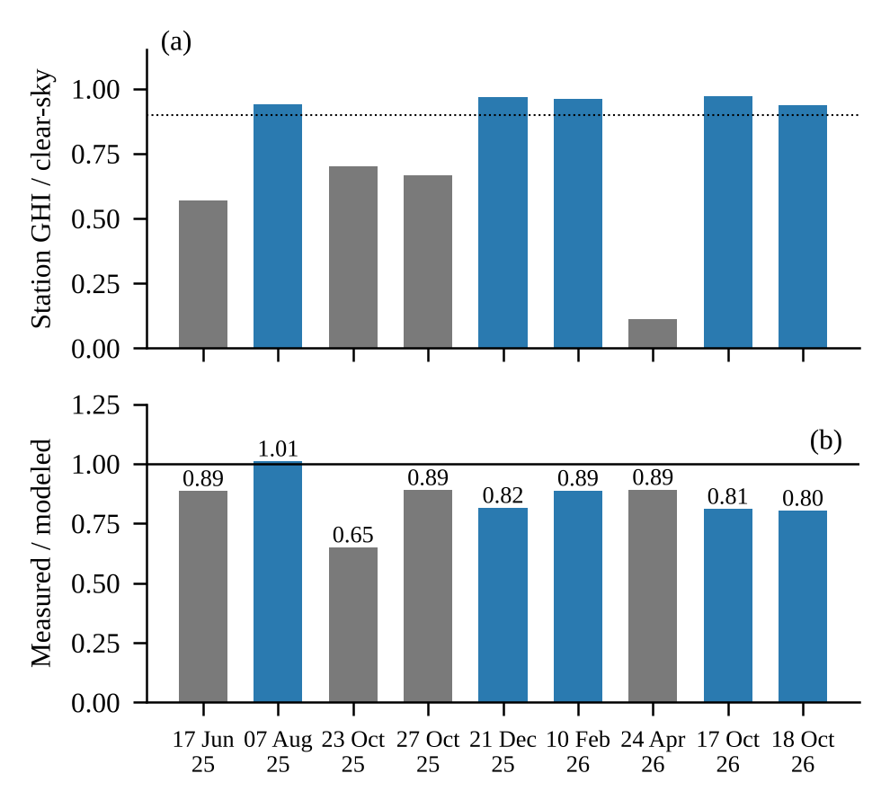
Fig. 11 (a) Clear-sky fraction of the station irradiation and (b) R per record; blue: fraction above 0.9.
4.4 Closing the budget
Fig. 12 stacks the lowest end of every factor. With isotropic transposition (−3.9% alone) and Boland decomposition (−1.0%), which the earlier stack omitted, the model reaches 82.0% of the baseline, close to the measured 81%. This joint extreme is implausible: the isotropic model underestimates tilted irradiance under clear skies [27], the combination lowers the annual energy by 13.6% against a 5th percentile of −5.5%, and on 10 February it underestimates the measurement by 6%.
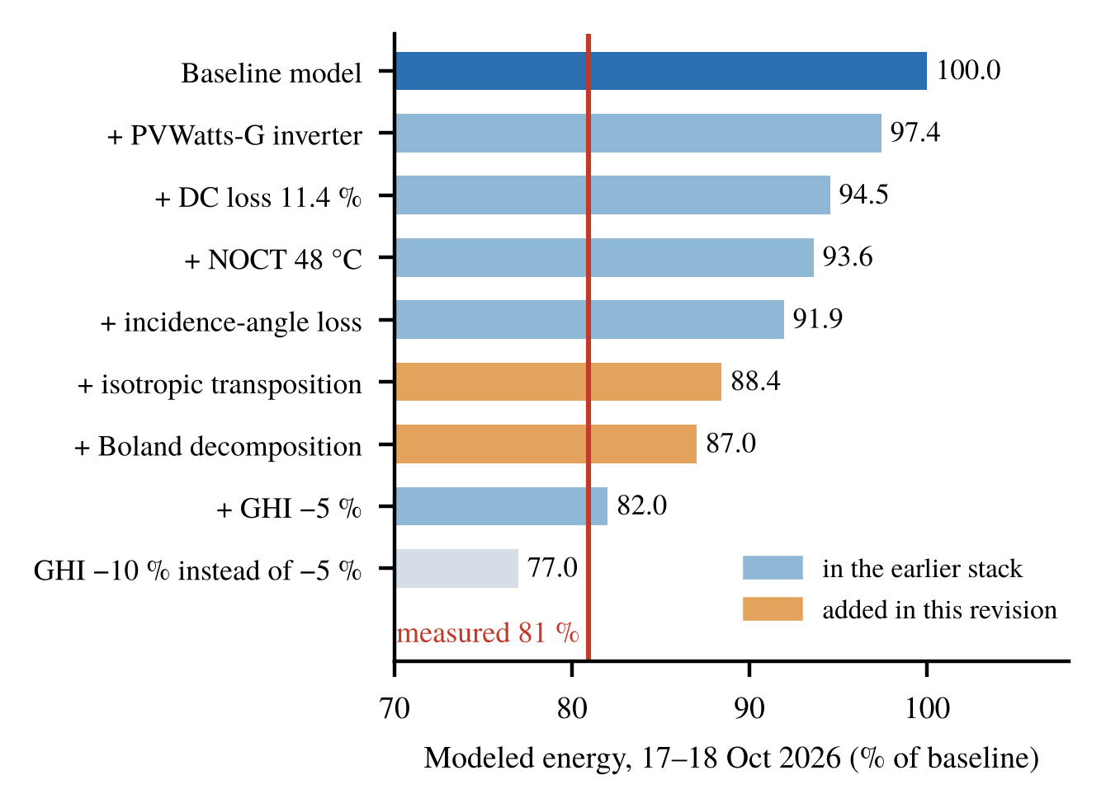
Fig. 12 Modeled energy of 17–18 October with the lower ends stacked; orange: added in this revision; red: measured.
4.5 Long-term check
The lifetime counters of the two 50 kW inverters (269,093 and 264,693 kWh after 1280 days) exceed the model for the same calendar period by 0.8% and 2.7% (1411 and 1437 against 1399 kWh/kWp per year; Fig. 13), although they read 3% above the recorder and the weather of 2024–2026 is not modeled. A permanent 19% loss would have shown, so the clear-day bias is condition-specific. Candidate causes are shading by the tower and frame, soiling, string mismatch, de-rating of the middle inverter and the uncalibrated recorder; the inverter formulations (≤ 2.6%) explain about a seventh of the gap.
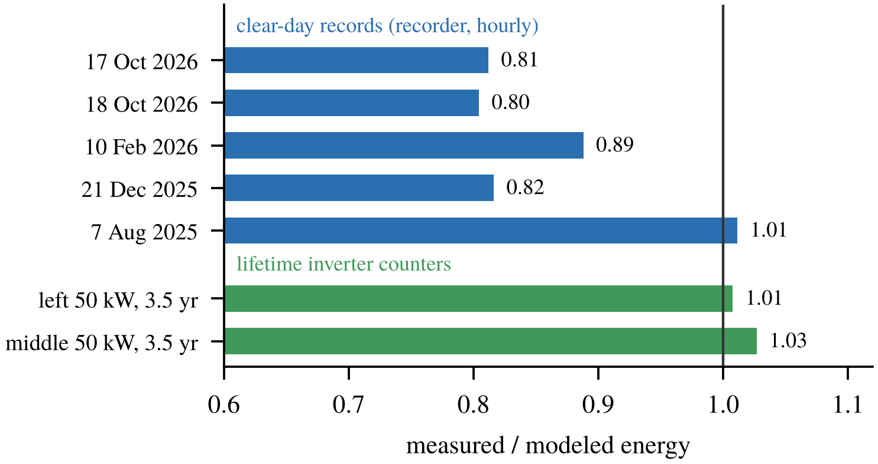
Fig. 13 Measured over modeled energy: clear-day records and 3.5-year inverter counters.
5. Discussion and Limitations
The model is suitable for annual energy, within the budget of −5.5% to +11.4%, but not for hourly prediction on clear days, where it is about 20% too high. (1) The field data are three days and seven two-hour records, mostly autumn and winter, and two uncalibrated counters; utility meter data and a year of logging would allow a seasonal check. (2) Without irradiance on the roof the error cannot be split into an irradiance and a plant part; this is the main gap. (3) Only the combined AC output was measured. (4) The ranking depends on the assigned ranges.
6. Conclusions
The datasheet model gives 195 MWh (1399 kWh/kWp) per year. DC loss and irradiation error dominate the converged Sobol budget, and the inverter effect (−2.6% to +0.4%) is an efficiency assumption rather than a structural one. The weather source matters at monthly scale (−12% to +19%). On clear days the plant produced 80–89% of the modeled energy, reached by the budget only at its joint extreme, while over 3.5 years the inverter counters agree within 3%. Roof-level irradiance is the next step before the inverter model is refined further.
Data Availability
Code and data: https://github.com/cliff1221/ncue-pv-inverter.
References
1. W. F. Holmgren, C. W. Hansen and M. A. Mikofski, “pvlib python: a python package for modeling solar energy systems,” Journal of Open Source Software, Vol. 3, No. 29, Article 884, 2018.
2. K. S. Anderson, C. W. Hansen, W. F. Holmgren, M. A. Mikofski, A. R. Jensen and A. Driesse, “pvlib python: 2023 project update,” Journal of Open Source Software, Vol. 8, No. 92, Article 5994, 2023.
3. A. P. Dobos, PVWatts Version 5 Manual, NREL/TP-6A20-62641, National Renewable Energy Laboratory, Golden, CO (2014).
4. D. L. King, S. Gonzalez, G. M. Galbraith and W. E. Boyson, Performance Model for Grid-Connected Photovoltaic Inverters, SAND2007-5036, Sandia National Laboratories, Albuquerque, NM (2007).
5. A. Driesse, P. Jain and S. Harrison, “Beyond the curves: Modeling the electrical efficiency of photovoltaic inverters,” Proceedings of the 33rd IEEE Photovoltaic Specialists Conference, San Diego, CA, USA (2008).
6. B. Burger and R. Rüther, “Inverter sizing of grid-connected photovoltaic systems in the light of local solar resource distribution characteristics and temperature,” Solar Energy, Vol. 80, No. 1, pp. 32-45, 2006.
7. Sandia National Laboratories, Uncertainty and Sensitivity Analysis for Photovoltaic System Modeling, SAND2013-10358, Albuquerque, NM (2013).
8. C. Reise et al., Uncertainties in PV System Yield Predictions and Assessments, IEA PVPS Task 13, Report IEA-PVPS T13-12:2018 (2018).
9. M. Theristis et al., “Blind photovoltaic modeling intercomparison: A multidimensional data analysis and lessons learned,” Progress in Photovoltaics: Research and Applications, Vol. 31, No. 11, pp. 1144-1157, 2023.
10. H. Hersbach et al., “The ERA5 global reanalysis,” Quarterly Journal of the Royal Meteorological Society, Vol. 146, No. 730, pp. 1999-2049, 2020.
11. I. M. Sobol’, “Global sensitivity indices for nonlinear mathematical models and their Monte Carlo estimates,” Mathematics and Computers in Simulation, Vol. 55, No. 1-3, pp. 271-280, 2001.
12. A. Saltelli, P. Annoni, I. Azzini, F. Campolongo, M. Ratto and S. Tarantola, “Variance based sensitivity analysis of model output. Design and estimator for the total sensitivity index,” Computer Physics Communications, Vol. 181, No. 2, pp. 259-270, 2010.
13. AJP-S672-365W~375W Datasheet, Anji Technology.
14. CyberPower, CPSPV22000-36000ETLA-WB and CPSPV50000-66000ETL-WB Datasheets, Cyber Power Systems, Inc. (2024-2025).
15. Central Weather Administration, CWA Observation Data Inquiry System (CODiS), https://codis.cwa.gov.tw/
16. European Commission Joint Research Centre, Photovoltaic Geographical Information System (PVGIS) v5.3, https://re.jrc.ec.europa.eu/pvg_tools/
17. T. Huld, R. Müller and A. Gambardella, “A new solar radiation database for estimating PV performance in Europe and Africa,” Solar Energy, Vol. 86, No. 6, pp. 1803-1815, 2012.
18. Hioki E.E. Corporation, MR8875 Memory HiCorder Instruction Manual, Nagano, Japan.
19. D. G. Erbs, S. A. Klein and J. A. Duffie, “Estimation of the diffuse radiation fraction for hourly, daily and monthly-average global radiation,” Solar Energy, Vol. 28, No. 4, pp. 293-302, 1982.
20. R. Perez, P. Ineichen, R. Seals, J. Michalsky and R. Stewart, “Modeling daylight availability and irradiance components from direct and global irradiance,” Solar Energy, Vol. 44, No. 5, pp. 271-289, 1990.
21. R. G. Ross Jr., “Design techniques for flat-plate photovoltaic arrays,” Proceedings of the 15th IEEE Photovoltaic Specialists Conference, Orlando, FL, USA (1981).
22. N. Martin and J. M. Ruiz, “Calculation of the PV modules angular losses under field conditions by means of an analytical model,” Solar Energy Materials and Solar Cells, Vol. 70, No. 1, pp. 25-38, 2001.
23. IEC 61724-1:2021, Photovoltaic system performance - Part 1: Monitoring, International Electrotechnical Commission, Geneva (2021).
24. D. Faiman, “Assessing the outdoor operating temperature of photovoltaic modules,” Progress in Photovoltaics: Research and Applications, Vol. 16, No. 4, pp. 307-315, 2008.
25. D. L. King, W. E. Boyson and J. A. Kratochvil, Photovoltaic Array Performance Model, SAND2004-3535, Sandia National Laboratories, Albuquerque, NM (2004).
26. J. Herman and W. Usher, “SALib: An open-source Python library for sensitivity analysis,” Journal of Open Source Software, Vol. 2, No. 9, Article 97, 2017.
27. P. G. Loutzenhiser, H. Manz, C. Felsmann, P. A. Strachan, T. Frank and G. M. Maxwell, “Empirical validation of models to compute solar irradiance on inclined surfaces for building energy simulation,” Solar Energy, Vol. 81, No. 2, pp. 254-267, 2007.
28. IEEE Std 1459-2010, IEEE Standard Definitions for the Measurement of Electric Power Quantities Under Sinusoidal, Nonsinusoidal, Balanced, or Unbalanced Conditions, IEEE, New York (2010).

