A pvlib-Based Computational Model of a Multi-Inverter Rooftop Photovoltaic Plant Driven by Public Weather Data: Sensitivity Analysis and Field Validation

Cliff Nathanael Govino*, Wen-Ren Yang
International Master Program of Engineering, National Changhua University of Education, Changhua, Taiwan
*Email: cliffgovin@gmail.com

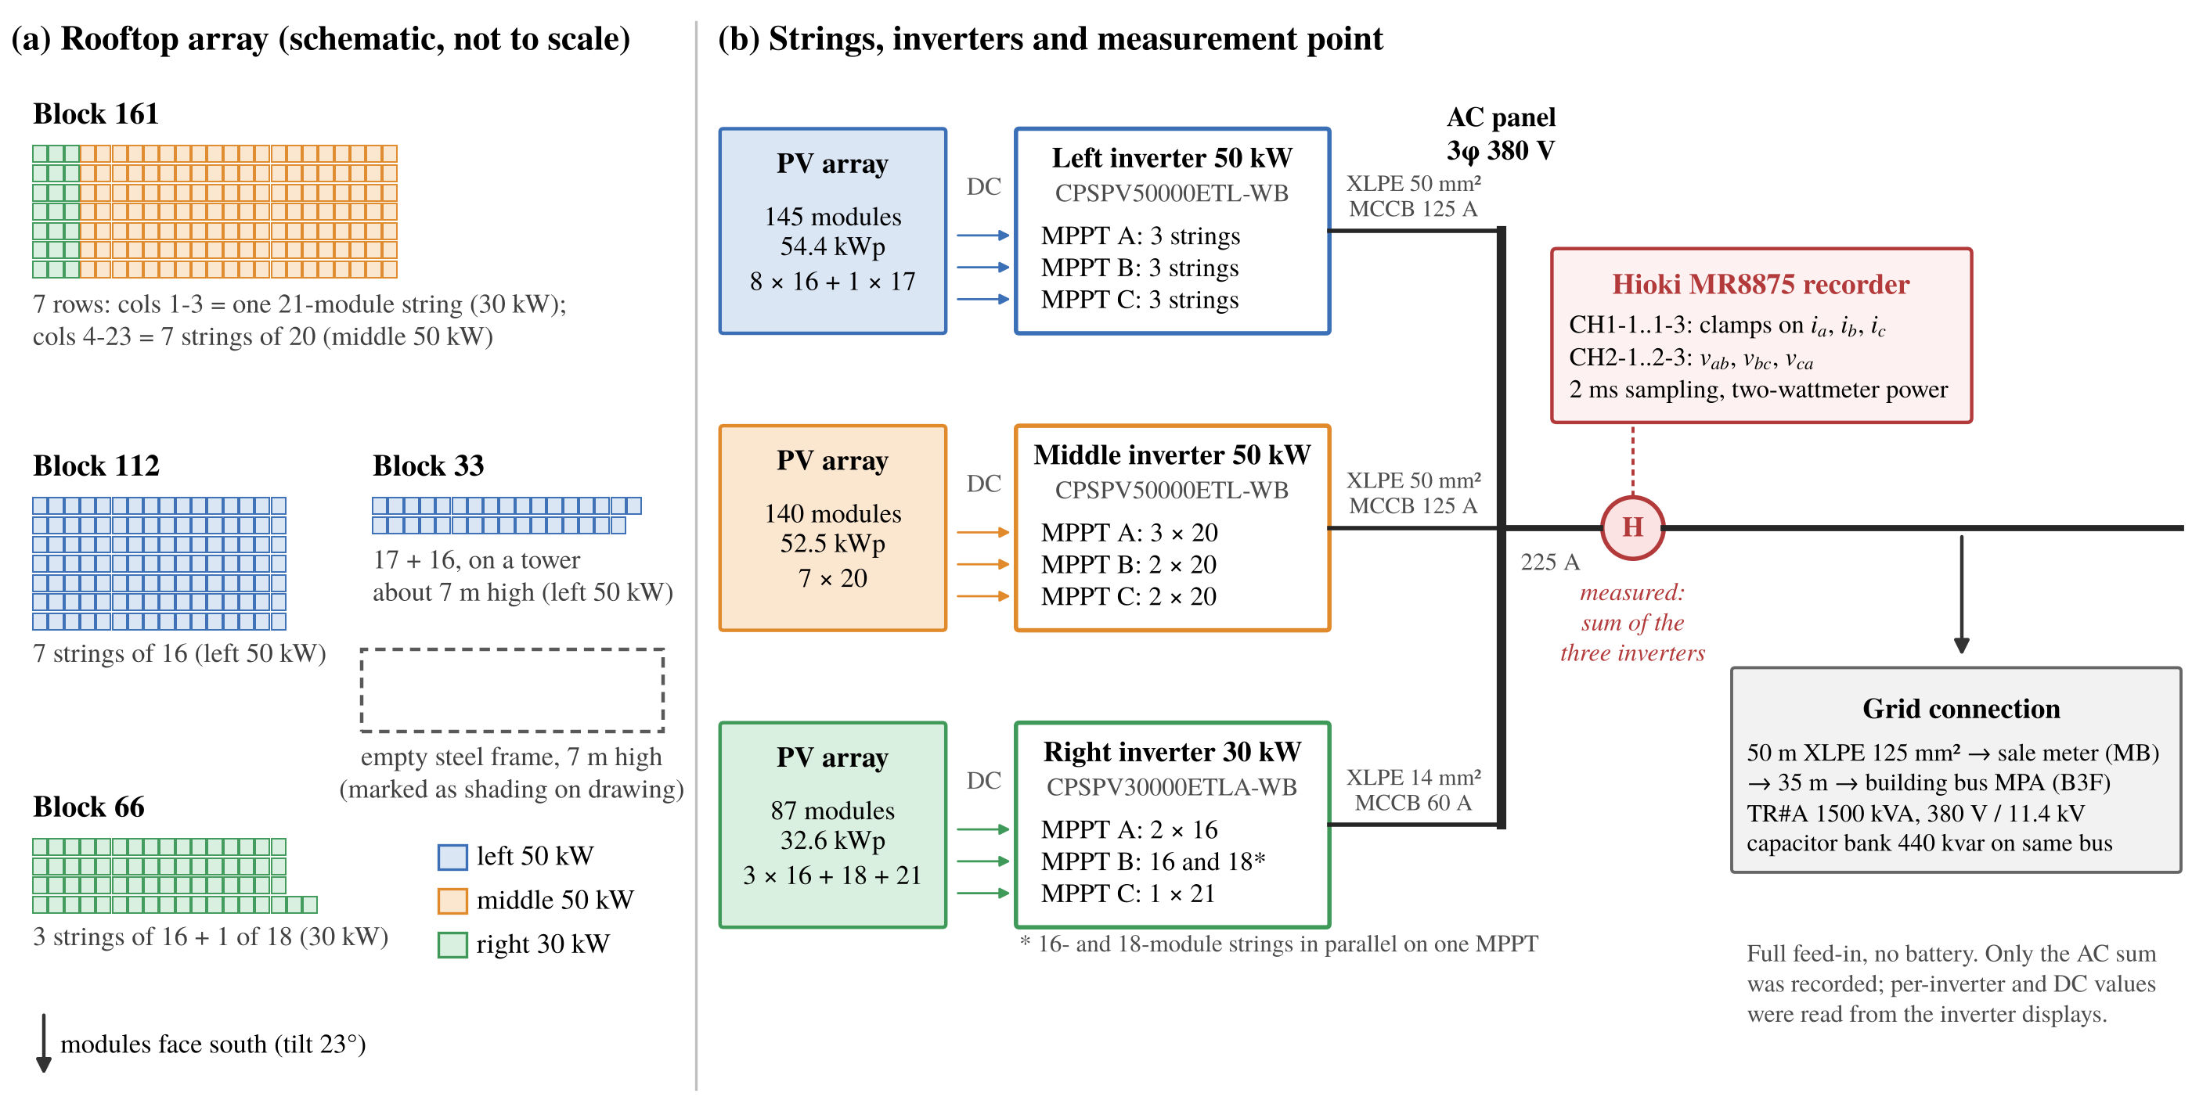
Fig. 1 Plant layout. (a) Roof blocks and their inverter (positions schematic). (b) Strings per MPPT, AC connection and the recorder at the common AC output of the three inverters.

Abstract
Rooftop PV energy is often estimated from datasheets and public weather data. We model a 139.5 kWp plant in Taiwan (372 modules; one 30 kW and two 50 kW inverters) with pvlib, rank nine uncertain factors with a converged Sobol analysis (45,056 runs), and compare the model with the AC power recorded at the common inverter output and with the lifetime energy counters of the inverters. DC loss and irradiation error explain 84% of the annual variance and the inverter model 7%; this inverter effect comes from the assumed efficiency (2.6%) and hardly from the model structure (0.4–0.6%). On clear autumn and winter days the plant delivered 80–89% of the modeled energy (nMBE up to +24%), although the hourly profile is reproduced (r ≥ 0.97); the budget reaches this only when all factors are at their lowest ends together. Over 3.5 years, however, the inverter counters agree with the model within 3%. The model is thus suitable for annual energy but biased on clear days at hourly scale, and separating the causes requires irradiance measured on site.
Keywords: Photovoltaic; Inverter modeling; pvlib; Uncertainty budget; Field validation
1. Introduction
The energy of a PV plant can be estimated from module and inverter datasheets and public weather data with pvlib [1], [2], but the result depends on the assumption made at each step. For the inverter, a constant efficiency is the simplest choice, PVWatts [3] adds a load-dependent efficiency, and the Sandia [4] and ADR [5] models need test data that datasheets rarely give; hourly data also underestimate clipping [6]. Uncertainty studies point to plane-of-array modeling [7], 2–6% annual uncertainty of satellite irradiation [8] and derate assumptions [9], but seldom treat a single rooftop plant whose weather data come from a distant station.
For the 139.5 kWp rooftop plant of National Changhua University of Education (NCUE), Taiwan, we ask: (i) how large the effect of the inverter model is compared with other factors, and whether it stems from model structure or assumed efficiency; (ii) how much the weather source (a station 21 km away or ERA5 [10]) matters; and (iii) whether the variance-based uncertainty budget [11], [12] encloses the energy the plant delivers.
2. Plant, Data and Model
2.1 Plant
The plant (24.066°N, 120.559°E) has 372 AJP-S672-375 modules [13] on open racks, facing south at 23° tilt, and feeds one 30 kW and two 50 kW inverters [14] without storage (Fig. 1, Table 1). A site inspection in October 2026, based on the hand annotations of the drawings, the module count of each roof block and the string currents and MPPT voltages on the inverter displays, found a layout that differs from the drawings (144/144/84 modules): 145, 140 and 87 modules in 21 strings of 16 to 21 modules (Fig. 1b). For the annual energy this changes the result by only +0.02%. Two blocks of the left inverter stand on a 7 m tower next to an empty frame of the same height, the middle inverter logs fan faults with de-rating, and the counter of the 30 kW inverter is faulty.
Table 1 Plant data (as built).
Item | Value
Module | 375 W, γ = −0.44 %/°C, NOCT 46 ± 2 °C
Inverter 30 / 50 kW | η_{max} 98.6 / 98.5%
Modules (left / middle / right) | 145 / 140 / 87
Capacity (kWp) | 54.4 / 52.5 / 32.6
DC/AC ratio | 1.09 / 1.05 / 1.09
2.2 Weather data
Hourly irradiation and air temperature come from the CWA Tianzhong station (467270) [15], 21.4 km from the site (1626 kWh/m² in 2023), and hourly ERA5 data from PVGIS [16], [17]. The hour label refers to the end of the hour (1 MJ/m² per hour = 277.8 W/m²), and one missing hour was interpolated. No irradiance sensor exists on the roof.
2.3 Power measurement
A Hioki MR8875 [18] records the three line currents and line-to-line voltages at the common AC output (Fig. 1b). The bus voltages are three sinusoids displaced by 120° (Fig. 2); for balanced conditions the active power is
P = √3 V_{LL} I_{L} cos φ (1)
with rms values. With three wires and no neutral, the instantaneous power follows from two products (two-wattmeter method), which also holds under unbalance and distortion [28]:
P = ⟨v_{ab} i_{a} − v_{bc} i_{c}⟩ (2)
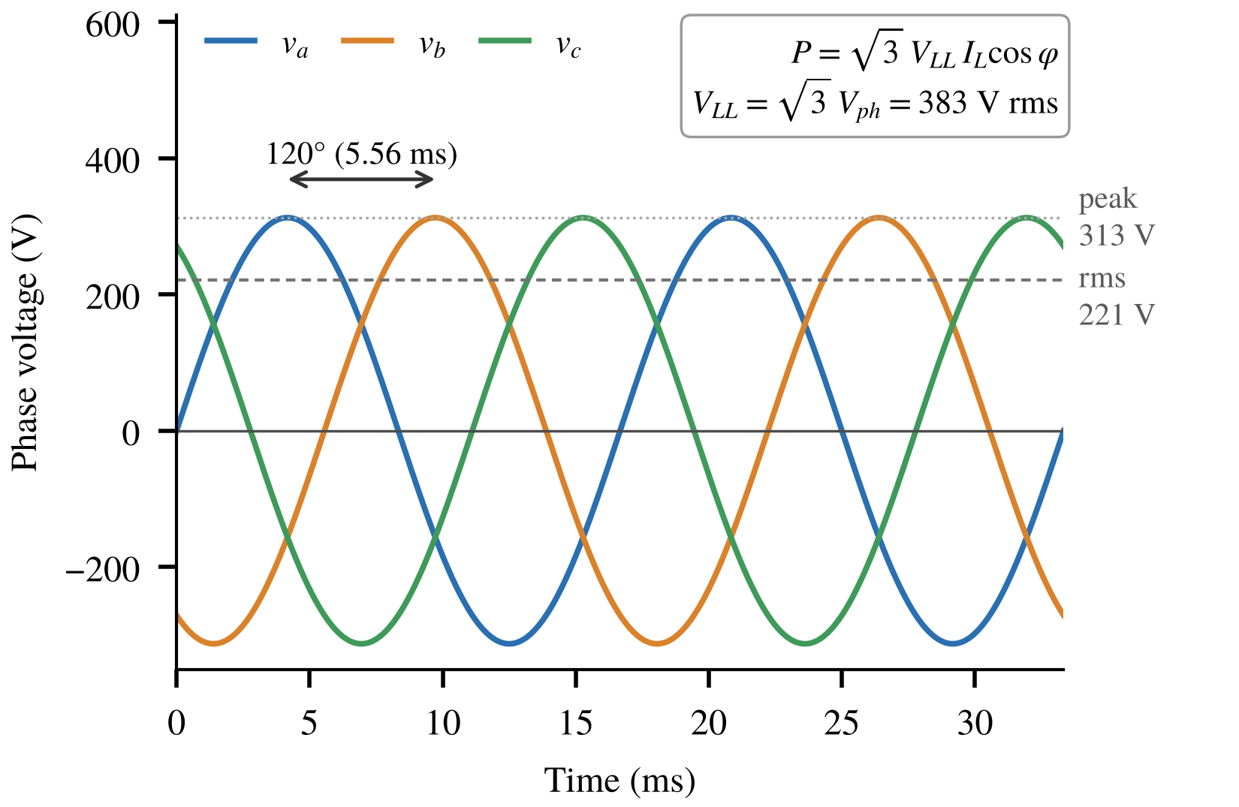
Fig. 2 Phase voltages of the AC bus (60 Hz): equal amplitude, displaced by 120°; 221 V rms per phase, 383 V rms line-to-line.
Because v_{ab} = v_{a} − v_{b}, a line-to-line voltage is √3 times the phase voltage and leads it by 30°; multiplying each current by its own line-to-line voltage would therefore overstate the power by 3 cos 30°/√3 = 1.5. The records show voltages 120° ± 1.5° apart, currents lagging by 0.5–4.3°, unbalance below 3.8% and a power factor of 0.995, and Eq. (1) applied to the fundamentals agrees with Eq. (2) within 0.13% (median).
The main record (16–19 October 2026) was sampled at 2 ms, thinned to 10 ms and averaged to 4,201 one-minute values (no gap longer than 90 s); seven two-hour records (2025–2026) were thinned to 20 ms. Thinning without a filter aliases the 60 Hz waveforms, but at 10 and 20 ms the samples fall on five equally spaced points of the cycle, so the power ripple averages out over a minute; intervals of whole cycles, such as 200 ms, sample a single point and were avoided. A test with 400 synthetic minutes carrying the measured unbalance, harmonics and ±30% power changes confirms this: the error of the one-minute power is at most 0.06% (10 ms) and 0.05% (20 ms), 0.12% with the grid frequency at exactly 60 Hz, against up to 12% for 200 ms.
The measurement chain was not calibrated. The night-time offset is −0.011 kW, and on 18 October the inverter displays showed 3.0% more energy than the recorder (572 against 555 kWh at 16:58); the middle inverter showed 39.3% of the recorded energy, against a module share of 37.6%.
2.4 Model chain
Fig. 3 shows the chain: Erbs decomposition [19], Perez transposition [20] (albedo 0.25), Ross cell temperature [21] and PVWatts DC power [3],
P_{dc} = P₀(G/1000)[1 + γ(T_{c} − 25)](1 − f_{dc}) (3)
with f_{dc} = 8.7% (11.4% with the default shading loss). Each inverter is modeled with constant efficiency, PVWatts-DS (datasheet peak η as nominal, an upper bound) or PVWatts-G (η 0.96, the pvlib default); our code equals pvlib.inverter.pvwatts to 0 W. A variant adds the Martin–Ruiz incidence-angle loss [22]; the performance ratio follows IEC 61724-1 [23].
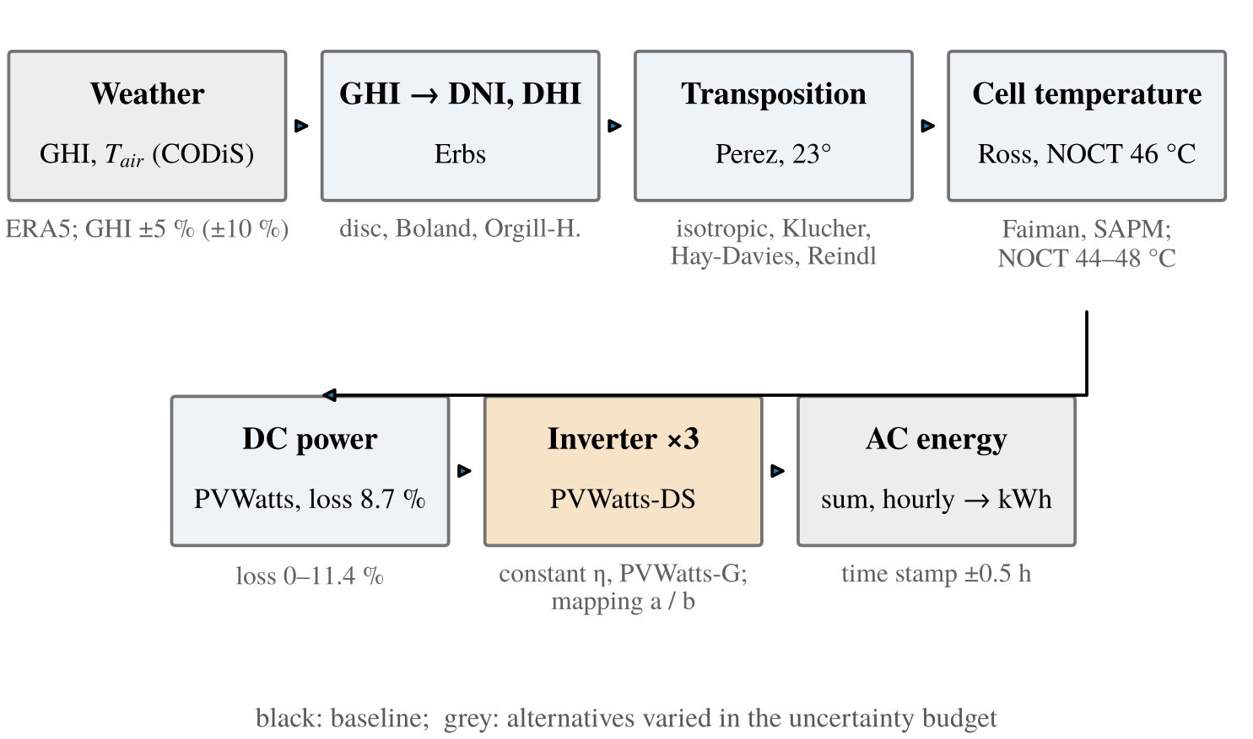
Fig. 3 Model chain. Grey: alternatives varied in Section 3 (e.g. Faiman [24] and SAPM [25] cell temperature).
3. Annual Uncertainty Budget
Nine factors were varied with SALib [26] (Table 2): continuous factors uniformly over the stated ranges, model options with equal weight. The ranges are assumptions with the given basis, and the ranking depends on them, as the ±5% and ±10% GHI cases show.
Table 2 Factors and ranges (model options with equal weight) and Sobol total index S_{T} for ±5% and ±10% GHI error (4,096 base samples, 95% interval).
Factor | Range, distribution, basis | S_{T} ±5% | S_{T} ±10%
DC loss | 0–11.4%, uniform; PVWatts loss without / with shading [3] | 0.495 ± 0.020 | 0.243 ± 0.010
GHI error | ±5% (±10%), uniform; sensor class, 21 km distance [8] | 0.344 ± 0.014 | 0.678 ± 0.025
Inverter | constant η, PVWatts-DS, PVWatts-G | 0.071 ± 0.003 | 0.035 ± 0.001
Transpos. | Perez, isotropic, Klucher, Hay-Davies, Reindl | 0.058 ± 0.003 | 0.028 ± 0.001
Cell temp. | Ross, Faiman, SAPM | 0.029 ± 0.001 | 0.015 ± 0.001
GHI split | Erbs, disc, Boland, Orgill-Hollands | 0.003 ± 0.000 | 0.001 ± 0.000
NOCT | 44–48 °C, uniform; datasheet 46 ± 2 | 0.002 ± 0.000 | 0.001 ± 0.000
Time shift | −0.5, 0, +0.5 h (hour label) | 0.001 ± 0.000 | 0.000 ± 0.000
Mapping | two layouts within inverter limits | 0.000 ± 0.000 | 0.000 ± 0.000
3.1 Results and convergence
The baseline gives 195 MWh AC (1399 kWh/kWp), and the 5th–95th percentile spans −5.5% to +11.4%. DC loss (−3.0% to +9.6%) and GHI error (±5%) explain 84% of the variance, and the inverter model ranks third (Fig. 4; 3% with ±10% GHI error). The total indices change by at most 0.004 between 1,024 and 4,096 base samples, their standard deviation over six scrambling seeds is at most 0.002, and the ranking is stable from 64 samples; the intervals of the first five factors do not overlap. Interactions are negligible (ΣS_{T} − ΣS₁ = 0.005), the layout mapping changes the energy by less than 0.01%, and no inverter clips at the baseline loss (without DC loss at most 21 kWh per year).
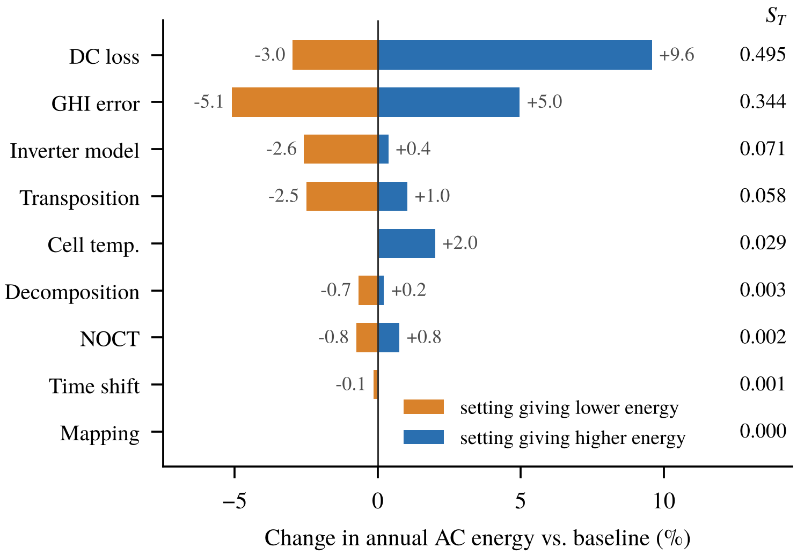
Fig. 4 Change in annual AC energy when one factor moves within its range (orange: setting giving the lowest, blue: the highest energy) and Sobol total index S_{T} (4,096 base samples).
3.2 Inverter: structure or efficiency
The formulations differ in curve shape and in assumed efficiency at once. Fig. 5 separates the two: at equal η, constant efficiency and PVWatts differ by 0.36–0.63%, whereas lowering η from 0.985 to 0.96 removes 2.6%. The inverter share of the budget is therefore an efficiency assumption, not a structural effect. On the clear October days, when most energy is produced near full load, the two structures with equal η differ by less than 0.1%.
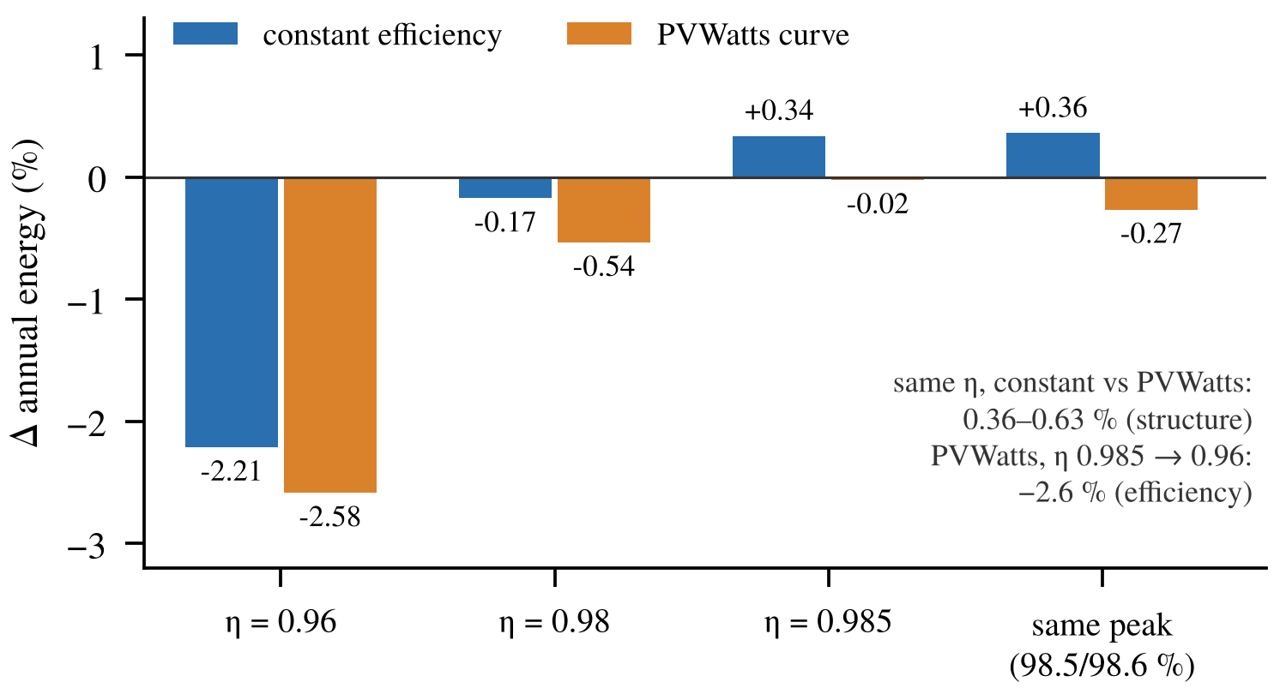
Fig. 5 Annual energy relative to PVWatts-DS for both structures at equal efficiency (as-built layout, 2023).
3.3 Weather source
Station and ERA5 irradiation differ by +2.6% mean bias and 37% RMSE (r = 0.83). The annual energy changes by +3.4%, but the monthly energy by −12% to +19% (Fig. 6), so at monthly scale the weather source outweighs the inverter model.
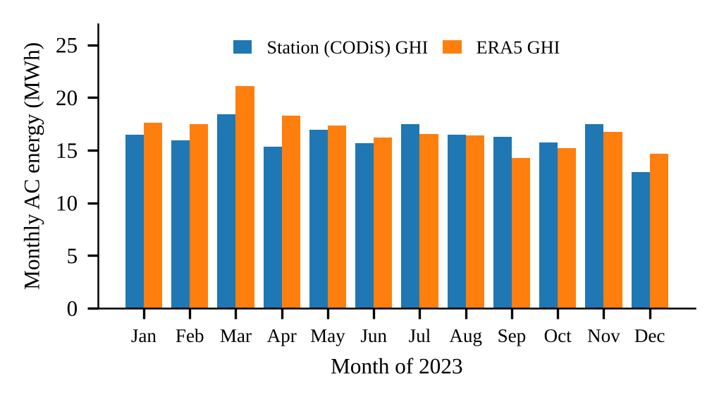
Fig. 6 Monthly AC energy driven by station or ERA5 irradiation (2023).
4. Field Validation
4.1 Measured output
On 17 and 18 October, with 97% and 94% of clear-sky irradiation at the station, the plant produced 585 and 557 kWh (4.20 and 3.99 kWh/kWp), with a peak of 100.5 kW against the 130 kW rating (Fig. 7). The one-minute power still shows dips (variability 0.06 and 0.13 of the mean between 10:00 and 14:00, against 0.003 on a clear February day) that AC data alone cannot attribute.
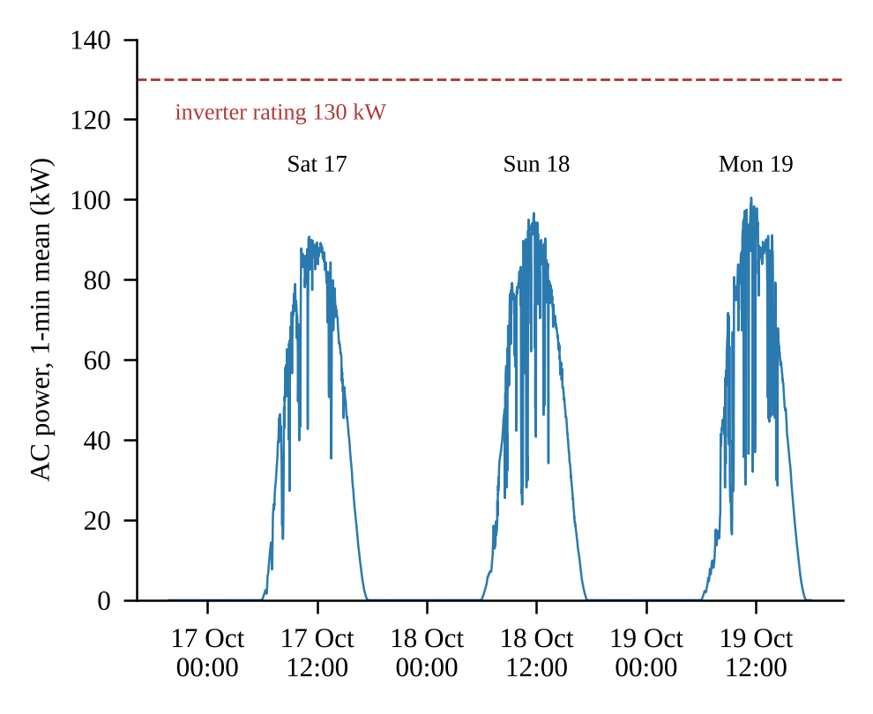
Fig. 7 Measured AC power, 16–19 October 2026 (one-minute means).
4.2 Model against measurement
Agreement is expressed by the ratio
R = ΣP_{actual} / ΣP_{model} (4)
over the hours of a record (R < 1: model too high) and by the mean bias and RMS errors normalized by the mean measured power (Table 3). A high correlation shows only that the hourly shape is reproduced (r = 0.99 and 0.97, centroid shift 0.05 and 0.10 h); the model is higher in almost every hour, by 12.3 kW on average (Fig. 8): R = 0.81 with nMBE +23% and +24% on 17 and 18 October, and 0.80 on 19 October; the performance ratio is 0.63 measured against 0.78 modeled. The hourly ratio stays near 0.8 from morning to afternoon (morning/afternoon 0.82/0.80 and 0.76/0.86; Fig. 9), so a one-sided obstruction is unlikely. With this bias the model does not predict the hourly power on clear days.
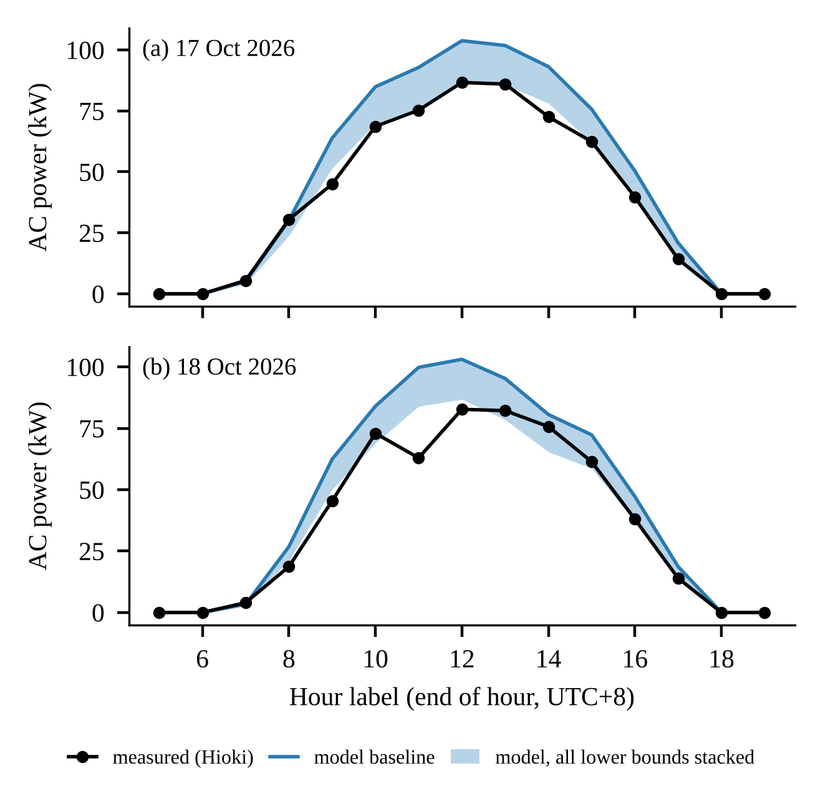
Fig. 8 Hourly AC power, measured and modeled; the band reaches the stacked lower bounds of Section 4.4.
Table 3 Error metrics on clear-sky records (hours ≥ 20 min, weighted; r for full days).
Record | h | R | MBE (kW) | nMBE (%) | RMSE (kW) | nRMSE (%) | r
17 Oct 26 | 11 | 0.81 | +12.3 | +23 | 14.2 | 26.7 | 0.99
18 Oct 26 | 11 | 0.80 | +12.3 | +24 | 15.6 | 30.8 | 0.97
10 Feb 26 | 3 | 0.89 | +11.9 | +13 | 12.0 | 12.7 | –
21 Dec 25 | 2 | 0.82 | +16.9 | +22 | 17.5 | 23.2 | –
7 Aug 25 | 3 | 1.01 | −0.9 | −1 | 11.2 | 14.6 | –
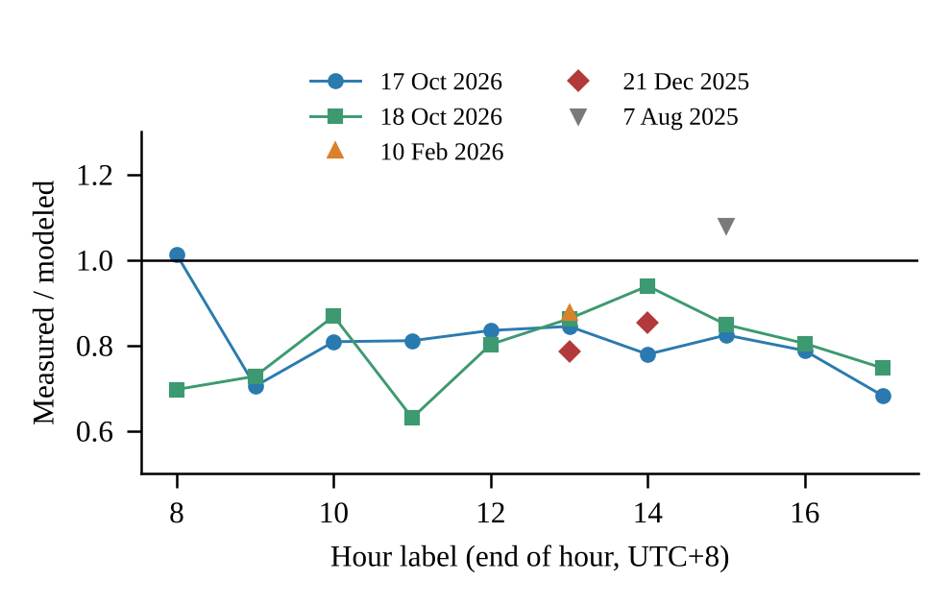
Fig. 9 Measured over modeled hourly power on the clear-sky records.
4.3 Other records
Across the nine days with station data, R lies between 0.65 and 1.01 (Fig. 10). Only the five days above 0.9 of clear-sky irradiation are used for the bias, because a station 21 km away does not follow the clouds over the roof; with so few records a seasonal pattern cannot be separated from day-to-day differences. A single correction factor does not transfer either: the factor fitted on 17 October (0.812) leaves biases of +0.9% on 18 October and −0.5% on 21 December, but −8.6% on 10 February and −19.7% on 7 August, so R must not be used as an annual correction.
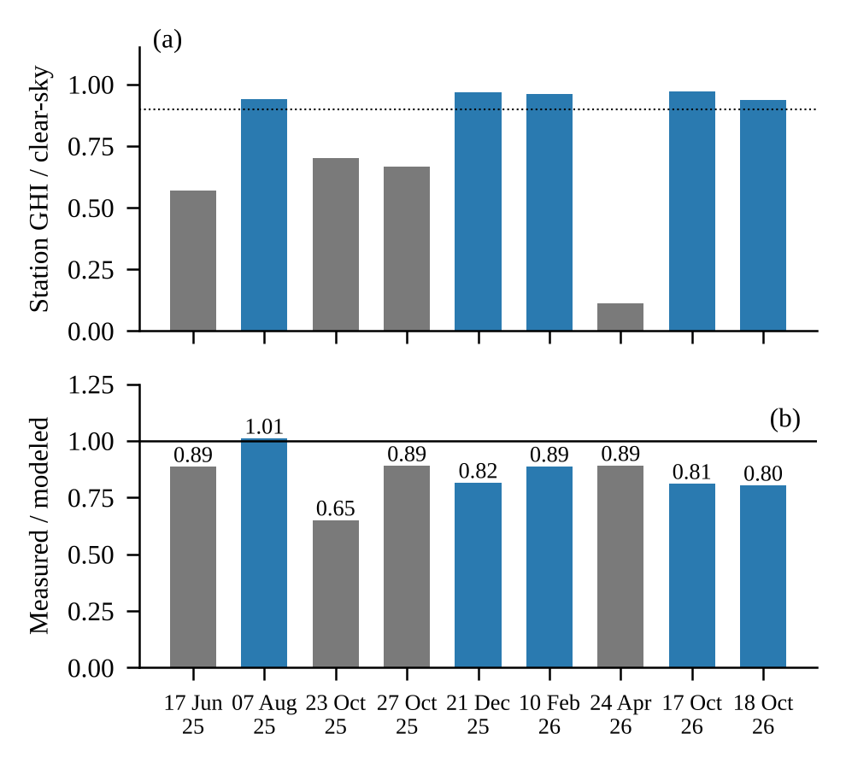
Fig. 10 (a) Clear-sky fraction of the station irradiation and (b) R per record; blue: fraction above 0.9.
4.4 Closing the budget
Fig. 11 stacks the lowest end of every factor. With isotropic transposition (−3.9% alone) and Boland decomposition (−1.0%), which the earlier stack omitted, together with PVWatts-G, a DC loss of 11.4%, NOCT 48 °C and the incidence-angle loss, the model falls to 87.0%, and an irradiation 5% lower brings it to 82.0%, close to the measured 81% (R = 0.99 and 0.98). This joint extreme is implausible: the isotropic model underestimates tilted irradiance under clear skies [27], the combination lowers the annual energy by 13.6% against a 5th percentile of −5.5%, and on 10 February the same setting underestimates the measurement by 6%. No single set of factor values fits the clear days of October and February; the stacked bounds are also not independent of each other.
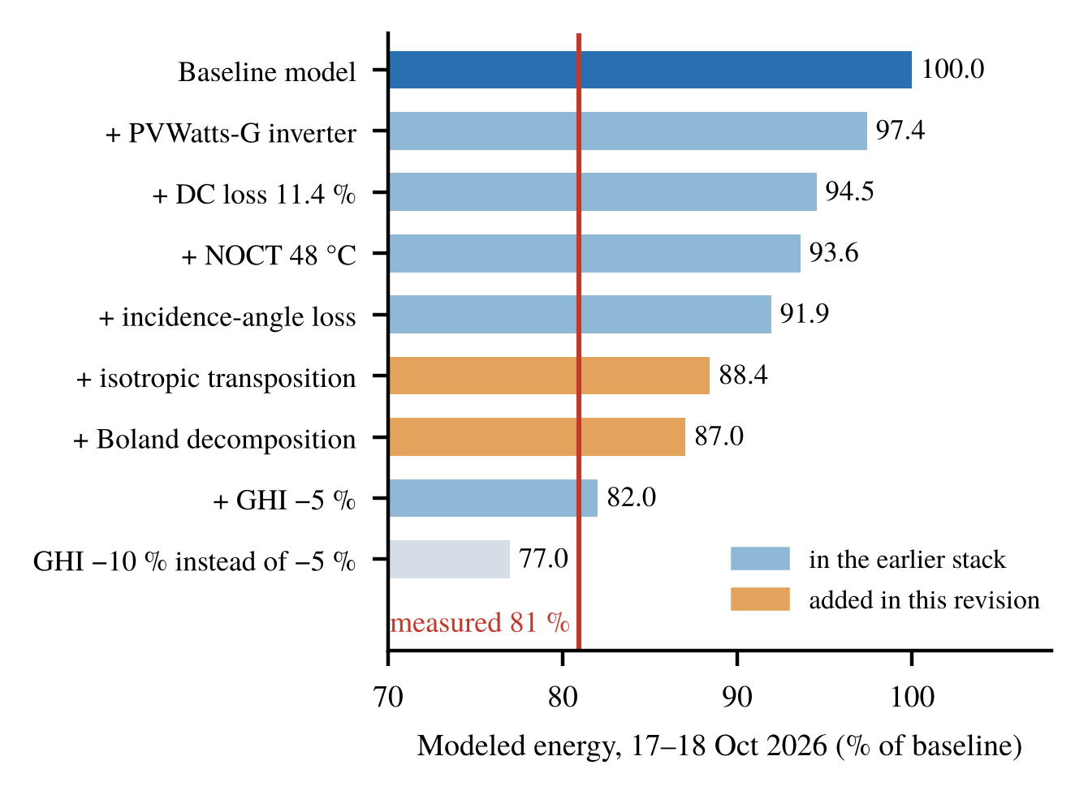
Fig. 11 Modeled energy of 17–18 October with the lower ends stacked; orange: added in this revision; red: measured.
4.5 Long-term check
The lifetime counters of the two 50 kW inverters (269,093 and 264,693 kWh after 1280 days) exceed the model for the same calendar period by 0.8% and 2.7% (1411 and 1437 against 1399 kWh/kWp per year; Fig. 12). The counter of the 30 kW inverter shows 3.6 GWh after 497,827 h, which is impossible, and is not used. The counters are the inverters' own meters (3% above the recorder on 18 October), the weather of 2024–2026 is not modeled, degradation is ignored and outages are included. Even so, a permanent 19% loss would have shown in 3.5 years, so the clear-day bias is condition-specific: either the model is lower than the plant under other conditions, or the October days are atypical. The short records, mostly from autumn and winter, cannot show which; the only summer record (7 August 2025) gives 1.01.
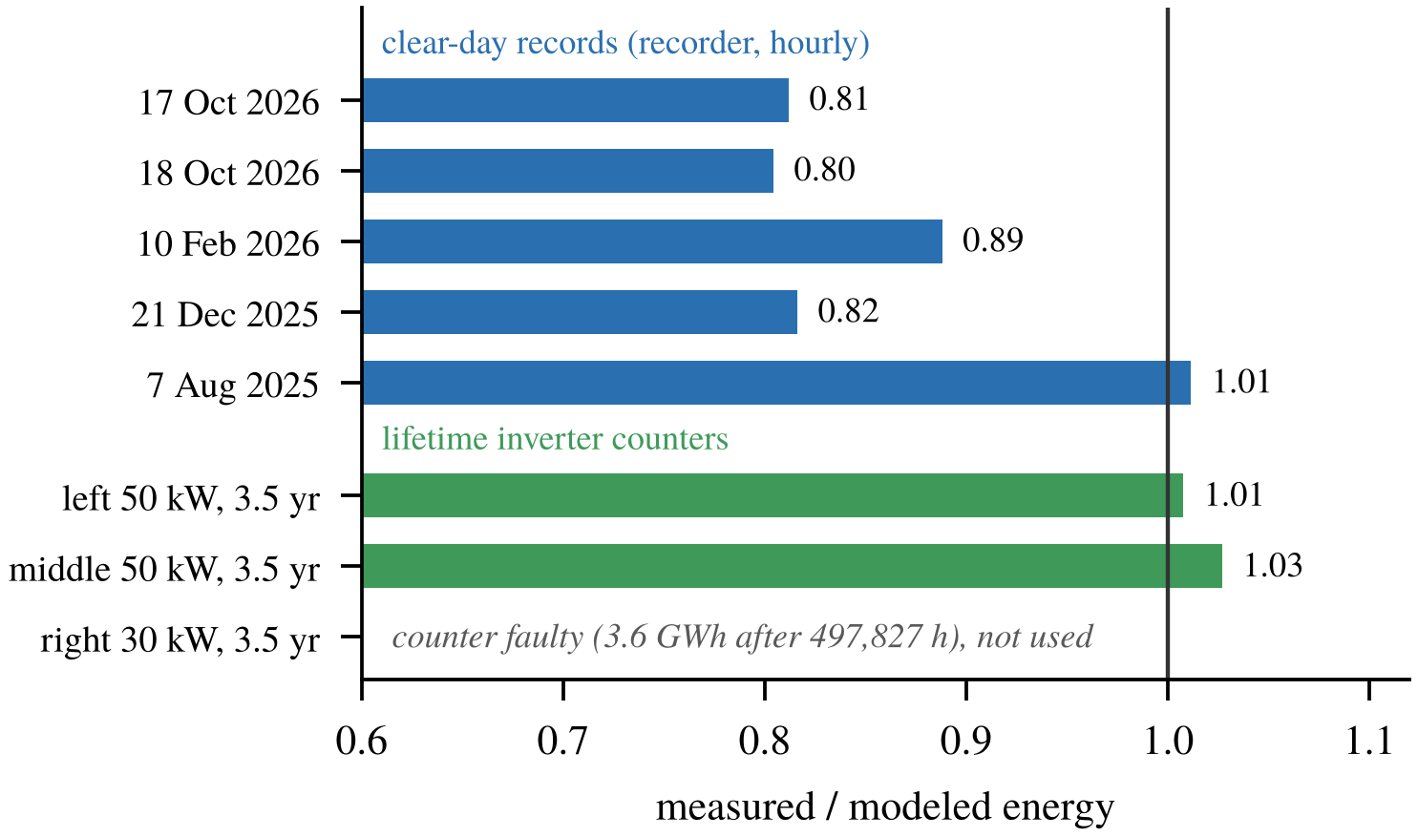
Fig. 12 Measured over modeled energy: clear-day records (recorder) and 3.5-year inverter counters (the 30 kW counter is faulty).
4.6 Causes and the inverter model
The data narrow the cause but do not settle it. A large bias of the station irradiation on cloud-free days is unlikely, and a fixed one-sided shadow is not supported. Candidates on the plant side are shading by the tower and frame, soiling before the rainy season, string mismatch, the 21-module string on the 30 kW inverter, de-rating of the middle inverter and short outages; on the measurement side, the uncalibrated recorder. Separating them requires plane-of-array irradiance, inverter-level AC logging and string currents. The inverter formulations move the energy by at most 2.6%, about a seventh of the gap, and give the same correlation, so AC data alone cannot tell which is better.
5. Discussion and Limitations
The model is suitable for annual energy, within the budget of −5.5% to +11.4%, but not for hourly prediction on clear days, where it is about 20% too high. (1) The field data are three days and seven two-hour records, mostly autumn and winter, and two uncalibrated counters; utility meter data and a year of logging would allow a seasonal check. (2) Without irradiance on the roof the error cannot be split into an irradiance and a plant part; this is the main gap. (3) Only the combined AC output was measured. (4) The ranking depends on the assigned ranges. (5) The cause of the clear-day shortfall has not been confirmed.
6. Conclusions
The datasheet model gives 195 MWh (1399 kWh/kWp) per year. DC loss and irradiation error dominate the converged Sobol budget, and the inverter effect (−2.6% to +0.4%) is an efficiency assumption rather than a structural one. The weather source matters at monthly scale (−12% to +19%). On clear days the plant produced 80–89% of the modeled energy, reached by the budget only at its joint extreme, while over 3.5 years the inverter counters agree within 3%. Roof-level irradiance is the next step before the inverter model is refined further.
7. Data Availability
Code and data: https://github.com/cliff1221/ncue-pv-inverter.
8. References
- W. F. Holmgren, C. W. Hansen and M. A. Mikofski, “pvlib python: a python package for modeling solar energy systems,” Journal of Open Source Software, Vol. 3, No. 29, Article 884, 2018.
- K. S. Anderson, C. W. Hansen, W. F. Holmgren, M. A. Mikofski, A. R. Jensen and A. Driesse, “pvlib python: 2023 project update,” Journal of Open Source Software, Vol. 8, No. 92, Article 5994, 2023.
- A. P. Dobos, PVWatts Version 5 Manual, NREL/TP-6A20-62641, National Renewable Energy Laboratory, Golden, CO (2014).
- D. L. King, S. Gonzalez, G. M. Galbraith and W. E. Boyson, Performance Model for Grid-Connected Photovoltaic Inverters, SAND2007-5036, Sandia National Laboratories, Albuquerque, NM (2007).
- A. Driesse, P. Jain and S. Harrison, “Beyond the curves: Modeling the electrical efficiency of photovoltaic inverters,” Proceedings of the 33rd IEEE Photovoltaic Specialists Conference, San Diego, CA, USA (2008).
- B. Burger and R. Rüther, “Inverter sizing of grid-connected photovoltaic systems in the light of local solar resource distribution characteristics and temperature,” Solar Energy, Vol. 80, No. 1, pp. 32-45, 2006.
- Sandia National Laboratories, Uncertainty and Sensitivity Analysis for Photovoltaic System Modeling, SAND2013-10358, Albuquerque, NM (2013).
- C. Reise et al., Uncertainties in PV System Yield Predictions and Assessments, IEA PVPS Task 13, Report IEA-PVPS T13-12:2018 (2018).
- M. Theristis et al., “Blind photovoltaic modeling intercomparison: A multidimensional data analysis and lessons learned,” Progress in Photovoltaics: Research and Applications, Vol. 31, No. 11, pp. 1144-1157, 2023.
- H. Hersbach et al., “The ERA5 global reanalysis,” Quarterly Journal of the Royal Meteorological Society, Vol. 146, No. 730, pp. 1999-2049, 2020.
- I. M. Sobol’, “Global sensitivity indices for nonlinear mathematical models and their Monte Carlo estimates,” Mathematics and Computers in Simulation, Vol. 55, No. 1-3, pp. 271-280, 2001.
- A. Saltelli, P. Annoni, I. Azzini, F. Campolongo, M. Ratto and S. Tarantola, “Variance based sensitivity analysis of model output. Design and estimator for the total sensitivity index,” Computer Physics Communications, Vol. 181, No. 2, pp. 259-270, 2010.
- AJP-S672-365W~375W Datasheet, Anji Technology.
- CyberPower, CPSPV22000-36000ETLA-WB and CPSPV50000-66000ETL-WB Datasheets, Cyber Power Systems, Inc. (2024-2025).
- Central Weather Administration, CWA Observation Data Inquiry System (CODiS), https://codis.cwa.gov.tw/
- European Commission Joint Research Centre, Photovoltaic Geographical Information System (PVGIS) v5.3, https://re.jrc.ec.europa.eu/pvg_tools/
- T. Huld, R. Müller and A. Gambardella, “A new solar radiation database for estimating PV performance in Europe and Africa,” Solar Energy, Vol. 86, No. 6, pp. 1803-1815, 2012.
- Hioki E.E. Corporation, MR8875 Memory HiCorder Instruction Manual, Nagano, Japan.
- D. G. Erbs, S. A. Klein and J. A. Duffie, “Estimation of the diffuse radiation fraction for hourly, daily and monthly-average global radiation,” Solar Energy, Vol. 28, No. 4, pp. 293-302, 1982.
- R. Perez, P. Ineichen, R. Seals, J. Michalsky and R. Stewart, “Modeling daylight availability and irradiance components from direct and global irradiance,” Solar Energy, Vol. 44, No. 5, pp. 271-289, 1990.
- R. G. Ross Jr., “Design techniques for flat-plate photovoltaic arrays,” Proceedings of the 15th IEEE Photovoltaic Specialists Conference, Orlando, FL, USA (1981).
- N. Martin and J. M. Ruiz, “Calculation of the PV modules angular losses under field conditions by means of an analytical model,” Solar Energy Materials and Solar Cells, Vol. 70, No. 1, pp. 25-38, 2001.
- IEC 61724-1:2021, Photovoltaic system performance - Part 1: Monitoring, International Electrotechnical Commission, Geneva (2021).
- D. Faiman, “Assessing the outdoor operating temperature of photovoltaic modules,” Progress in Photovoltaics: Research and Applications, Vol. 16, No. 4, pp. 307-315, 2008.
- D. L. King, W. E. Boyson and J. A. Kratochvil, Photovoltaic Array Performance Model, SAND2004-3535, Sandia National Laboratories, Albuquerque, NM (2004).
- J. Herman and W. Usher, “SALib: An open-source Python library for sensitivity analysis,” Journal of Open Source Software, Vol. 2, No. 9, Article 97, 2017.
- P. G. Loutzenhiser, H. Manz, C. Felsmann, P. A. Strachan, T. Frank and G. M. Maxwell, “Empirical validation of models to compute solar irradiance on inclined surfaces for building energy simulation,” Solar Energy, Vol. 81, No. 2, pp. 254-267, 2007.
- IEEE Std 1459-2010, IEEE Standard Definitions for the Measurement of Electric Power Quantities Under Sinusoidal, Nonsinusoidal, Balanced, or Unbalanced Conditions, IEEE, New York (2010).

