Jinx!
The iPhone Chat App
Functional Specification

Clifton C. Craig
Last Updated: 12/10/2010
-CONFIDENTIAL-

Overview
Jinx is an iPhone native chat application that connects you to a fictitious user on the other end of the Internet with photo exchange support. A minimally Artificial Intelligence algorithm will be employed to power the fictional chat buddy. It’s purposed is to illustrate the development approaches of one engineer who is applying for a position at one of the most popular VOIP companies on the Internet.

This documentation is complete and contains an accurate description of the product to date.

Scenarios
The following scenarios illustrate comical, fictional, though possible real world uses of the “Jinx!” app. The inclusion of subtle humor is intended to maintain the interest of all project participants who would rather watch another discovery of yet more water on the moon than drudge through the pages of many typical technical specs. (No offense to NASA, I thought it was interesting!)

Scenario 1:
Joe Nogotfriendz is a financial accountant working at “The Legal Offices of Fildman and Diddler”. A math nerd, he’s held this position for twelve years and managed to alienate himself from anything remotely resembling human contact in the process. With a passion for technology, Joe loves to entertain himself with his iPhone on his spare time. One lonely Friday night, he finds “Jinx!” in the App Store after hours of paging through hundreds of app downloads in the social networking category. (Did I mention Joe has a touch of OCD?) He desperately craves a social connection but is too awkward in from of people to carry on a conversation that feels like anything other than a multiple choice exam.

Scenario 2:
Moe Hoohaha is a practical jokester that loves to prank others. He tricked his lady friend into believing he was a musical recognition genius after running Shazaam from his side pocket on several occasions. He finds “Jinx” in the app-store and wishes to fool his brother into thinking he is having an affair with his wife.

Goals
“Jinx!” is aimed at the occasional hermit or bored iPhone user with too much time on his/her hands. Its main features will be to respond in some way to arbitrary text input. Revision 1 of the product will have all of the functionality of a modern Fisher Price or LeapFrog product as the timeline is constrained and the sole employed resource is working nights/weekends when he should be celebrating and entertaining his daughter for her recent birthday on the 12th. An attempt will be made to include a photo taking/embedding feature as well as one or more audio features yet to be determined.

Non-Goals
“Jinx!” will not negotiate a network connection or run on the iPad in anything other than iPhone compatibility mode. It is not intended as a production level product so advanced features, like text-to-speech and voice recognition will be scoped out.

Flow Chart
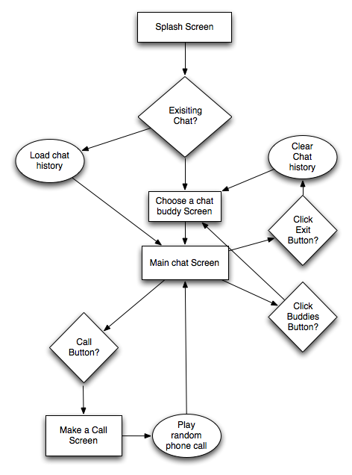
Splash Screen
The first screen the user sees upon loading the app will mask any background processing that needs to be done to initialize the application. It should transition smoothly to either the Main chat Screen or the Choose a chat buddy Screen depending on if there had been a chat in-progress the last time it was launched. The 1st launch should always bring you to the Choose a chat buddy Screen.
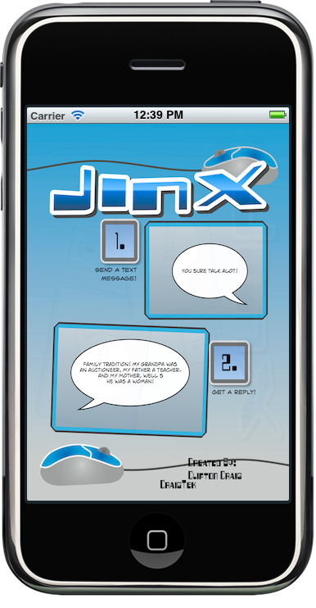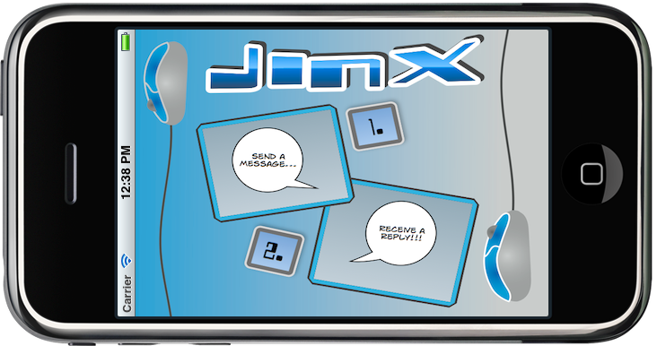

Choose a chat buddy Screen
This is a screen that will display a list of fictitious buddy names. This screen should feature graphical images of each chat buddy. Upon initial launch if the device is held portrait style an auto scroll animation will trigger to indicate other buddies off screen. Additional buddies will be made available through future releases with the possibility of charging per buddy through in-app purchase. Tapping on any buddy will drill into the Main chat Screen where the chat will begin. The following is an example of the Choose a chat buddy Screen

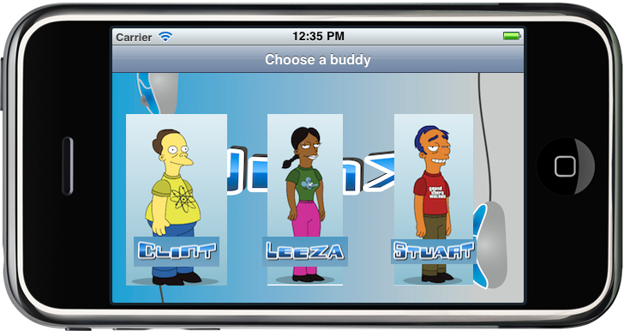

Main chat Screen
The Main chat Screen is the heart of the application. Upon entering this screen the AI engine will initialize and begin automagically texting the user. This screen will have a “buddies” button, and an “exit” button. The exit button will clear the chat history and return to the Choose a chat buddy Screen while the “buddies” button will merely return to the Choose a chat buddy Screen. This screen should support autorotation to landscape to facilitate easier typing on the wider style keypad. It will also feature a “call” button. The “call” button will transition into the Call Me Screen. Below is an approximation of what the app will look like upon completion. The main chat window features auto-scrolling to the last chat message..

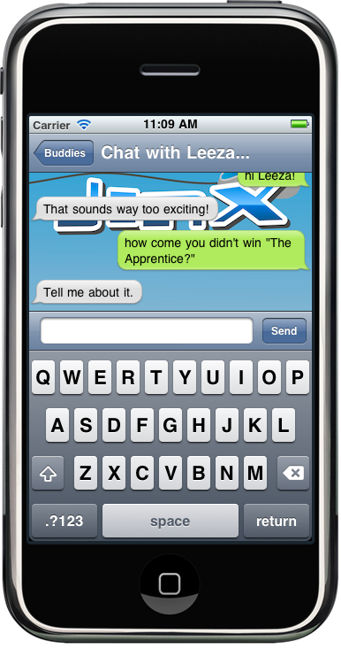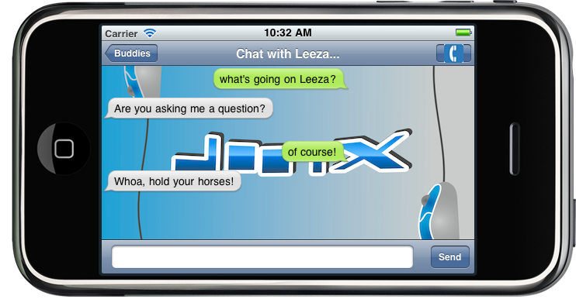

Call Me Screen
This screen will transition from a dialing screen while playing a phone ringing sound. It will then transition, after a number of rings (TBD through rough testing), to an in call screen where a simulated (Fisher-Price style) phone conversation with the current chat buddy will play. The app will not recognize any spoken input much like the Barney never responded to my then 3 year old’s desperate pleas for attention. The idea is that the chat buddy’s avatar will appear in the box indicated by the “them” chat bubble. Rotating of the device will trigger rotation of the avatars and text labels indicating who is who. Below is an example of what the app will look like during a call me session.
