**Student**: Clifton Anderson

**Advisor**: Dr. William Pitt

**Topic**: Rapid separation of bacteria from blood: disk improvements and model building

# Introduction and Background

Consistent use of antibiotics has resulted in bacterial strains with a spectrum of drug-resistant genes. When an infection cannot be treated using general antibiotics, more potent drugs are used. Carbapenem, for example, is a common last-resort drug that induces severe side effects in treated patients. However, some strains of bacteria have acquired carbapenem-resistant genes, requiring alternative treatments.

Blood-borne infections have particularly high mortality rates. The mortality rate of septic shock is 50% after treatment in an intensive care unit (Schoenberg, Weiss et al. 1998, Shankar-Hari, Phillips et al. 2016), and the chance of declining from sepsis, the body’s response to blood infection, to septic shock increases by 7.6% per hour left untreated. Minimizing the mortality rate requires rapid profiling of the bacterial DNA. Polymerase chain reaction, a common DNA amplification technique, is severely hindered by human blood and enzymes (Kumar, Roberts et al. 2006). Furthermore, blood cultures require 12-48 hours, and most hospitals begin treatment with broad spectrum antibiotics immediately (Buckman, Turnbull et al. 2018). Depending on the type of infection, correct antibiotic treatments can reduce the mortality rates by almost half (Leibovici, Paul et al. 1997).

Dr. Pitt’s group has developed a centrifugal disk that takes about 7 mL of blood and sediments the RBCs out, leaving bacteria in the plasma. Equilibrium centrifugation cannot be used because the densities of most bacteria and of RBCs overlap. However, the small size of bacteria (0.5-5 um) relative to RBCs (6-8 um) makes the bacteria move slower in a centrifugal field, meaning that the RBCs can sediment out before the bacteria. Thus, differential centrifugation can catch the bacteria in the supernatant plasma before they have had the opportunity to sediment into the cake of red cells.

The current disk faces two main challenges: red cell interference and low bacterial recovery. The amount of red cells recovered by a disk ranges from 0 to 20 volume percent red cells. The disk will be modified to reduce the maximum red cell recovery to below 5%. The bacterial recovery is the product of two values: volume of recovered plasma and concentration of bacteria in the plasma. The current recovery is about 70%. We can address these challenges by changing two things: the disk and the operating parameters.

### Disk modifications

As the disk slows, the centrifugal field strength decreases, and the separated blood is deformed downward. The plasma is prevented from flowing into the collection area, however, by the high surface energy of the disk; this causes the plasma to bulge until the surface resistance is overcome by gravity. The droplet flows down suddenly, entraining a large quantity of sedimented red cells. If the resistance to flow between the plasma and the blood is reduced, the plasma should flow into the collection area more smoothly. We want to use our 3D printed disks as a model to test the wetting effects of mechanical cutouts and polymer coatings.

Ruffles

Spontaneous capillary flow (SCF) is a phenomena exploited in microfluidics to induce liquid flow based on surface energy gradients. It occurs when a liquid front moves down the length of an unfilled channel. The conditions for SCF are sufficiently narrow channel geometry and low surface energy between the liquid and the surface. Downward-sloping capillary channels would prevent sudden red cell entrainment by giving the separated plasma a wetted surface to flow down smoothly. If capillary channels are cut into the disk, then red cell recovery from sudden breakthrough should be reduced.

Polymers

Polymer coatings present another method of controlling plasma flowdown. Polymers with high free electron density have similar energy density to water and are more wettable than aliphatic polymers because they don’t require as much energy to form an interface. This allows water to travel over a surface without needing as much force. Provided the polymer not absorb too much liquid, a hydrophilic surface would provide a low-energy flow path for the plasma, thus preventing RBC entrainment from “bulk flow”.

A confounding factor in surface coatings is the adsorption of plasma proteins onto the disk. As the disk begins to spin, blood flows briefly over the weir and leaves a film of liquid that begins to dry as the disk continues to spin. Preliminary results show that a plasma coated surface has a lower contact angle than a clean one. Thus, plasma may mask the effects of polymer coatings. Therefore, we will use water for preliminary experiments. The reason we’re bothering with polymers at all is because the dried plasma film in normal operation has thus far not produced even flowdown on matte surfaces.

### Operating parameters from a mathematical model

Models for centrifugal blood separation have been developed using conservation laws. The movement of the suspended cells and of the plasma can be written as

$$\frac{∂ρ_{i}}{∂t}+u_{i}\left(ρ_{i}\right)\frac{∂ρ_{i}}{∂x}=0, i=1,…,N, -\frac{∂ρ_{f}}{∂t}+\frac{∂}{∂x}\left(\left(1-∑ρ_{i}\right)u_{f}\right)=0$$

Where $ρ_{i}$ is the volume fraction of a cell type (RBC, WBC, platelet, bacteria) in a blood suspension, and $u_{i}(ρ_{i})$ is the sedimentation velocity of that cell type as a function of local cell concentration. At infinite dilution, cells move through the plasma at the stokes velocity. However, as the suspension becomes more concentrated, the flow fields around the cells interact and hinder cell movement. Various functions exist to describe this and are called hindered settling functions. These functions consider sedimentation non-ideality by correcting one of two parameters: suspension viscosity or particle velocity (Lerche and Frömer 2001). They range from empirical to semi-empirical and different forms consider particle deformity, shape and variable density (Van Wie and Hustvedt 1988). Most numerical simulations of blood centrifugation use only 1 function and have not compared the predictions of the several forms. Furthermore, many whole blood sedimentation models erroneously consider RBCs as rigid spheres. In reality, RBCs are extremely deformable and can exhibit packing factors between 0.65 and 0.97 (Chien, Dellenback et al. 1968) depending on the centrifugal force exerted on them.

The purpose of a model is to predict operating conditions that maximize bacterial recovery and minimize red cell recovery. One of these parameters is the time and speed of centrifugation; short spin times are desirable, but rapid deceleration creates shear, which mixes the RBCs back into the supernatant plasma. Another parameter is the initial concentration of the blood sample. Sedimentation velocity is a strong function of local concentration, so diluting a blood sample with physiological saline may increase the sedimenting velocity of RBCs relative to bacteria, thus improving separation.

# Objective: Improve disk design and optimize operation.

The first objective is to improve the amount and the purity of recovered plasma from a centrifugal spinning disk. The second objective is to create a mathematical model to simulate bacterial sedimentation. Further, the third objective is to predict operating parameters to maximize bacterial recovery.

Modifications to the separation disk will include coarse enough features for easy manufacturing. They will also maintain a total volume greater than 1 and less than 10 mL, near the volume of a vacutainer ™ tube. The disk will not be modified to be microfluidic.

The mathematical model will use a conservation form considering the cells as discrete liquid phases. This reduces to a system of 1D hyperbolic partial differential equations. With certain concentrations and settling functions, the system of equations can become parabolic and require a different integration scheme (Bürger and Hvistendahl Karlsen 2001). I will using functions and conditions that remain hyperbolic for simplicity. My main objective is to find optimal operating conditions, which will require an accurate model. To do this, I will focus my attention on testing the various hindered settling functions. Because I care about the suspended bacteria only, I will not investigate the further settling that may occur in the cell pack. To validate this model, I’ll refer to the bacterial concentration recovery data collected by previous group members. I addition, I’ll do some experiments to track the cell interface.

## Statement of work

1. Task 1: Mechanical changes
   1. Estimate the effects of ruffle depth and angle on wettability by placing water/plasma on 1 in2 printed wafers with different ruffle shapes. Incline the wafer and measure the angle at which the liquid front starts to move (**Done**)
   2. Print disk with best combination of ruffle angle and depth and compare plasma and red cell recovery with smooth weir
2. Task 2: Chemical coatings on weir edge
   1. Measure contact angles of plasma on matte and glossy surfaces to determine the effect of plasma coatings on wettability (**Done**)
   2. Repeat 1.a, but replace ruffles with polyacrylic acid and polyethylene oxide (**Done**)
   3. Coat matte and glossy disks with polymer and compare plasma recovery with uncoated
   4. Combine ruffles and polymer coating to see if there is any interaction effect
3. Task 3: Develop model for 1D sedimentation
   1. Test velocity functions and compare to experimental data
      1. K corrections to stokes’ law using experimental data
      2. Sedimentation coefficients (Bar, Streichman et al. 1997)
      3. Richardson-Zaki correlation
      4. Porosity model (Patwardhan and Tien 1985)
4. Task 4: Predict and test optimal operating parameters
   1. Predict bacterial recovery using combinations of parameters and extract
   2. Spin blood at those parameters and determine if there is an improvement in bacterial recovery.

## Timeline

See gantt chart. The work is divided into experimental disk modifications and mathematical modeling. Most disk modifications should be done by the end of August 2018, when modeling begins. The modeling will start at the beginning of the school year, and finish in the middle of winter semester. Experimental work through the school year will focus on model validation.

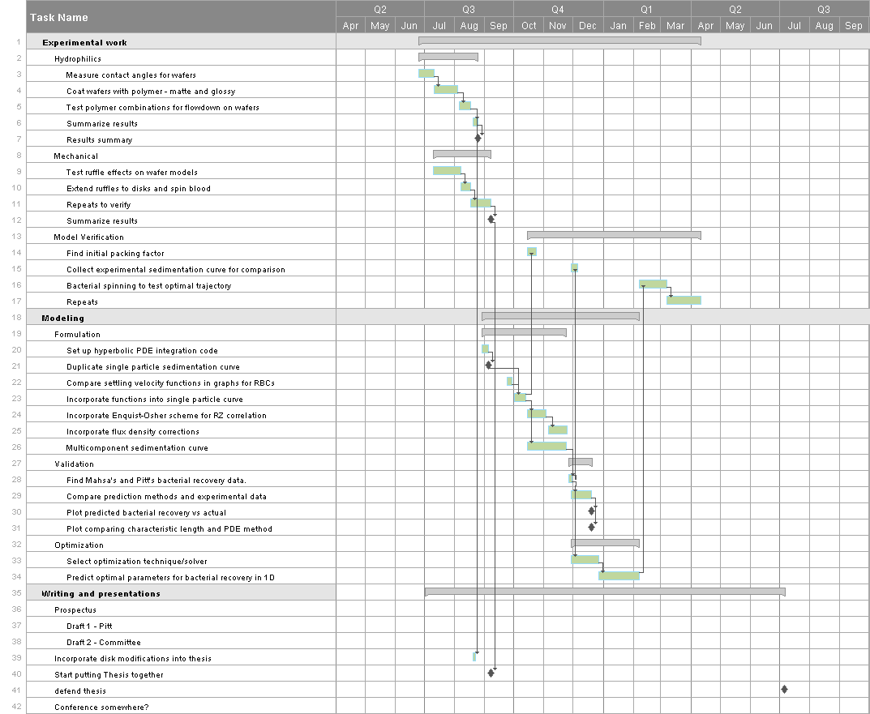

# References

Bar, S., S. Streichman and A. Marmur (1997). "The sedimentation coefficient of red blood cell suspensions as a measure of deformability: continuous monitoring of centrifugal sedimentation." Chemical Engineering Science **52**(6): 1059-1064.

Buckman, S. A., I. R. Turnbull and J. E. Mazuski (2018). "Empiric Antibiotics for Sepsis." Surg Infect (Larchmt) **19**(2): 147-154.

Bürger, R. and K. Hvistendahl Karlsen (2001). "On some upwind difference schemes for the phenomenological sedimentation-consolidation model." Journal of Engineering Mathematics **41**(2): 145-166.

Chien, S., R. J. Dellenback, S. Usami, G. V. Seaman and M. I. Gregersen (1968). "Centrifugal packing of suspensions of erythrocytes hardened with acetaldehyde." Proceedings of the Society for Experimental Biology and Medicine **127**(4): 982-985.

Kumar, A., D. Roberts, K. E. Wood, B. Light, J. E. Parrillo, S. Sharma, R. Suppes, D. Feinstein, S. Zanotti, L. Taiberg, D. Gurka, A. Kumar and M. Cheang (2006). "Duration of hypotension before initiation of effective antimicrobial therapy is the critical determinant of survival in human septic shock." Crit Care Med **34**(6): 1589-1596.

Leibovici, L., M. Paul, O. Poznanski, M. Drucker, Z. Samra, H. Konigsberger and S. D. Pitlik (1997). "Monotherapy versus beta-lactam-aminoglycoside combination treatment for gram-negative bacteremia: a prospective, observational study." Antimicrob Agents Chemother **41**(5): 1127-1133.

Lerche, D. and D. Frömer (2001). "RBC aggregation and deformation." Biorheology **38**(2-3): 249-262.

Patwardhan, V. S. and C. Tien (1985). "Sedimentation and liquid fluidization of solid particles of different sizes and densities." Chemical Engineering Science **40**(7): 1051-1060.

Schoenberg, M. H., M. Weiss and P. Radermacher (1998). "Outcome of patients with sepsis and septic shock after ICU treatment." Langenbecks Arch Surg **383**(1): 44-48.

Shankar-Hari, M., G. S. Phillips, M. L. Levy, C. W. Seymour, V. X. Liu, C. S. Deutschman, D. C. Angus, G. D. Rubenfeld and M. Singer (2016). "Developing a New Definition and Assessing New Clinical Criteria for Septic Shock: For the Third International Consensus Definitions for Sepsis and Septic Shock (Sepsis-3)." Jama **315**(8): 775-787.

Van Wie, B. J. and E. L. Hustvedt (1988). "Particle interaction effects on blood cell sedimentation and separations." Biorheology **25**(4): 651-662.