**Improving and modeling bacterial recovery in hollow disk system**

**Student:** Clifton Anderson

**Advisor:** Dr. Bill Pitt

In fulfillment of M.S. degree

# Introduction and Background

Consistent use of antibiotics has resulted in many bacterial strains acquiring antibiotic-resistant genes. When an infection cannot be treated using general antibiotics, more potent antibiotics must be used. Carbapenems, for example, are common last-resort antibiotics that induce severe side effects in treated patients. However, some strains of bacteria have acquired carbapenem-resistant genes, requiring immediate detection so alternative treatments can be used to save lives.

Blood-borne infections have particularly high mortality rates. Without proper treatment, blood infections develop into septic shock. The mortality rate of septic shock is 50% after treatment in an intensive care unit (Schoenberg, Weiss et al. 1998, Shankar-Hari, Phillips et al. 2016), and the chance of progressing from sepsis, the body’s initial response to blood infection, to septic shock increases by 7.6% per hour left untreated (Schoenberg, Weiss et al. 1998). Minimizing the mortality rate requires rapid analysis of the bacterial DNA to identify the resistance genes in the bacteria. Polymerase chain reaction, a common DNA amplification and identification technique, is severely hindered by human blood and enzymes therein (Kumar, Roberts et al. 2006). Furthermore, bacterial amplification by culturing blood samples requires 12-48 hours, and as most hospitals begin treatment with broad spectrum antibiotics immediately (Buckman, Turnbull et al. 2018), the wrong treatment is sometimes given. Depending on the type of infection, correct antibiotic treatments can reduce the mortality rates by almost half (Leibovici, Paul et al. 1997).

Dr. Pitt’s group has developed a centrifugal disk that uses 7 mL of blood and quickly sediments the RBCs out, leaving bacteria in the plasma. Equilibrium centrifugation cannot be used because the densities of most bacteria and of RBCs overlap. However, the small size of bacteria (0.5-5 um) relative to RBCs (6-8 um) makes the bacteria move slower in a centrifugal field, meaning that the RBCs can sediment out before the bacteria. Thus, differential centrifugation can leave the bacteria in the supernatant plasma as the red blood cells quickly sediment out of the plasma.

The current disk design faces two main challenges: (1) there are still a few red cells in the plasma that interfere with the subsequent analysis, and (2) there is low bacterial recovery. The amount of residual red cells remaining in recovered plasma ranges from 0 to 20 volume percent. It is desired to modify the disk to reduce the maximum red cell recovery to below 5%. The overall bacterial recovery is the product of two values: volume of recovered plasma and concentration of bacteria in the plasma. The current best recovery is from 60 (Alizadeh 2018 - manuscript) to 70% (Buchanan, Wood et al. 2017). Our objective is to increase bacterial recovery and purity by changing two things: the disk design and the operating parameters.

### Disk modifications

As the disk slows following separation of cells and bacteria, the centrifugal field strength decreases, and the separated blood is pulled downward by gravity. An illustration of the flow down interfaces is shown in Figure 1. The plasma is prevented from immediately flowing into the collection area, however, by the low surface energy of the disk; this causes the plasma to bulge until the surface resistance is overcome by gravity. The plasma flows down suddenly, entraining a large quantity of sedimented red cells. If the resistance to flow of plasma over the weir is reduced, the plasma should flow into the collection area more smoothly. We want to use our 3D printed disks as a model to test the wetting effects of polymer coatings and vertical channels (grooves) in the weir.

Figure 1 Flowdown interface for (left) hydrophobic and (right) hydrophilic weirs.

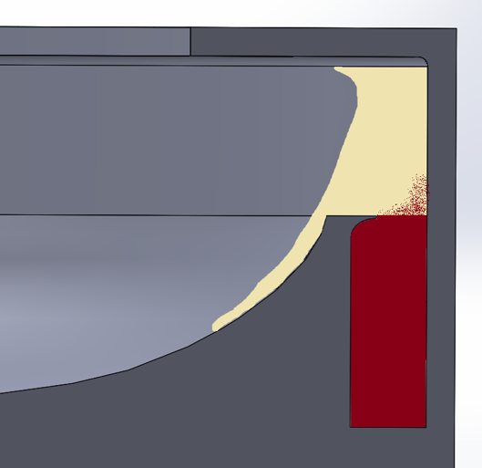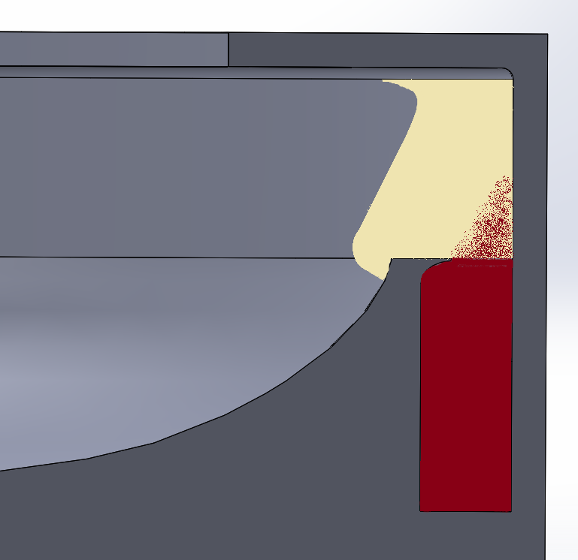

Capillary flow

Spontaneous capillary flow (SCF) is a phenomena exploited in microfluidics to induce liquid flow based on surface energy gradients (Berthier and Brakke 2012). It occurs when a liquid front moves down the length of an unfilled channel. The conditions for SCF are sufficiently narrow channel geometry and low interfacial energy between the liquid and the surface. We have observed that red cell entrainment occurs upon initial flowdown. Thus, we suspect downward-sloping capillary channels in our disk may prevent sudden red cell entrainment by giving the separated plasma a wetted surface to flow down smoothly. If capillary channels are cut into the disk, then red cell entrainment from sudden breakthrough should be reduced. This is part of my study.

Surface coatings

Polymer coatings present another method of controlling plasma flowdown. Polymers with high free electron density have similar energy density to water and are more wettable than aliphatic polymers because the interfacial energy between plasma and a polymer-coated surface is lower. This allows water to travel over a surface without requiring as much force to push it. Provided the polymer not absorb too much liquid, a hydrophilic surface would provide a low-energy flow path for the plasma. Low wetting resistance would have two potential benefits: (1) more consistent volumes of recovered plasma and (2) lower red cell contamination.

A confounding factor in surface coatings is the adsorption of plasma proteins onto the coating itself. As the disk begins to spin, blood flows briefly over the surface and leaves a film of protein-filled liquid that begins to dry as the disk continues to spin. Preliminary results show that a blood plasma-coated surface has a lower contact angle with water than with a clean plastic surface. Thus, plasma may mask the effects of polymer coatings. This is another aspect of my study.

### Operating parameters from a mathematical model

Optimal operating parameters can be predicted from a working model. This section describes the proposed system of conservation laws and equations for the convective flux of the suspended cells.

Stokes’ Law and corrections

The velocity of particles in a centrifugal field can be predicted using Stokes’ law (Equation 1). This law gives the drag force on a rigid sphere in creeping flow at infinite dilution (i.e. no interparticle interactions) as a function of fluid viscosity (), particle diameter (), and particle velocity () relative to the suspending fluid:

When balanced against the centrifugal body force, Stokes’ law predicts the particle’s terminal velocity, or “Stokes velocity”:

where is the particle velocity at infinite dilution, and are the particle and fluid density, respectively, is the distance between the particle and the axis of rotation, and is an empirical correction. Many equations have been developed that modify the Stokes velocity to account for nonideality in sedimentation. A scalar shape factor, , can be used to modify the Stokes velocity for non-rigid, non-spherical shapes (Alizadeh 2018 - manuscript). These shape factors describe dilute sedimentation satisfactorily (Ungarish 1993), but when a suspension concentration rises above 4 volume percent, the Stokes velocity overpredicts true sedimentation velocity. Further corrections have been made to account for higher particle concentration.

Hindered settling corrections (HSCs) consider how particle interactions in concentrated suspensions inhibit particle movement. These corrections further reduce the sedimentation velocity to some fraction of the Stokes velocity. Correlations exist for a broad range of particle sizes and flow regimes, but this present description will be based on HSCs applicable in creeping flow. These correlations all decrease the settling velocity to zero in the following limit: , where is the volumetric particle concentration. Some authors have derived analytical expressions for drag forces in arrays of suspended particles, but the assumptions in these calculations are difficult to apply to red blood cells, or erythrocytes (Sangani and Acrivos 1982). The most common HSCs range from empirical to semi-empirical for practical conditions.

The most common empirical HSC is by far the Richardson-Zaki (RZ) correlation. It is a simple power law and is given below:

Here, is a constant that varies with the Reynolds number (Richardson and Zaki 1954). For RBC centrifugation, this value varies between 2.5 and 3.5, but most commonly is reported as 2.71 (Barnea and Mizrahi 1973, Van Wie and Hustvedt 1988). This correlation is widely used for its simplicity and applicability, but it has a few problems. First, it predicts non-physical velocities at concentrations higher than the maximum particle packing. For instance, the maximum packing factor of rigid spheres is 0.65, but the RZ correlation predicts positive velocities until a particle volume fraction of 1, which is impossible for solid particles. As a result, many people use a piecewise form where the velocity is truncated to 0 at . Physically, this says that particles move at constant speed until they collide with the bed of stationary particles at the wall. For systems involving flexible particles, however, the sediment compresses with time and the interface may not be sharp between suspension and sediment. For concentrations well below the sediment concentration, however, the RZ correlation predicts sedimentation velocities accurately and is widely used.

Corrections that are valid over the entire domain of concentrations have also been developed. These tend to be more theoretical, though still quite empirical. For example, the Michaels correlation is an amendment to the RZ correlation that restricts the domain to (Michaels 1962). It is as follows:

where is a parameter describing particle deformability. This equation predicts a zero velocity at maximum packing. Whereas the (clipped) RZ correlation physically implies that particles collide with a sediment and stop instantaneously, forming a clear suspension-sediment interface, the Michaels correlation slowly decreases the velocity to zero and does not predict a sharp interface between suspension and sediment. This is valuable because reported maximum packing factors range from 0.8 (Lerche and Frömer 2001) to 0.97 (Chien, Dellenback et al. 1968) depending on the strength and duration of the centrifugal field. One group emphasized the slow compaction of the red cell sediment by combining the RZ and Michaels correlations in the following way:

Here, the Michaels correlation is used to simulate the viscosity of the red cell sediment. Lerche et al. showed that this form accurately modeled RBC sedimentation for a broad range of conditions.

HSCs for particle mixtures have also been developed and are necessary for our application. The Masliyah-Lockett-Bassoon (MLB) (Masliyah 1979)correlation is a generalized form of the RZ correlation. Another HSC describes the “apparent porosity,” or average interparticle spacing as a concentration-weighted sum of particle diameters. This will not be described here, but the reader is referred to the following sources: (Patwardhan and Tien 1985, Van Wie and Hustvedt 1988). These HSCs resemble their single-particle counterparts and behave qualitatively the same in terms of velocity correction.

Conservation laws

Theory for sedimentation processes was pioneered by Kynch in 1954, who described the convective flux of particles along an accelerating field as a function of local concentration. In conservation form, the hyperbolic system of PDEs describing blood sedimentation can be written as follows:

where is an array of volume fractions for each component (i.e. red cells, white cells, platelets, bacteria), including the plasma. This is a continuum approach that considers the cells as incompressible liquid phases. The function is referred to in the literature as the “batch Kynch flux function” (Bürger and Hvistendahl Karlsen 2001) and is equivalent to the product of volume fraction and velocity for any component. Expanding the array and flux function from the above equation yields the following:

where is the sedimentation velocity of the ith cell type and is the fluid velocity. The velocity will come from the HSCs, and the system will be solved using a second order Godunov scheme. In terms of solving the system, Basson et al. have described in depth a procedure for solving polydisperse sedimentation using HSCs for particle mixtures (Basson, Berres et al. 2009) that I will follow.

The purpose of a model is to predict operating parameters that maximize bacterial recovery and minimize red cell recovery. The two parameters I will target are spin conditions (time, velocity) and initial blood dilution. First, short spin times are desirable, but rapid deceleration creates shear, which mixes the RBCs back into the supernatant plasma. Second, sedimentation velocity is a strong function of local concentration, so diluting a blood sample with physiological saline may increase the sedimenting velocity of RBCs relative to bacteria, thus improving separation.

# Objectives: Improve disk design and optimize separation operation.

The first objective is to improve the amount and the purity of recovered plasma from a centrifugal spinning disk. The second objective is to create a mathematical model to simulate bacterial sedimentation in whole blood. Further, a third objective is to predict and then test operating parameters to maximize bacterial recovery.

Additional polymer coatings on the spinning disk may introduce greater flexibility in manufacturing. For example, our 3D printed disks can have a smooth surface known as “glossy”, and a rough surface, known as “matte”. The surface roughness is a byproduct of printing disks with overhanging material, which requires a soluble support resin. The support resin is removed before the disk is used, but it leaves a rough surface. Nearly all our 3D printed disks thus far have been printed with a rough surface known as “matte”, which has not given uniform plasma flowdown. Because of the possibility of producing roughness in manufacturing, we will test the effects of roughness and polymer coatings upon the uniformity of plasma drainage (flowdown) from the weir of the disk.

The mathematical model will use a hyperbolic conservation form that considers the cells as discrete liquid phases. Because I care about suspended cells only, I will not investigate the further sediment compaction that may occur in the cell pack. This is for two reasons. First, the spin time is short enough that these effects may be negligible. Second, modeling the sediment compaction requires parabolic integration schemes (Bürger and Hvistendahl Karlsen 2001), which are beyond the scope of this project. I will use functions and conditions that remain hyperbolic for simplicity. My main objective is to find optimal operating conditions for bacterial recovery in the plasma. To do this, I will focus my attention on testing the accuracy of various hindered settling functions. To validate this model, I will refer to the bacterial concentration recovery data collected by previous group members.

## Statement of work

1. Task 1: Mechanical changes
   1. Observe and estimate the effects of groove depth and angle on wettability by placing water/plasma on 1 in2 printed wafers with different ruffle shapes. Incline the wafer and measure the angle at which the liquid front starts to move (**Completed**)
   2. Print disk with the best combination of ruffle angle and depth and compare plasma and red cell recovery with disks having a smooth weir
2. Task 2: Surface characteristics of weir edge
   1. Measure contact angles of blood plasma on matte and glossy surfaces to determine the effect of plasma coatings on wettability (**Completed**)
   2. Repeat 1.a, replacing grooves with polyacrylic acid and polyethylene oxide (**Completed**)
   3. Coat matte and glossy disks with polymer and compare plasma recovery with uncoated disks.
   4. Combine ruffles and polymer coating to observe any interaction effect
3. Task 3: Develop model for 1D sedimentation
   1. Write code to examine quantitative and qualitative differences in the following HSCs and compare to experimental data
      1. K corrections to Stokes’ law using experimental data (Alizadeh 2018)
      2. Lerche flux function
      3. Sedimentation coefficients (Bar, Streichman et al. 1997)
      4. Richardson-Zaki correlation
      5. Porosity model (Patwardhan and Tien 1985)
4. Task 4: Predict and test optimal operating parameters
   1. Predict bacterial recovery using combinations of parameters and determine optimal parameters. Parameters will include initial concentration and spin conditions.
   2. Spin blood at those parameters and determine if there is an improvement in overall bacterial recovery.
5. Task 5: Write papers
   1. Write paper describing spontaneous capillary flow as a technique for inducing flow over open surfaces.
   2. Write paper comparing current model to previous models and describing the new model’s impact on centrifugal blood-bacteria separation

## Timeline

Please see the attached Gantt chart. The work is divided into experimental disk modifications and mathematical modeling. **Most disk modifications should be done by the end of August 2018,** when modeling begins. The modeling will start at the beginning of the school year, and finish in the middle of winter semester. Experimental work through the school year will focus on model validation.

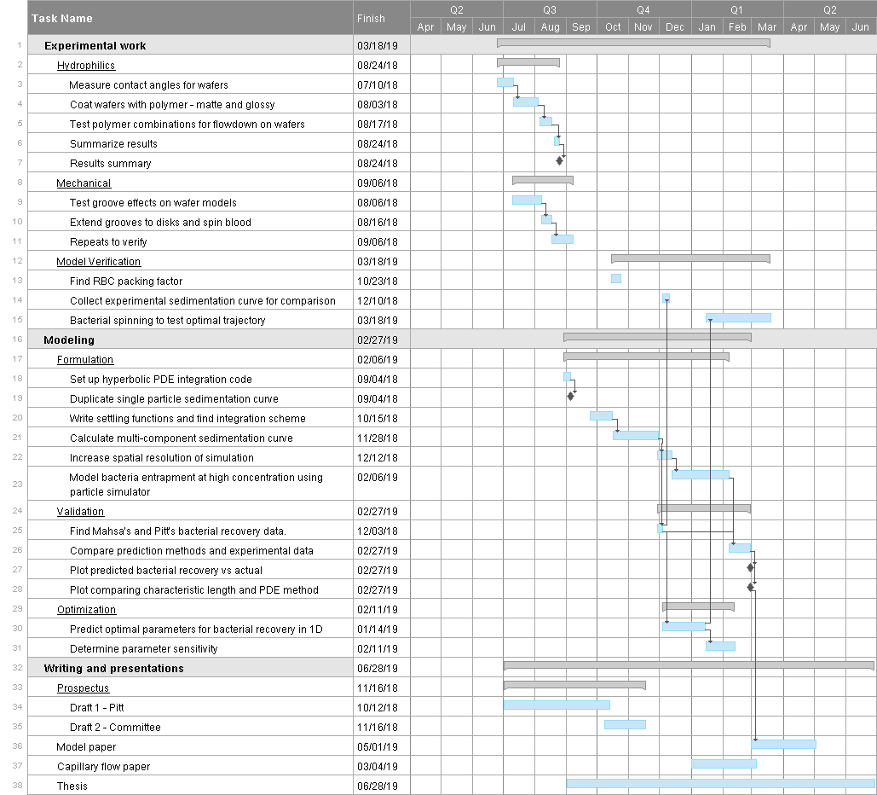

# References

Bar, S., S. Streichman and A. Marmur (1997). "The sedimentation coefficient of red blood cell suspensions as a measure of deformability: continuous monitoring of centrifugal sedimentation." Chemical Engineering Science **52**(6): 1059-1064.

Barnea, E. and J. Mizrahi (1973). "A generalized approach to the fluid dynamics of particulate systems: Part 1. General correlation for fluidization and sedimentation in solid multiparticle systems." The Chemical Engineering Journal **5**(2): 171-189.

Basson, D. K., S. Berres and R. Bürger (2009). "On models of polydisperse sedimentation with particle-size-specific hindered-settling factors." Applied Mathematical Modelling **33**(4): 1815-1835.

Berthier, J. and K. A. Brakke (2012). The physics of microdroplets, John Wiley & Sons.

Buchanan, C. M., R. L. Wood, T. R. Hoj, M. Alizadeh, C. G. Bledsoe, M. E. Wood, D. S. McClellan, R. Blanco, C. L. Hickey, T. V. Ravsten, G. A. Husseini, R. A. Robison and W. G. Pitt (2017). "Rapid separation of very low concentrations of bacteria from blood." J Microbiol Methods **139**: 48-53.

Buckman, S. A., I. R. Turnbull and J. E. Mazuski (2018). "Empiric Antibiotics for Sepsis." Surg Infect (Larchmt) **19**(2): 147-154.

Bürger, R. and K. Hvistendahl Karlsen (2001). "On some upwind difference schemes for the phenomenological sedimentation-consolidation model." Journal of Engineering Mathematics **41**(2): 145-166.

Chien, S., R. J. Dellenback, S. Usami, G. V. Seaman and M. I. Gregersen (1968). "Centrifugal packing of suspensions of erythrocytes hardened with acetaldehyde." Proceedings of the Society for Experimental Biology and Medicine **127**(4): 982-985.

Kumar, A., D. Roberts, K. E. Wood, B. Light, J. E. Parrillo, S. Sharma, R. Suppes, D. Feinstein, S. Zanotti, L. Taiberg, D. Gurka, A. Kumar and M. Cheang (2006). "Duration of hypotension before initiation of effective antimicrobial therapy is the critical determinant of survival in human septic shock." Crit Care Med **34**(6): 1589-1596.

Leibovici, L., M. Paul, O. Poznanski, M. Drucker, Z. Samra, H. Konigsberger and S. D. Pitlik (1997). "Monotherapy versus beta-lactam-aminoglycoside combination treatment for gram-negative bacteremia: a prospective, observational study." Antimicrob Agents Chemother **41**(5): 1127-1133.

Lerche, D. and D. Frömer (2001). "RBC aggregation and deformation." Biorheology **38**(2-3): 249-262.

Masliyah, J. H. (1979). "Hindered Settling in a Multi-Species Particles System." Chem. Eng. Sci. **34**: 1166-1168.

Michaels, A. S. B., Justin (1962). "Settling Rates and Sediment Volumes of Flocculated Kaolin Suspensions." I&EC Fundamentals.

Patwardhan, V. S. and C. Tien (1985). "Sedimentation and liquid fluidization of solid particles of different sizes and densities." Chemical Engineering Science **40**(7): 1051-1060.

Richardson, J. F. and W. N. Zaki (1954). "The sedimentation of a suspension of uniform spheres under conditions of viscous flow." Chemical Engineering Science **3**(2): 65-73.

Sangani, A. S. and A. Acrivos (1982). "Slow flow through a periodic array of spheres." International Journal of Multiphase Flow **8**(4): 343-360.

Schoenberg, M. H., M. Weiss and P. Radermacher (1998). "Outcome of patients with sepsis and septic shock after ICU treatment." Langenbecks Arch Surg **383**(1): 44-48.

Shankar-Hari, M., G. S. Phillips, M. L. Levy, C. W. Seymour, V. X. Liu, C. S. Deutschman, D. C. Angus, G. D. Rubenfeld and M. Singer (2016). "Developing a New Definition and Assessing New Clinical Criteria for Septic Shock: For the Third International Consensus Definitions for Sepsis and Septic Shock (Sepsis-3)." Jama **315**(8): 775-787.

Ungarish, M. (1993). Hydrodynamics of suspensions : fundamentals of centrifugal and gravity separation. Berlin ; New York, Springer-Verlag.

Van Wie, B. J. and E. L. Hustvedt (1988). "Particle interaction effects on blood cell sedimentation and separations." Biorheology **25**(4): 651-662.