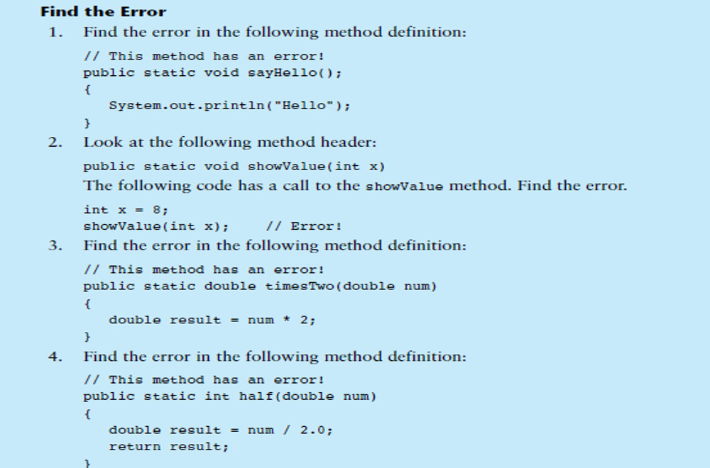

Solution

1. remove the semi-colon from the header. method headers are never terminated by semi-colons.
2. showValue(int x); cannot pass a data type with an argument
3. in the header if return type is specified there must be a return statement
4. int doesn’t match with double