經典 EMA 公式為：
其中
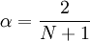

A modified moving average (MMA), running moving average (RMA), or smoothed moving average (SMMA) is defined as:
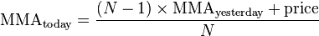
In short, this is an exponential moving average, with .
Mathematically:
- MACD = EMA(prices,fast) − EMA(prices,slow)
- signal = EMA(MACD,9)
- histogram = MACD − signal
where
EMA is exponential moving average;
prices are prices to which the indicator is applied (Open, High, Low or Close);
fast is the number of periods for fast EMA (typically 12);
slow is the number of periods for slow EMA (typically 26).

