Guide to SV DB via Docker Desktop
- Open Docker Desktop
- Search for sv_db using the top search bar, select hub images
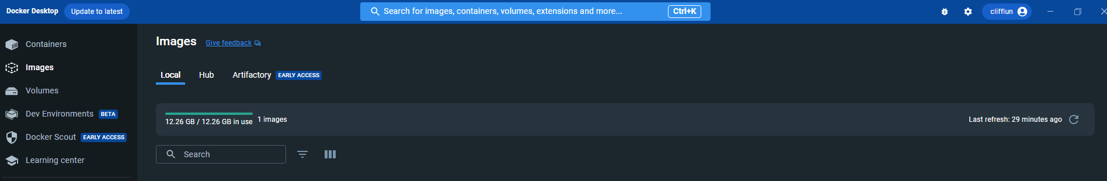
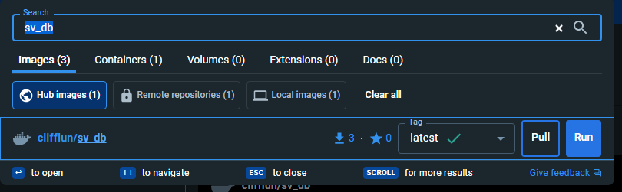
- Pull(download) the image from Docker Hub
- Run the image using these options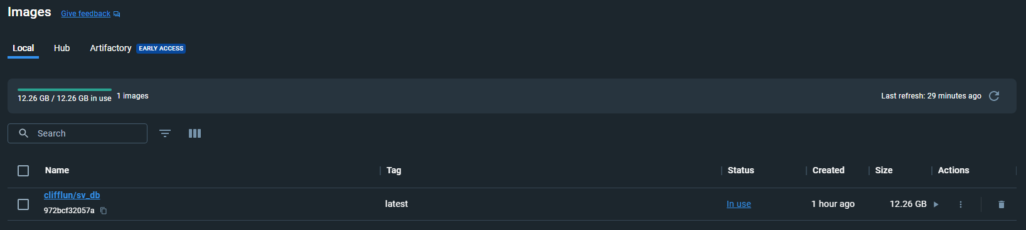
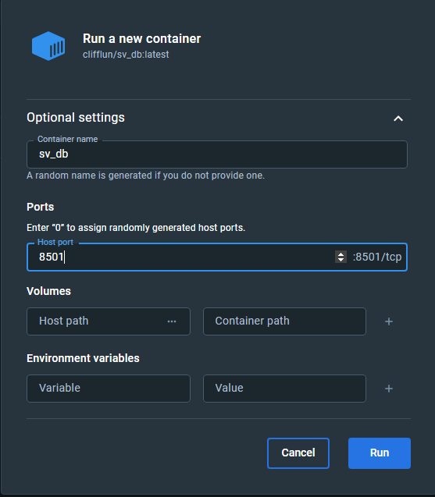
- There are a few ways to access the application
a.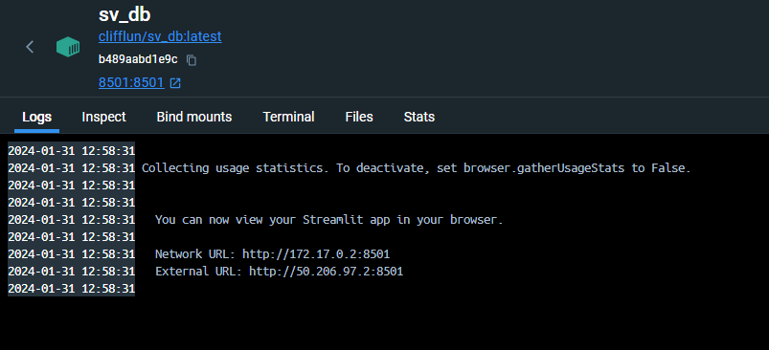
b.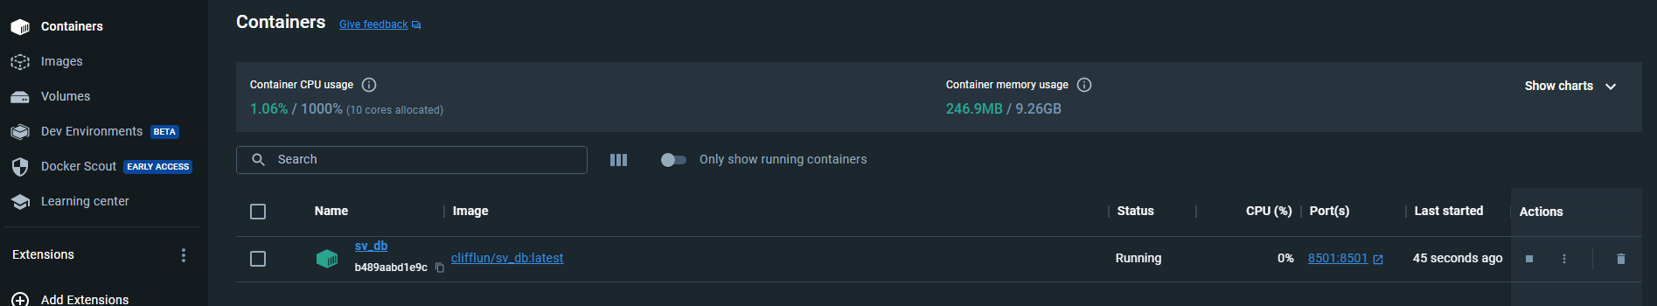
c.
Or simply type http://localhost:8501/ in your browser

- Do a test search, set cluster number to 1 (The first query will take a relatively long time, ~3-5 minutes. Subsequent queries will be much faster)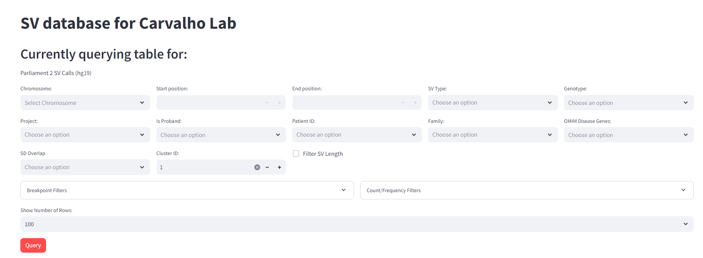
If you see this spinner, it is working

- Solve some cases!
- When you are done, it is preferable to stop the container.
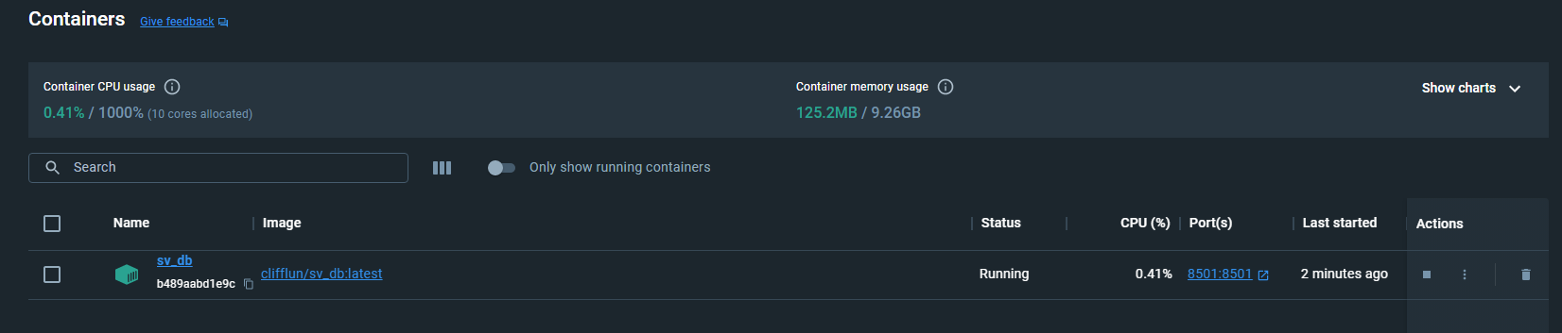
- Start the container again if you wish to query again
