Website requirements

I have a registered construction company that mainly deals with aluminum installation and fittings. The company has been present for the past five years.

It mostly does domestic installation of windows, doors and entry ways, shower cubicles, balcony railings, stair case railings and curtain walls

Commercially ,-office partitions (frameless, framed), curtain walls, doors, windows,

Header Will have

* Logo
* Navigation menu
* Phone number +254725921532
* Address

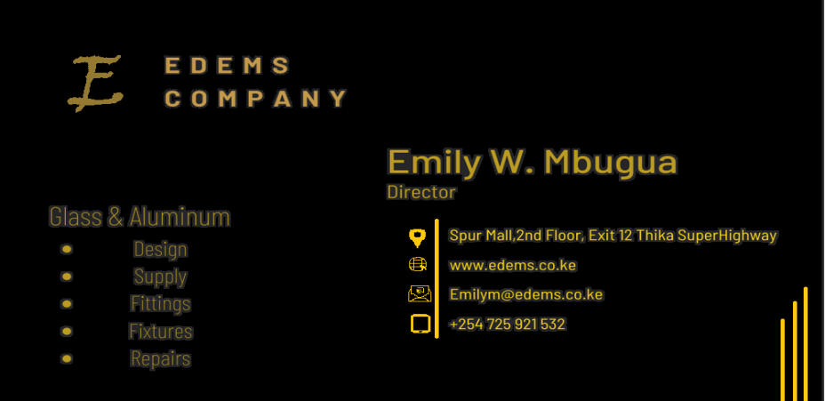

* Social media icons

About us page-

* Welcome visitors
* Help them realize they’re in the right place
* Immediately make it clear what you do

Preferably writings infront of a picture

Products and services- as on card and add some pics.

Projects- Lots of pics. Places weve worked. Tatucity, Hard Rock Estate, Zetu Furnitures, Croton Ridge Estate, Horeb Estate, South C, Ruaka

Contact us- as on pic