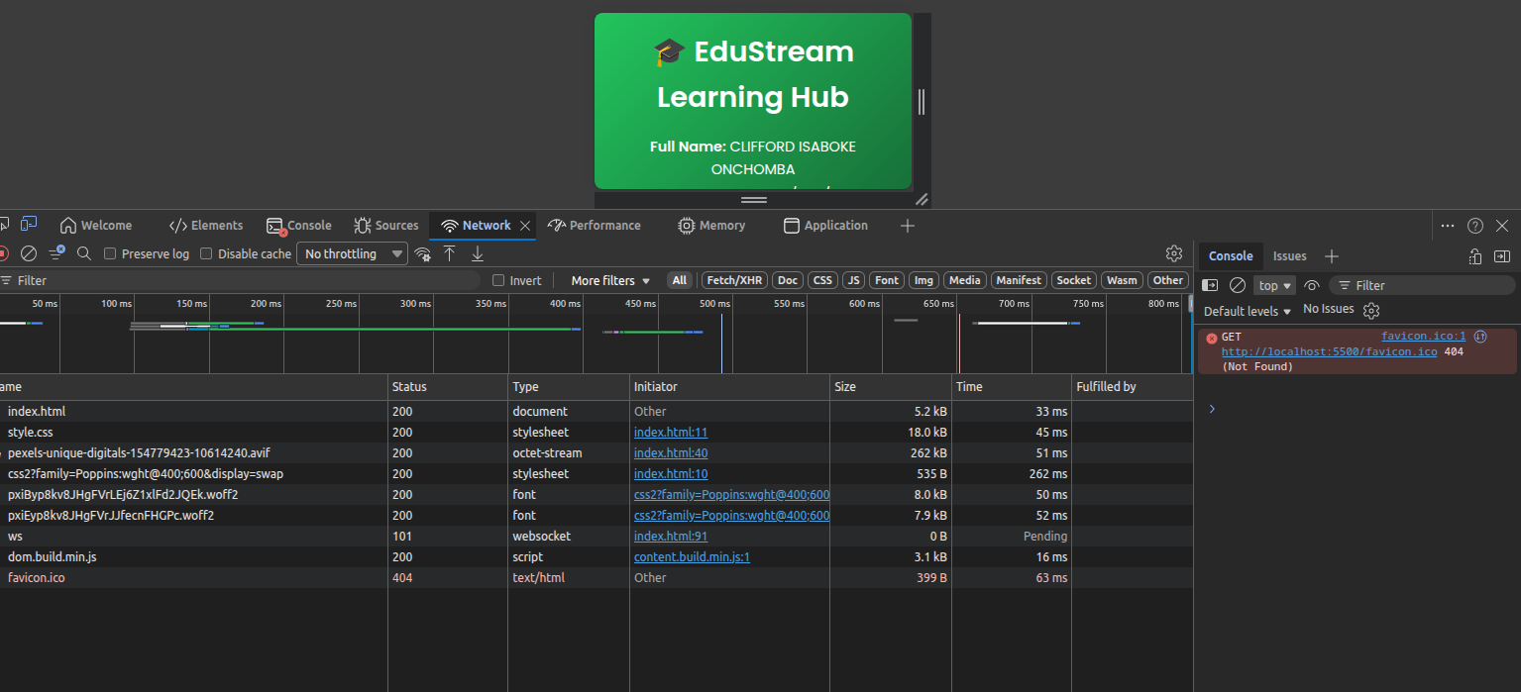
Asset audit table
Filename | Asset Type | MIME Type | File Size | Dimensions | Load Time (ms) | Format Justification
index.html | HTML document | text/html | 5.2 kB (5,200 bytes) | N/A | 33 ms | Required as the entry point of the multimedia application. Contains all media references and structure.
style.css | Stylesheet | text/css | 18.0 kB (18,000 bytes) | N/A | 45 ms | Controls the visual presentation, responsive grid layout, and colour‑coded badges for media cards.
pexels-unique-digitals-154779423-10614240.avif | Video (temporal media) | application/octet-stream (video/avi) | 262 kB (262,000 bytes) |  | 51 ms | Example of temporal media . The .avi container holds compressed video and possibly audio. Served as a single 200 response for this small demo file.

(a) Why the HTML document is always fetched before image assets
The HTML document is always the first resource requested because it is the entry point of a web page. When a browser navigates to a URL (e.g., http://localhost:5500/index.html), it performs an HTTP GET request for that exact resource. The server returns the HTML file, which the browser then parses. During parsing, the browser discovers dependent assets – such as <link> for CSS, <img> for images, <script> for JavaScript, and <video> for media. Only after reading the HTML does the browser know which images, fonts, or videos are required. This sequential dependency explains why the HTML request always appears first in the Network tab. Without the HTML, the browser would have no way of knowing what images to fetch. This behaviour is fundamental to how the web works and is consistent with the “progressive enhancement” model taught in Week 1 (INF 424 notes, p. 4–5).

(b) Difference between a static image request and a temporal video request (using Week 1 concepts)
According to Week 1 lectures, non‑temporal media (static) does not have a time dimension – it can be displayed at any moment and looks the same. An image (e.g., JPEG, PNG) is non‑temporal. In the Network tab, a static image request is a single, complete file download. Once the bytes arrive, the browser decodes the entire image once and renders it. No further requests are needed unless the image is lazy‑loaded or replaced.
A temporal media request, such as the .avi video file shown in the screenshot, has a time dimension. Its meaning unfolds over time. Video requests often differ in several ways:
- Partial / range requests – Browsers may request only a portion of the video initially (using Range headers) to start playback quickly, then fetch subsequent chunks.
- Streaming or progressive download – The video can be played while still downloading, unlike a static image which must be fully received before display (except for progressive JPEG).
- Ongoing network activity – A video may keep the connection open or issue multiple byte‑range requests as the user seeks forward. The Network tab may show a single long‑lasting request or several partial ones.

Purpose of EduStream
EduStream Learning Hub is a web‑based multimedia platform . It demonstrates the integration of text, images, audio, video, and animations using modern web standards and JavaScript APIs. The application serves as an interactive learning resource that showcases both temporal media (audio, video) and non‑temporal media (images, text), following the concepts taught in Weeks 1–10 of the course.

Pages Built and Multimedia Concepts
Page |  | Filename | Multimedia API / Concept | Week
Home |  | index.html | Responsive hero image with AVIF/WebP/PNG fallbacks | Week 2
Audio Lab |  | audio-player.html | HTML5 Audio API + Web Audio API (AnalyserNode visualiser) | Weeks 3, 6
Video Lab |  | video-player.html | HTML5 Video API with custom controls & keyboard shortcuts | Weeks 3, 5
Animations |  | animations.html | CSS keyframes, SVG animations, Lottie JSON animations | Week 3
Gallery |  | gallery.html | Component‑based architecture; renderMediaCard() pure function; event delegation; live filter | Week 7

Live Deployment
https://clifford130.github.io/inf424-multimedia-hub/index.html

Non-Temporal vs Temporal Media Analysis
According to the teaching notes
Non-temporal media - does not have a time dimension. You can display it at any moment and it looks the same.
Temporal media- has a time dimension – its presentation unfolds over time and depends on when it is displayed.
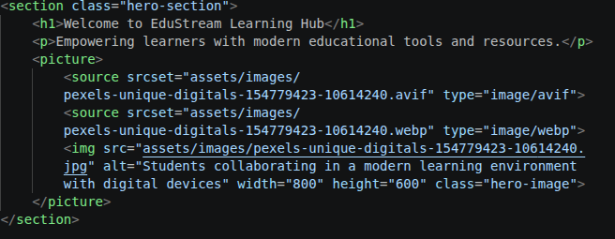

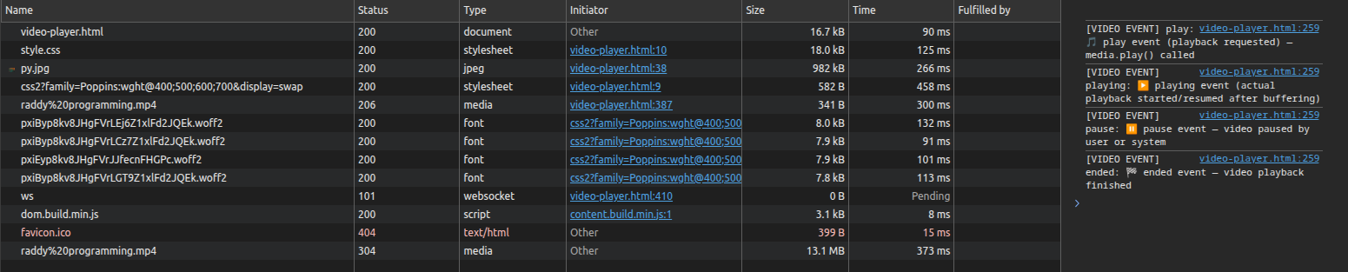

Why Temporal Media Requires More Complex Code Management
In my EduStream application, temporal media (video/audio) demands:

Event handling – Listening to play, pause, timeupdate, ended, seeking events to update UI (progress bar, time display).

Playback state management – Tracking whether media is playing, paused, or buffering.

Asynchronous loading – Using promises or callbacks to handle when media is ready (canplay event).

Seeking and buffering – Implementing custom sliders that respond to user input and update currentTime.

Real‑time visualisation – In the Audio Lab, the Web Audio API’s AnalyserNode constantly pulls frequency data (requestAnimationFrame loop) to draw a live waveform.

Non‑temporal images require none of these: simply set an <img src> and the browser displays it. No timeline, no events, no synchronisation.

Asset File | Format | Justification
pexels-unique-digitals-154779423-10614240  .avif | AVIF | Best compression – 50% smaller than JPEG. Supports HDR and wide colour gamut. Used as primary format in <picture> for modern browsers (Chrome, Firefox, Safari).
pexels-unique-digitals-154779423-10614240  .webp | WebP | Fallback for older modern browsers – 25–34% smaller than JPEG/PNG. Supports lossy/lossless and transparency. Served when AVIF is not supported.
pexels-unique-digitals-154779423-10614240  .png | JPG | Lossless & transparency – Used as final fallback. Ensures compatibility with very old browsers that don’t support WebP or AVIF. Larger file size but guaranteed display.

Event-Driven Programming Analysis
The video player in EduStream passes through a well‑defined sequence of states from page load to playback completion. When the page first loads, the loadstart event fires, indicating that the browser has begun loading the video. In response, the UI displays a loading spinner and disables the play button to prevent premature interaction. Once the browser has loaded the video’s metadata (duration, dimensions), the loadedmetadata event is triggered. At this point, the application sets the maximum value of the progress slider, displays the total duration, and enables the play button. When enough data has been buffered to begin playback, the canplay event fires, and the UI hides the spinner while making the play button fully active.
The video initially remains in a paused state, waiting for user action. When the user clicks the play button, the play event fires, transitioning the video to the playing state. The UI updates the button icon to “Pause” and begins updating the progress bar. During playback, the timeupdate event fires approximately four times per second; each time it updates the current time display and the slider position. If the user drags the progress slider, the seeking event fires, temporarily pausing progress updates and showing a “seeking…” message. When the user releases the slider, the seeked event fires, and the video’s currentTime is updated to the new position, resuming normal timeupdate events.
If the network connection slows and the video buffer runs out, the waiting event fires, entering the buffering state. The UI shows a buffering overlay and disables controls to prevent confusion. Once enough data has been refilled, the playing event fires again, the overlay is hidden, and controls are re‑enabled. When the user clicks the pause button, the pause event returns the video to the paused state, and the button icon changes back to “Play”. Finally, when the video reaches the end, the ended event fires, the button changes to “Replay”, the progress slider resets to zero, and a completion message is shown. If any fatal error occurs (e.g., unsupported format), the error event displays an appropriate error message and disables all controls. This event‑driven approach, described in Teaching Notes Week 6 (pages 21–22) and Lab Guide Week 3 (Step 4), ensures a responsive and robust user experience.

12. Web Audio API Architecture
The tone generator in the EduStream Audio Lab follows the standard SOURCE → PROCESSING → DESTINATION signal graph defined by the Web Audio API. At the source, an OscillatorNode generates a raw periodic waveform – such as sine, square, sawtooth, or triangle – at a specific frequency (for example, 261.63 Hz for middle C). This oscillator is connected to a GainNode, which acts as the processing stage. The gain node controls the volume (amplitude) of the audio signal, allowing it to be increased, decreased, or smoothly faded in and out. From the gain node, the signal finally reaches the AudioContext.destination, which represents the physical output device, typically the user’s speakers or headphones.
The GainNode plays a critical role beyond simple volume control. Without a gain node, any change in volume would be instantaneous, causing an abrupt discontinuity in the waveform. This discontinuity produces an audible “click” or pop sound because the speaker cone is forced to jump instantly from one position to another. To avoid this, the EduStream implementation uses gain ramping, specifically linearRampToValueAtTime. This method changes the gain value smoothly over a few milliseconds – for example, from 0 to 0.5 in 0.01 seconds at the start of a note, and back to 0 before stopping. If gain ramping were removed, every note would begin and end with a sharp click, making the synthesiser sound amateurish and unpleasant. As explained in Teaching Notes Week 5 (pages 19–20), proper envelope shaping using gain nodes is essential for professional audio synthesis.

Component Architecture Reflection
The renderMediaCard() function in gallery.html implements a pure component‑based approach to generating the media gallery. If the card layout needed to be changed – for instance, adding a “share” button or rearranging the thumbnail position – the component approach requires editing only one function in one file, affecting approximately five to ten lines of code. In contrast, a hardcoded HTML repetition would require locating and editing every individual card’s markup across all pages. With seventeen cards in the gallery, that could mean changing over one hundred lines spread across multiple files, which is error‑prone and difficult to maintain.
Event delegation further improves performance and code simplicity. Instead of attaching a separate click listener to each of the seventeen cards (or more, if cards are added dynamically), the gallery uses a single event listener on the parent container #galleryGrid. When a click occurs, e.target.closest('.media-card') identifies the relevant card, and the listener reads its data-id, data-title, and data-type attributes. This single‑listener pattern consumes less memory, works automatically for cards that appear after filtering (without needing to re‑attach listeners), and keeps the code clean. Without delegation, each new card would require manually adding a listener, leading to performance degradation and increased complexity.
The current component approach is conceptually identical to how modern frameworks like React or Vue.js work. In React, a component is a function that accepts props (data) and returns JSX (a representation of the UI). EduStream’s renderMediaCard(item) accepts a data object and returns an HTML string – the same fundamental idea. The next architectural step would be to adopt a real component library. For example, a React version of the media card would look like:
function MediaCard({ id, title, type, thumbnail }) { return <div className="media-card">...</div>; }
This would bring additional benefits such as a virtual DOM for efficient updates, built‑in state management, and a richer ecosystem of tools. However, the vanilla JavaScript component pattern already demonstrates the core principle of reusable, self‑contained UI units, which is the foundation of all modern component‑based architectures (Teaching Notes Week 7, pages 23–24).

