Radiated Immunity Test Report
Contents
1. Test lab facility 2
Test Site: 2
Facility name: 2
Facility address: 2
Facility site description: 2
Test Standards 2
EMC Directive 2014/30/EU 2
Test Equipment: 2
Environmental conditions: 2
Test Operator and Date: 2
2. Product Information 3
3. EUT setup 3
Photograph of EUT: 3
4. Test Result 3
5. Summary 3

Test lab facility

Test Site:
Facility name: Keysight Technology, Technology Order Fulfillment, Colorado Springs Hardware Test Center.
Facility address: 1900 Garden of the Gods Rd, Colorado Springs, CO. 80907
Facility site description:
The Keysight Technologies Technology Order Fulfillment Colorado Spring Hardware Test Center is a certified radiated interference testing facility, which is comply with the standard requirements defined by IEC 61326.

Test Standards

EMC Directive 2014/30/EU
IEC 61326-1:2012 / EN 61326-1:2013 (Basic)
Radiated Immunity Reference Standards:
IEC 61000-4-3:2016 Group 1 Class A.
The products were tested in a typical configuration with Keysight Technologies test systems. This product is intended for use in a basic electromagnetic environment.

Test Equipment:

Traceability
Power line Immunity Tester | Model:EMCPro, SN:102311, Calibration Exp.:8/22/2019
Misc. Information
Test Standard | IEC 61000-4-5 / EN 61000-4-5 Basic ETM 765.002
Test Standard | IEC 61000-4-6 / EN 61000-4-6 Basic ETM 765.002
Test Standard | IEC 61000-4-11 / EN 61000-4-11 Basic ETM 765.002
Test Site | Colorado Springs TOF Hardware Test Center
Test Voltage | 110V
Test Software Version | V1.5

Environmental conditions:

Temperature: 72°F; Humidity :50 RH
Note: There will be no effect to the result due to changes in mains voltage or frequency.

Test Operator and Date:

Operator: Clifford; Report generated at: Jun.21,2019 11:18:49 AM

Product Information
Product Name: | Myst LP2
Product Model: | MXR608A
Product SN: | LP2-19 SN 59140019
Project Stage: | LP2
Deliver date of the test samples: | 5/31/2019
DUT power: | 110V
Auxiliary equipment list: | N/A
Model numbers covered by the test: | MXR604A MXR 608A
.-Hardware Difference | N/A
.-Software/firmware difference: | N/a
.-Cosmetic difference: | NA
Test Configuration
Test Software Version | V1.5

EUT setup
Radiated Immunity Test Setup- Table-Top and Control Room

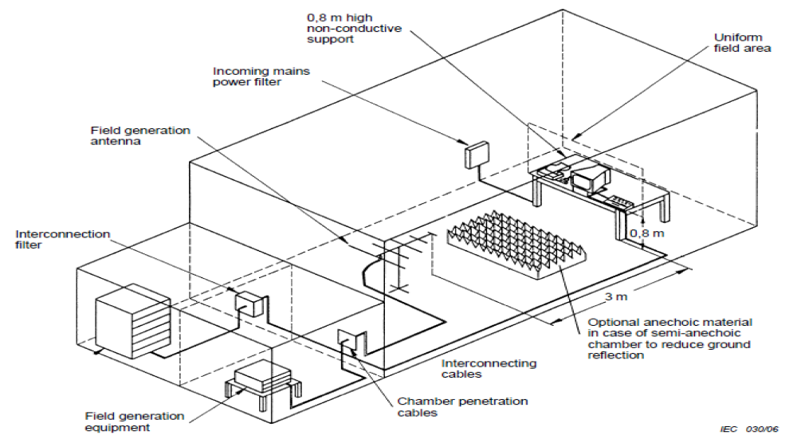

Photograph of EUT:
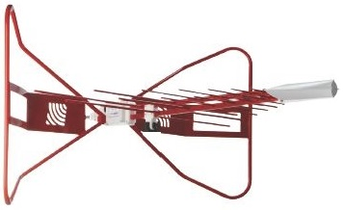
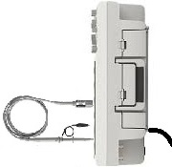

Test Result
Test Parameters:
Frequency 80 MHz - 6 GHz; 80% Amplitude Modulated at 1 KHz
Sweep Rate 2.5 Seconds dwell per 1% step, 1.73E-03 Decades per Second
Filed Strength 3 v/m
Polarity Horizontal and Vertical
Rotation Front (0°) Left (90° ) Rear (180°) and Right (270°)

================================================================================
KeyTek CEWare Compliance Tester Log Report 15 February 2019
================================================================================
REMOTE/TESTER RUN
Versions: SW v3.00 FW v6.06 Str v6.00 EMCPro S/N
Operator: Clifford Hu
Sequence File: DVD-61000-4-5-11_newstandard 2KV.SEQ
EUT: Coyote New Line Filter
================================================================================
--------------------------------------------------------------------------------
DSOX4104A MY57190468
--------------------------------------------------------------------------------
11:36:42A SEQUENCE START
SEQUENCE TYPE SEQUENCE DESCRIPTION
EFT User Defined 1000-4-4 (EFT To Power Lines)
Frequency Voltage Output:LC Duration
11:36:42A 5.0 kHz -2000V MAINS:L1 60 sec.
11:37:52A 5.0 kHz 2000V MAINS:L1 60 sec.
11:39:02A 5.0 kHz -2000V MAINS:L2 60 sec.
11:40:12A 5.0 kHz 2000V MAINS:L2 60 sec.
11:41:22A 5.0 kHz -2000V MAINS:PE 60 sec.
11:42:32A 5.0 kHz 2000V MAINS:PE 60 sec.
SEQUENCE TYPE SEQUENCE DESCRIPTION
EFT Standard Class1
Frequency Voltage Output:LC Duration
11:43:41A 5.0 kHz -500V CLAMP 60 sec.
11:44:49A 5.0 kHz 500V CLAMP 60 sec.
SEQUENCE TYPE SEQUENCE DESCRIPTION
Srg 1.2/50 User Defined EN 61000-4-5 (Surge 1.2/50 us)
Waveform Voltage Output:LC Phs Ref Phs Ang Tests Delay
11:45:53A 12 Ohm -2000V MAINS:L1/PE L1 0 deg. 5 60 sec.
11:51:15A 12 Ohm -2000V MAINS:L1/PE L1 90 deg. 5 60 sec.
11:56:37A 12 Ohm -2000V MAINS:L1/PE L1 270 deg. 5 60 sec.
12:01:59P 12 Ohm 2000V MAINS:L1/PE L1 0 deg. 5 60 sec.
12:07:22P 12 Ohm 2000V MAINS:L1/PE L1 90 deg. 5 60 sec.
12:12:44P 12 Ohm 2000V MAINS:L1/PE L1 270 deg. 5 60 sec.
12:18:07P 12 Ohm -2000V MAINS:L2/PE L1 0 deg. 5 60 sec.
12:23:29P 12 Ohm -2000V MAINS:L2/PE L1 90 deg. 5 60 sec.
12:28:52P 12 Ohm -2000V MAINS:L2/PE L1 270 deg. 5 60 sec.
12:34:14P 12 Ohm 2000V MAINS:L2/PE L1 0 deg. 5 60 sec.
12:39:37P 12 Ohm 2000V MAINS:L2/PE L1 90 deg. 5 60 sec.
12:44:59P 12 Ohm 2000V MAINS:L2/PE L1 270 deg. 5 60 sec.
12:50:22P 2 Ohm -1000V MAINS:L1/L2 L1 0 deg. 5 60 sec.
12:55:44P 2 Ohm -1000V MAINS:L1/L2 L1 90 deg. 5 60 sec.
01:01:07P 2 Ohm -1000V MAINS:L1/L2 L1 270 deg. 5 60 sec.
01:06:29P 2 Ohm 1000V MAINS:L1/L2 L1 0 deg. 5 60 sec.
01:11:51P 2 Ohm 1000V MAINS:L1/L2 L1 90 deg. 5 60 sec.
01:17:14P 2 Ohm 1000V MAINS:L1/L2 L1 270 deg. 5 60 sec.
01:22:37P SEQUENCE COMPLETE
[1]
================================================================================
KeyTek CEWare Compliance Tester Log Report 20 February 2019
================================================================================
REMOTE/TESTER RUN
Versions: SW v3.00 FW v6.06 Str v6.00 EMCPro S/N NA
Operator: Clifford Hu
Sequence File: QFP-61000-11_newstandard.SEQ
EUT:
================================================================================
09:26:11A SEQUENCE START
SEQUENCE TYPE SEQUENCE DESCRIPTION
PQF User Defined PQF61000-4-11
Test Level Phs Ang Dur. Value Duration Tests Delay
09:26:11A 0% Open 0 deg. 0.50 cyc 3 10 sec.
09:26:47A 0% Open 180 deg. 0.50 cyc 3 10 sec.
09:27:22A 0% Open 0 deg. 1.00 cyc 3 10 sec.
09:27:57A 0% Open 180 deg. 1.00 cyc 3 10 sec.
09:28:33A 70% Dip 0 deg. 25.00 cyc 3 10 sec.
09:29:09A 70% Dip 180 deg. 25.00 cyc 3 10 sec.
09:29:45A 0% Short 0 deg. 250.00 cyc 3 10 sec.
09:30:33A 0% Short 180 deg. 250.00 cyc 3 10 sec.
09:31:20A SEQUENCE COMPLETE
--------------------------------------------------------------------------------
Passed
--------------------------------------------------------------------------------
[1]

Criteria: |  | A. Pass - Normal performance within specified limits.
 |  | B. Pass - Temporary degradation, self recoverable.
 |  | C. Pass - Temporary degradation, requires operator intervention.
 |  | D. Fail - Not recoverable, component damage.

Field Uniformity Calibration Data
Field Uniformity Exceptions: (>6dB)
 | Horizontal Axis | 2107.0 MHz | 8.80 dB
 | Horizontal Axis | 5040.0 MHz | 7.13 dB
 | Horizontal Axis | 5499.0 MHz | 6.37 dB
 | Vertical Axis | None | N/A

Summary

The unit failed the Radiated Immunity Test!

