Conducted Immunity Test Report
Contents
1. Test lab facility 2
Test Site: 2
Facility name: 2
Facility address: 2
Facility site description: 2
Test Standards 2
EMC Directive 2014/30/EU 2
Test Equipment: 2
Environmental conditions: 2
Test Operator and Date: 2
2. Product Information 2
3. EUT setup 3
Photograph of EUT: 3
4. Test Result 3
5. Summary 3

1. Test lab facilityClick or tap here to enter text.

Test Site:
Facility name: Keysight Technology, Technology Order Fulfillment, Colorado Springs Hardware Test Center.
Facility address: 1900 Garden of the Gods Rd, Colorado Springs, CO. 80907
Facility site description:
The Keysight Technologies Technology Order Fulfillment Colorado Spring Hardware Test Center is a certified radiated interference testing facility, which is comply with the standard requirements defined by IEC 61326.

Test Standards

EMC Directive 2014/30/EU
IEC 61326-1:2012 / EN 61326-1:2013 (Basic) Radiated Emission Reference Standards:
CISPR 11:2009+A1:2010 / EN 55011:2009+A1:2010 Group 1 Class A. The products were tested in a typical configuration with Keysight Technologies test systems. This product is intended for use in a basic electromagnetic environment.

Test Equipment:

Click here to enter text.

Environmental conditions:

Click here to enter text.
Note: There will be no effect to the result due to changes in mains voltage or frequency.

Test Operator and Date:

Click here to enter text.

2. Product Information Click or tap here to enter text.
Click here to enter text.

3. EUT setup Click or tap here to enter text.

Test System Schematic Diagram injection to power line
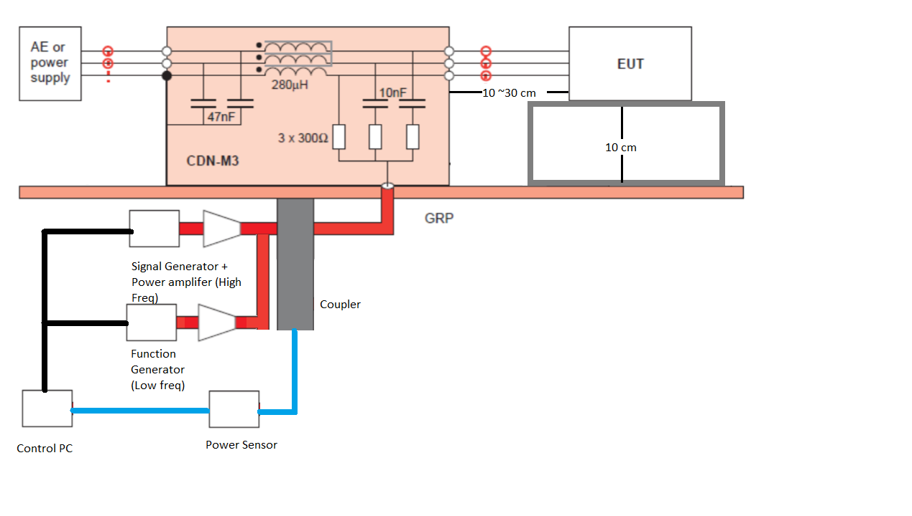

Test System Schematic Diagram injection to signal line

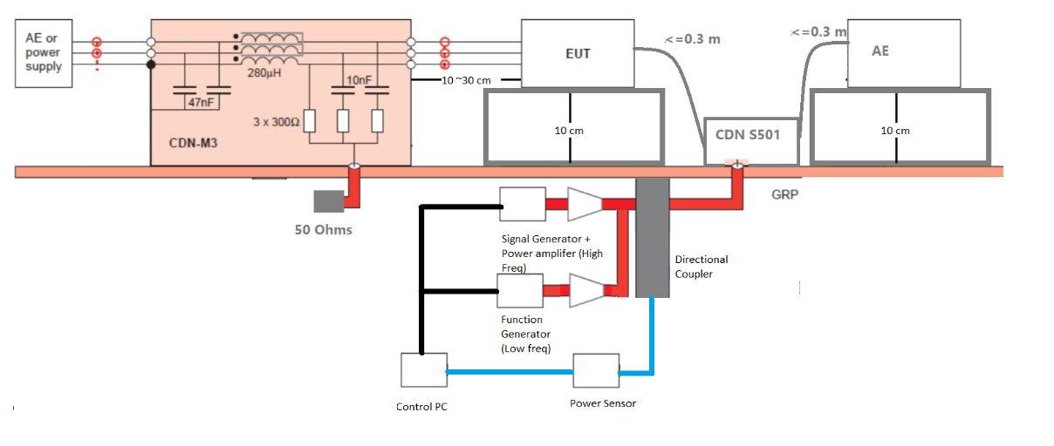

Test Procedure
The frequency range is wept from 150kHz to 80 MHz, using the signal levels established during the calibration process and with the disturbance signal 80% AM with 1 MHz sign wave. The actual output power is monitored by a power sensor connected from a directional coupler. Pausing to adjust the RF signal level as needed during the test to enable the actual injected disturbance noise level is no less than the calibrated power request. The frequency is swept incrementally, the step size doesn’t exceed 1% of the preceding frequency value. The dwell time of the amplitude modulated carrier at teach frequency is not less than 0.5 second and not less than the time necessary for the EUT to be exercised and to respond. The sensitive frequencies like clock frequencies shall be analyzed separately. The noise is injected to the power line using a CDN. The DUT should be placed 10 cm above the ground plane and the power line should be short like 10cm to 30cm above the ground plane. The DUT is monitored during the frequency sweeping, if any abnormal operations are found, they should be logged and tagged at the frequency with performance level A, B, C and D. where
A. Pass - Normal performance within specified limits.
B. Pass - Temporary degradation, self recoverable.
C. Pass - Temporary degradation, requires operator intervention.
D. Fail - Not recoverable, component damage.

Photograph of EUT:
Click here to enter text.
Click here to enter text.
Click here to enter text.
Click here to enter text.
Click here to enter text.

4. Test Result Click or tap here to enter text.
Click here to enter text.

Click here to enter text.
Click here to enter text.
Click here to enter text.
Click here to enter text.
Click here to enter text.

5. Summary Click or tap here to enter text.

Click here to enter text.
Click here to enter text.

