Electrical Fast Transient/Burst immunity, Surge immunity and Voltage Dips/Drops/Interrupts Immunity Test Report
Contents
1. Test lab facility 2
Test Site: 2
Facility name: 2
Facility address: 2
Facility site description: 2
Test Standards 2
EMC Directive 2014/30/EU 2
Test Equipment: 2
Environmental conditions: 2
Test Operator and Date: 2
2. Product Information 3
3. EUT setup 3
Test procedure 3
-EFT Immunity test: 3
-Surge Immunity test: 3
-Voltage Dips/drops/interrupts Immunity test: 3
Photograph of EUT: 3
4. Test Result 3
5. Summary 3

1. Test lab facility Click or tap here to enter text.

Test Site:
Facility name: Keysight Technology, Technology Order Fulfillment, Colorado Springs Hardware Test Center.
Facility address: 1900 Garden of the Gods Rd, Colorado Springs, CO. 80907
Facility site description:
The Keysight Technologies Technology Order Fulfillment Colorado Spring Hardware Test Center is a certified radiated interference testing facility, which is comply with the standard requirements defined by IEC 61326.

Test Standards

EMC Directive 2014/30/EU
IEC 61326-1:2012 / EN 61326-1:2013 (Basic)
Electrical Fast Transient/Burst Immunity Reference Standards: IEC 61000-4-4: Group 1 Class A.
Surge Immunity Reference Standards: IEC61000-4-5
Powerline quality test standards: IEC61000-6-11
The products were tested in a typical configuration with Keysight Technologies test systems. This product is intended for use in a basic electromagnetic environment.

Test Equipment:

Click here to enter text.

Environmental conditions:

Click here to enter text.
Note: There will be no effect to the result due to changes in mains voltage or frequency.

Test Operator and Date:

Click here to enter text.

2. Product Information Click or tap here to enter text.
Click here to enter text.

3. EUT setup Click or tap here to enter text.
Block diagram of the setup for Electrical fast transient/burst immunity and surge immunity test. Note: PE N and L all three lines simultaneously were supplied with burst pulses.

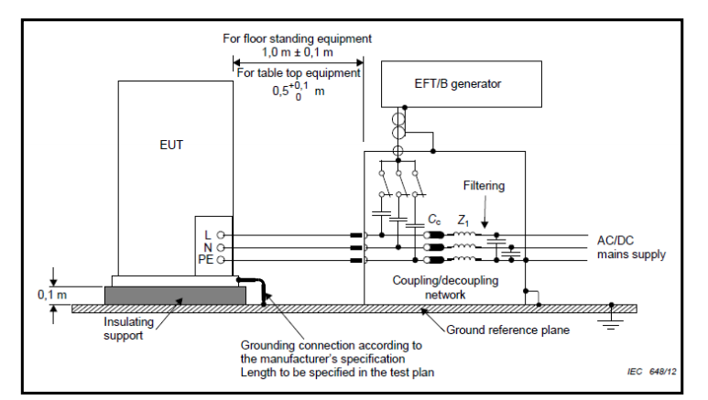
Block diagram of the setup for coupling on I/O lines with capacitive coupling clamp (if applicable )
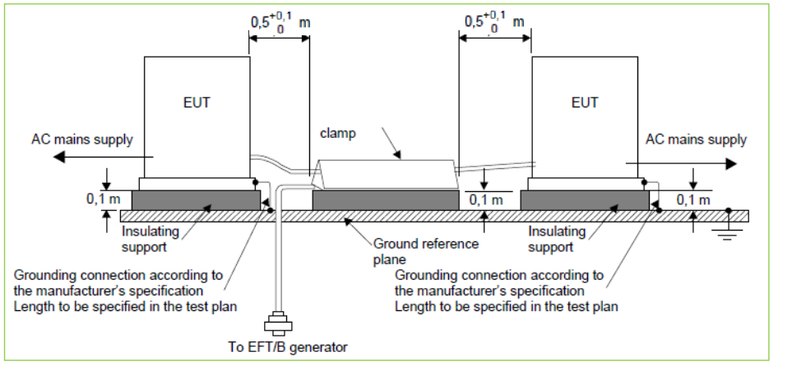
Block diagram of the setup for voltage dips/drops/interrupts immunity test

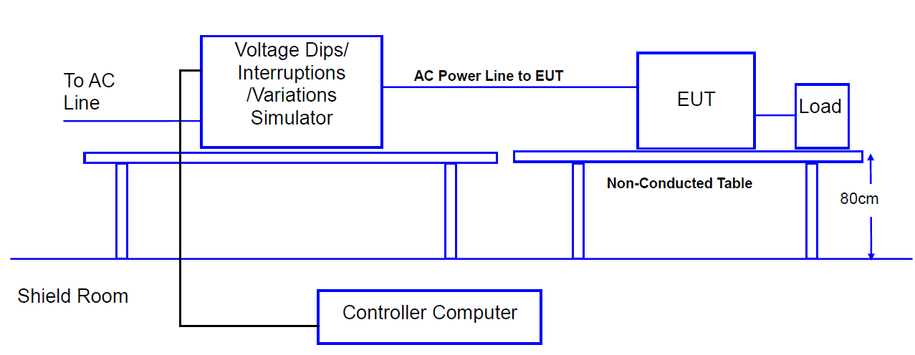

Test procedure

-EFT Immunity test:
The EUT and its load were placed 10 cm above the ground reference plane. The EFT/Burst generator is placed on the GRP plane. The EUT is connected to the power mains through a coupling/decoupling network that directly injected the transient energy. Bursts of pulse trains at up to 2KV at 5KHz was applied to Line, Neutral and PE simultaneously against ground reference with 1-minute resting time. The EUT was monitored for any degradation of performance. The burst of pulse is defined below.
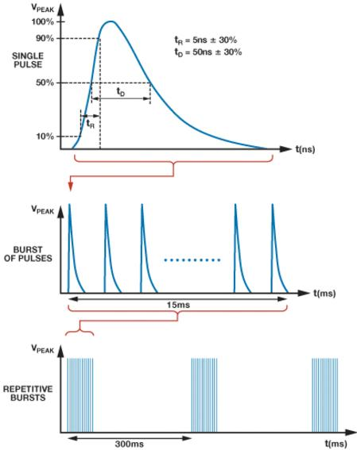
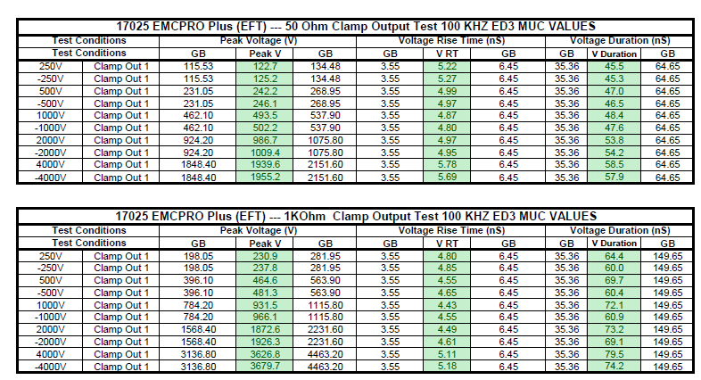
Measured EFT burst Waveform data.

-Surge Immunity test:
A combination wave as specified in IEC 61000-4-5 was applied to the EUT. The surge pulses were applied onto the power line, in both positive and negative polarities. The test level was up to 2KV. The pulses were applied to Line- Neutral, Line-PE, Neutual-PE with one minute resting time at 0,90,180,270 degree phase angel. The EUT was monitored for any degradation of performance. The 1.2/50 µs waveform of surge pulse is shown below.

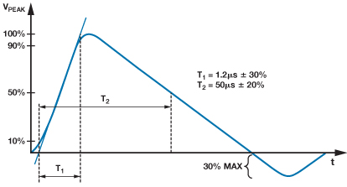
Captured waveform
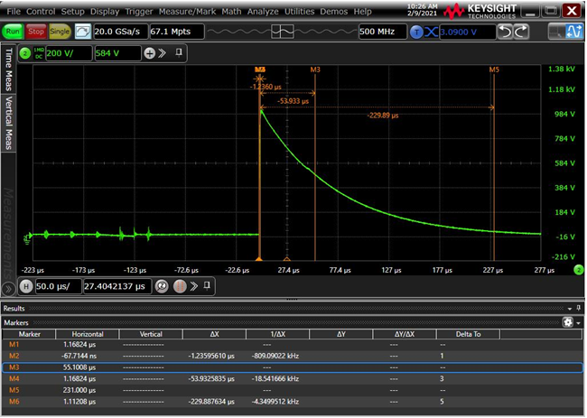

-Voltage Dips/drops/interrupts Immunity test:
The EUT was connected to the power mains through a coupling device that directly couples to the voltage dips and interruption generator. The voltage dip of 100% half cycle, 100% dip full cycle and 30% dip 25 cycles were applied and interruption of 100% for 5000ms was applied to the EUT three times with 60 second resting time between intervals.

Photograph of EUT:
Click here to enter text.
Click here to enter text.
Click here to enter text.
Click here to enter text.
Click here to enter text.

4. Test Result Click or tap here to enter text.

Click here to enter text.

Criteria: |  | A. Pass - Normal performance within specified limits.
 |  | B. Pass - Temporary degradation, self recoverable.
 |  | C. Pass - Temporary degradation, requires operator intervention.
 |  | D. Fail - Not recoverable, component damage.

5. Summary Click or tap here to enter text.
Click here to enter text.
Click here to enter text.

