ESD Immunity Test Report
Contents
1. Test lab facility 2
Test Site: 2
Facility name: 2
Facility address: 2
Facility site description: 2
Test Standards 2
EMC Directive 2014/30/EU 2
Test Equipment: 2
Environmental conditions: 2
Test Operator and Date: 2
2. Product Information 2
3. EUT setup 3
Block diagram of test setup for ESD: 3
Test Procedure: 3
Photograph of EUT: 3
4. Test Result 3
5. Summary 3

1. Test lab facilityClick or tap here to enter text.

Test Site:
Facility name: Keysight Technology, Technology Order Fulfillment, Colorado Springs Hardware Test Center.
Facility address: 1900 Garden of the Gods Rd, Colorado Springs, CO. 80907
Facility site description:
The Keysight Technologies Technology Order Fulfillment Colorado Spring Hardware Test Center is a certified radiated interference testing facility, which complies with the standard requirements defined by IEC 61326.

Test Standards

EMC Directive 2014/30/EU
IEC 61326-1:2012 / EN 61326-1:2013 (Basic) Radiated Emission Reference Standards:
ESD IEC 61000-4-2, ETM 765.002 Group 1 Class A. The products were tested in a typical configuration with Keysight Technologies test systems. This product is intended for use in a basic electromagnetic environment.

Test Equipment:

Click here to enter text.

Environmental conditions:

Click here to enter text.
Note: There will be no effect to the result due to changes in mains voltage or frequency.

Test Operator and Date:

Click here to enter text.

2. Product Information Click or tap here to enter text.
Click here to enter text.

3. EUT setup Click or tap here to enter text.

Block diagram of test setup for ESD:
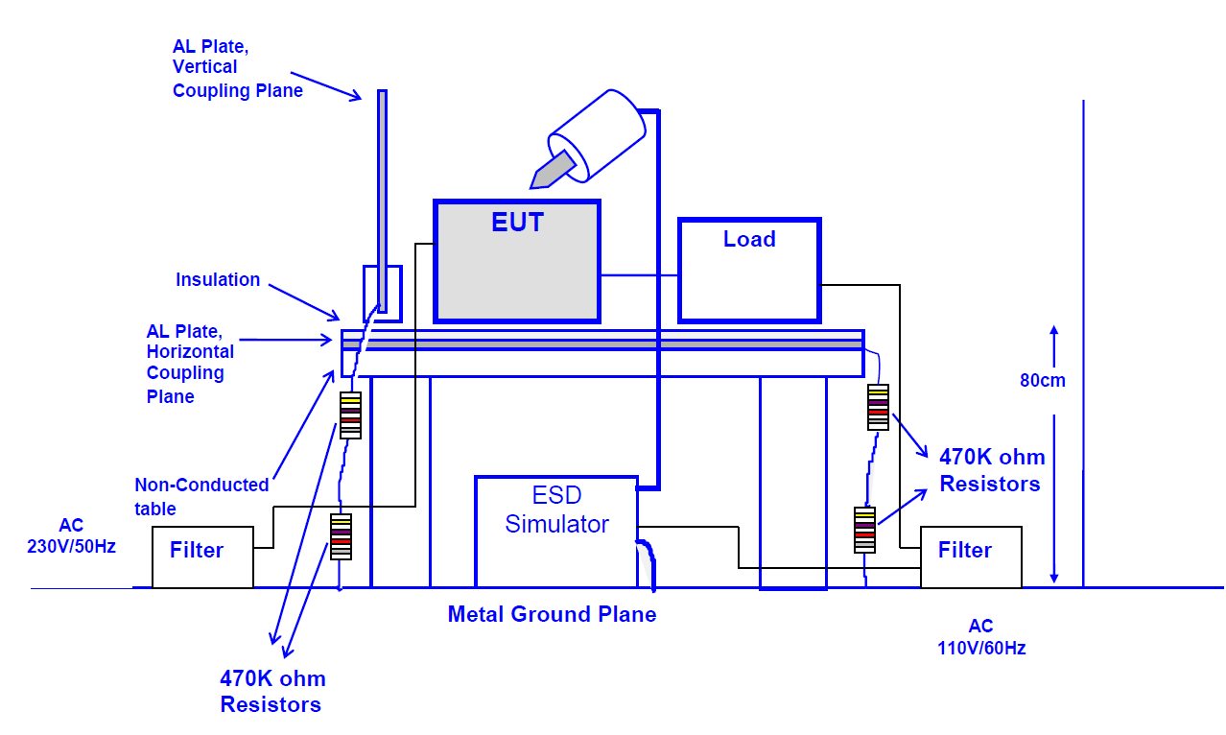

Test Procedure:
-Air Discharge: The test was performed on non-conductive surfaces on according with IEC 61000-4-2. Single discharge at >1 second interval. At least 10 positive and 10 negative discharges. Air discharges to surfaces of the EDUT.
-Contact Discharge: Single discharge at >1 second interval. At least 25 positive and 25 negative discharge.
-HCP Discharge: ESD was applied to the earth reference plane on each accessible side of the EUT.
-VCP Discharge: Vertical coupling plane was positioned at the distance of 0.1m from the EUT. ESD was applied to each side of the EUT.

Photograph of EUT:
Click here to enter text.
Click here to enter text.
Click here to enter text.
Click here to enter text.
Click here to enter text.

4. Test Result Click or tap here to enter text.
Contact: 10 single contact discharges (+/-) to select points and to vertical and horizontal coupling plane (4 faces). Contact discharges are not applied to insulated areas. | PC= Performance code:  A= Normal, within specific limits  B= Temporary degradation, self recoverable.  C=Temporary degradation requiring operator intervention.  D= Not recoverable ND=No Discharge

Click here to enter text.

Click here to enter text.
Click here to enter text.
Click here to enter text.
Click here to enter text.
Click here to enter text.

5. Summary Click or tap here to enter text.

Click here to enter text.
Click here to enter text.

