Radiated Emission Test Report
Contents
1. Test lab facilityClick or tap here to enter text. 2
Test Site: 2
Facility name: 2
Facility address: 2
Facility site description: 2
Test Standards 2
EMC Directive 2014/30/EU 2
Test Equipment: 2
Environmental conditions: 2
Test Operator and Date: 2
2. Product Information Click or tap here to enter text. 3
3. EUT setup Click or tap here to enter text. 3
Block diagram of test setup for radiated emission: 3
Photograph of EUT: 3
4. Measurement Results Click or tap here to enter text. 3
5. Summary Click or tap here to enter text. 3

1. Test lab facilityClick or tap here to enter text.

Test Site:
Facility name: Keysight Technology, Technology Order Fulfillment, Colorado Springs Hardware Test Center.
Facility address: 1900 Garden of the Gods Rd, Colorado Springs, CO. 80907
Facility site description:
3 Meter Semi-anechoic chamber for pre-compliance test and 10 Meter OATS chamber for compliance test.
Note: The radiated RF disturbance measurements were first performed on an alternate test site of a semi–anechoic chamber at a 3 m distance for pre-scan and signal selection, then the selected signals are tested at the distance of 10 m using antenna with 4 meter height in OATS chamber for compliance test.

Test Standards:

EMC Directive 2014/30/EU
IEC 61326-1:2012 / EN 61326-1:2013 (Basic) Radiated Emission Reference Standards:
CISPR 11:2009+A1:2010 / EN 55011:2009+A1:2010 Group 1 Class A. The products were tested in a typical configuration with Keysight Technologies test systems. This product is intended for use in a basic electromagnetic environment.

Test Equipment:

Click here to enter text.

Environmental conditions:

Click here to enter text.
Note: There will be no effect to the result due to changes in mains voltage or frequency.

Test Operator and Date:

Click here to enter text.

2. Product Information Click or tap here to enter text.
Click here to enter text.

3. EUT setup Click or tap here to enter text.

Block diagram of test setup for radiated emission:
The measurement antenna was mounted to a non-conductive mast capable of moving the antenna vertically. EUT was rotated from 0 degree to 360 degree. Antenna scans from 1 meter to 2.5 meter* in 3 meter chamber and 1 meter to 4 meter in OATS. Both horizontal and vertical polarization were tested. Ground is covered by conducted copper mesh so that the maximum emission was captured.

*Note: The use of 1 to 2.5 meter scan height on a 3-meter site was investigated and found to be in compliance with the intent of the CISPR 11, CISPR 16, and ANSI C63.4 standards. For compliance test, it is recommended to test using 4 meter antenna height.

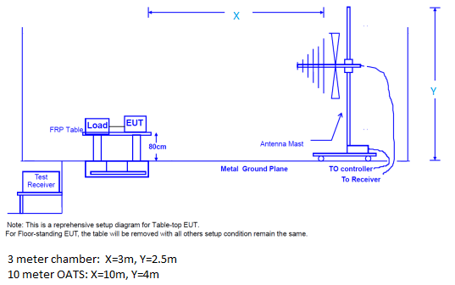

Photograph of EUT:
Click here to enter text.
Click here to enter text.
Click here to enter text.
Click here to enter text.
Click here to enter text.

4. Measurement Results Click or tap here to enter text.

Click here to enter text.

Click here to enter text.
Click here to enter text.
Click here to enter text.
Click here to enter text.
Click here to enter text.

5. Summary Click or tap here to enter text.

Click here to enter text.
Click here to enter text.

