Radiated Immunity Test Report
Contents
1. Test lab facility 2
Test Site: 2
Facility name: 2
Facility address: 2
Facility site description: 2
Test Standards 2
EMC Directive 2014/30/EU 2
Test Equipment: 2
Environmental conditions: 2
Test Operator and Date: 2
2. Product Information 3
3. EUT setup 3
Radiated Immunity Test Setup- Table-Top and Control Room 3
Block diagram of the setup for Radiated Immunity: 3
Test procedure: 3
Photograph of EUT: 3
4. Test Result 3
5. Summary 3

1. Test lab facilityClick or tap here to enter text.

Test Site:
Facility name: Keysight Technology, Technology Order Fulfillment, Colorado Springs Hardware Test Center.
Facility address: 1900 Garden of the Gods Rd, Colorado Springs, CO. 80907
Facility site description:
The Keysight Technologies Technology Order Fulfillment Colorado Spring Hardware Test Center is a certified radiated interference testing facility, which is comply with the standard requirements defined by IEC 61326.

Test Standards

EMC Directive 2014/30/EU
IEC 61326-1:2012 / EN 61326-1:2013 (Basic)
Radiated Immunity Reference Standards:
IEC 61000-4-3:2016 Group 1 Class A.
The products were tested in a typical configuration with Keysight Technologies test systems. This product is intended for use in a basic electromagnetic environment.

Test Equipment:

Click here to enter text.

Environmental conditions:

Click here to enter text.
Note: There will be no effect to the result due to changes in mains voltage or frequency.

Test Operator and Date:

Click here to enter text.

2. Product Information Click or tap here to enter text.
Click here to enter text.

3. EUT setup Click or tap here to enter text.

Radiated Immunity Test Setup- Table-Top and Control Room

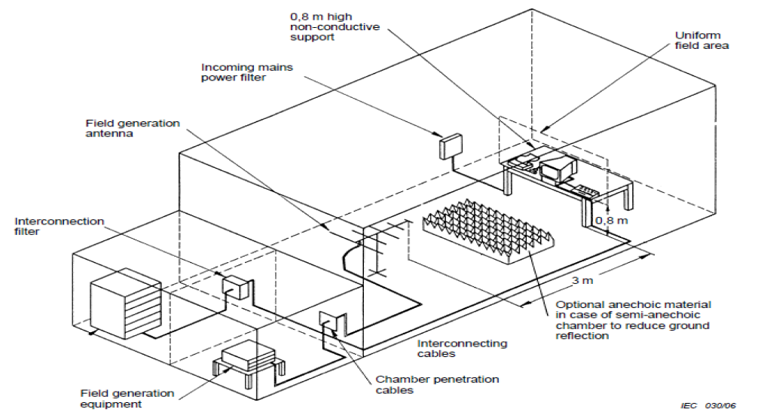

Block diagram of the setup for Radiated Immunity:

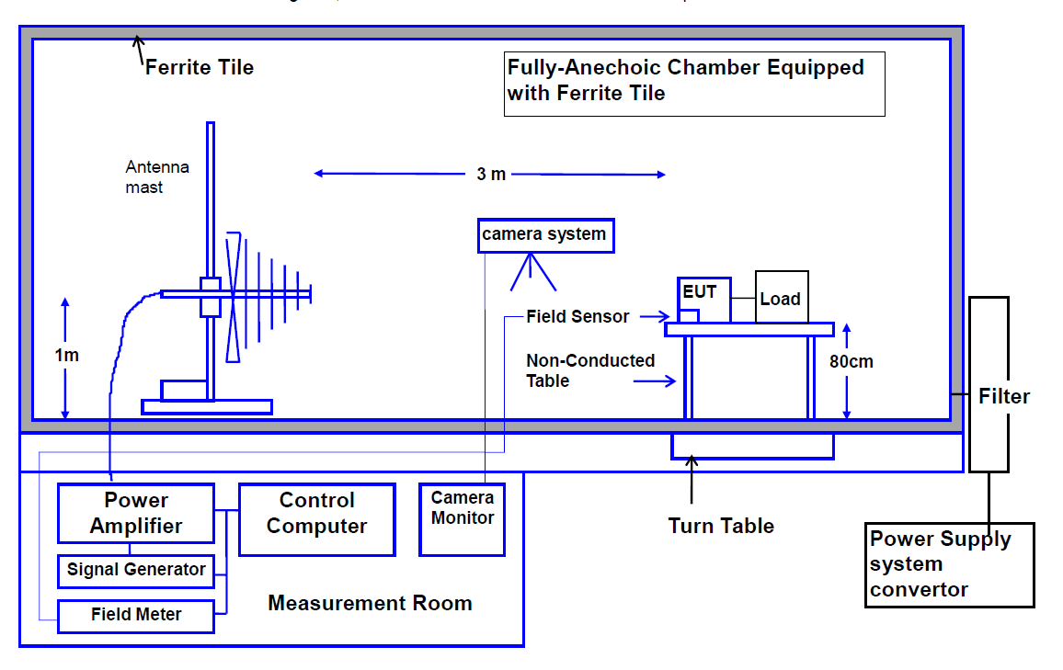

Test procedure:
The EUT and load were placed on a table, which is 0.8 meter high. The field sensor (optional) was also placed on the same table to monitor field strength from transmitting antenna. EUT was set 3 meter away from the transmitting antenna. Both horizontal and vertical polarizations of the antenna were used during testing. A CCD camera was used to monitor the function of the EUT. The test condition is 3V/m from 80MHz to 6GHz with 1Khz sinewave 80% amplitude modulation Frequency step size is 1%.

Photograph of EUT:
Click here to enter text.
Click here to enter text.
Click here to enter text.
Click here to enter text.
Click here to enter text.

4. Test Result Click or tap here to enter text.
Test Parameters:
Frequency 80 MHz - 6 GHz; 80% Amplitude Modulated at 1 KHz
Sweep Rate 2.5 Seconds dwell per 1% step, 1.73E-03 Decades per Second
Filed Strength 3 v/m
Polarity Horizontal and Vertical
Rotation Front (0°) Left (90° ) Rear (180°) and Right (270°)

Click here to enter text.

Click here to enter text.
Click here to enter text.
Click here to enter text.
Click here to enter text.
Click here to enter text.

Criteria: |  | A. Pass - Normal performance within specified limits.
 |  | B. Pass - Temporary degradation, self recoverable.
 |  | C. Pass - Temporary degradation, requires operator intervention.
 |  | D. Fail - Not recoverable, component damage.

Field Uniformity Calibration Data
Field Uniformity Exceptions: (>6dB)
 | Horizontal Axis | 2107.0 MHz | 8.80 dB
 | Horizontal Axis | 5040.0 MHz | 7.13 dB
 | Horizontal Axis | 5499.0 MHz | 6.37 dB
 | Vertical Axis | None | N/A

5. Summary Click or tap here to enter text.

Click here to enter text.
Click here to enter text.

