ESD Immunity Test Report

Contents

1. Test lab facility 2

Test Site: 2

Facility name: 2

Facility address: 2

Facility site description: 2

Test Standards 2

EMC Directive 2014/30/EU 2

Test Equipment: 2

Environmental conditions: 2

Test Operator and Date: 2

2. Product Information 3

3. EUT setup 3

Block diagram of test setup for ESD: 3

Test Procedure: 4

Photograph of EUT: 5

4. Test Result 6

5. Summary 7

# . Test lab facility

## Test Site:

Facility name: Keysight Technology, Technology Order Fulfillment, Colorado Springs Hardware Test Center.

Facility address: 1900 Garden of the Gods Rd, Colorado Springs, CO. 80907

Facility site description:

The Keysight Technologies Technology Order Fulfillment Colorado Spring Hardware Test Center is a certified radiated interference testing facility, which complies with the standard requirements defined by IEC 61326.

## Test Standards

### EMC Directive 2014/30/EU

IEC 61326-1:2012 / EN 61326-1:2013 (Basic) Radiated Emission Reference Standards:

ESD IEC 61000-4-2, ETM 765.002Group 1 Class A. The products were tested in a typical configuration with Keysight Technologies test systems. This product is intended for use in a basic electromagnetic environment.

## Test Equipment:

|  |  |
| --- | --- |
| Traceability |  |
| ESD Tester | Model:MZ-15/EC, SN:0005295, Calibration Exp.:8/13/2020 |
| Misc. Information |  |
| Test Standard | IEC 61000-4-2 / EN 61000-4-2 Basic ETM 765.002 |
| Test Site | Colorado Springs TOF Hardware Test Center |
| Test Voltage | 110V |
| Test Software Version | V1.5 |

## Environmental conditions:

Temperature: 72°F; Humidity :50 RH

Note: There will be no effect to the result due to changes in mains voltage or frequency.

## Test Operator and Date:

Operator: Clifford; Report generated at: Dec.18,2019 10:12:33 AM

# 2. Product Information

|  |  |
| --- | --- |
| Product Name: | Bullwinkle |
| Product Model: | EDUX1052G |
| Product SN: | HTC PP-012 |
| Project Stage: | PP |
| Deliver date of the test samples: | 12/17/2019 |
| DUT power: | 110V |
| Auxiliary equipment list: | USB Cable Lan Cable Probe BNC cable |
| Model numbers covered by the test: | DSOX1202G EDUX1052G DSO1202A EDUX1052A |
| .-Hardware Difference | Bandwidth and Wavegen function |
| .-Software/firmware difference: | N/a |
| .-Cosmetic difference: | NA |
| Test Configuration | DUT turned on, Maximum power mode |
| Test Software Version | V1.5 |

# 3. EUT setup

## Block diagram of test setup for ESD:

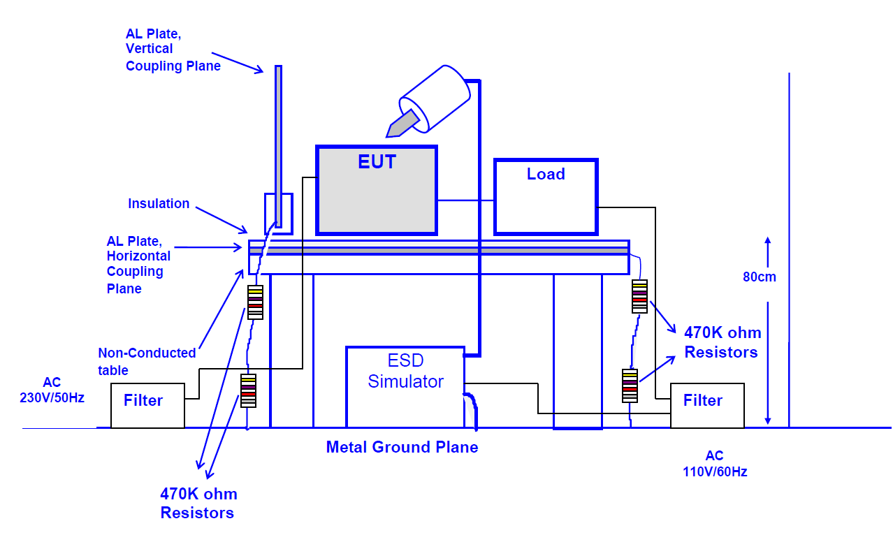

## Test Procedure:

-Air Discharge: The test was performed on non-conductive surfaces on according with IEC 61000-4-2. Single discharge at >1 second interval. At least 10 positive and 10 negative discharges. Air discharges to surfaces of the EDUT.

-Contact Discharge: Single discharge at >1 second interval. At least 25 positive and 25 negative discharge.

-HCP Discharge: ESD was applied to the earth reference plane on each accessible side of the EUT.

-VCP Discharge: Vertical coupling plane was positioned at the distance of 0.1m from the EUT. ESD was applied to each side of the EUT.

## Photograph of EUT:

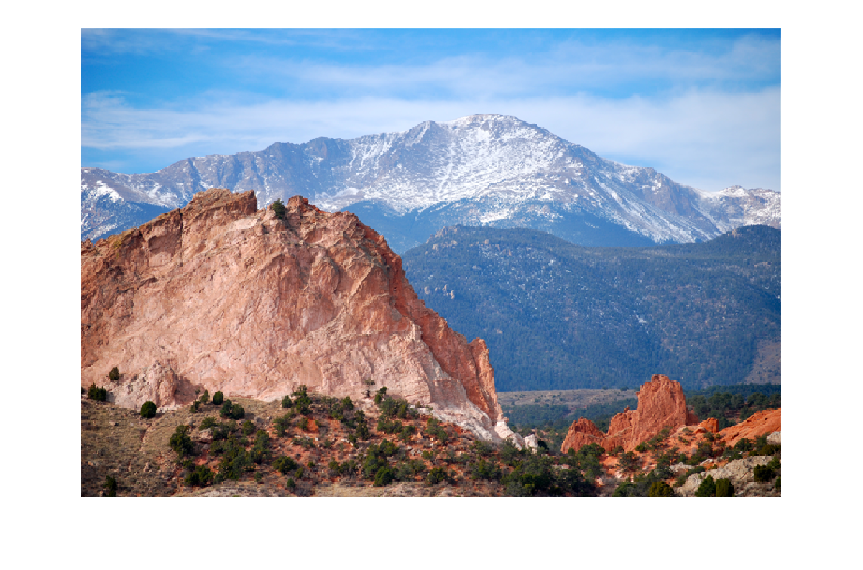

# 4. Test Result

|  |  |
| --- | --- |
| Contact: 10 single contact discharges (+/-) to select points and to vertical and horizontal coupling plane (4 faces). Contact discharges are not applied to insulated areas. | PC= Performance code:  **A**= Normal, within specific limits  **B**= Temporary degradation, self recoverable.  **C**=Temporary degradation requiring operator intervention.  **D**= Not recoverable **ND**=No Discharge |

|  |  |  |  |  |  |  |
| --- | --- | --- | --- | --- | --- | --- |
| Discharge Type | Location | 2KV | 4KV | 6KV | 8KV | Comments: |
| Contact Discharge | Horizontal Plane | A | A | A | A | Pass.-Normal performance within specified limits. |
| Contact Discharge | Vertical Plane | A | A | A | A | Pass.-Normal performance within specified limits. |

|  |  |  |  |  |  |  |  |  |  |
| --- | --- | --- | --- | --- | --- | --- | --- | --- | --- |
| Discharge Type | Location | 2KV | 4KV | 6KV | 8KV | 10KV | 12KV | 15KV | Comments: |

# 5. Summary

The unit Passed the ESD test!