Attachments for Experiment 0

Recruitment Email and Information Consent Letter

Dr. Andrew Lim will recruit fellow experts for the crowdEEG experiment using the following email: Title: A framework for hybrid machine and human computation for the accurate and scalable analysis of human clinical EEG recordings

Hello everyone,

My name is Dr. Andrew Lim and I am neurologist at Sunnybrook health sciences center. You are being invited to participate in an EEG analysis task run by Josh Bradshaw, under the supervision of professor Edith Law from the University of Waterloo as part of the study titled: *A framework for hybrid machine and human computation for the accurate and scalable analysis of human clinical EEG recordings.*

Professor Edith Law and student Josh Bradshaw are working on developing interfaces for crowdsourcing EEG analysis, to provide a low cost EEG analysis method for various clinics in the third-world. Participants in this task will use our custom-made EEG annotation interface to identify sleep spindles in EEG. Participants will be asked to talk aloud during this task to share their thoughts about the task, and about the interface. This discussion will be recorded on video, so that researchers in professor Edith Law’s lab can review the discussion, and use the insights to improve training materials used in spindle detection crowdsourcing, and improve the spindle identification interface. The annotations made in the EEG viewer will also be recorded, for use as gold standard benchmark annotations for Josh’s crowdsourcing interface.

A screenshot of the expert interface is shown below:

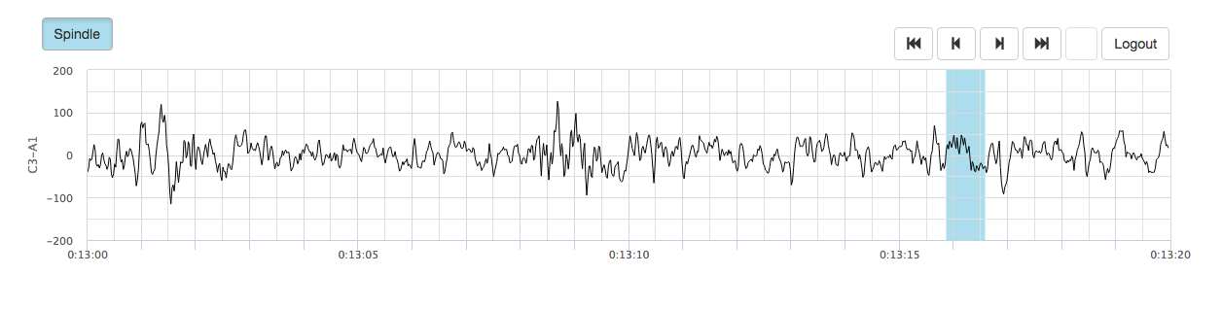

The videos will be reviewed only by the researchers in Edith Law's lab, while the annotation data will be anonymized and shared with collaborators for use as training data for their automatic EEG analysis algorithms. The video data will be kept for a period of 7 years in a secure location then destroyed. There are no known or anticipated risks associated with participation in this study.

As remuneration for the time spent on this task, you will be paid $50/hour. The task is expected to take 1-2 hours, and can be adapted based on your availability.

**Withdrawl:** Participation in this study is voluntary. You may decline to answer any questions that you do not wish to answer and you can withdraw your participation at any time by ceasing to answer questions without loss of renumeration. If you choose to withdraw, all video recordings of you and your annotations will be discarded.

**Taxability: Note that the remuneration for this study is taxable income. You are responsible for reporting this for income tax purposes.**

**Confidentiality:** It is important for you to know that any information that you provide will be confidential. The only data that will be shared with other researchers, will be the spindle annotations that you make, and those will be anonymized. The videos will be encrypted, and stored on a password protected computer in the human computer interaction lab with restricted physical access. The videos will be reviewed only by members of the Waterloo CrowdEEG research team. As well, the data will be electronically archived after completion of the study and maintained for 8 years and then erased.

Should you have any questions about the study, please contact either Josh Bradshaw (jabradsh@uwaterloo.ca) or Edith Law (edith.law@uwaterloo.ca). Further, if you would like to receive a copy of the results of this study, please contact either investigator. I would like to assure you that this study has been reviewed and received ethics clearance through a University of Waterloo Research Ethics Committee. However, the final decision about participation is yours. If you have any comments or concerns resulting from your participation in this study, please feel free to contact Dr. Maureen Nummelin in the Office of Research Ethics at 1-519-888-4567, Ext. 36005 or maureen.nummelin@uwaterloo.ca. Thank you for considering participation in this study.

To sign up for this study please email Edith Law: [edithlaw@uwaterloo.ca](mailto:edithlaw@uwaterloo.ca)

Yours sincerely,

Andrew

Feedback

Please remember that any data pertaining to you as an individual participant will be kept confidential. Once all the data are collected and analyzed for this project, I plan on sharing this information with the research community through seminars, conferences, presentations, and journal articles.

If you are interested in receiving more information regarding the results of this study, or would like a summary of the results, please provide your email address, and when the study is completed, anticipated by December 2015, I will send you the information. In the meantime, if you have any questions about the study, please do not hesitate to contact me by email or telephone as noted below. As with all University of Waterloo projects involving human participants, this project was reviewed by, and received ethics clearance through a University of Waterloo Research Ethics Committee. Should you have any comments or concerns resulting from your participation in this study, please contact Dr. Maureen Nummelin, the Director, Office of Research Ethics, at 1-519-888-4567, Ext. 36005 or maureen.nummelin@uwaterloo.ca. Josh Bradshaw (jabradsh@uwaterloo.ca) Dr. Edith Law (edith.law@uwaterloo.ca).

**Consent of Participant**

By signing this consent form, you are not waiving your legal rights or releasing the investigator(s) or involved institution(s) from their legal and professional responsibilities.

I have read the information presented in the information letter about a study being conducted by student investigator *Josh Bradshaw under the supervision of Professor Edith Law* of the Department of *Computer* Science at the University of Waterloo. I have had the opportunity to ask any questions related to this study, to receive satisfactory answers to my questions, and any additional details I wanted. I am aware that I may withdraw from the study without penalty at any time by advising the researchers of this decision.

This project has been reviewed by, and received ethics clearance through a University of Waterloo Research Ethics Committee. I was informed that if I have any comments or concerns resulting from my participation in this study, I may contact the Director, Office of Research Ethics at 519-888-4567 ext. 36005.

With full knowledge of all foregoing, I agree, of my own free will, to participate in this study.

________________________________________

Print Name

________________________________________

Signature of Participant

________________________________________

Dated at Waterloo, Ontario

________________________________________

Witnessed

**Consent for Videotaping**

As a participant in this study, I agree to being videotaped and recorded for the purpose of tracking my movements, speech and computer screen. I am aware that I may withdraw this consent at any time without penalty, at which point, the videotape will be erased.

I was informed that if I have any comments or concerns resulting from my participation in this study, I may contact the Director, Office of Research Ethics, at 519-888-4567 ext. 36005.

____________________________   
Print Name

____________________________  
Signature of Participant

_____________________________  
Dated at Waterloo, Ontario

______________________________  
Witnessed