Attachments for Experiment 1

Mechanical Turk Task Advertisement / Recruiting Materials

**Title of Task**: Annotating Sleep Spindles in EEG

**Renumeration:** You will be paid a $0.10 per window of EEG that you annotate, up to a maximum of $2 for 20 windows.

**Time Commitment:** The complete task (20 windows) is estimated to take 10-20 minutes.

**Task Overview:** Your task is to read the very short instructions page, and then use the interface below to identify sleep spindles in EEG. You will be presented with windows, and asked to highlight the spindles in each window. You will be able to review the instructions at any time without penalty. You may quit the task at any time without the loss of remuneration. You will be paid for the number of windows that you complete. The task is twenty windows long, and your progress is indicated by the progress bar in the top right corner of the screen.

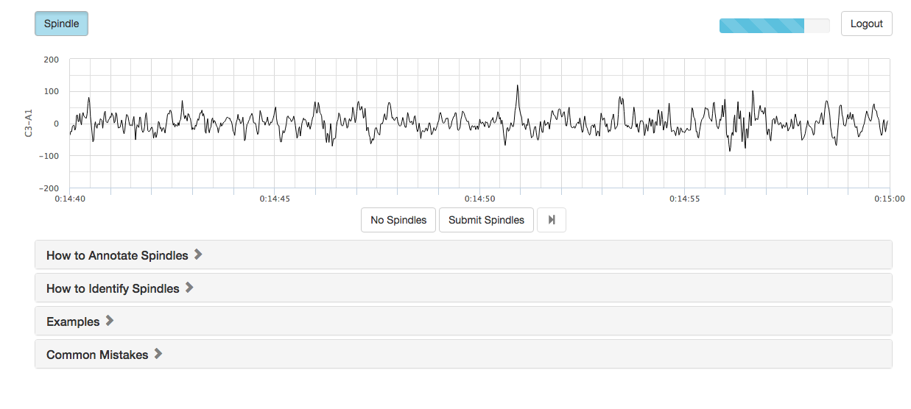

Information Consent Letter

Title of Project: ***Annotating Sleep Spindles in EEG***

You are invited to participate in a research study conducted by ***Josh Bradshaw*** under the supervision of ***Professor Edith Law*** of the University of Waterloo, Canada. The objectives of the research study are ***to develop a crowdsourcing for low cost, system for EEG analysis for use in the third world.***

If you decide to volunteer, you will be asked to complete a ***10-20*** minute online EEG analysis task, as described on the task listing. Participation in this study is voluntary. You may decline to answer any questions that you do not wish to answer and you can withdraw your participation at any time by not submitting further responses and pressing ‘QUIT TASK’. You will be paid $0.20 per window for the windows you complete, and there is **no need to enter a code to receive payment**. There are no known or anticipated risks from participating in this study.

It is important for you to know that any information that you provide will be confidential. All of the data will be summarized and no individual could be identified from these summarized results. Furthermore, the web site is programmed to collect responses alone and will not collect any information that could potentially identify you (such as machine identifiers). The data eight

This survey uses Mechanical TurkTM which is a United States of America company. Consequently, USA authorities under provisions of the Patriot Act may access this survey data. If you prefer not to submit your data through Mecahnical TurkTM, please do not participate.

Participation in this study is voluntary. You may decline to answer any questions that you do not wish to answer and you can withdraw your participation at any time by ceasing to annotate windows and/or pressing quit without loss of renuneration.

Note that the remuneration you receive may be taxable income. You are responsible for reporting this income for tax purposes. Should you have any questions about the study, please contact either Josh Bradshaw (jabradsh@uwaterloo.ca)or ***Edith Law (edith.law@uwaterloo.ca).*** Further, if you would like to receive a copy of the results of this study, please contact either investigator.

**I would like to assure you that this study has been reviewed and received ethics clearance through a University of Waterloo Research Ethics Committee. However, the final decision about participation is yours. Should you have any comments or concerns resulting about your participation in this study, please contact Dr. Maureen Nummelin in the Office of Research Ethics at 1-519-888-4567, Ext. 36005 or [maureen.nummelin@uwaterloo.ca](mailto:maureen.nummelin@uwaterloo.ca).**

[ ] I agree to participate

[x] I do not agree to participate

**Submit**

Feedback

Please remember that any data pertaining to you as an individual participant will be kept confidential. Once all the data are collected and analyzed for this project, I plan on sharing this information with the research community through seminars, conferences, presentations, and journal articles. If you are interested in receiving more information regarding the results of this study, or would like a summary of the results, please provide your email address, and when the study is completed, anticipated by December 2015, I will send you the information. In the meantime, if you have any questions about the study, please do not hesitate to contact me by email or telephone as noted below. As with all University of Waterloo projects involving human participants, this project was reviewed by, and received ethics clearance through a University of Waterloo Research Ethics Committee. Should you have any comments or concerns resulting from your participation in this study, please contact Dr. Maureen Nummelin, the Director, Office of Research Ethics, at 1-519-888-4567, Ext. 36005 or maureen.nummelin@uwaterloo.ca. William C (krschen@uwaterloo.ca) Dr. Edith Law (edith.law@uwaterloo.ca)