Detecting Machine-Generated Text
50.007 Machine Learning, COLING 2026 GenAI Content Detection
Task 4: documenting the journey
Cliffton, Brian, Jovyan, Koko, Vincent
[TODO: registered Kaggle team name]

1. Summary
Our best submission scores 0.80143 Macro F1 on the public leaderboard. It is a LightGBM classifier trained on 40,385 features built from the raw text, and its predictions are turned into labels by thresholding the two test id groups separately rather than applying one global cut.
Starting from the supplied 5,000-dimension TF-IDF matrix, the same model family scored 0.73583. Of the +0.06560 we added, roughly two thirds came from changing what the model sees and one third from changing how its scores are converted into labels. Almost none came from the model itself: three rounds spent on tuning and ensembling produced gains inside the leaderboard's own noise, and we report those rounds as the nulls they were.
Throughout, we treated the public leaderboard as a measuring instrument with a quantified precision. On roughly 3,570 scored rows at F1 near 0.8, binomial sampling noise is about 0.0084. Any difference smaller than that is reported as a tie, including several of our own later gains.
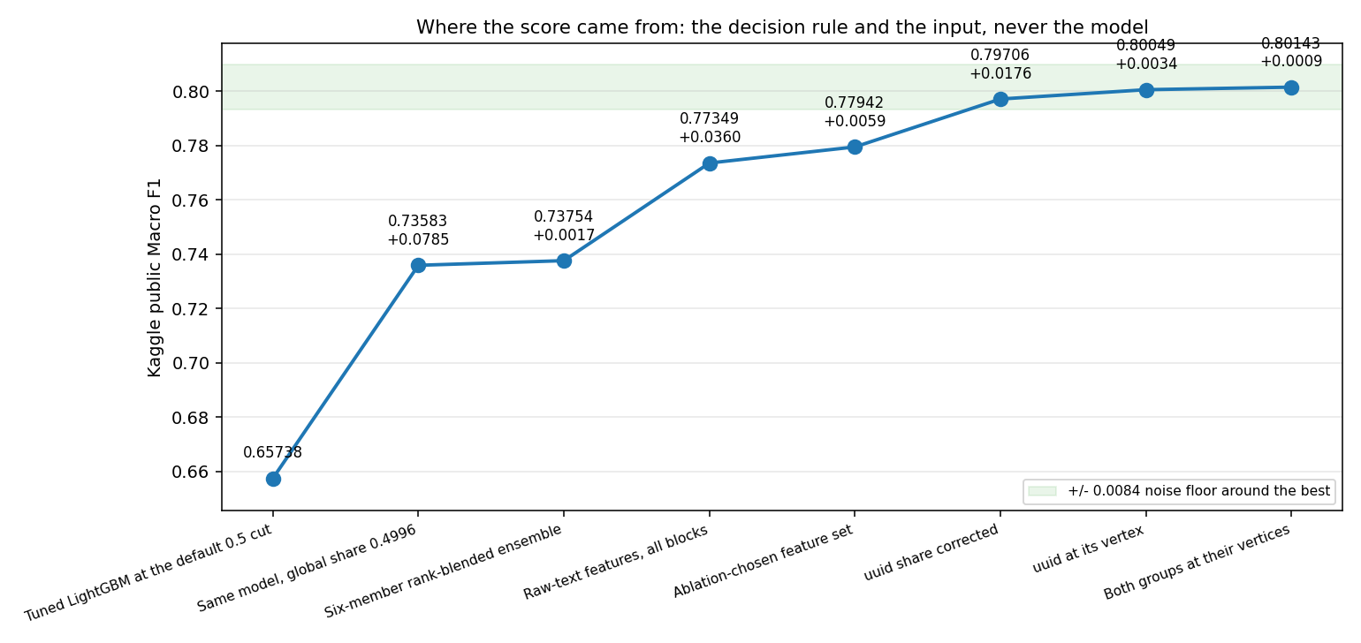
Figure 1. Public Macro F1 across the milestone submissions. The shaded band is the noise floor around the final score; three steps clear it, the first global share calibration, the representation change, and the first per-group share correction.

2. The data, and the shift the brief warned about
The task is binary: label a document 1 if machine-generated and 0 if human-authored, scored on Macro F1. Training data is 20,000 labelled documents and the test file holds 6,999. The course supplies a pre-computed 5,000-column TF-IDF matrix, lemmatised and with stop words removed.
Two properties of the data shaped every decision that follows.
The classes are unbalanced.
Training is 62.52% machine and 37.48% human. A majority-class predictor would reach 62.5% accuracy and about 0.38 Macro F1, which is why we stratified every split and used class-weighted estimators throughout.
Train and test are different source corpora.
The brief warns of a deliberate train-to-test shift, and the COLING shared-task paper explains its shape: training draws on HC3, M4GT and MAGE, while the test split is CUDRT, IELTS, NLPeer, PeerSum and MixSet, with no overlap. The paper's figures put training at 62.6% machine against 53.1% for the test split, matching the 0.6252 we measured and the ~0.53 we later inferred from the leaderboard.
The test file also contains two visibly different populations. 1,999 rows carry UUID-style ids like the training rows, and 5,000 carry numeric ids. The numeric rows are longer (median 1,862 characters against 1,189), carry markdown bold at 2.52 occurrences per document against 0.44, and contain the word "reviewer" in 15.8% of documents against 0.2%. They are academic peer reviews. This split turned out to matter more than any modelling decision we made.
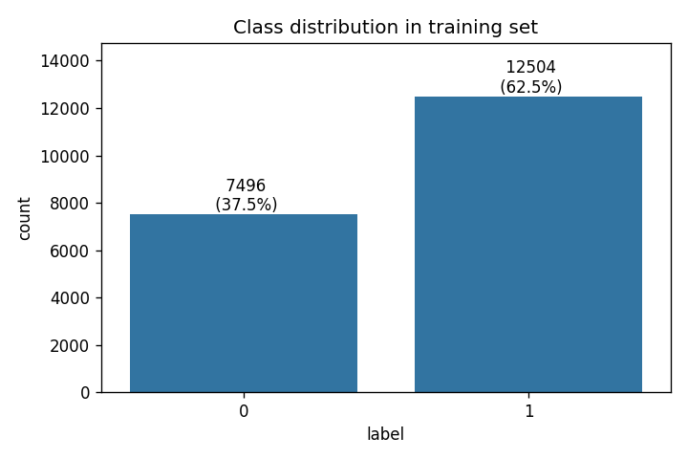
Figure 2. Class balance in the training set: 12,504 machine against 7,496 human.
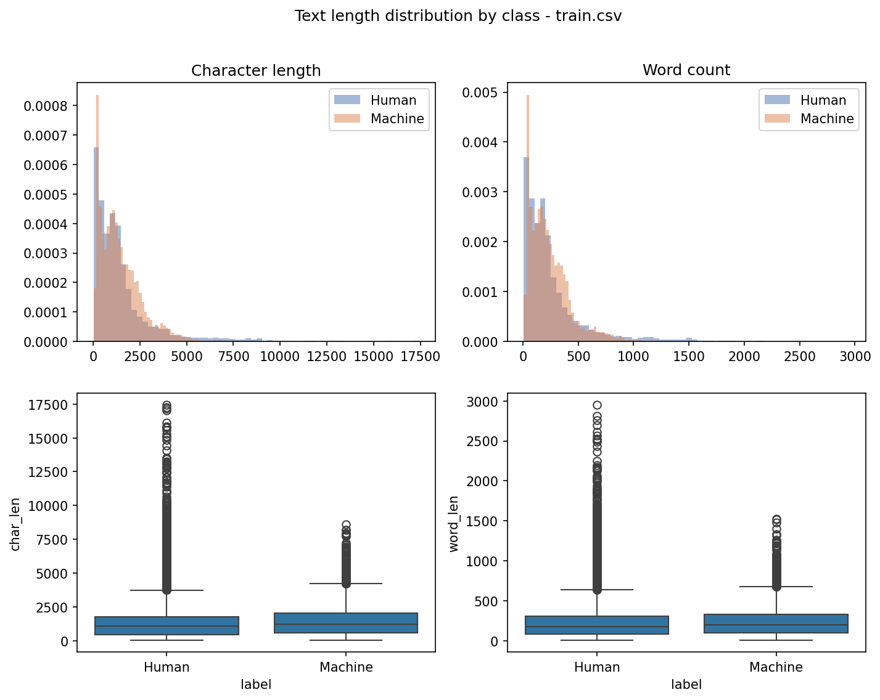
Figure 3. Document length distribution. Length correlates with the label, and later became the basis of our validation protocol.

3. Question 1: the best model and how it works

3.1 The classifier
LightGBM is a gradient-boosted decision tree ensemble. It fits trees in sequence, each one trained on the gradient of the loss left over by the trees before it, so every tree corrects its predecessors rather than voting independently. Its leaf-wise growth strategy splits whichever leaf promises the largest loss reduction instead of growing level by level, which is what makes it efficient on very wide sparse inputs like ours.
We pass class_weight="balanced", which reweights the 62/38 split so the minority human class is not simply outvoted. Macro F1 averages the two per-class F1 scores with equal weight, so a model that quietly sacrifices the human class is punished twice: once in that class's recall and once in the average.
Every other hyperparameter is at its default. That is a real finding rather than an omission, and section 4.5 explains what we did about it.

3.2 The features
The model sees 40,385 columns in eight blocks, all built from the raw text. Blocks A to F are per-document statistics that cannot leak; H and I are TF-IDF vectorizers fitted on the training text alone.
Block | Columns | What it measures
A function words | 318 | rates of 318 English stop words
B punctuation | 37 | per-1000-character symbol rates, plus markdown counts
C casing | 5 | uppercase, ALL-CAPS, Titlecase, internal-capital rates
D structure | 10 | newlines, line lengths, bullets, headers, hard-wrap
E length | 10 | log counts, word and sentence length moments, burstiness
F diversity | 5 | TTR, hapax rate, Yule's K, MATTR over a 100-word window
H char n-grams | 20,000 | char_wb 2-5 TF-IDF, sublinear
I word n-grams | 20,000 | word 1-2 TF-IDF, stop words kept, no lemmatisation

Two families are deliberately absent, and the table below is why. We dropped each family in turn from the full set and re-scored on a held-out document type, so the column is what that family is worth for transfer rather than for fitting the training domains.
Family dropped | Macro F1 given up | Columns
F_diversity | +0.0510 | 5
H_char_ngrams | +0.0299 | 20,000
E_length | +0.0177 | 10
C_casing | +0.0129 | 5
I_word_ngrams | +0.0123 | 20,000
D_structure | +0.0012 | 10
B_punctuation | +0.0011 | 37
A_function_words | +0.0002 | 318
G_readability | -0.0001 | 5
tfidf_supplied | -0.0074 | 5,000

Readability contributes nothing and the supplied TF-IDF is actively harmful: removing it improves held-out-domain Macro F1 by 0.0074. Note also that diversity returns more than character n-grams from five columns against 20,000, which is why we later spent a round trying to extend it. Section 5.5 reports how that went.

3.3 The decision rule
The model emits a probability per row, but we do not threshold at 0.5. We sort the rows by score and label a fixed fraction of them machine, and we do this separately for each id group: 0.6198 of the UUID rows and 0.4756 of the numeric rows.
This is the single highest-leverage choice in the project and section 4.4 derives it. The short version is that the two groups need corrections in opposite directions, so any single global threshold is a compromise between them.

4. Question 2: the roadmap
Each subsection states what we chose, what else we measured, the drawback we accepted, and why we judged it acceptable.

4.1 Representation: raw text over the supplied TF-IDF
Chosen: eight blocks built from raw text, 40,385 columns, scoring 0.8811 on standard cross-validation
Also tried:
- The supplied 5,000-column TF-IDF alone: 0.7303. The intended input, and the weakest option we measured.
- Character n-grams alone (block H): 0.8188. One block carrying 59% of the total gain.
- Word n-grams with stop words kept (block I): 0.7676, against the supplied features' 0.7303 on the same corpus. Suggestive that the course preprocessing costs signal, though block I also has four times the vocabulary so the comparison is confounded by capacity.
- The cheap per-document style blocks alone (A to G): 0.8458, from features that each score below the control individually.
- Supplied TF-IDF plus everything: 0.8795, a tie with raw text alone using 5,000 more columns, so the supplied features add nothing once raw text is present.
Drawback: we hand-build 40,385 features where the course supplies 5,000 ready to use, which is far more engineering effort, far more code to get wrong, and a pipeline that would need rebuilding for any new corpus.
Why that is acceptable: the supplied features are lemmatised with stop words removed, so they are a pure content signal, and content vocabulary is exactly what changes when the test set comes from different corpora. Function words, punctuation, casing and layout survive a corpus change, and the course preprocessing deletes precisely those. The brief permits extra feature engineering when it is described, and this is that description.
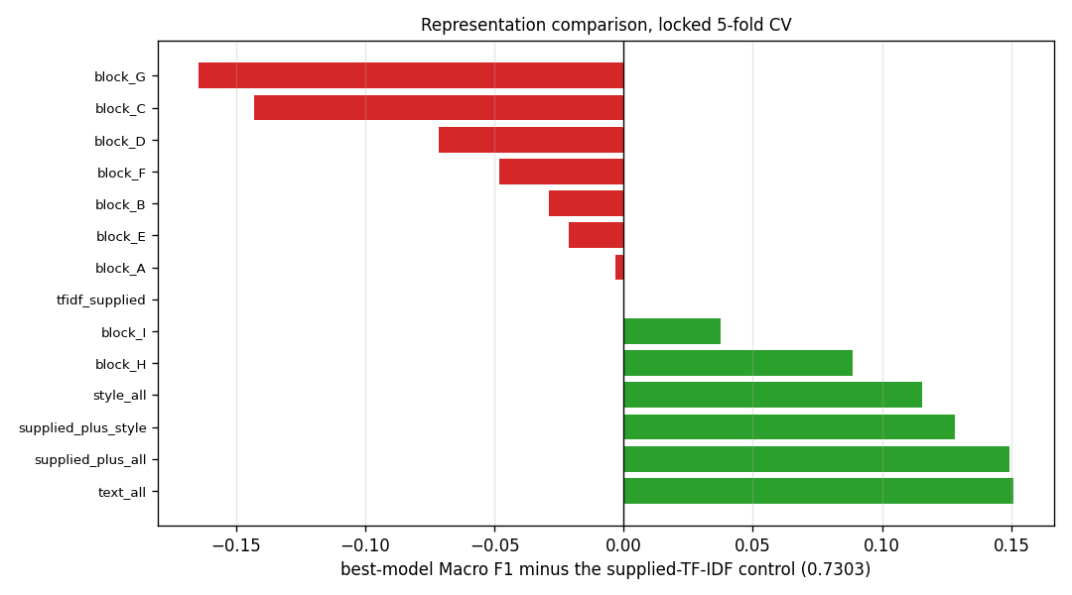
Figure 4. Each representation's best model, measured against the supplied TF-IDF control re-run in the same session.

4.2 Model family: LightGBM, and why we stopped ensembling
Chosen: LightGBM, best of twelve baselines at 0.7391
Also tried:
- XGBoost: 0.7289
- HistGB: 0.7262
- LogReg_Ridge: 0.7246
- LinearSVC: 0.7228
- LogReg_ElasticNet: 0.7196
- LogReg_Lasso: 0.7112
- Weaker still: RandomForest 0.6871, ComplementNB 0.6580, KNN 0.6542, MultinomialNB 0.6505, AdaBoost 0.5978.
- A six-member ensemble with four families of combiner across 48 configurations (weighted blending, voting, meta-learners, rank aggregation). Best gain on Kaggle: +0.00171, a fifth of the 0.0084 noise floor.
Drawback: a single boosted-tree model has no diversity to fall back on, and ensembling is the standard way to buy a last fraction of a point.
Why that is acceptable: we measured that fraction and it was not there. Round 4 spent a full round on combiners and gained less than the leaderboard can resolve. Shipping one model also keeps the pipeline auditable, which mattered when we later needed to attribute gains precisely.
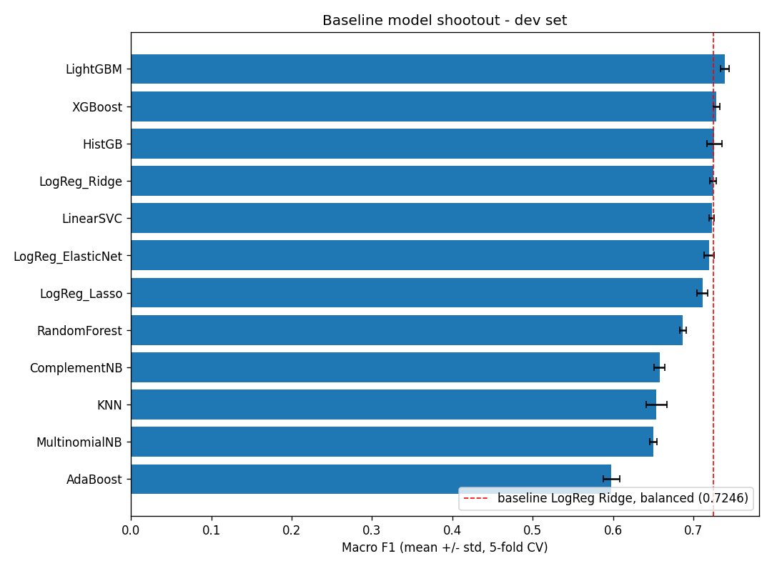
Figure 5. The twelve-model baseline sweep on the supplied features. The ordering held up: LightGBM led locally and, once compared fairly, on the leaderboard.

4.3 Validation: leave-one-length-band-out
Chosen: grouped cross-validation holding out one document-length band at a time, giving 0.8089 for the shipped model
Also tried:
- Standard 5-fold stratified CV: 0.8764, but it overstates the leaderboard by about 0.10 because it trains and tests on the same domains.
- K-means clusters on the style features, intended as discovered domains. Rejected: the stability gate passed at adjusted Rand index 0.9703 on one machine and 0.5991 on another, and fell to 0.1043 over five seeds.
- A deliberately random grouping, run as a control. It scored 0.8742 against standard CV's 0.8764, which is the evidence that the transfer gap comes from the structure of the grouping rather than from training on fewer rows.
Drawback: length bands are a crude proxy for domain, and the absolute level is not trustworthy: across three sensible groupings the score spans 0.0195, so the number carries roughly +/- 0.03.
Why that is acceptable: we use it to rank candidates, not to predict a leaderboard score, and for ranking it was several times more faithful than standard CV. It is also deterministic and unfitted, so all five of us compute identical folds, which the k-means version demonstrably could not.
The control is the load-bearing row of the table below. If a meaningless grouping had produced the same gap, the protocol would have been measuring reduced training-set size rather than domain structure, and no version of it could have been a selection rule.
Grouping of the training rows | Held-out Macro F1 | Usable folds
k-means, seed 42 | 0.7894 | 2
k-means, seed 43 | 0.8051 | 2
length terciles | 0.8089 | 3
random 3-way (control) | 0.8742 | 3
standard 5-fold CV, for reference | 0.8764 | 5

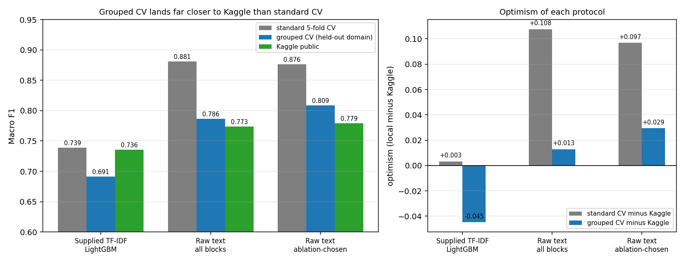
Figure 6. Standard CV, grouped CV and the leaderboard for three milestone models. Grouped CV is not unbiased, but its error is several times smaller.

4.4 The decision rule: per-group share
This subsection is the one we would most want a reader to take away, because the mistake it corrects is easy to make and invisible from inside.
We swept the global predicted share twice, in two different rounds and on two different models, and both times it came back flat. On the raw-text model, share 0.4996 gave 0.77349 and share 0.5299 gave 0.77231, a tie. We concluded share was exhausted. That conclusion was correct about the quantity we measured and wrong about the question we thought we were answering.
The reason is that a global cut moves both id groups in the same direction, and the two groups need corrections in opposite directions. The UUID rows wanted a higher predicted machine share and the numeric rows a lower one, so a global sweep moved one toward its optimum while pushing the other away, and the two effects cancelled. Thresholding the groups separately breaks the cancellation.
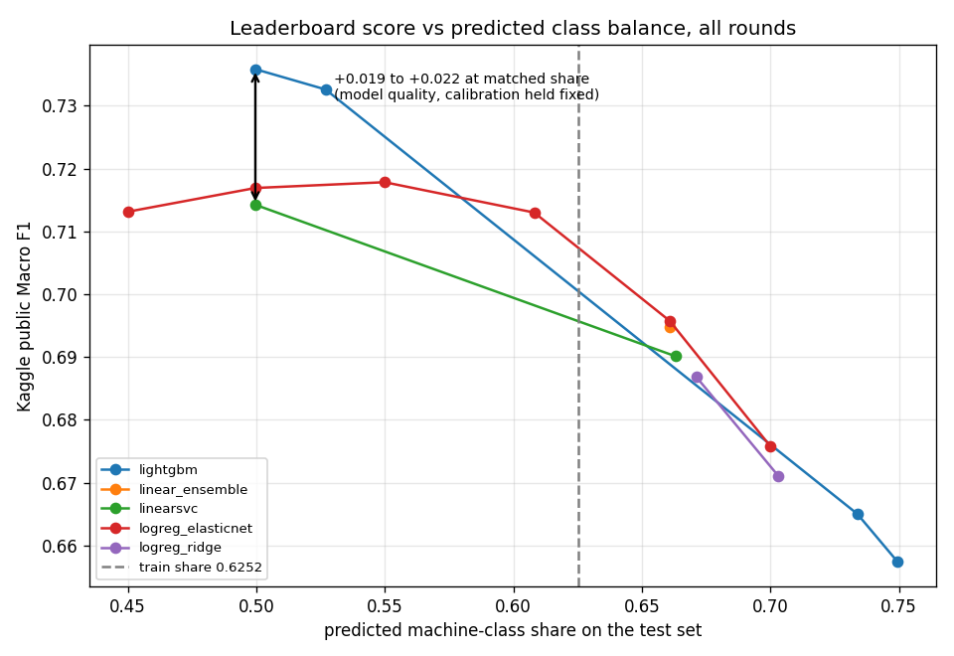
Figure 7. The global predicted-share curve, fitted across two rounds. Flat across a wide band, which is exactly what a cancelling pair of effects looks like when they are averaged together.
UUID share | Numeric share | Kaggle Macro F1
0.6198 | 0.4756 | 0.80143
0.6198 | 0.5120 | 0.80049
0.5598 | 0.5120 | 0.79706
0.6198 | 0.5484 | 0.79123
0.4687 | 0.5120 | 0.77942

Chosen: per-group shares of 0.6198 for UUID rows and 0.4756 for numeric rows
Also tried:
- The default 0.5 probability threshold, which inherits the training prior of 0.6252 and scored 0.65738, the worst result of the project.
- A threshold tuned against held-out data, which moved it the wrong way and scored 0.66502. Local data cannot pick a threshold here: dev and holdout are both carved from training and carry a class balance the test set does not.
- Global share swept from 0.44 to 0.56 on two models. Flat both times.
- Per-group share swept on both axes to their vertices, at 0.6214 and 0.4897 respectively.
Drawback: the shares are fitted entirely to the public leaderboard, which no local data can validate, and seven submissions went into locating them. A coordinate search that size on a noisy objective can manufacture 0.005 to 0.010 of gain that is not on the private rows.
Why that is acceptable: the shape of the surface is solid even if the last decimal is not. The first correction gained 0.01764 and the wrong-direction probe lost 0.00926, both clearing the noise floor, and the same correction was confirmed independently on a completely different model. We also stop refining inside a flat region rather than chasing it, and our two final picks pair the best point with a more central one instead of taking the top two public scores.
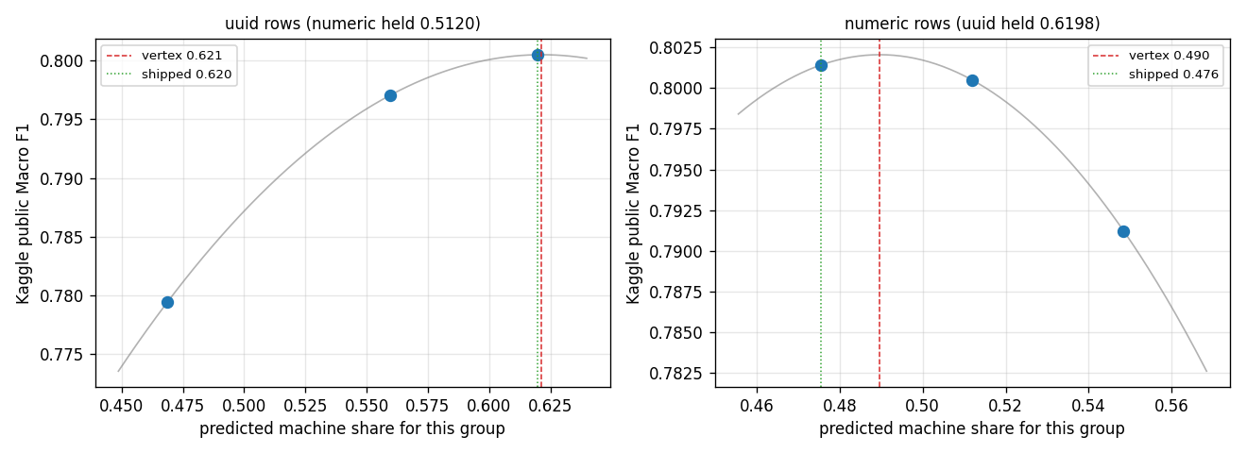
Figure 8. The per-group share surface. Both axes are at their fitted vertices; the numeric axis is asymmetric, and only the upward step clears the noise floor, which is what makes the direction certain.

4.5 Hyperparameters
Every hyperparameter search in this project ran against the supplied 5,000 features. Nothing has been tuned on the 40,385-column raw-text matrix, which is a different problem in shape: far wider, far sparser, and three quarters character n-grams. The shipped model therefore runs on LightGBM defaults.
The search is designed and split five ways across the team, sampling learning rate, tree count, leaf count, depth, minimum child samples, column subsampling, row subsampling and both regularisation terms. It selects on paired per-fold differences against the default configuration rather than on raw means, requires a candidate to improve on every fold, and confirms the winner on a protocol the search never selected on.
[TODO: hyperparameter search result, once notebook 17 has been run by the team]
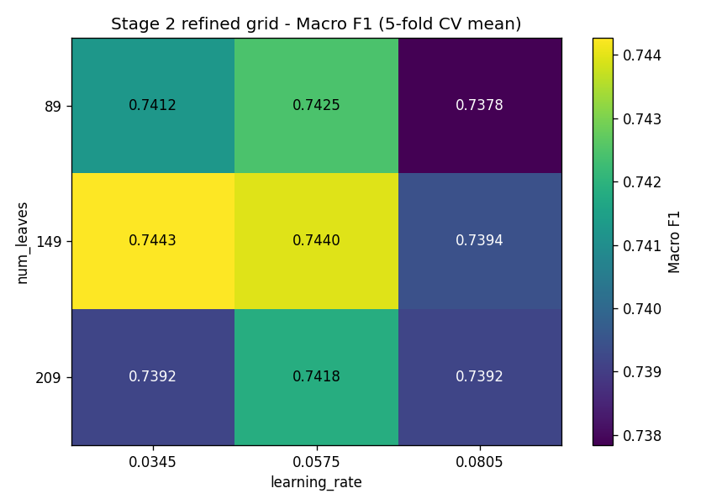
Figure 9. The equivalent search on the supplied features, for reference. It moved cross-validated Macro F1 from 0.7391 to 0.7443, about +0.005, which is the scale of gain we expect and why defaults were acceptable to ship in the meantime.

5. Question 3: difficulties, and what they cost
Every item below is a mistake we made and then caught. We include the cost of each because the cost is the part that taught us something.

5.1 We compared models along an axis we had not held fixed
For three notebooks we believed local validation was anti-correlated with the leaderboard. LightGBM had the best cross-validation and holdout scores of anything we tried and the worst leaderboard score, so we wrote it off and spent a round on linear models instead.
The inversion was an artifact. Each model had been submitted at whatever predicted class balance its own default threshold happened to produce, so "which model is best" and "which model is best calibrated for this test set" were being answered as one question. Re-testing at a matched share of 0.4996, LightGBM beat ElasticNet by 0.0189, in the same direction and roughly the same magnitude as its local lead. Local validation had never been broken.
What fixed it was designing the test in advance to be able to overturn our own conclusion, and writing down what each outcome would mean before the scores came back. We kept that habit for the rest of the project.

5.2 Three rounds of local gains that did not transfer
Round 3 gained 0.0017 on cross-validation and nothing measurable on the leaderboard. Round 4 gained 0.0075 out-of-fold AUC and 0.0017 on the leaderboard, a fifth of the noise floor. The diagnosis, once we read the shared-task paper properly, was that we had been optimising the model while holding the representation fixed, and the representation was the binding constraint. Round 5 changed it and gained 0.036.

5.3 A validation protocol that would not reproduce
We built domain clusters with k-means and gated everything downstream on a stability check. It passed at adjusted Rand index 0.9703 on one machine and failed at 0.5991 on another, from identical code and seeds. The cause was a 460,000-fold spread in feature scales feeding a decomposition that ran before standardisation, on a partition that turned out to be genuinely multi-modal.
Rather than discard the idea we tested whether the score depended on the labelling, including a deliberately random grouping as a control. The control reproduced standard CV almost exactly while every structured grouping sat well below it, which told us the mechanism was sound even though the specific clusters were not. We replaced them with deterministic length bands.

5.4 A diagnostic that silently contaminated itself
We built a submission to test whether the public leaderboard scores the UUID rows, by changing only those rows and holding the numeric rows fixed. The first version pinned the numeric group to the global share of 0.4996, believing that held them constant. Their realised share was 0.5482, so it silently moved 243 rows it was supposed to freeze, which would have made the answer unreadable in both directions.
The general lesson we took: setting a knob to the value a baseline used is not the same as leaving those rows alone, and the two coincide only when the knob is applied at the same granularity. Every later per-group file asserts that the held group is byte-identical rather than trusting the share.

5.5 Two predictions we made, and both were wrong
We predicted that the formatting features were dataset fingerprints that would not survive the corpus change, since machine text in training carries markdown bold at ten times the human rate. We built a stripped-down feature set to test it. Removing those blocks cost 0.04944 on the leaderboard, six times the noise floor in the opposite direction from the prediction.
We then predicted that our strongest feature family had more to give, since it returned the largest transfer value of any block from only five columns. We added fourteen further diversity measures. They made held-out-domain performance slightly worse while improving same-domain performance, which is the exact signature of a feature that memorises rather than generalises.
Both experiments were designed so they could fail, and both did. We would rather report two falsified predictions than a roadmap in which every idea worked.

5.6 What we could not overcome
- Predicted share cannot be validated locally, at all. Our dev and holdout splits are carved from training data and inherit its class balance, so every share decision rests on leaderboard feedback alone. We managed the risk rather than solving it.
- The absolute level of our grouped protocol is not trustworthy to better than about +/- 0.03, so we can rank candidates but not forecast a score.
- A gap of about 0.075 remains between standard cross-validation and the leaderboard. The brief says to expect it by design, and closing it further was not something we found a lever for.

6. Question 4: what we learned beyond the course

6.1 Blocked comparison, and why averages mislead
Our held-out bands differ in difficulty by far more than any two candidates differ from each other. Comparing mean scores against a fold standard deviation of 0.087 sets a bar nothing can clear. Because band difficulty is common to every candidate, the correct comparison is paired: subtract fold by fold and test the differences. We had already reported one result as a null using the conservative bar before realising this, and we say so rather than quietly restating it.

6.2 Averaging can hide two large effects that cancel
The single most useful idea we took from this project generalises well beyond it. When one global threshold is applied to a population that is a mixture, the optimum for the mixture can be flat while the optima for the components are far apart and moving in opposite directions. We measured the flat curve twice, correctly, and drew the wrong conclusion from it both times. A roughly +0.019 effect and a roughly -0.019 effect had been cancelling in the average.

6.3 A leaderboard is a measuring instrument with a precision
We computed the sampling noise of the public leaderboard once, about 0.0084 on its row count at our score, and then held every claim to it. That single number let us stop several searches at the right moment, decide which of our own gains to disbelieve, and avoid spending submissions inside flat regions. It is also why our final picks are not simply the top two public scores.

6.4 Reading the dataset paper was worth more than any model
The shared-task paper told us the test corpora were disjoint from training, gave us the class balance of each, and explained the two id populations. Those facts produced the two changes that moved our score. No amount of hyperparameter search would have found them.

7. Task 1: Logistic Regression from scratch
Implemented without sklearn or any pre-built logistic regression package, on the supplied TF-IDF features, with sigmoid, log loss, an analytic gradient, mini-batch gradient descent and a predict step.
Design choices worth noting: the gradient of the log loss with respect to the weights reduces to X-transpose times the residual divided by the batch size, so no numerical differentiation is needed; and the sigmoid is computed in a numerically stable branch to avoid overflow on large negative inputs.
[TODO: batch size, epochs and learning rate used, plus the validation Macro F1]
[TODO: Kaggle Macro F1 for LogReg_Prediction.csv, and confirmation that the file exists with that exact name]

8. Task 2: PCA and KNN
PCA applied to the supplied 5,000 TF-IDF features, followed by K-nearest neighbours with n_neighbors fixed at 2, evaluated at 2,000, 1,000, 500 and 100 components. Predictions for all four counts have been generated.
The scree plot below is the diagnostic for how much variance each component count retains. The four counts are fixed by the task rather than chosen from the elbow, which is worth stating because it is the one place in the project where we did not pick a structural hyperparameter from a diagnostic.
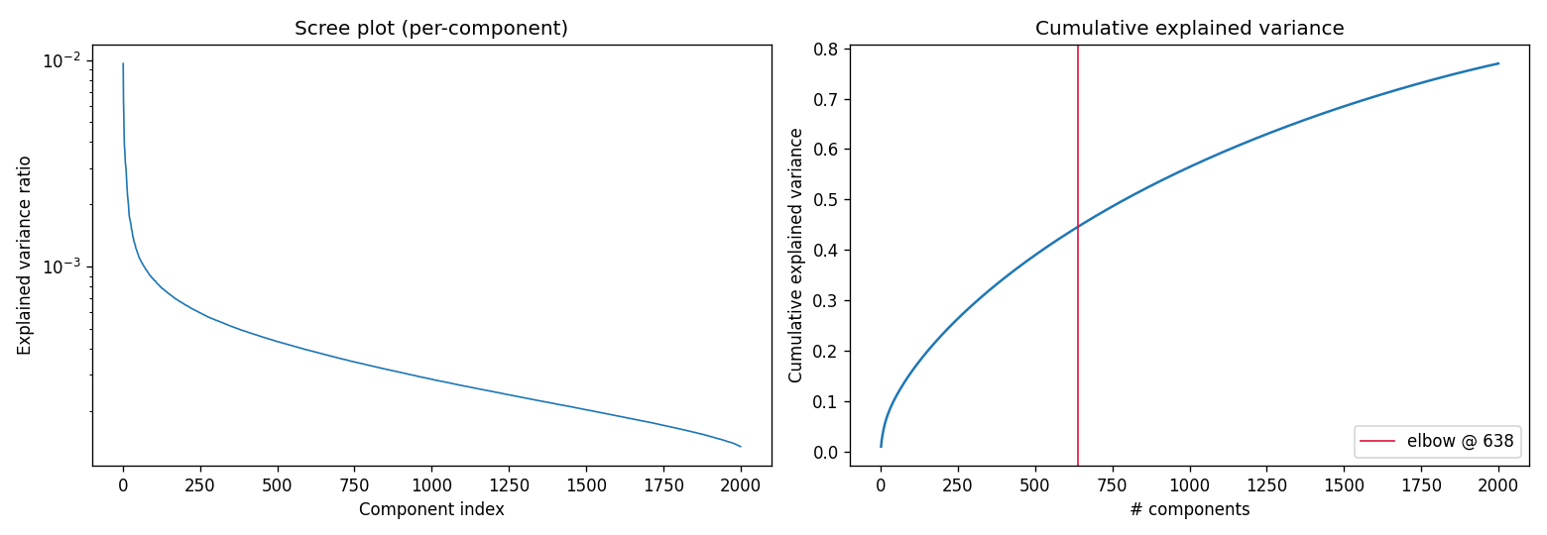
Figure 10. Explained variance against component count for PCA on the supplied features.
[TODO: test Macro F1 at 2000, 1000, 500 and 100 components, read back from Kaggle]
[TODO: analysis of the reduced components, which the rubric rewards separately]

9. Reflection and next steps
What we consider settled:
- The representation. Raw-text features beat the supplied TF-IDF by a wide margin, and adding the supplied features back changes nothing.
- Global predicted share. Flat across 0.44 to 0.56 on two different models.
- Per-group share. Both axes measured to their vertices.
- Feature expansion in the directions we tried. Four ideas, all inside the bar: extended diversity (J, 14 cols) -0.0022; variability (K, 12 cols) +0.0049; J and K together +0.0011; char n-grams at 5x capacity +0.0023.
What remains open:
- Hyperparameter tuning on the raw-text representation, designed and split across the team but not yet run.
- A second model family blended with the first on this representation, which we specified but did not manage to measure.
- Final submission selection, where our rule is to pair the best public point with a more central one rather than taking the top two, because the share coordinates are fitted to a leaderboard with a known noise floor.
For calibration, the shared task's own fine-tuned RoBERTa baseline reached 73.42 Macro F1 on the full English test set. We reach 80.14 with classical models and no deep learning, though the numbers are not strictly comparable because the course uses a subsample.

