**Module ICT3715**

## Year 2020

**INFORMATION AND COMMUNICATION TECHNOLOGY**

**ASSIGNMENT 1**

**DUE DATE: 31 MARCH 2020**

|  |  |  |  |  |  |  |  |  |  |
| --- | --- | --- | --- | --- | --- | --- | --- | --- | --- |
| STUDENT NUMBER (Student completes) | | | | | | | | | |
| ***4*** | ***9*** | ***2*** | ***2*** |  | ***8*** | ***8*** | ***8*** |  | ***9*** |

|  |  |  |  |  |  |  |  |  |  |  |  |  |
| --- | --- | --- | --- | --- | --- | --- | --- | --- | --- | --- | --- | --- |
| **IDENTITY NUMBER (Student completes)** | | | | | | | | | | | | |
| ***8*** | ***4*** | ***0*** | ***3*** | ***2*** | ***1*** | ***5*** | ***2*** | ***2*** | ***3*** | ***0*** | ***8*** | ***2*** |

*No handwritten assignments will be accepted.*

**INSTRUCTIONS:**

**Instructions for the student:**

*Complete this front page (page 1).*

*Complete the Plagiarism Pledge (page 3). Your assignment will not be assessed without this.*

*After you’ve completed the front page with your information, the plagiarism pledge and section A, save the document as a PDF. Keep a copy of the original should there be problem with the upload.*

**Instructions for the marker:**

*Marker indicate the marks obtained by the student for each component of the assignment on page 2. Refer to the Criteria Document that you’ve received for the detailed description and requirement for each component. Comments are made in the document itself and/or page 2.*

|  |  |  |  |  |
| --- | --- | --- | --- | --- |
| System component (Marker completes) | **Marks** | | | |
| **Markers** | | | |
|  | | **Comments**  **From Marker** | |
|  | Max | Stud |  | |
| ***SECTION A – GENERAL INFORMATION [5 marks]*** | | | | |
| 1. Logo | [no marks] |  |  | |
| 2. Programming language(s) | (2) |  |  | |
| 3. Relational database | (2) |  |  | |
| 4. Operating system | (1) |  |  | |
| ***SECTION B – ERD [20 marks]*** | | | | |
| Either use the incomplete ERD on page 4 or create your own. |  |  |  | |
| ***SECTION C – Database [25 marks]*** |  |  |  | |
|  |  |  |  | |
| MARKER (SIGNATURE) |  | |  |  |

**PLAGIARISM PLEDGE BY THE STUDENT**

1. I have read Unisa’s plagiarism policy.
2. I understand Unisa’s plagiarism policy.
3. I agree to abide by Unisa’s plagiarism policy.
4. I have read the direct copying, plagiarism, and “patch-writing” document.
5. I understand what direct copying, plagiarism, and “patch-writing” is.
6. I undertake to avoid copying directly, plagiarism and patch writing.
7. All academic work, written or otherwise, that I submit is expected to be the result of my own skill and labour.
8. I understand that, if I am guilty of the infringement of breach of copyright/plagiarism or unethical practice, I will be subject to the applicable disciplinary code as determined by Unisa.
9. The marker has the right to refuse to assess the assignment and the system if plagiarism is detected.

Student name and Surname: ________***CLIFTON MANYETSA***____________________

Student number: ________**492288898**_________________

___________________________ ___________

Student signature: Date:

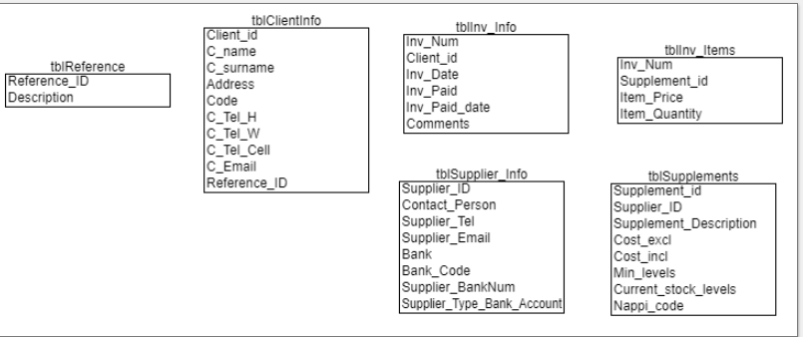

Use this template and complete Sections A and B.

Save it as *your student number*.*pdf*, e.g. *12345678.pdf*.

In the header of this template, add your student number.

Create the database.

Export it to SQL.

Save it as *your student number*.*sql*, e.g. *12345678.sql*.

Combine the PDF and the SQL into on ZIP file.

Save it as *your student number*.zip, e.g. *12345678.zip*.

[Please use the compress (ZIP) functionality of Windows, not 7ZIP or any other ZIP functionality]

Test that the ZIP folder can be unpacked. Should you submit a ZIP folder that we cannot open, then we will not be able to assess it, and you will receive 0%. As a backup, you may upload the ZIP folder to the DROPBOX on myUNISA. But, you still have to upload it via myUNISA to reflect on the Assignment system.

Upload the ZIP file to myUNISA, Assignment 1.

**SECTION A:**

**Question 1: Logo**



**Question 2:**

PHP & Java Script

**Question 3:**

MySQL

**Question 4:**

Windows OS

**SECTION B:**

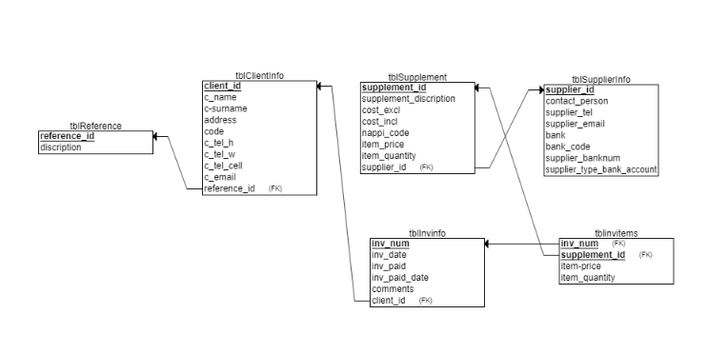

**SECTION C:**