**CSc 3320: Systems Programming**

Spring 2021

Homework

# 4: Total points 100

Submission instructions:

1. Create a Google doc for each homework assignment submission. 2. Start your responses from page 2 of the document and copy these instructions on page 1.

3. Fill in your name, campus ID and panther # in the fields provided. If this information is missing in your document TWO POINTS WILL BE DEDUCTED per submission.

4. Keep this page 1 intact on all your submissions. If this *submissions instructions* page is missing in your submission TWO POINTS WILL BE DEDUCTED per submission.

5. Each homework will typically have 2-3 PARTS, where each PART focuses on specific topic(s).

6. Start your responses to each PART on a new page.

7. If you are being asked to write code copy the code into a separate txt file and submit that as well.

8. If you are being asked to test code or run specific commands or scripts, provide the evidence of your outputs through a screenshot and copy the same into the document.

9. Upon completion, download a .PDF version of the document and submit the same.

Full Name: Noah Platt

Campus ID: nplatt1

Panther #: 002310477

**ALL PROGRAMS MUST BE COMMENTED. YOUR SOLUTION WILL NOT BE ACCEPTED IF THERE ARE NO COMMENTS IN YOUR SCRIPT. Also note that the comments MUST be useful and not be random.**

**PART 1: 40pts**

**Must incorporate use of Functions and Pointers**

1. 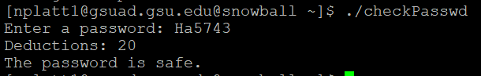

2. 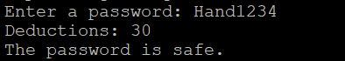

**Part II : 40pts**

**Must incorporate the use of Functions and Pointer arrays**

3. 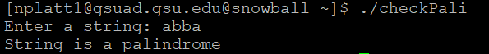

4. 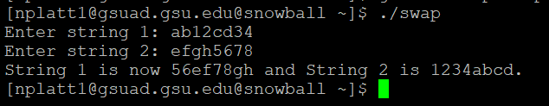

**Part III : 20pts**

**Must incorporate Functions, Pointers or PointerArrays, and Structures or Unions**

5. 