**CSc 3320: Systems Programming**

Spring 2021

Midterm 1: Total points = 100

Assigned: 26th Feb 2021: 12.01 PM

**Submission Deadline: 2nd Mar 2021: 12.01 PM**

**(No extensions. If your submission is not received by this time then it will NOT be accepted.)**

Submission instructions:

1. Create a Google doc for your submission.

2. Start your responses from page 2 of the document and copy these instructions on page 1.

3. Fill in your name, campus ID and panther # in the fields provided. If this information is missing TWO POINTS WILL BE DEDUCTED.

4. Keep this page 1 intact. If this *submissions instructions* page is missing in your submission TWO POINTS WILL BE DEDUCTED.

5. Start your responses to each QUESTION on a new page.

6. If you are being asked to write code copy the code into a separate txt file and submit that as well. The code should be executable. E.g. if asked for a C script then provide myfile.c so that we can execute that script. In your answer to the specific question, provide the steps on how to execute your file (like a ReadMe).

7. If you are being asked to test code or run specific commands or scripts, provide the evidence of your outputs through a screenshot and/or screen

video-recordings and copy the same into the document.

8. Upon completion, download a .PDF version of the google doc document and submit the same along with all the supplementary files (videos, pictures, scripts etc).

Full Name: Noah Platt

Campus ID: nplatt1

Panther #:002-31-0477

**Questions 1-5 are 20pts each**

1. I have placed 10 commands, awk, sed, cat, grep, vi, mkdir, rm, chmod, and rmdir in the mandatabase.txt file. The helpme.sh shell file, when run with ./helpme.sh, prompts the user to type a command. When a command in the database is typed, the corresponding information is printed, and the shell script terminates. If the command typed is different from one of the 10, “sorry, I cannot help you” is printed and the script terminates.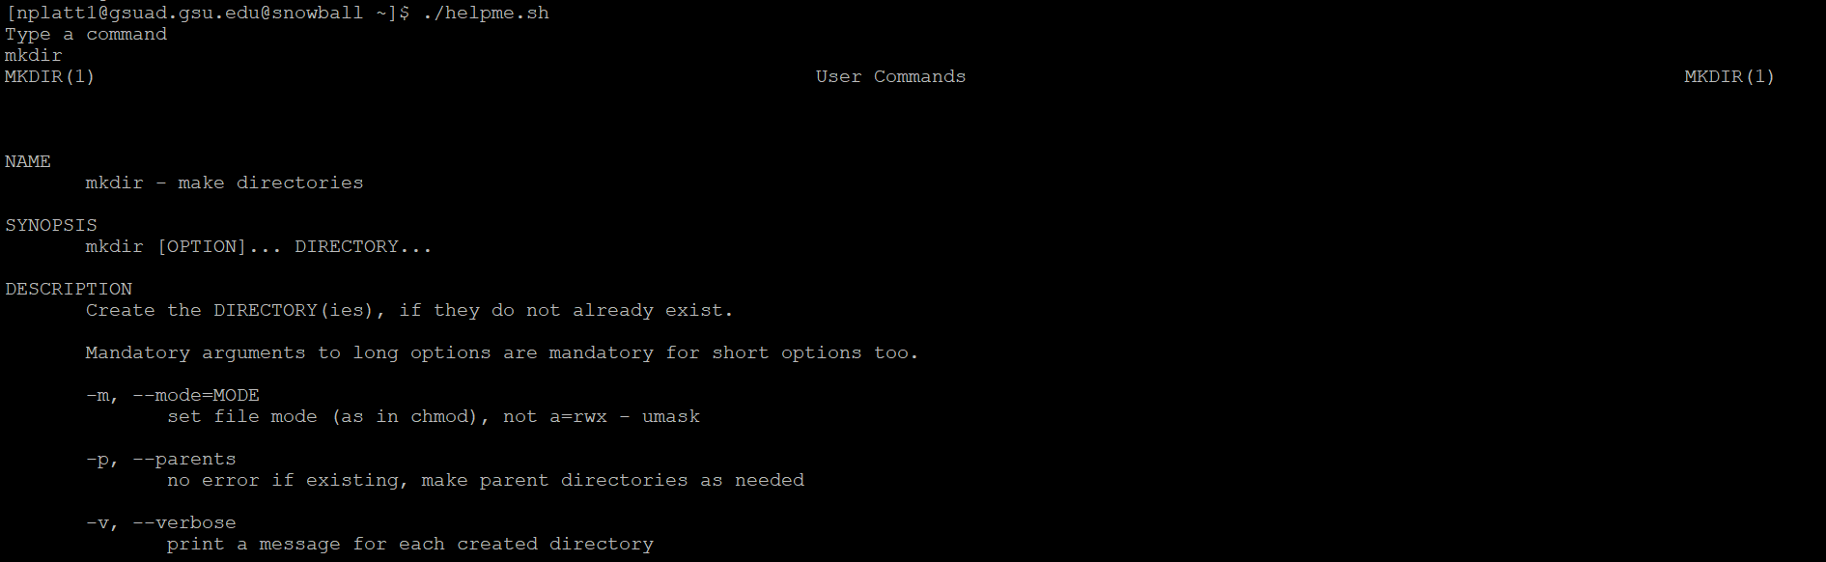

2. I used the wikipedia page for lemongrass for this question. The shell script I created, search.sh, is called using ./search.sh. This prompts the user to enter a keyword, and the shell script then searches the myexamfile.txt for the matching keywords, and prints the number of occurrences.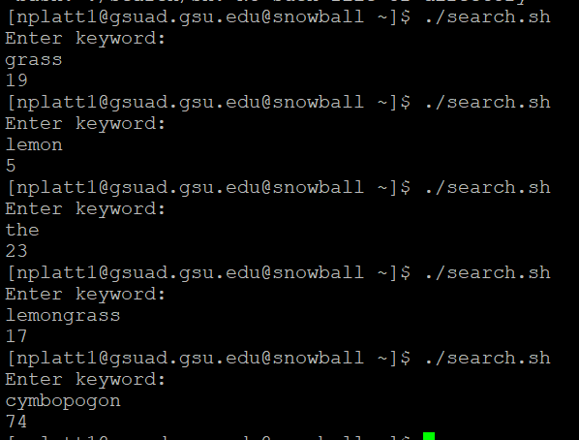

3. The shell script I wrote, access.sh, when executed with ./access.sh, asks the user to input a number equal to a number of days. It then finds all files in the current working directory that haven’t been accessed in that number of days and feeds that list to a tar command, which archives them.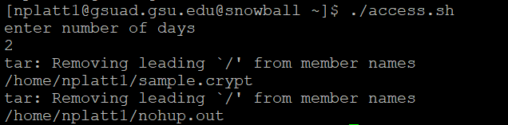

4. I wrote a phonebook utility, called with ./phonbook.sh, that prompts the user to either add, delete, or list the contents of the phonebook phonebook.txt. Typing add prompts the user to enter the name, number, and address of the person. Typing list lists the entries in phonebook.txt in alphabetical order. Typing delete prompts the user to enter the name of the entry being deleted. Typing quit exits the utility.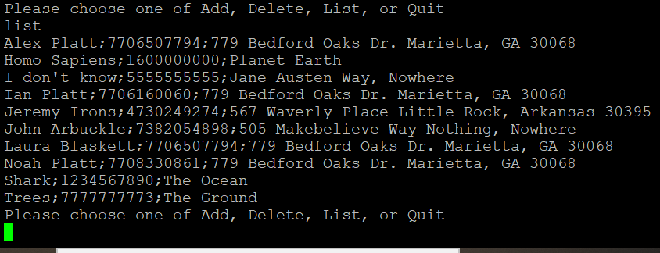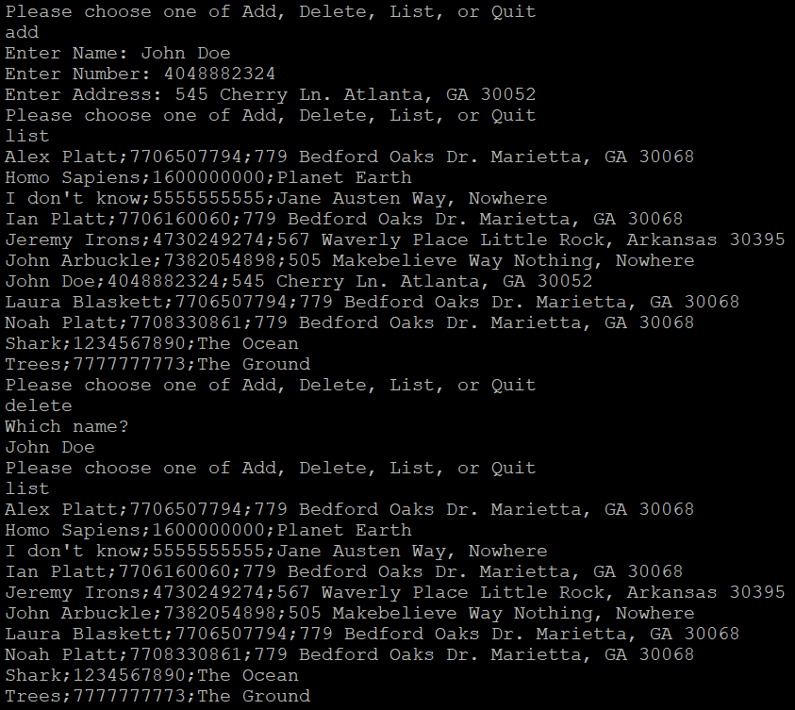

5.

1. I wrote a C script factorial.c. This prompts the user to enter a positive integer, and computes the factorial of the integer. The script factorial.c needs to be compiled using gcc, before being run with ./factorial.c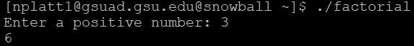
2. I wrote a C script shift.c. This takes an integer, shifts it three left bitwise, then adds the 1’s complement to it. After being compiled with gcc and run with ./shiftc, the script prompts the user to type an integer, and then generates the sum of the integer shifted left 3 bitwise, and the complement of the integer.