**,CSc 3320: Systems Programming**

Spring 2021

Midterm 2: Total points = 100

Assigned: 11th Apr 2021, Sunday 11:59 PM **Submission Deadline: 18th Apr 2021, Sunday, 11.59 PM (No extensions. If your submission is not received by this time then it will NOT be accepted.)**

Submission instructions:

1. Create a Google doc for your submission.

2. Start your responses from page 2 of the document and copy these instructions on page 1.

3. Fill in your name, campus ID and panther # in the fields provided. If this information is missing TWO POINTS WILL BE DEDUCTED.

4. Keep this page 1 intact. If this *submissions instructions* page is missing in your submission TWO POINTS WILL BE DEDUCTED.

5. Start your responses to each QUESTION on a new page.

6. If you are being asked to write code copy the code into a separate txt file and submit that as well. The code should be executable. E.g. if asked for a C script then provide myfile.c so that we can execute that script. In your answer to the specific question, provide the steps on how to execute your file (like a ReadMe).

7. If you are being asked to test code or run specific commands or scripts, provide the evidence of your outputs through a screenshot and/or screen

video-recordings and copy the same into the document.

8. Upon completion, download a .PDF version of the google doc document and submit the same along with all the supplementary files (videos, pictures, scripts etc).

Full Name: Noah Platt

Campus ID: nplatt1

Panther #:002-310477

**Questions 1-3 are 20pts each. Question 4 is 40pts**

**All programs have to be well commented. Non commented programs will receive 0 points. Comments have to be easily comprehensible and concise.**

1. To run the code, first copy it into your computer, then change the permissions so that it is executable. Then, compile the code using gcc, and run it using ./numSort.c. It will prompt the user with to chose to sort in ascending or descending order by typing a or d, case does not matter. The code will the sort and print the array in the correct order based on the user input. If a valid input is not entered, the code with notify the user and print the original array.



2. To run the program, first copy the c file into the computer. Change the permissions so the file is executable, then compile the file using gcc. Finally, tun the program using ./alphaSort.c. The file will prompt the user to enter a to sort in alphabetical order or d to sort is reverse order. The program will then print the strings in the indicated order. If an invalid input is entered, the computer will notify the user and print the strings in the original order.

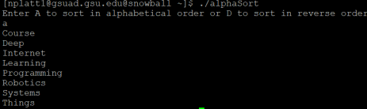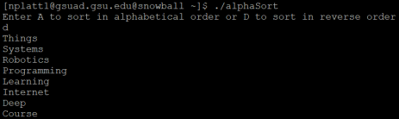

3. To run the program, compile it and enter ./dynaSort.c. It will prompt the user to enter the number of entries in the array to be sorted. This allows the code to allocate enough memory for the array. The program then prompts the user to enter the data. The user must type a number then press enter. It does this a number of times equal to the number the user entered at the beginning. After the data has been entered, the code prompts the user to choose in what order to sort the data. It then prints the data in the chosen sorted order. If there is an invalid input in choosing the order, the array is printed in the order the data was input.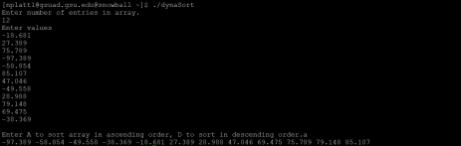

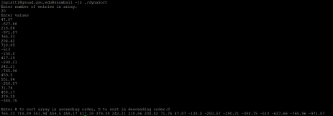

4. After loading and compiling the code, it can be run with ./codeReg.c. This prompts the user with (R)egister (V)iew (Q)uit. Entering one of the emphisized letters enables that action, while any other input causes the code to notify the user of an invalid input. Entering register leads the code to prompt the user to enter the information for the database entry. This includes name, dob, vaccine type, and zipcode, among other things. After entering all of the information, the code saves it and generates an 8 character code unique to the entry. This code can be used in the program. Selecting view prompts the user to enter a code. The program then prints the entry associated with the code. Quit exits the program.