Attendance Quiz #1

Name:_____________________________________________

1. Which one of these variables is a categorical variable?
  - Number of ear pierces a person has
  - Height of a person
  - Weight of a person
  - Opinion about legalization of marijuana

2. The following histogram shows the number of CDs owned by a sample of college students.
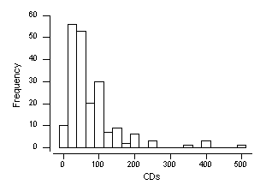
What is the approximate shape of the distribution?
  - Nearly symmetric.
  - Skewed
  - Bimodal

3. Which one of the summaries does NOT measure spread (variability)?
A. Mean B. IQR C. Standard deviation D. Range

4. Following is a five-number summary of n = 190 student responses to the question, “How many hours per week do you spend using a computer?”
Min Q1 Median Q3 Max
2 4 7 14 30

What is the value of the interquartile range (IQR)?
A. 7 B. 10 C. 28 D. None of choices A, B, C are correct
--------------------------------------------------------------------------------------------------

ANSWERS

Question | 1 | 2 | 3 | 4
Answer

