Attendance Quiz #3

Name:_____________________________________________

- Rank the following four scatterplots from strongest to weakest in terms of strength of relationship.
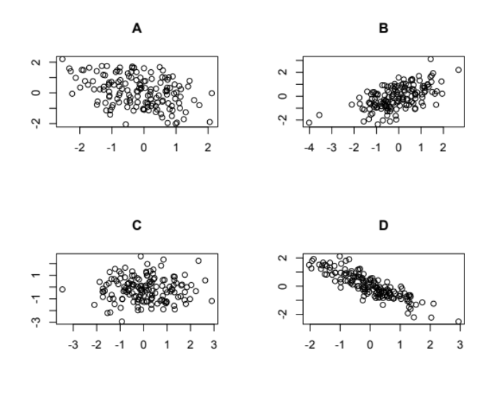
  - D, B, A, C
  - B, D, A, C
  - B, C, A, D
  - D, B, C, A

2. Suppose that a regression equation is determined relating weight (lbs.) to height (in.). The equation for the fitted line is given as: weight = -180 + 5*height. Which of the following statements is true?
A. We would predict the weight of a 5 foot tall person to be -155 lbs.
B. We would predict the weight of a 5 foot tall person to be 300 lbs.
C. We would predict the weight of a 5 foot tall person to be 120 lbs.
D. We can’t make a prediction about the weight of this person from this regression equation.

3. Refer to the regression equation in #2. Which of the following statements is the best interpretation of the slope?
A. If I grow one inch, I will gain five pounds.
B. If I grow one inch, I would expect to lose five pounds.
C. If I grow one inch, I will lose five pounds.
D. If I grow ten inches, I would expect to gain fifty pounds.

4. Refer to the regression equation in #2. Which of the following statements about the intercept is true?
A. It can help us to understand how heavy fetuses might be on average.
B. It is interpretable only if very short people were included in the sample used to build the equation.
C. It is not interpretable.
D. There is not enough information to say anything about the intercept.
-------------------------------------------------------------------------------------------------
ANSWERS

Question | 1 | 2 | 3 | 4

Answer

