Attendance Quiz #9

Name:______________________________________________________________________________________

- Which of the following statements is true about a parameter and a statistic for samples taken from the same population?
  - The value of the parameter varies from sample to sample.
  - The value of the statistic varies from sample to sample.
  - Both A and B are true.
  - Neither A nor B are true.

- Which of the following statements best describes the relationship between a parameter and a statistic?
  - A parameter estimates the unknown value of a statistic
  - A statistic estimates the unknown value of a parameter

- In a poll of n = 200 randomly selected individuals, 60 people said they are opposed to the death penalty for persons convicted of murder. What is the value of (p-hat) here?

  - 60
  - .60
  - .30
  - 200

- In a poll of n = 200 randomly selected individuals, 60 people said they are opposed to the death penalty for persons convicted of murder. What is the value of the standard error of the sampling distribution of p-hat here?
  - 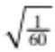
  - 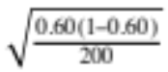
  - 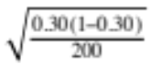
  - 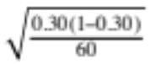
  - 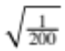

-----------------------------------------------------------------------------------------------
ANSWERS

Question | 1 | 2 | 3 | 4
Answer

