8.58 **a.** *P*(0 <= *X* <= 30) = .5 (because the interval from 0 to 30 is one-half of the interval of possible outcomes (0 to 60) and the distribution is uniform. **)**

**b.** *P*(30 <= *X* <= 60) = .5 by the same reasoning as in part (a).

8.60

**a.** The rectangle has height =1/10=0.1 because the range of *X* is 2010 = 10. Figure for Exercise 8.60a

**b.** The rectangle has height =1/20=0.05 because the range of *X* is 20  0 = 20. Figure for Exercise 8.60b

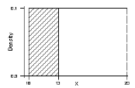 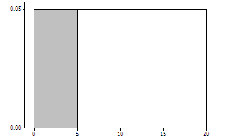

142

**c.** The rectangle has height =1/8=0.125 because the range of *X* is 8  0 = 8.

Figure for Exercise 8.60c

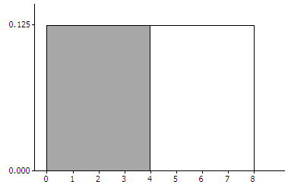

8.64

(70  65) / 4= 1.25

(115120) / 10 = -.5

(8272) / 8 = 1.25

(62  72) / 8 = -1.25

8.66 a. .9750 **b.** .0099 c**.** .9951 **d.** .9505

8.68**a.** 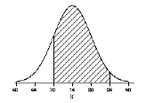

*Note*: The range of this normal curve was determined using the fact that about 99.7% of the area will be in the range mean  3 standard deviation.

**b.** 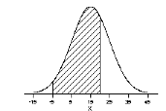

*Note*: The range of this normal curve was determined using the fact that about 99.7% of the area will be in the range mean  3 standard deviation.

**c.**  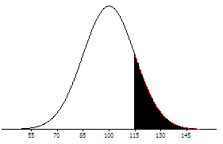

*Note*: The range of this normal curve was determined using the fact that about 99.7% of the area will be in the range mean  3 standard deviation.

8.72 **a.** Note that 500 is the mean, and the distribution is symmetric, so *P*(*X* < 500) = .5 (because the probability  is .5 on each side of the mean).

**b.** For 650, *z* (650-500)/1001.5 so *P*(*X* < 650)=*P*(*Z* < 1.5)=.9332

**c.** For 700,

*z*  (700-500)/1002, so *P*(*X* >700)=*P*(*Z*>2)=1*P*(*Z*<2)=1.9772=.0228.

Equivalently,*P*(*Z* > 2) = *P*(*Z* < 2) = .0228

**d.** *P*(500<*X*<700)=*P*(0<*Z*<2)=*P*(*Z*<2)*P*(*Z*<0)=.9772.5=.4772

8.82

**a.** mu = 100*.5 = 50, sd = sqrt(50*.5) = 5

**b.** P(X ≥ 60) = 1-P(X≤59) ≈ 1 – P(Z < (59-50)/5) = 1 – P(Z < 1.8) = 1  .9641 = .0359.

**c.** P(X ≥ 60) = 1-P(X≤59) ≈ 1 – P(Z < (59.5-50)/5) = 1 – P(Z < 1.9) = 1  .9713 = .0287.

**d.** P(X ≥ 60) for n = 100 and p = .5 is 0.0284. With some software, this is found as 1 – P(X ≤ 59) = 1 – .971556.

**e.** The most accurate is the exact probability in part (d). The least accurate is the approximation without the continuity correction, in part (b).

8.90

**a.** Normal.

**b.** 70 – 70 = 0.

**c.** sqrt(2.8^2 + 2.8^2) = 3.96

**d.** z* = 3/3.96 = .76, P(Z>.76) = 1-P(Z<.76) = 1–.7764=.2236.

**e.** By symmetry, P(*D* < 3) = P(D > 3) = .2236 (value found in part (b)).  Thus, P(*D* < 3) + P(*D* > 3) =.2236 + .2236 = .4472.

8.92 **a.** =75+70=145 and  sqrt(62 82 )=10

**b.**=7570=5 and  sqrt(6282)=10.