**MLflow Alpha Release**

Warning

The current version of MLflow is an alpha. This means that APIs and storage formats are subject to change!

**Installing**

Install MLflow from PyPi via pip install mlflow

MLflow requires conda to be on the PATH for the projects feature.

**Documentation**

Official documentation for MLflow can be found at <https://mlflow.org/docs/latest/index.html>.

**Running a Sample App With the Tracking API**

The programs in example use the MLflow Tracking API. For instance, run:

python example/quickstart/test.py 需要增加一点东西 比如import Mlflow mlflow.set_tracking_uri(**".//log"**)

This program will use MLflow log API, which stores tracking data in ./mlruns, which can then be viewed with the Tracking UI.

**Launching the Tracking UI**

The MLflow Tracking UI will show runs logged in ./mlruns at [http://localhost:5000](http://localhost:5000/). Start it with:

mlflow ui

首先要进到有log产生的目录然后运行mlflow ui这样会产生mlruns目录 产生mlruns目录后再<http://localhost:5000>就能访问log信息

Mlruns目录下必须有很多记录信息时才能在网站上查找到

**Running a Project from a URI**

The mlflow run command lets you run a project packaged with a MLproject file from a local path or a Git URI:

mlflow run example/tutorial -P alpha=0.4

mlflow run git@github.com:databricks/mlflow-example.git -P alpha=0.4

mlflow run --no-conda https://github.com/cliicy/MLProjs.git -P alpha=5

mlflow run --no-conda https://github.com/databricks/mlflow-example.git -P alpha=8

_fetch_project:从本地fetch或者从github上fetch

_run_project

See example/tutorial for a sample project with an MLproject file.

**Saving and Serving Models**

To illustrate managing models, the mlflow.sklearn package can log Scikit-learn models as MLflow artifacts and then load them again for serving. There is an example training application in example/quickstart/test_sklearn.py that you can run as follows:

$ python example/quickstart/test_sklearn.py

Score: 0.666

Model saved in run <run-id>

$ mlflow sklearn serve -r <run-id> model

$ curl -d '[{"x": 1}, {"x": -1}]' -H 'Content-Type: application/json' -X POST localhost:5000/invocations

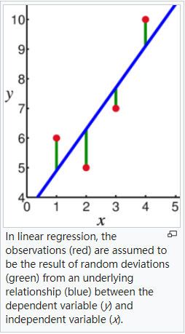

https://en.wikipedia.org/wiki/Linear_regression

file:///H:/2018_git_task/

Notes:

1. Install conda from E:\tools\Anaconda3-5.2.0-Windows-x86_64.exe
2. Fix the co-existence problem about multiple python version: channge the environment variable path
3. Make sure you are using the higher version of pip
4. When you are encountering the error like URI is not set correctly, you need to set the URI: using environment variable



1. It seems like mlflow.set_tracking_uri("..\\") doesn’t work actually under conda env, however it works fine under --no-conda env.
2. Adding the function about let it run modulexx.py under windows platform by changing the code under E:\Anaconda\Lib\site-packages\mlflow\project.py

