Q1A) 1,2,4

Q1B) {}

Q2:

S = AA | B | SS

Q3.

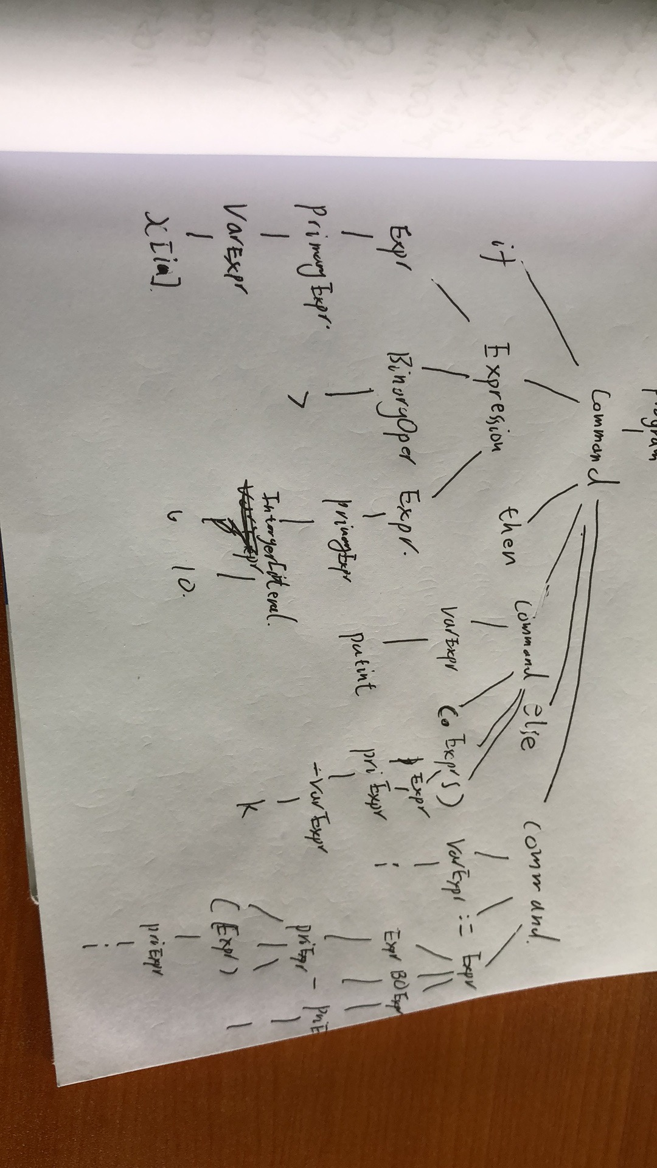

if a > b then

let var a : Integer

in

b := a

else

a := b

Q5,

(If,line 1, column 1)

(Id {idName = "a"},line 1, column 4)

(Op {opName = ">"},line 1, column 6)

(Id {idName = "b"},line 1, column 8)

(Then,line 1, column 10)

(Let,line 2, column 1)

(Var,line 2, column 5)

(Id {idName = "a"},line 2, column 9)

(Colon,line 2, column 11)

(Id {idName = "Integer"},line 2, column 13)

(In,line 3, column 1)

(Id {idName = "b"},line 4, column 1)

(ColEq,line 4, column 3)

(Id {idName = "a"},line 4, column 6)

(Else,line 5, column 1)

(Id {idName = "a"},line 6, column 1)

(ColEq,line 6, column 3)

(Id {idName = "b"},line 6, column 6)

(EOF,line 7, column 1)

Q6,

CmdIf <line 1, column 1>

ExpApp <line 1, column 4>

ExpVar ">"

ExpVar "a"

ExpVar "b"

CmdLet <line 2, column 1>

DeclVar <line 2, column 5>

"a"

TDBaseType "Integer"

CmdAssign <line 4, column 1>

ExpVar "b"

ExpVar "a"

CmdAssign <line 6, column 1>

ExpVar "a"

ExpVar "b"