Computer Graphic Assignment 1 Report

Like Chen 16518695

1. OpenGL version: 4.0

GLUT Version: 3.7

Freeglut: freeglut 2.8.1-1.mp for MSVC

Windows version: Windows 10

Visual Studio version: Visual Studio 2017

1. First, I separate function for draw the head, shoulders and Knees, body, arms and legs.

In the highest hierarchical I have:

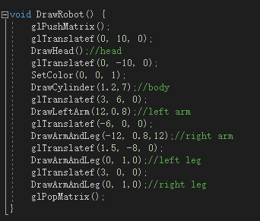

Which represent

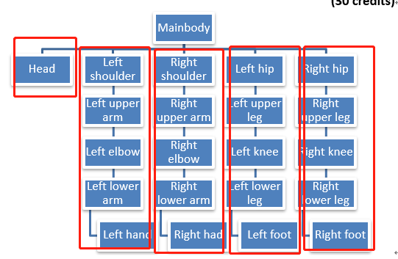

Then

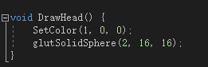

Represent

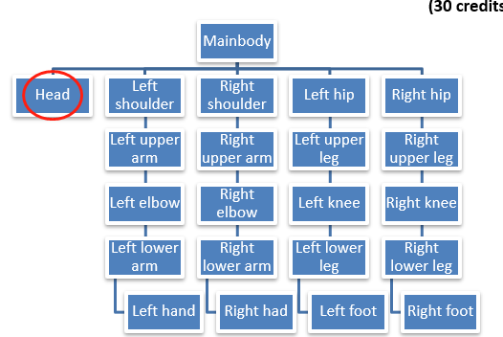

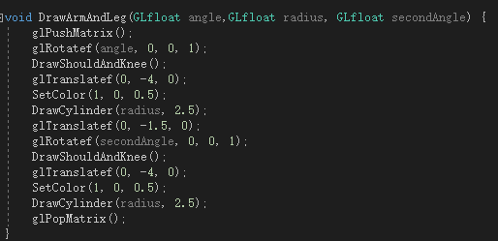

For draw whole arm or leg.

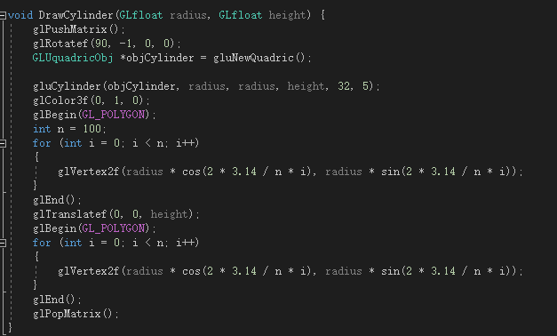

For draw body and single arm or leg 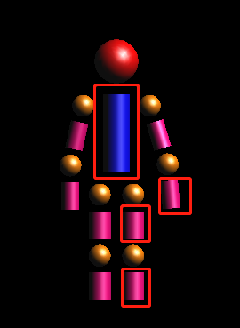.

And

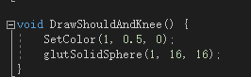

For shoulders and knees.

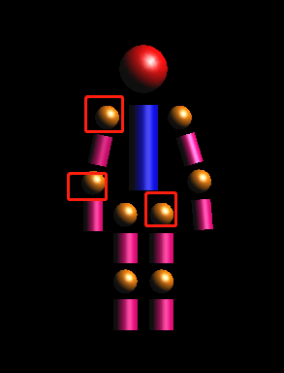

1. Structure of program 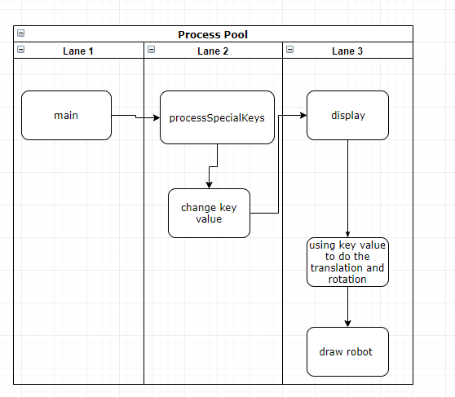
2. X: rotate about x-axis

Y: rotate about y-axis

Z: rotate about z-axis

A: rotate lower arm

S: rotate lower arm opposite

Q: rotate upper arm

W: rotate upper arm opposite

D: rotate forward lower arm

F: rotate backward lower arm

E: rotate forward upper arm

R: rotate backward upper arm

2,4,6,8: translate down left right and up (using num keyboard)

5: translate forward

0: translate backward

‘space’: reset all state

e)

origin:

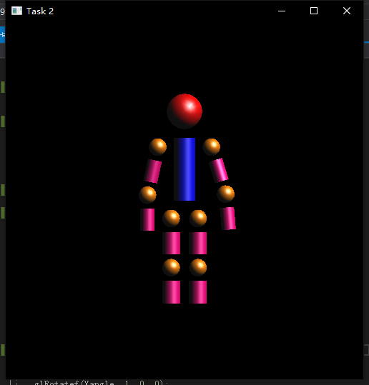

rotate about x 45 degree

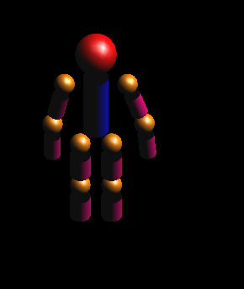

Rotate about y 90 degree

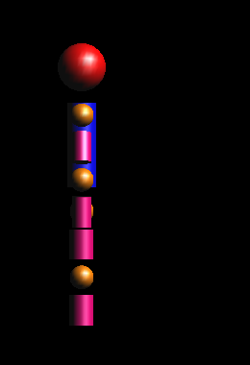

Rotate about z 90 degree

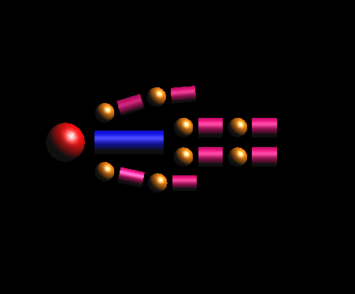

Move:

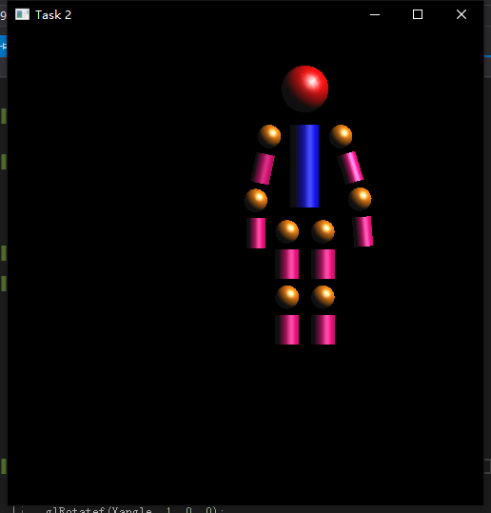

Raise lower arm:

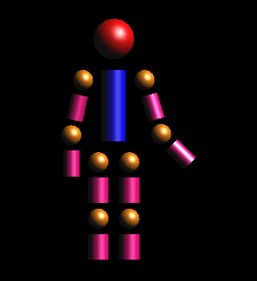

Raise upper arm:

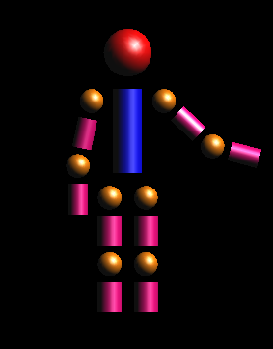

Move lower arm forward:

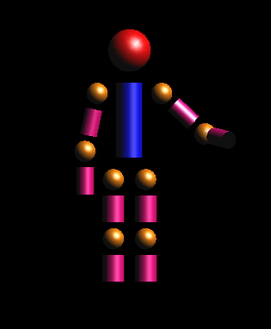

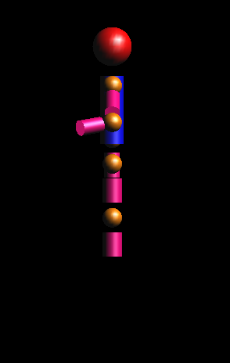

Move upper arm forward:

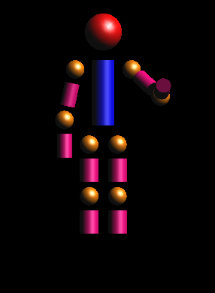

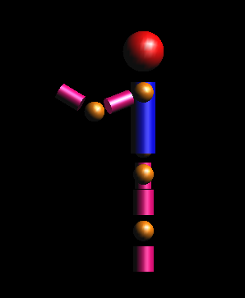

RESET:

