**COMP 3069 -- Computer Graphics**

**Project (Draft) -- *subject to small change***

**(*Not formally released yet*, just let you to first think about it.)**

## Description

The project requires you to create a 3D scene by yourself. The scene could be a scene from real world, or a virtual scene created by your imagination. The purpose of the project is to require you to demonstrate your knowledge of techniques taught in the lectures and labs. We also give credits for your creative ideas being contributed in your project. Some example 3D scene are given as follows:

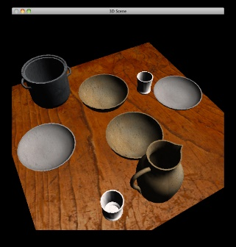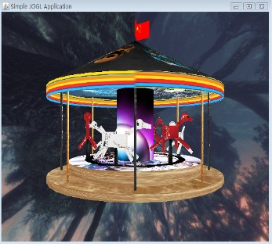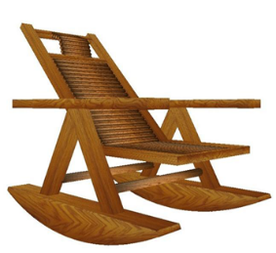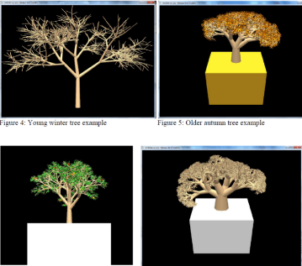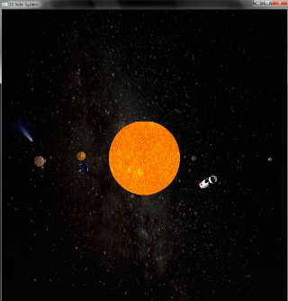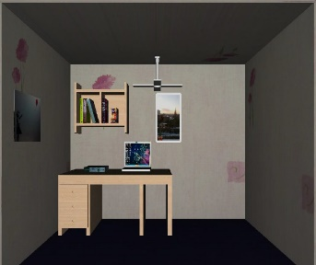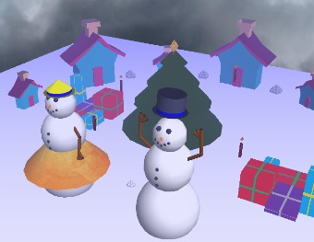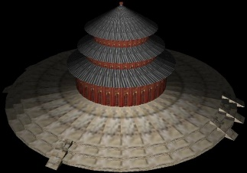

You are required to create a 3D scene with the majority of the following items:

* + Several 3D models,
  + Transformation of models (scaling, translating, rotating),
  + Different viewpoint, or animations,
  + Texturing –you need to employ texture to make some models look more realistic.
  + Lighting – you should apply lighting effect in your scene.

## Proposal

After two weeks of the release date, you need to submit a 3-page draft proposal of what you want to do for creating the 3D scene (although you could deviate a bit when you are progressing in doing your project).

**(3% marks)**

## Interim report

After five weeks of the release date, you need to submit a 6-page progress report telling us the progress of your program, what tasks are remained to be done. The purpose of this interim report is to remind you NOT to do the whole project until the very last minute.

**(7% marks)**

## Full program

After eight or nine weeks of the release date, you need to submit the full program, including:

* + Program (source code)

**(70% marks)**

* + Demo (compiled executable)

**(10% marks)**

## Full report

After eight or nine weeks of the release date, you need to submit a 8 to 10-page full report, describing how to use your program, how you meet the requirements, and your creative ideas contributed in creating the scene.

**(10% marks)**

## Submission

A digital copy of your report, code, and compiled executable along with a printed version of your report, in a single zip file, should be submitted on Moodle.

Your digital version should be packaged in a folder titled CG_2018_YOURNAME_IDNUMBER. Your report should have the filename CG_2018_IDNUMBER_REPORT.pdf.