**Technical Meeting Minutes**

Teleconference hold on 4th of June 2020

Issued by: Tecnalia / Nieves Peña

Date: 04/06/2020

Ref: C3S_429c_D0.2.1.04062020_TechnicalMeetingMinutes_v1.docx

Official reference number service contract: 2019/ C3S_429c_TECNALIA

# Attendees

1. Table of attendees

|  |  |  |
| --- | --- | --- |
| Name | Organization | e-mail |
| Isabella Mazza | ECMWF | [Isabella.Mazza@ecmwf.int](mailto:Isabella.Mazza@ecmwf.int) |
| Eva Remete | ECMWF | [eva.remete@ecmwf.int](mailto:eva.remete@ecmwf.int) |
| Chiara Cagnazzo | ECMWF | [chiara.cagnazzo@ecmwf.int](mailto:Chiara.Cagnazzo@ecmwf.int) |
| Stijn Vermoote | ECMWF | [Stijn.Vermoote@ecmwf.int](mailto:Stijn.Vermoote@ecmwf.int) |
| Jorge Paz | Tecnalia | [jorge.paz@tecnalia.com](mailto:jorge.paz@tecnalia.com) |
| Blas Lajarín | Tecnalia | [blas.lajarin@tecnalia.com](mailto:blas.lajarin@tecnalia.com) |
| Nieves Peña | Tecnalia | [nieves.pena@tecnalia.com](mailto:nieves.pena@tecnalia.com) |
| Jon Ander Gabantxo | Tecnalia |  |

# Agenda

The proposed agenda for this technical meeting was to discuss about the following issues: the Landing Page and the ERA5_Land versus observational data.

# Summary and Main action points:

**Presentation of the technical work performed**

Firstly, the plots of ERA5land vs AEMET´s observations (previously sent to Chiara) are shown. As it can be observed there is a strong linear correlation, but important biases for each point studied.

Tecnalia suggest that as there is different bias for each station, for each region, an average could be done and applied to recalculate:

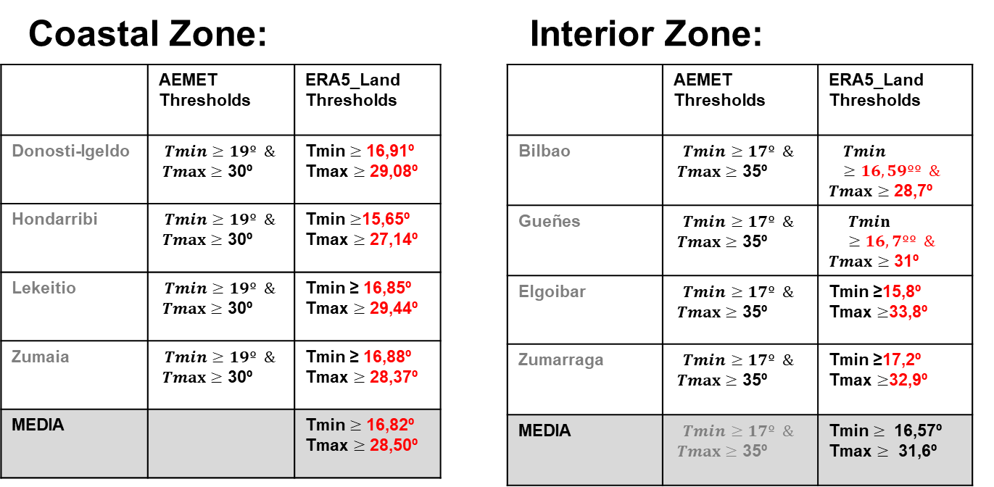

Chiara agree with this firs approach. She also mentions other possibilities, as place all the points (from different stations) in the same plot, but the outcome will be more or less the same. So she agree with that firs approach of using the average value.

Secondly, Tecnalia presents a second approach to take into account the altitude of each station. But the numbers are still a bit confusing as the altitude of the stations don’t correspond with the geopotential altitude obtained from ERA5Land. For example:

|  |  |  |
| --- | --- | --- |
| **Location** | **AEMET station altitude** | **ERA5Land geopotential altitude** |
| Igeldo-San Sebastian | 251 m | 361 m |
| Hondarribia-Malkarroa | 4m | 441m |
| Zumaia | 28m | 308m |
| (more values on the slide) | | |

Tecnalia asks about the difference between these number. That is, the correction of the altitude of the pixel vs the altitude of the station will be explored in the coming days. Tecnalia will send the equations that is using for this.

**Landing Page**

Several important comments in the landing page are shared by Chiara. Tecnalia will review the current text and share it again.

**Other issues:**

Stijn asks about the planning of the coming activities. The idea is to finalize the web portal in the coming days to start the validation interviews with the users: plans will be shared soon with ECMWF.(in the next deliverable)

Tecnalia and Vizzuality will sent eventual questions about the development to Chiara and Eva.

Isabella also asks about the signature of the amendment of this contract, as they haven’t received it yet. Tecnalia will be in chare of asking about this and answer as soon as possible.

**Next Activities and to-do’s**

* Sent the updated version of the **landing page** to Eva. (already done)
* Tecnalia will send the equations that is using for regressions and comparative numbers to be validated by Chiara.
* Signature of the contract amendment (already done and solved)