
 FeliXSim Facilitator Guide Template

<EVENT TITLE>
Date: ? | Location: Online/Physical | Time: ?
Facilitators: ? | Participants: ?

Tool: https://climatechoice.github.io/felix/

Flow of Workshop
- [Time – Time] Introduction: ???
- [Time – Time] Exercise 1: ???
- [Time – Time] Discussion: ???

Total: ??? mins

Materials
- Would be useful in larger facilitation settings, e.g. guides, writing materials, whiteboards, etc.

*Useful Icons
Navigation
Input Tabs | 
Input Buttons
Output Tabs
Multi Scenario | 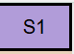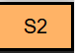

Introduction (Sample)
Setting the Context
- Usage: FeliXSim creates scenarios using:
  - Inputs: actions (consumer/producer), uncertainties, and drivers.
  - Outputs: outcomes on environmental and social systems.
- Framing: FeliXSim creates scenarios on a global scale - “what if the world adopts your actions”, showing the translation of personal choices into broader outcomes.

Main Interface: How to use FeliXSim
- Basic Interface: Inputs on Left, Outputs on Right.
  - Briefly explain the content on the home screen.
- Demonstrate a basic scenario.
  - Focus on 1 action, 1 outcome on the home screen.
- Demonstrate more customisation in actions.
  - Show different input tabs (,)
  - Show custom inputs
  - Show mini graph , also extended description
- Demonstrate customisation in outcomes.
  - Explain Summary Tab + Targets
  - Show graph links between summary to system tabs
  - Show Trade-off Graphs

Optional: Other Advanced Functions
Not necessary since it can be introduced DURING the exercises.
- Multi-Scenario Mode
- Survey Function
- Storyline Function

E1 What if the world starts eating like you?

Building your first scenario
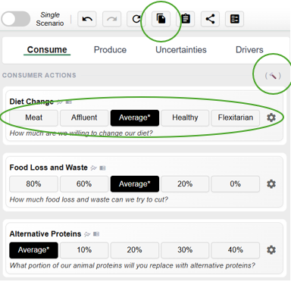
Participants build a personalised scenario that represents a future in which everyone adopts the same food behaviour. There are multiple ways for participants to do this:
- Automatic (for laymen):
Use the survey function to generate a scenario from responses.
- Manual (some knowledge):
Select input buttons/custom inputs only from

Participants can save the scenarios using the copy button and volunteer to share them.
Figure 1: Key scenario building functions

Observation of outcomes
Participants and Facilitators can look at the results of the scenario created:

- Facilitators guide Participants to understand each outcome/indicators; also addressing if scenario presents positive or negative change
  - E.g. “Biodiversity falls, more species are lost, which is bad”. Tooltips have helpful explanations.
  - Compare results with the target as a way to understand positive/negative change.

- Facilitators can prompt Participants to find out why their actions lead to these changes.
  - (Suggestion) Participants explore 2 outcomes.
  - *Clicking the graphs in the summary tab, which links them to system tabs that have relevant graphs.

Discussion: Open-ended reflections
Facilitators ask Participants what they feel and have learnt from exploring the effects of their consumer actions.

E2 What is the role of sustainable consumption?

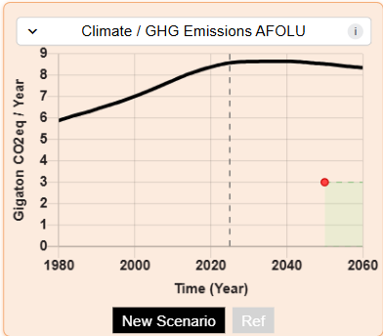
Setting the context of targets
Facilitators explain the goal that we should keep the world within a “safe operating space”.
- The goal is visualised by the targets which are both international agreements and normative targets.
Figure 2: Key scenario building functions

Participants can explore what scenarios enable the goals.
- First, explore “optimistic” actions (beyond their original scenario). They will learn that this is insufficient.

- Second, explore only . They will learn that some trade-offs happen.
Figure 2: Projected outcome (of Climate) with the visualised target space

- Finally, explore combinations of and to learn that it is indeed possible.

Discussion: What role do we play as consumers?
Facilitators are to engage with Participants on learning points from this.

Can our targets be reached from only changes in consumption behaviour?
“A combination of Actions is needed to reduce environmental pressures” (Springmann et al., 2018). Demand-side (and supply-side) approaches are not enough to meet targets, but they should be used in combination with other solutions.

Between consumption and production actions - what role does consumption play?
“Sustainable Consumption and Production policies are most effective at minimising trade-offs and argue for their centrality to the formulation of coherent SDG strategies.” (Obersteiner et al., 2016). Demand-side approaches’ key advantage is that they incur few trade-offs. Positive changes in all indicators in any low-meat scenario illustrate this.

Discussion
- If the exercises lead to a central point or insight. Use this section to debrief with participants
- Discuss what they observed, compare results or connect the exercise back to the main concepts introduced

Feedback Collection
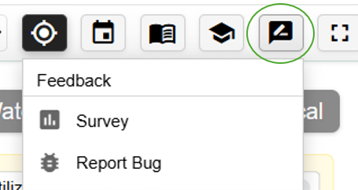

Feedback can be collected via two main channels
- Feedback on user experiences can be collected using a survey form.
- Feedback on technical bugs can be collected via our github repo.

References
- (If discussion points require citations)

