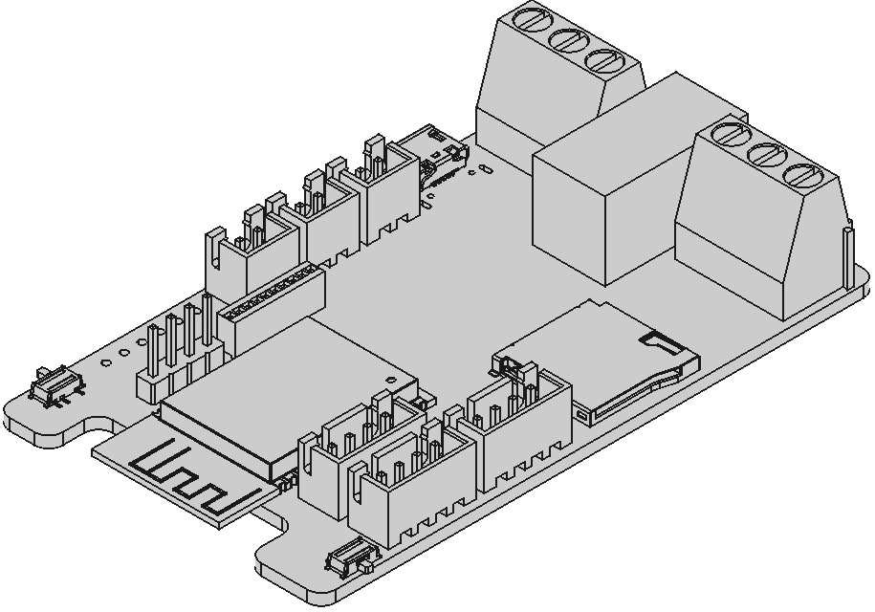

# 1 Key features

**Functional:**

* Low power consumption in IDLE state
* Can be powered by lithium-ion battery
* Build-in battery protection
* Solar panel support for battery charging
* Build-in bistable relay
* TYPE-C port for powering the board
* Firmware can be flashed via TYPE-C in DFU mode
* Micro-SD slot
* Main controller – ESP32S2
* Support for up to 2 I2C and 1 UART devices
* Ability to measure battery voltage
* USB host controller
* Support for GSM modules like sim800l

**Electrical**:

* Supply voltage: 5V
* Power consumption in low power mode: 80 uA

**Technical**:

* Compact dimensions:  
  78.5mm х 46mm х 13.5mm
* Board weight:12 g
* Operating temperature range:   
  -40°C - +70°C

# 2 Description

CG_lpc_board – universal motherboard with low power consumption. Onboard central controller – ESP32S2. The board is designed to be used as the main controller for an autonomous weather station.

An unprotected 1S (3.7V) lithium battery can be used as the primary power source for the board. A built-in changer controller can be powered by a solar panel or a 5V DC power adapter.

For power efficiency, all the peripheral devices can be powered off.

External actuators can be controlled by the electromechanical relay.

A microSD card can be used for storing information.

The board can be programmed either through a type-c in DFU mode or using CG_Programmer by ClimateGuard.

Table of Contents

1 Key features 1

2 Description 1

Table of Contents 2

3 Device Characteristic 3

3.1 Technical 3

3.2 Dimensions 3

4. Board pinout 4

5. Device drawing 5

6 Reference 5

# 3 Device Characteristic

## 3.1 Technical

|  |  |  |  |  |
| --- | --- | --- | --- | --- |
| **Parameter** | **Value** | | | **Unit** |
| **Not less** | **Normal** | **Less than** |
| Supply voltage | 5.0 | 5.0 | 5.0 | V |
| Battery voltage | 2.7 | -- | 4.2 | V |
| Board power consumption | 0.08 | -- | 350 | mA |
| Battery charge current | -- | 350 | -- | mA |
| Operating temperature range | -40 | +20 | +70 | °С |
| Operating humidity range | 0 | 60 | 98 | % |

*Table 1 (Technical characteristics)*

## 3.2 Dimensions

Dimensions: 78.5 mm х 46 mm х 13.5 mm.

Board weight: 50 g.

# 4. Board pinout

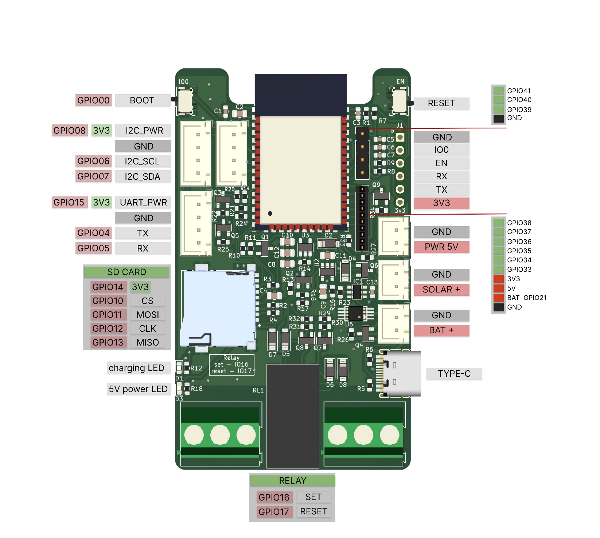

# 5. Device drawing

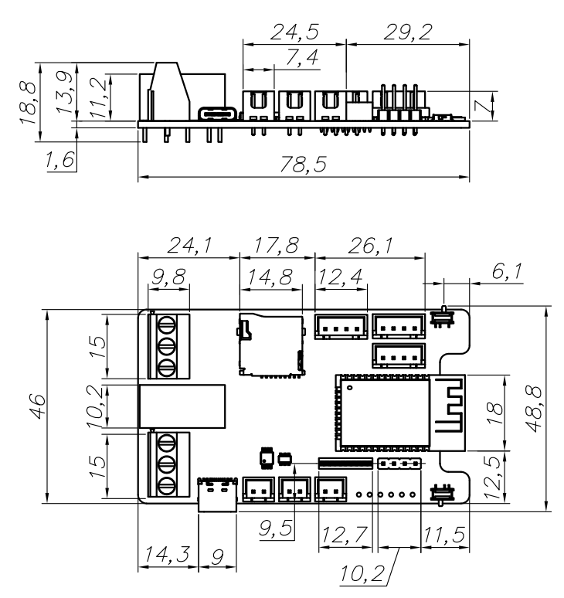

# 6 Reference

Contacts and additional information are presented in the table below.

|  |  |
| --- | --- |
| **Description** | **Link** |
| Manufacture website | <http://climateguard.ru/> |
| Additional materials | <https://github.com/climateguard/CG_LPC_Board> |
| Telegram community | <https://t.me/climateguard_community> |

*Table 2 (Reference)*