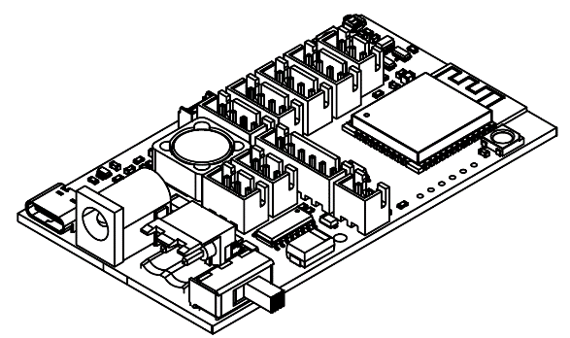

# 1 Main features

* Hardware:

- Onboard microcontroller – ESP32-WROOM

- External watchdog timer

- 2 RGB LEDs – WS2812B

- Onboard step-down DC-DC converter

- Logic output for external relay, beeper and etc. up to 0.5a power.

-Fan output with PWM support and filtration.

- connectors JST 2.54 for external sensors and devices

- simultaneously support:

- up to 3 I2C sensors

- up to 2 UART sensors

- up to 1 analog sensor

- up to 1 OneWire sensor

- up to1 SPI sensor

- up to 1 relay / beeper

- input reverse polarity protection

- Input power supply connectors: USB type-C, DC barrel, terminal connector

* Electrical:

- supply voltage: type-C – 5V, terminal/DC – 9..28V.

* Technical:

- compact dimensions  
76mm х 46mm х 13,5mm

- board weight <12 г

- Operating temperature range  
-40°C - +70°C

# 2 Описание

CG-mini – universal motherboard designed for sensors based, monitoring and executive device control projects. Onboard microcontroller – esp32 by Espressif has built in WIFI and Bluetooth interfaces for communication with over devices and data systems.

Increased reliability of the system is provided by an external watchdog timer.

Оглавление

1 Main features 1

2 Description 1

3 Device characteristics 3

4 Whatchdog timer 4

5 Connectors 5

6 Drowing 6

Attachment 7

# 3 Device characteristics

|  |  |  |  |  |
| --- | --- | --- | --- | --- |
| **PARAMETER** |  | | | **UNIT** |
| **MIN** | **TYP** | **MAX** |
| Power supply operating range | 7.5 | - | 28 | V |
| Max provide output current on 5v power line | - | - | 2 | A |
| Max provide output current on 3.3v power line | - | - | 1 | A |
| Temperature operating range | -40 | +20 | +70 | °C |
| Humidity operating range | 0 | 60 | 98 | % |

*Table 1*

# 4 Watchdog timer

Board has built in external watchdog timer. It’s needs for prevent possible freezes of microcontroller and increase the reliability of the system as a whole.

When the board is working, watchdog must be rebooted periodically. To do this, apply to the IO32 pin a variable edge (signal transition from low to high) of the pulse. This impulse must be received by watchdog at least every 60 seconds (or often).

If microcontroller is freezes and do not apply the impulses to IO32 at a set time interval, the watchdog reboots it by switching power. The microcontroller has no power during ~200 msec.

# 5 Connectors

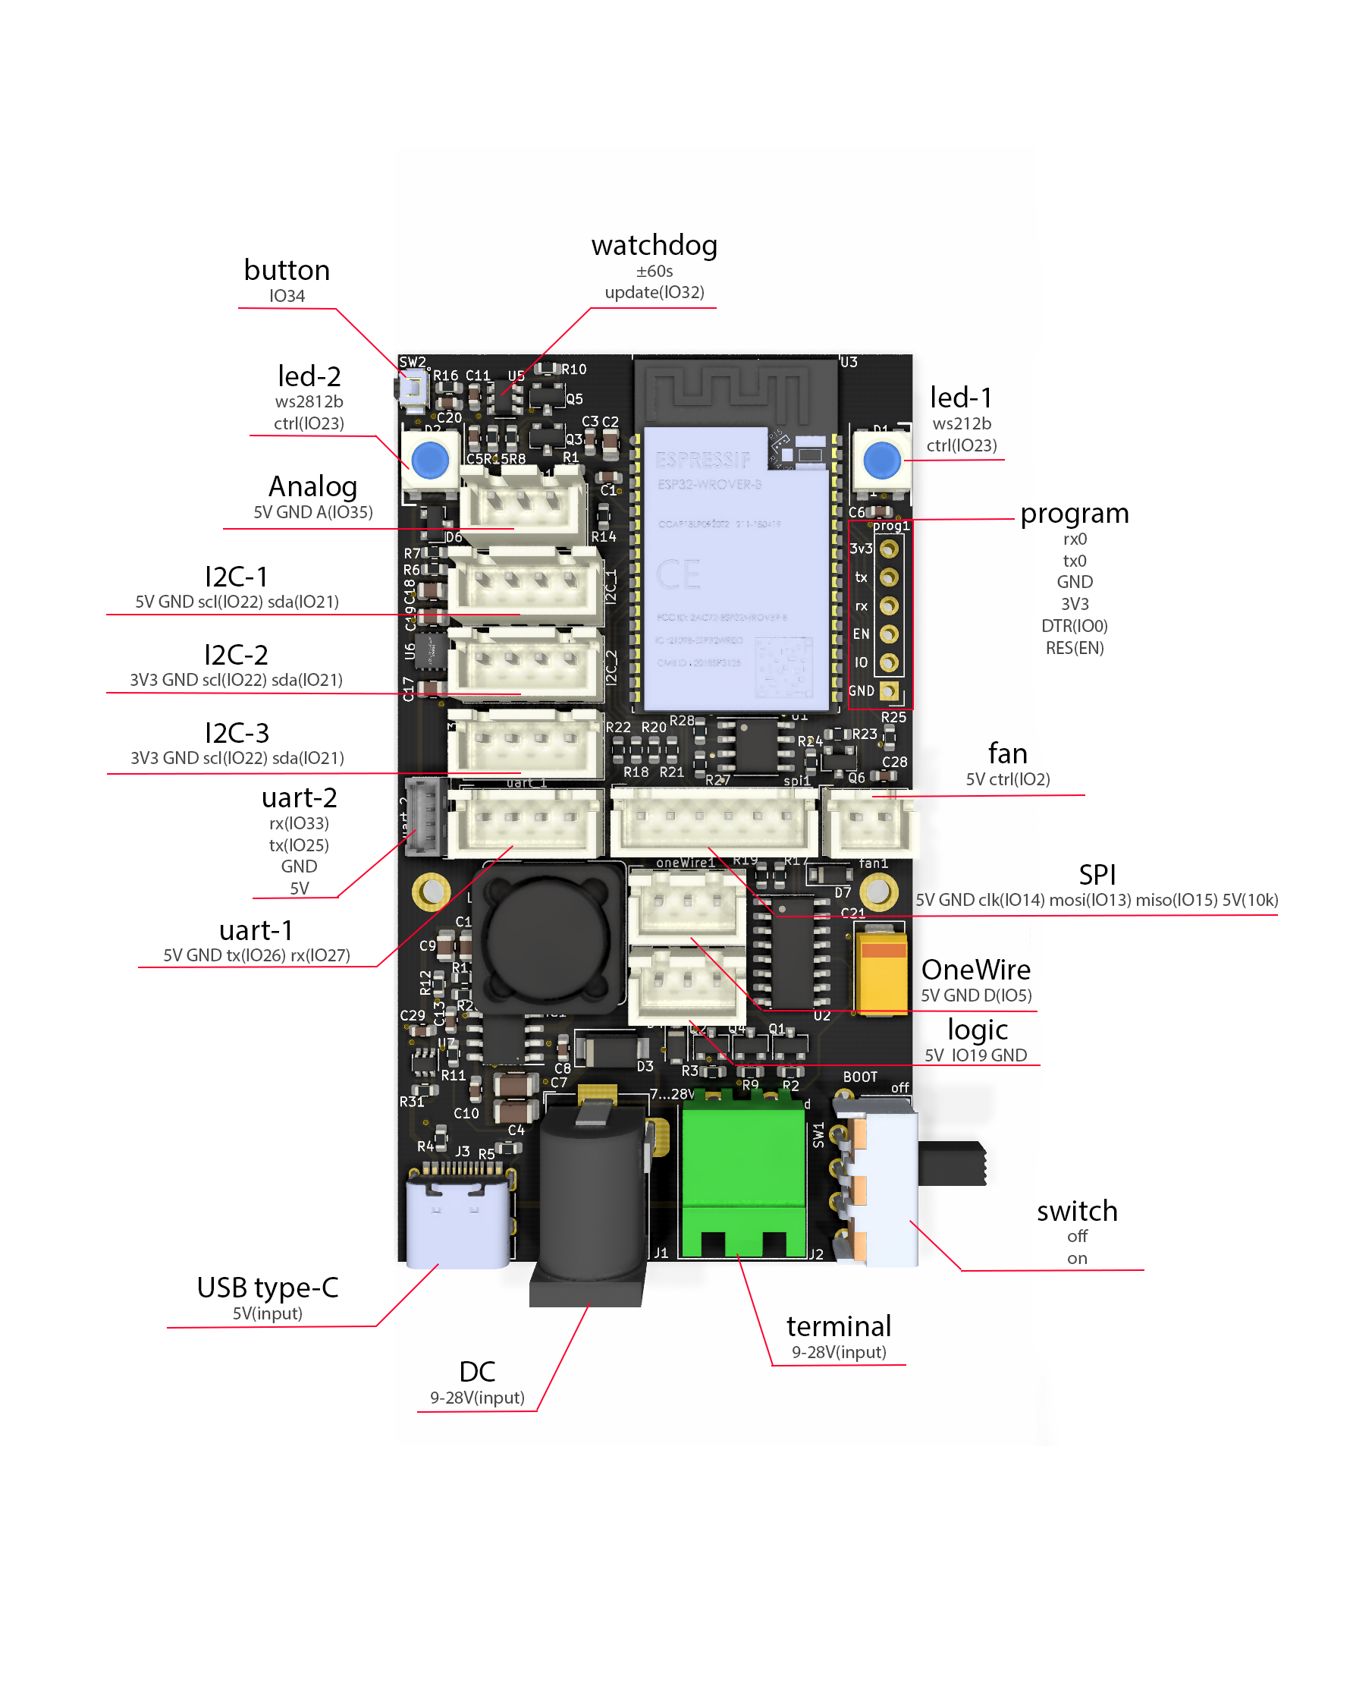

# 6 Drowing

# All dimensions are specified in mm.

# Attachment

Сircuit design

