The Plan aims to finance the recovery of the economy affected by COVID-19 and to support accelerated and sustainable growth, while maintaining fiscal stability by mobilizing capital from the private sector in addition to the funds allocated from the budget and borrowings.

Ministry of Finance and Prime Minister’s Office, Government of the Republic of North Macedonia, September 2021
Growth Acceleration Plan
2022-2026

GROWTH ACCELERATION PLAN
2022-2026

TABLE OF CONTENTS

Executive Summary 2
Introduction 4
1. Economic Overview 5
2. Financing Transmission Mechanism 10
3. Governance Structure and Project Management 11
4. Institutional and Regulatory Framework 14
5. Expected Outcomes 20
6. Implementation Roadmap 26
References 29
Appendix 1. Business Environment 30
Appendix 2. NIC Project List 36
Appendix 3. Fund for Innovations and Technology Development (FITD) 37
Appendix 4 “Greening Business” Facility (North Macedonia FZA) 43
North Macedonia Free Zones Authority 45
Appendix 5. Development Bank of North Macedonia 47
Appendix 6 Invest North Macedonia 51

Executive Summary

Aim of the document | - The plan aims to finance the recovery of the economy affected by COVID-19 and to support accelerated and sustainable growth while maintaining fiscal stability by mobilizing capital from the private sector in addition to the funds allocated from the budget and borrowings.
Expected outcomes | - Accelerated growth - to accelerate the medium-term economic growth rates from 2.5% to 5% average growth;  - Fiscal consolidation - to maintain the fiscal consolidation of the public debt and the budget deficit in the medium term within the fiscal rule of the general government debt up to 60% and the deficit up to 3% of the country's GDP;  - Increased investments in the public and private sector;  - Increased jobs and reduced unemployment; and  - Efficient and effective institutional framework for investment project’s implementation.
Subject to support | - Investments in public projects;  - Investments in the private sector; and  - Policy and institutional reforms.
Areas for support | - Green economy;  - Digitalisation;  - Innovations and technology development  - Human capital;  - Physical infrastructure; and  - Social cohesion.
Sources for financing | - Budget (revenues and borrowing);  - International and bilateral financial institutions;  - Private institutional investors and banks; and  - Development partners (grants).
Implementing agencies | - Government Ministries;  - Development Bank of North Macedonia;  - Fund for Innovations and Technology Development;  - North Macedonia Free Zones Authority;  - Local and Regional Development Agency;  - Invest North Macedonia;  - Other institutions / state agencies.
International development partners | - World Bank Group (IBRD, IFC, MIGA); EBRD; EIB; KfW; UNDP; USAID; SDC...  - Financial Support (lending, equity, guarantees)  - Technical Assistance, Advisory Services (knowledge transfer)
Instruments and mechanisms for financing | - Budget revenues and borrowings  - CAPEF  - Development bond  - Green bond  - Public asset management  - Public-Private Partnership  - Concessions  - Blended financing  - Guarantee Fund  - Energy Efficiency Fund  - Fund for Local and Regional Development  - Fund for Development  - Hybrid SMEs Investment Fund (FITD)  - Hybrid Green Strategic Investment Fund (North Macedonia FZA)  - Venture Capital Fund  - Fund of Funds  - Crowdfunding platforms
Governance structure and Project management | - Projects and prioritisation  - Steering Committee  - Delivery Unit  - Project Implementation Unit  - Project Monitoring Unit  - Public Investment Management Unit
Policy leverage | - Institutional optimisation and capacity (enhance project implementation)  - Blended financing (additional funds increase, multiplier)  - Business and investment climate (structural and policy reforms)

Introduction

Health and socio-economic crisis induced by COVID-19 pandemic in 2020 disrupted the pre-crisis growth trajectory in almost all economies. The Government of North Macedonia vigorously and timely responded to the medical and socio-economic emergencies by designing and implementing health prevention measures and six packages of economic measures in the total amount of over EUR 1 billion. The properly coordinated government response limited a more severe socio-economic downturn, saved a large number of jobs and protected many socially vulnerable households. Emergency measures have directed financial support to affected firms and individuals and helped keep the economy alive. The international development partners strongly contributed to the policy-making process with concrete proposals and provided crisis-related project financing.

Although the economy has emerged from a pandemic-induced recession, challenges remain, especially given that the number of people infected with COVID-19 is rising again due to the rapid spread of the delta variant. However, Government of the Republic of North Macedonia is fully committed not only to preserving human lives and protecting public health, but also to supporting the recovery and re-growth of the economy.

The economic crisis started with a significant deterioration in the international economic environment and a sharp decline in external demand caused by the health crisis. Economic activity declined by 4.5% in 2020, coupled with a small and temporary increase of the unemployment rate. Without the fiscal stimulus packages and the accommodative monetary policy, the economic activity would have plunged by 8.3% in 2020 and the unemployment rate would have exceeded 20%. The economic crisis impacted both the supply – as a result of closing of manufacturing facilities, winded-down construction, tourism, trade and real estate activities –, and the demand – due to reduced purchasing power of the population and the overall fear and uncertainty among the citizens and the corporate sector, leading to decline in personal consumption and business investments.

By September 2021, there have been many signs of economic recovery. In June 2021, value added in industrial production increased by 11.4% in the second quarter, thus continuing the positive trends for four months in a row. In the first half of 2021, exports of goods grew by 39.1% on an annual basis, coupled with an increase of imports of goods by 38.7%, which led to widening of the trade deficit by 27.8%. In the first seven months of 2021, the average net nominal wage grew by 6.1% y/y, and the real net wage grew 3.5% in the same period. In June 2021, credit activity increased by 5.1% on an annual basis, led by higher household lending (8.7% growth), whereby lending to enterprises grew by 1.2%. Total deposits were higher by 6.8% (y/y), reflecting growth in both corporate (16.7%) and household (4.2%) deposits.

The pandemic widened fiscal deficit/imbalances and elevated public debts across the world. The negative economic outlook has affected countries’ ability to collect revenues amidst immense financing needs to respond to the health emergency and socio-economic impact of the crisis. The budget deficit in 2020 increased to 8.1% of GDP, and it is projected to be reduced to the level of 6.5% of GDP in 2021. The revised Fiscal Strategy 2022-24, the Public Debt Management Strategy 2022-24 (both with an outlook until 2026), and the Economic Reform Programme 2021-23 envisage gradual and continued fiscal consolidation in the coming years. The strong rise of budget revenues in January-August 2021 suggests that the fiscal position is improving significantly. Higher allocations for public investments and the commitment to and the mechanism for higher execution of capital expenditure will strengthen the medium-term growth prospects.

Facing the new reality due to the pandemic challenges, to recover and to thrive in these changing times, we, as the Government, aim to establish so-called Growth Acceleration Plan as a general framework which consists of all the elements that could contribute to better utilisation of resources and increased growth potential on a medium-term basis. Besides the current activities that we have located, we suggest innovative ways to finance the investments, to consume all the available funds offered from official creditors and finally to reach all the possibilities to mobilise private investments.

This document, Growth Acceleration Plan (GAP), consolidates all existing and new plans, initiatives and funds allocated by the Government of North Macedonia and the international development partners for the 2022-2026 period.

The Growth Acceleration Plan will play a key role in boosting jobs and growth in the economy of North Macedonia. The ultimate goals are threefold:

- Increase investments - to make more efficient use of the publicly funded investment in the amount of EUR 4 billion in the next five years by mobilizing additional EUR 8 billion invested by the private sector and reaching a total of EUR 12 billion.
- Accelerate growth - to double the rates of medium-term economic growth from 2.5% (last decade average) to 5% annual growth.
- Ensure fiscal consolidation - to facilitate the reduction of the public debt below 60% of the country’s GDP in the medium-term.

It is important to underline that the Plan also establishes an Implementation Roadmap which defines priorities, steps and tools in terms of timeline and commitment by the Line Ministries and other domestic institutions.

The next section provides a brief economic overview with a focus on the macroeconomic outlook and the business environment. The financing transmission mechanism that blends public and private sources of financing and supports much stronger investment activity is elaborated in the third section. The governance structure and project management within the Growth Acceleration Plan are explained in the fourth section. In the next section, a detailed outline of the Institutional and Regulatory Framework is provided. The sixth section provides insights into the expected outcomes of the Growth Acceleration Plan with a brief risk outlook. The concluding section elaborates the implementation roadmap.

Economic Overview

  - Macroeconomic framework

After the COVID-19 pandemic-induced recession and the first quarter of 2021, the economy recovered in the second quarter of 2021 (growth of 13.1%), with growth of 5.2% in the first half of the year. Regarding the global prospects, the international financial institutions foresee a gradual stabilisation of the global supply chains, growth of the economic activity among the main trading partners, and a robust growth of the external demand. A downside risk to global projections would be a steep rise in delta-variant infections, triggering new travel restrictions, closures, and other containment measures.

Figure 1. The pace of recovery in Southeastern Europe (2019=100)
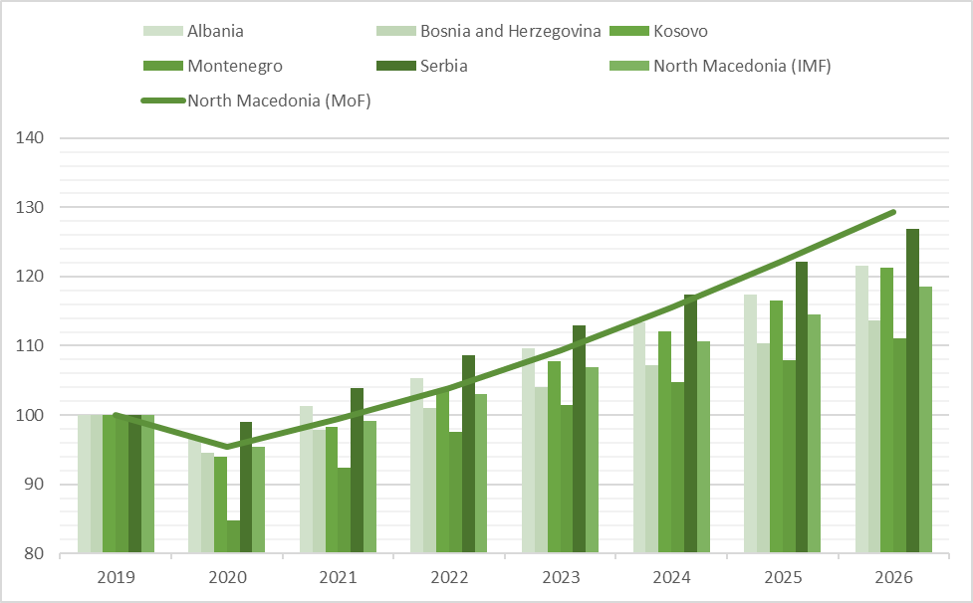

Source: IMF projections (World Economic Outlook, April 2021) and MoF projections for North Macedonia (August 2021).

The fiscal stimulus packages and the gradual decline in new cases in mid-2021 are in line with the government forecast of real GDP growth of 4.1%, as well as the IMF forecast (4.0%) and the World Bank forecast (4.6%) for 2021. In the medium term, the growth acceleration would yield an average annual growth of 5.4%, mainly driven by a strong domestic demand, while net exports are expected to have a slightly negative contribution.

Investments will play a significant role in the recovery of the economy, supported by a credible and feasible Growth Acceleration Plan. Real growth of gross investments is projected at 7.7% in 2021, whereas in the period 2022-2026 investments are expected to register an average annual growth of 9% (Figure 2). This steady investment growth reflects accelerated gross capital formation by the private sector (supported by a gradual increase of business confidence, more intensive foreign investment inflows and improved business environment) and strong public investment (mainly Investments in improving or expanding the existing physical infrastructure). The expected fiscal impulse will be channeled through greater capital expenditures and their higher execution, improved targeting of priority investment areas, and much stronger support for mobilisation and leverage of private capital.

Private consumption is also projected to support the growth of domestic demand (Figure 3). After the decline in 2020, which was significantly mitigated through economic measures to support the most affected by the pandemic, private consumption is expected to grow by 4.8% in 2021, amid a gradual return of confidence and optimism with the acceleration of mass vaccination, recovery of remittances, supported by the fiscal measures taken to deal with the pandemic. Favorable developments in the private consumption are expected to continue in the period 2022-2026, with an average annual growth of 3.9% projected, supported by the expectations for further improvement of the labor market situation, strengthening of the social protection system and growth of disposable household income.

Growth of public consumption is projected at 1.8% on a real basis in 2021, following its strong positive contribution to the economic activity in the course of 2020, as a result of the health-related expenditures to manage the pandemic and its effects on both the citizens and the economy. In the coming years, public consumption is expected to grow at a slower pace, i.e. an average annual growth of 1.4% in the period 2022-2026 is projected, due to the efforts to reduce non-essential expenditures, their rationalisation and fiscal consolidation.

Figure 2. Contribution to real GDP growth (in percentage points, 2017-26)
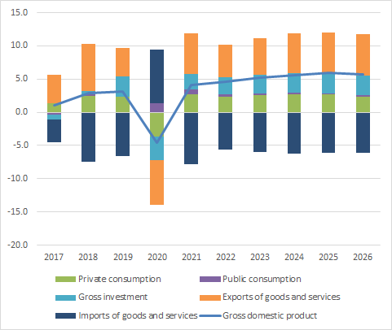
Source: Projections of the Ministry of Finance (August 2021).

Exports of goods and services, following the reparation of global production chains, are projected to grow by 13.7% in 2021. In the medium term, in light of the expected gradual surge of the external demand, the exports are expected to have a strong contribution to economic growth. It is projected to record an average annual growth of 8.7 % on a real basis in the period 2022-2026. The growth of export activity and the recovery of domestic demand in 2021 would also cause higher imports of intermediate, capital, and consumer goods. The real growth of imports of goods and services is projected at 13.6%, which implies a negative contribution of net exports to economic growth. In the 2022-2026 period, an average annual growth of the import of goods and services of 7.8% on a real basis is forecasted. This would also lead to a gradual improvement of the contribution of net exports to economic growth.

According to the baseline macroeconomic scenario, an employment growth of 0.8% is expected in 2021. Throughout the entire period under consideration (2022-2026), employment is projected to grow at a higher pace of 3.6% per annum. The unemployment rate is forecasted to enter a single-digit territory from 2025 onwards. The inflation rate in 2021 is projected to be 3%, due to an upward movement of foreign effective inflation and global commodity prices (Table 1). In the period 2022-2026, inflation is expected to remain low and stable, projected at around 2% per year.

  - Banking sector

The banking system plays a crucial role for the stability of the financial sector, as its dominant segment, in which savings of the non-financial sector are concentrated, as well as the assets of other financial institutions, which makes the stability of the banking sector a key link for overall financial stability. Share of the banking system in the assets of the financial system, although gradually decreasing over the years, is still high and amounts to 80.7% on 31st December 2020.

Even in conditions of uncertainty due to the pandemic, the banking sector maintained stability and security in its operations. Thereby, it achieved growth of activities and contributed to mitigating the economic consequences of the crisis. The banks directed the growth of the sources of financing, driven by the growth of deposits, towards prolonged lending to the private sector. Solvency of the banking system is stable and has further improved, as has liquidity, and banks continue to make operating profits. Quality of the banks' loan portfolio has been maintained, with moderate materialisation of the credit risk during 2021, and the non-performing loans rate remaining at a relatively low level. The prudent behavior of the banks themselves and the risk management play an important role in the good preparedness of the banking system for dealing with shocks. In addition, strengthening of the regulation in the pre-crisis period contributed significantly thereto, providing for further strengthening of both the solvency and the liquidity of domestic banks, as key pillars of the stability of the sector. The National Bank has taken several measures in response to the pandemic, which include: reduction of the key interest rate, release of liquidity in the banking system, activation of non-standard measures and enabled regulatory flexibility in the area of ​​credit risk management. This has contributed to easing the financial burden on debtors and reduced the risk of possible greater concentration of credit risk in the short term, with adverse effects on banks' balance sheets and willingness to take risks. Furthermore, the measure the National Bank has undertaken, aimed at banks to refrain from paying dividends, has sent a clear signal to the banks about the need to build further capital potential, which is seen through the strengthening of solvency, mainly as a result of reinvestment of banks' profits.

During the first nine months of 2021, the banking system has continued to operate in conditions of uncertainty, despite some stabilisation of the epidemiological situation, immunisation and easing of restrictive measures, which has a favorable effect on the economic activity. In such conditions, the growth of deposits continues (9.2% on annual basis as of 30th September 2021), which has confirmed the public confidence in the stability of the banking system. From a sectoral point of view, annual growth of deposits of non-financial entities (9.2020-9.2021) is determined by the growth of deposits of both non-financial sectors, with a slightly higher contribution to the growth of household deposits (contribution of 50%) compared to the contribution of deposits of corporate sector (contribution of 48%). During the pandemic period, there is a greater tendency of depositors for foreign currency deposits and demand deposits. Such movements have caused moderate changes in the deposit structure, with strengthened share of demand deposits (reaching 63%) and moderately reduced share of Denar deposits, compared to the period before the pandemic, to 57%. On 30th September 2021, total deposits of non-financial entities amounted to Denar 451,675 million, accounting for 65% of GDP.

  - Business environment

As regards the business environment, the country outperforms regional peers at the World Bank's Doing Business Index. This Index is based on an assessment of the regulatory environment in a country along 10 dimensions: Starting a Business, Dealing with construction permit, Getting electricity, Registering property, Getting credit, Protecting minority investors, Paying taxes, Trading across borders, Enforcing contracts and Resolving insolvency. While academic literature shows the positive impact of improved business regulations on productivity, growth and unemployment, data show a positive correlation between the Foreign Direct Investments (FDI) and the Doing Business Performance. North Macedonia was ranked 17th globally in the 2020 edition, and the country has been in the top 20 since 2016. Its performance is better than that of several G7 countries, such as Germany (22nd), Canada (23rd), France (32nd) or Italy (58th). North Macedonia business environment attractiveness is in particular based on three indicators: Protecting minority investors (12th rank globally), mainly thanks to very high disclosure standards, i.e. transparency, Dealing with construction permit (15th), especially thanks to reduced number of procedures and shortened processes, and Getting credit (25th), in particular thanks to the legal framework.

Recent reforms contributing to the improvement of the business environment in North Macedonia, as per the World Bank, include simplification of the calculation of enforcement fees and an effort to make the overall process less costly. Similarly, the country made the construction permitting process less costly by reducing the land development fees. Beyond the Doing Business score calculation, North Macedonia also implemented reform to ease employment, with labor regulations on probationary period, priority rules during redundancy dismissals, reemployment, and severance payments. [Appendix 1]

Figure 3. North Macedonia’s performance at the World Bank’s Doing Business Index
Doing Business Index score (2020) | Doing Business Index rank (2020)
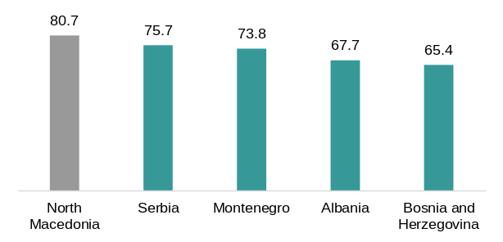 | 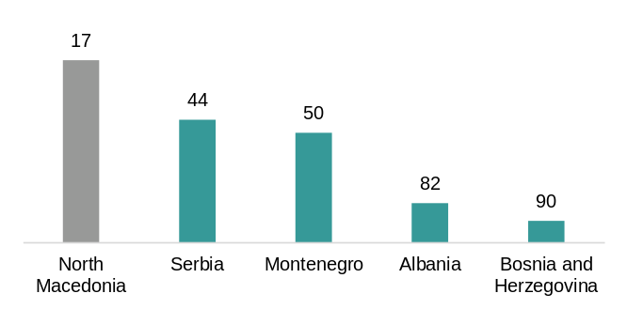
Source: World Bank

Financing Transmission Mechanism

The approach follows the Maximizing Finance for Development Initiative of the World Bank Group, which defines a system that systematically leverages all sources of finance, expertise and solutions to support developing countries’ sustainable growth. It is also partly inspired by the Investment Plan for Europe (Juncker’s Plan), which played a key role in boosting jobs and growth in the EU. It is also in compliance with the Economic and Investment Plan for the Western Balkans and the Sofia Declaration on the Green Agenda for the Western Balkans.

The Growth Acceleration Plan aims to improve the enabling environment, developing regulatory conditions, building capacities, putting in place standards and reducing risks. It provides a coordinated approach to the public and private side as a way to expand the range of options for financing efforts to sustainable growth of the economy and encourage business initiatives. During 2022-2026, the Growth Acceleration Plan will combine public sources in the total amount of EUR 4 billion, with a mobilised private capital of EUR 8 billion (Figure 4). The two sources will be blended within a defined Governance Framework and a set of implementing agencies (such as the Development Bank, the Fund for Innovations and Technology Development, North Macedonia Free Zones Authority, etc.).

Figure 4. The Growth Acceleration Plan: Transmission Mechanism

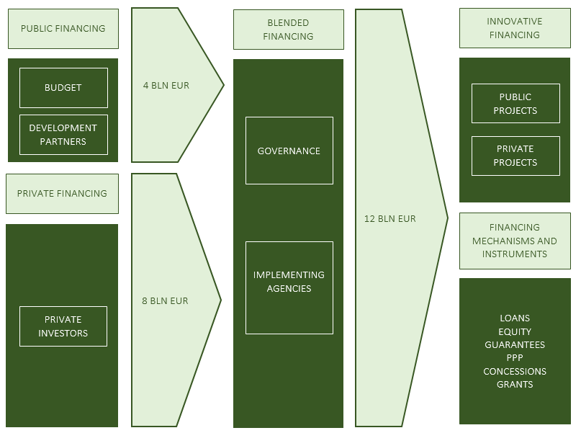

The private sources of financing will be encouraged by public funding and a rich array of conventional and innovative financing mechanism and instruments. The leverage of private investment will be facilitated by Public-Private Partnerships (PPP), privatisation of non-essential segments of the public enterprise sector, newly established investment funds, asset recycling, better execution of capital expenditures, etc.

The assessed combined impact of the Growth Acceleration Plan is EUR 12 billion invested in projects designed and implemented by both the public and the private sectors. The Plan will especially support environment and climate-friendly projects, innovations and initiatives for a fairer society, thereby facilitating a transition to a low-carbon, competitive, circular and sustainable economy.

Governance Structure and Project Management

To ensure effective delivery of the investment plan, a governance structure will be put in place to cover the entire project management process (see Figure 5), including a feedback loop to accelerate effectiveness over the years. The governance structure builds on existing institutional elements with new elements to be created in parts of the project cycle where there are current gaps. Government Ministries and Agencies will play a lead role in the implementation with support from external entities (development partners and official creditors) where needed.

Figure 5. The Growth Acceleration Plan: Governance Structure and Project Cycle
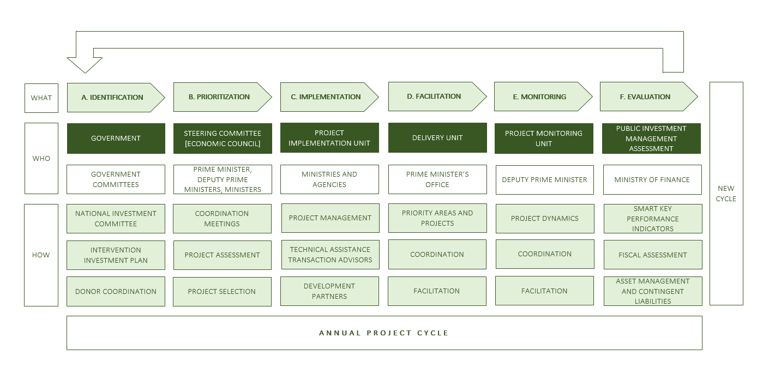

- Identification

The initial list of projects to be funded under this Plan comes from the Government’s NIC Project List [Appendix 2]. New projects will be added due to additional availability of funds the Plan will unlock, and each new project will need to be aligned with the government’s socio-economic priorities. Donors’ project funding will also be aligned towards these priorities and their implementation will fall under the Plan’s governance structure.

- Prioritisation

Economic Council of the Government will act as Steering Committee that will prioritise projects for funding. In addition to the contribution to the Government's priorities, other criteria, such as project readiness, will be considered for the prioritisation.

- Implementation

Project implementation will be done by existing Project Implementation Units (PIUs), and additional PIUs may be set up for some new projects. For the prioritised themes that the DU facilitates, the PIUs will benefit from support by the DU staff, including joint problem solving on challenges, rapid escalation to the Prime Minister and holistic measurement of progress and results.

- Facilitation

Delivery Unit (DU) is a proven institutional approach to help the Government deliver rapid results on its top priorities. DU achieves results by: (1) acting as extended hand of the Prime Minister to keep momentum in implementation through ‘pressure-chasing’, (2) providing recommendations to implementing entities to overcome implementation challenges, (3) tracking results/outcomes using high-frequency metrics and (4) coordinating across government entities to mobilise all stakeholders towards results.

The DU will be located within the Prime Minister’s Office and staffed with approximately 20 top-tier professionals who bring proven problem solving, leadership and communication skills. In addition, the DU staff will instill a mindset and culture of effective implementation across the entities they will engage with on the selected priorities.

Delivery Units (DUs) are innovation of this century that has proven effective, if set up in the right way, in delivering better outcomes. DUs have been used as institutional mechanism to accelerate implementation across numerous advanced and developing countries (UK, United States, Malaysia, Pakistan, etc.).

DUs comprise a small group of highly skilled and motivated professionals operating at the center of the Government to help Ministries and other implementing agencies to achieve outcomes for a selected themes (be it government services, capital projects or social topics) that are top priority for the Government. The DU staff leverage the authority they carry from being set up under the top government leadership, but, at the same time, use influencing and value adding as tools to build a collaborative working model with implementing entities.

Elements of a successful DU:
- Has clearly defined mission (priorities);
- Staffed with top talent that brings problem solving, leadership and communication skills (expertise is a secondary priority);
- Has access to and the attention of the Prime Minister to be able to act as his/her extended hand
- Focuses only on few themes (and not on the broad government agenda);
- Acts as a facilitator, but accountability remains with implementing entities;
- Has access to data from all relevant government entities

- Monitoring

The Project Monitoring Unit (PMU) will be established under the Office of the Deputy Prime Minister of the Government of Republic of North Macedonia in charge of Economic Affairs, Coordination of Economic Departments and Investments, and will be in charge of comprehensive monitoring of progress across the entire investment portfolio. The PMU will put in place a monitoring framework that will inform the government leadership on the implementation progress at monthly/quarterly intervals. The monitoring dashboards will flag delays in projects, with special focus on high impact projects. The PMU will collect and consolidate project information from PIUs and other implementing agencies.

- Evaluation

The Ministry of Finance will establish the Public Investment Management Unit, which will aim to assess the readiness and the effectiveness of the annual project cycle following the recommendations of the Public Investment Management Assessment. The outcome of this will be an annual evaluation report with concrete recommendations for the subsequent year’s project cycle.

Institutional and Regulatory Framework

The institutional framework for publicly available and publicly mobilised sources of financing the economic growth consists of a network of domestic institutions (Government Ministries and Agencies) and mechanisms, supported by a legal framework. Efforts to achieve the facilitation of the Growth Acceleration Plan, will be initially made within the current legal framework. Furthermore, all the opportunities that could be offered to facilitate this Plan will be supported by the initiated changes and improvements of the current legal framework in compliance with the EU legislation.

The Plan will support the legislative changes that should be made with respect to the following: Law on Investment Funds, Law on Alternative Investment Funds, Law on the Development Bank of North Macedonia, Law on Innovation Activity, Law on Balanced Regional Development, Law on Technological Industrial Development Zones, Law on Central Registry, Law on Obligations and other related laws if needed.

The institutional framework as presented in Figure 6. comprises: financing source; implementing agencies; financing instruments and mechanisms; governance structure and project implementation; beneficiary sectors; priority areas; and expected outcomes. Governance structure and project implementation process are explained in the previous section, while the expected outcomes will be elaborated in the following section, explaining the remaining part of the framework.

Figure 6. The Growth Acceleration Plan: Framework
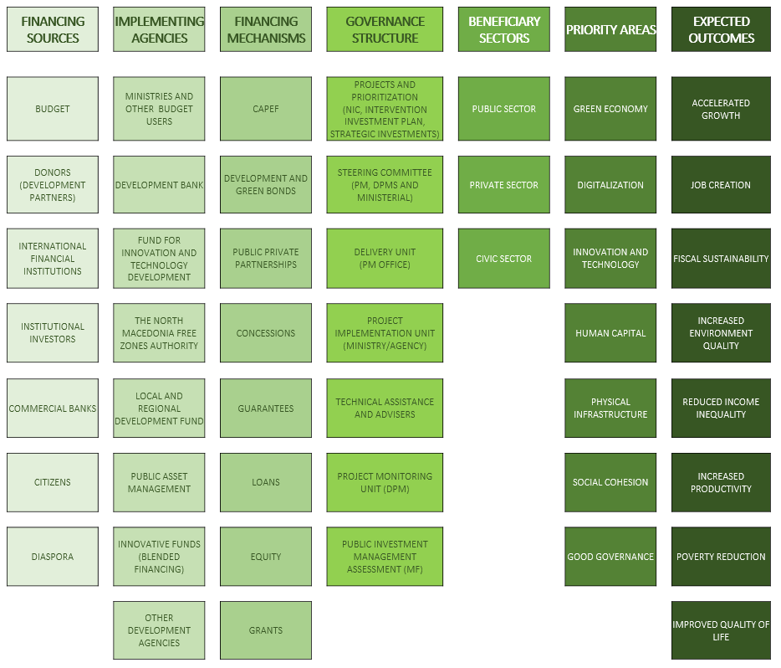

Financing sources

The framework presents alternative sources of financing aiming to provide greater support to the private sector, innovations and strengthening competitiveness in North Macedonia. The focus, besides the Budget (both revenues and borrowings), has been put on the following types of instruments: grants, stocks, loans, concessions, public-private partnerships, etc. Potential investors from which financing would be provided for investments in various forms are the state and the state institutions - ministries as investors through the State Budget; international institutions through different types of funds - for example, the European Investment Fund, the Fund for Innovations and Technology Development; institutional investors; business angels, general public (citizens and diaspora), commercial banks, and others.

Moreover, these sources will enrich the access to finance for small, medium and large enterprises (SMEs) to encourage their growth and development. The focus will be on priority areas and potential growth areas. The intention is to develop their competitive position via digitalisation, human resource development, innovations and technology, social cohesion, etc.

Implementing agencies

The present institutional framework for publicly available financing of the medium-term economic growth consists of: Government Ministries; Development Bank of North Macedonia; Fund for Innovations and Technology Development; North Macedonia Free Zones Authority; Invest North Macedonia; Local and Regional Development Agency; Securities and Exchange Commission; and other institutions. In terms of inter-institutional coordination, the National Investment Committee (NIC) is the key actor in the overall process of coordination among the implementing agencies.

Financing instruments and mechanisms

We outline the existing and newly proposed instruments that could provide project financing and improve efficiency when implementing projects. Their impact on the economy goes beyond the funds provided by public and private sources, additionally, the gross investments would be magnified by an instrument-specific multiplier.

The following mechanisms are planned to improve the efficiency of investments or projects:

Capital expenditure efficiency mechanism (CAPEF). This is a newly introduced mechanism for rewarding good performers among budget users in terms of capital expenditure execution. Capital expenditures have consistently been under-utilised: the average percent of execution of capital expenditures is 72.71% for the 2011-2019 period. CAPEF is expected to increase the degree of implementation to at least 82% per annum. The estimates are that this mechanism could generate additional EUR 1,521 million of general government capital expenditures over the 2022-2026 period.

Public asset management. The Government will develop a comprehensive plan to manage, use, and dispose of public assets. The activities will involve privatisation of non-essential segments of the public enterprise sector, restructuring of loss-making (but viable) public enterprises, etc.

Public-private partnerships. A new Law on Public-Private Partnership is being prepared, as well as a new Law on Concessions of Goods of General Interest, in order to focus on public-private partnerships. Government of the Republic of North Macedonia, in cooperation with international development partners, will target areas and projects for potential public-private partnerships.

The Organic Budget Law will enable the adoption of a standard methodology for defining, preparing, reviewing, evaluating and prioritizing new infrastructure projects. It means that the budget users, within the budget preparation process, have to submit feasibility studies or pre-studies, wherein all new major investment proposals are explained, and afterwards the Ministry of Finance will prepare and submit an opinion to the Government (cross-sectoral working group / committee) based on the results of the studies, before a project is taken into consideration for funding from the budget or other source.

Following instruments will be implemented within the existing legislation:

Development Bond. With the aim of efficient development of the financial markets and efficient use of foreign and domestic saving, the Plan is aimed at introducing a new medium-term instrument called ‘Development Bond’. It will provide financing of development projects of national importance and enable financial market development and deepening in North Macedonia. This type of financial instrument will be offered to the general public, the institutional investors and other financial market participants.

Inflation-indexed bonds are a type of long-term government securities issued by the Ministry of Finance. They are financial instruments indexed to the inflation rate in order to protect investors from a decline in the purchasing power of the invested funds. If the inflation rate rises, price of the bonds adjusts to maintain their value. The nominal value of these bonds will increase with the increase of inflation, while the payment of the coupon interest will vary with the adjusted value of the bond.

Project Bonds will be offered to encourage potential investors to engage in financing more specific development projects, sometimes of local or regional significance. Such projects are primarily in the area of physical infrastructure, such as construction of roads, sewage or irrigation systems, etc.

Green Bonds will be offered to encourage projects that support the “Green Agenda” and the “green transition”, aiming to improve energy efficiency; prevent or limit pollution; facilitate waste management; support sustainable agriculture, fishing and forestry; protect aquatic and terrestrial ecosystems; provide clean transport and sustainable management of waters; cultivate environment-friendly technologies, etc.

Guarantee Scheme. The Guarantee Scheme aims to support the private sector through the commercial banks. It is established within the Development Bank of North Macedonia. With the Guarantee Scheme, the state offers an additional opportunity for easier access to finance by taking part in the credit risk together with the commercial banks. The assets from the Guarantee Scheme will be used for issuing guarantees to commercial banks. Following benefits will be gained from the credit guarantee scheme: facilitating access to finance for micro, small and medium-sized companies (MSMEs); support for the private sector, improving the collateral requirements for loans from commercial banks to those companies that need additional financial security; and stimulating the banks in offering long-term loans for growth and development of MSMEs. Initially, the Guarantee Scheme will start with EUR 15 million invested by the Government. [Appendix 5]

Energy Efficiency Fund. The Fund will be established within the Development Bank of North Macedonia. The assets provided within this Fund will be intended for: (a) operating costs and marketing activities of the Fund; (b) preparation of energy controls, major projects and technical specifications, technical audit of major projects and technical specifications, performance supervision, certificates for energy classes and other technical studies, future energy efficient investments, as well as financing of the investments in energy efficiency and renewable energy in public buildings. The initial capital for the Energy Efficiency Fund is EUR 5 million to be provided with a loan within a World Bank funded project.

Fund for Local and Regional Development. This Fund (Agency) will replace the current Bureau for Balanced Regional Development, but with a more prominent role enabled by greater fiscal resources and broader competences. It will serve as a focal point for better coordination of activities and public resources aiming to mobilise private capital and promote local and a more balanced regional development. The goal of the Fund is to support local government and local and national public companies for extending and developing the local infrastructure, providing high-quality local public services and improving local governance. Fund’s capital will be provided by the central budget and will be supplemented with funds from commercial banks, official creditors and donors so as to provide additional financing for local and regional investment and development projects.

Financial Support of Investments. Pursuant to the Law on Financial Support of Investments, Government of the Republic of North Macedonia offers financing of Productive Initial Investments aimed at increasing the competitiveness of the economy and the employment. Total financial support to be provided pursuant to the Law on Financial Support of Investments may not exceed 50% of the amount of justified investments costs. [Appendix 6]

Fund for Development. The Fund will be established within the Development Bank of North Macedonia. This Fund will support, through favorable credit products, the export-oriented companies in research and development in order to boost exports, technological development and introduction of new products. The export support activities will also include a supplier development programme aimed to increase technological readiness and capacities of domestic companies to take part in global value chains. Initially, the Fund for Support of Companies in the area of Research and Development will start with EUR 10 million budget funds.

Hybrid Green and Digital Economy MSME Fund. This Fund is established for the purpose of investing in minority equity and quasi-equity stakes in green and digital startups and SMEs registered in North Macedonia (FITD). The Fund’s structure will be set up by establishing a Feeder Fund by the fund sponsoring company and the private fund management. The financing will be provided by international fund investors. Additionally, a domestic fund will be established which will attract investments from the Ministry of Finance (Budget), domestic institutional investors and the Feeder Fund. The governance structure of the domestic fund will consist of an advisory committee, investment committee and fund manager. The mechanism that will be used is equity and quasi-equity stakes. Depending on the Fund size, this model of funding allows the Feeder Fund (established in an EU eligible country) to invest in funds within the region (the Eastern European funds that cover North Macedonia, but also other countries). Under this model, no government resources will be leaving North Macedonia, as the government funds will be invested in the domestic fund and will be channeled down to beneficiary MSMEs in North Macedonia. Investments into the regional funds will be made through the Feeder Fund established in an EU eligible country. The respective Feeder Fund is funded only by international private investors (including the private arm of IFIs). [Appendix 3]

Hybrid Strategic Green Investment Fund. The Fund’s aim is investing in large enterprises and infrastructure PPP SPVs in the sectors of the European Green Deal in North Macedonia (North Macedonia FZA). The Fund’s structure will be set up the same way as the above Fund. Financing of this Fund will be provided by the following potential investors: fund investors, such as general partners, including fund sponsoring company, fund management company, limited partners, including Ministry of Finance, international and bilateral financial institutions, domestic and international institutional investors. Regarding the investment funds described above, pre-feasibility study for both models of investment funds is expected from the World Bank, which will describe in details the policy framework; governance and institutional setup; and proposed financial models for each fund (including the scope of financing, fund model size and sustainability of each proposed model, government and private sectors’ internal rate of return (IRR), etc.

Additionally, regarding the Hybrid Strategic Green Investment Fund, the preliminary assessment will produce, for each sector of the Energy Green Deal, a list of enterprise and infrastructure PPP investment projects showing project size, required financing by instrument (equity, quasi-equity, long-term debt, guarantee), and timetable. [Appendix 4]

Green Financing Instrument. The instrument aims to accelerate investments in renewable energy sources and finance energy efficiency solutions by small and medium-sized enterprises (SMEs), entrepreneurs and households. This instrument is transformative in the sense that the Green Financing Fund, as a flexible and financial mechanism, links multiple interventions to unlock private equity investments by financial institutions, SMEs and individuals to acquire renewable energy and energy technologies resulting in reduced emissions, greenhouse gases and air pollution, energy efficiency, as well as increased local market innovation and market connections. The Fund will absorb funding from the private sector, international partners and institutions.

In order to implement new financial instruments, it is necessary to create an appropriate institutional framework that will enable their implementation, as well as their further upgrading. Several legal solutions are being prepared Within the Ministry of Finance, which will support the creation of these investment funds, such as:

Fund of Funds. Multi-manager investment, pooled investment fund that invests in other types of funds. The Fund’s portfolio contains different underlined portfolios of other funds. The focus of this Fund will be on stimulating larger investments by growth-focused businesses. The target group of beneficiaries will be small and medium-sized enterprises (SMEs) in the phase of development and expansion of the business activities. The seed investment by the Fund of Funds is envisaged to be up to EUR 100,000 per company, including innovation advisory support and other forms of technical assistance from the Fund Manager. To establish such a fund, it is necessary to prepare and adopt the Law on Alternative Investment Funds.

Venture Capital Funds. Pooled investment funds that manage the money of investors who seek private equity, stakes in startups and SMEs with strong growth potential. These investments are generally characterised as of very high risk - high return opportunities. As regards the establishment of this type of funds, the Fund Manager will conclude limited partnership agreements with potential investors (institutional investors, private entrepreneurs, etc.). The assets raised in accordance with the Limited Partnership Agreements will be invested in different types of funds, as follows: (i) venture capital funds that will invest in small and medium-sized enterprises in order to encourage their growth and development; (ii) venture capital funds that will invest in companies with established social responsiveness, and (iii) regional venture capital fund, which investors from the countries in the region, including the Republic of North Macedonia, will invest in.

Crowdfunding. This is a practice of funding a project by raising a small amount of money from a large number of people. Crowdfunding brings together companies that intend to raise assets and investors seeking investment opportunities in early development companies. Potential users of this platform are excluded legal entities that are not established as joint stock companies. Establishment of this type of instrument with this type of Macedonian platform will require technical assistance to assess whether the existing regulation is in favor of the concept of group investment and to prepare a possible legal framework and organisational requirements for the establishment of this concept. The time frame for the establishment of this instrument is until the second half of 2022.

Beneficiary sectors

Beneficiaries of the Growth Acceleration Plan will be the public sector entities (both at the central and local level), the private (financial and non-financial) sector and the civil (non-governmental) sector.

Priority areas

Priority areas are defined by the four-year Government Programme 2020-2024 and other national strategic documents with a medium- and long-term term focus. Presently, the Government of North Macedonia is focused on the “Green Agenda”, digitisation, innovation and technology; human capital development; improvement of the physical infrastructure; social cohesion, and (first and foremost) good governance.

Expected Outcomes

The Government has an ambitious goal to support the recovery and the regrowth of the economy. The initiatives – such as this Growth Acceleration Plan – are aimed to speed up the income convergence and achieve the level of economic development of the 27 European Union (EU) Member States (EU-27 average), which is a moving target itself.

Macroeconomic impact

Growth acceleration – strongly supported by the Growth Acceleration Plan – is expected to bring significant benefits to the economy in the medium term. The cumulative growth of real GDP in 2026 is expected to be by 35.5% higher compared to the 2020 level (Figure 7). Nominal GDP would increase (on cumulative basis) by 56.9% in the same period. The medium-term growth will be broad-based, reflecting a strong expansion in investments (66%), private consumption (26.6%) and exports of goods and services (72.7%). Cumulative labor productivity growth of 15% would also enable a real economy-wide net-wage to increase by 13.4% in the 2022-2026 period.

Figure 7. Growth acceleration, competitiveness and human capital
Panel A. Growth acceleration (Cumulative real growth in percentage points, 2026 compared to 2020)
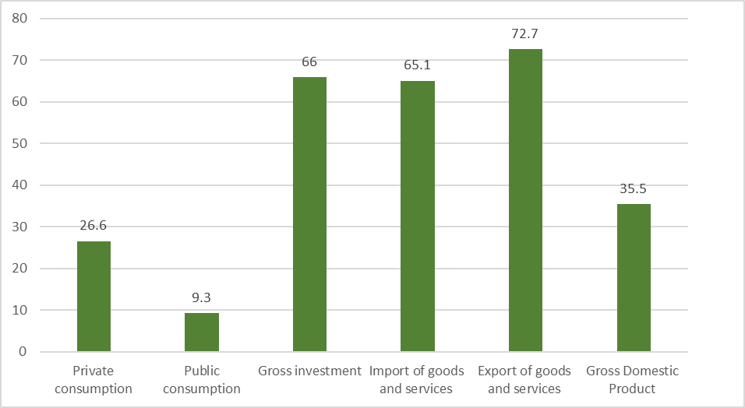
Panel B. Competitiveness and human capital (Cumulative real growth in percentage points, 2026 compared to 2020)

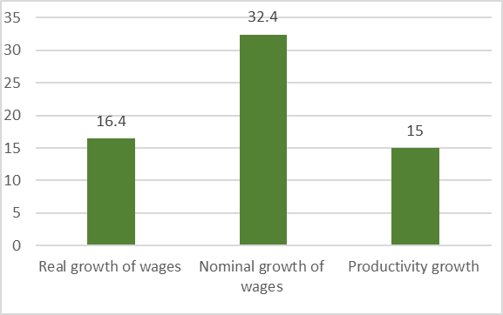
The favorable macroeconomic developments will improve public finance, leading to a fiscal sustainability, as evidenced by the reduction of the public and publicly guaranteed debt below 60% of GDP in 2026 (Table 3). The fiscal consolidation efforts in the period under consideration would bring the budget deficit (as a share of GDP) to the level of 2.2% of the country’s GDP in 2026. The rise in investments will be accompanied by job creation, as the employment rate is forecasted to increase to 54.1% in 2026 and the unemployment rate to enter the single-digit territory by 2026 (Table 1).

Table 1. Main macroeconomic indicators
Macroeconomic category | 2020 | 2021 | 2022 | 2023 | 2024 | 2025 | 2026
Real GDP growth | -4.5 | 4.1 | 4.6 | 5.2 | 5.7 | 5.9 | 5.7
Annual inflation rate | 1.2 | 3.0 | 2.4 | 2.0 | 2.0 | 2.0 | 2.0
Budget deficit (as percent of GDP) | 8.1 | 6.5 | 4.3 | 3.5 | 2.9 | 2.5 | 2.2
Public debt (as percent of GDP) | 60.2 | 63.9 | 65.9 | 65.2 | 62.5 | 60.1 | 57.7
Gross investment (% of GDP) | 29.6 | 32.2 | 33.4 | 34.6 | 35.8 | 37.0 | 38.2
Trade balance (% of GDP) | -16.9 | -19.1 | -18.8 | -18.2 | -17.6 | -16.9 | -16.2
Current account balance (% of GDP) | -3.5 | -3.2 | -2.7 | -2.3 | -2.0 | -1.5 | -1.3
Nominal net wage growth (%) | 7.8 | 5.6 | 4.7 | 4.6 | 4.6 | 4.7 | 4.5
Unemployment rate (annual average) | 16.4 | 15.8 | 14.4 | 12.9 | 11.4 | 9.9 | 8.6
Employment rate (annual average) | 47.2 | 47.3 | 48.4 | 49.6 | 51.1 | 52.6 | 54.1

Investment impact

The Growth Acceleration Plan is projected to significantly increase public investments and strongly encourage private investments over the medium term. The allocation of the financing resources will be channeled to priority investment areas, carefully selected by the responsible institutions. A significant portion of the rise in public investment would come from the improvement of the present under-execution of the capital expenditure.
To achieve this aspirational scenario, the Macedonian economy needs to increase total gross investments from EUR 2.7 billion (average for 2010-19 period) to EUR 4.8 billion (average for the 2022-2026 period). Figure 8 illustrates the forecast of nominal EUR amounts of the annual gross, private and public investments for the two periods.
Figure 8. Gross investments (EUR million), 2010-19 vs. 2002-2026
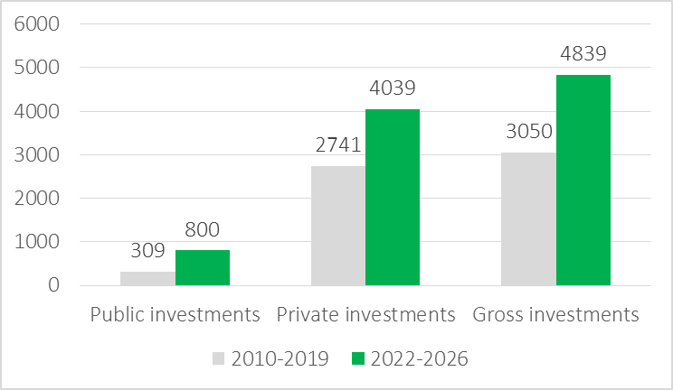

Despite the recession, the Government has successfully tapped global capital markets, as evidenced by the historically low interest rate (1.625%) of the Eurobond issued in March 2021. The prudent fiscal policy will secure funding for public investment projects, by optimizing the borrowing costs. Deposits and credit activity in the banking sector continue to grow, while capital adequacy ratios are well above the legal threshold. The banking sector is therefore seen as an important partner in providing finance for viable investment projects.
As presented in Table 2, the following investment impact is expected to be achieved during 2022-2026 as opposed to the pre-crisis 2010-2019 period. Average annual real GDP growth rates would more than double, while total gross investment would increase by EUR 1.7 billion per year.

Table 2. The Impact of the Growth Acceleration Plan: annual average
Category | 2010-2019 | 2022-2026 | Impact
Real GDP Growth (%) | 2.5% | 5.4% | 2.2. times
Gross investments (EUR billion) | 3.1 | 4.8 | 1.70
Public investments (EUR billion) | 0.3 | 0.8 | 0.5
Private investments (EUR billion) | 2.7 | 4.0 | 1.63
Memorandum item | Cumulative | Cumulative | Impact
Employment gains (new jobs created) | 167,750 | 156,000 | 1.9 times

Impact on quality of life and inclusiveness

The favorable impact of income convergence, reduction of poverty and improvements in education are also expected to increase the forecasted Human Development Index. This Index is an overall indicator of the quality of life. It would improve from 0.87 in 2021 to 0.89 in 2026, as presented in Figure 9. The impact on the Gini coefficient of income inequality is also favorable (Figure 9), as income inequality is expected to fall below 30%, a historical low.

The outlined conventional and innovative financing instruments aim to deliver prosperity for the citizens of North Macedonia, with or without the EU accession. Still, the country’s prospective EU membership holds a strong transformative power that should be used to implement these reforms in a more systematic and vigorous way. The UN Agenda for Sustainable Development 2030 will also receive prominent attention by the policymakers. This long-term development agenda brings less legalistic and more prosperity-centered vision of human development.

Figure 9. Impact on quality of life and income distribution
Panel A. Quality of life and Human Development Index | Panel B. Impact on the Gini coefficient of income distribution
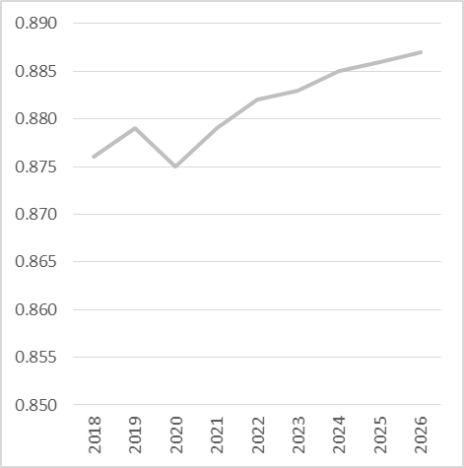 | 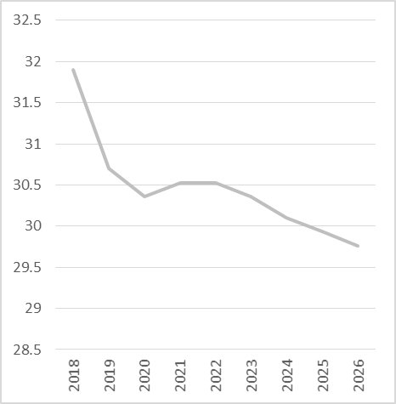
Notes: The estimates are based on a dynamic panel data analysis for nine transition countries from South Eastern Europe for the 1990-2020 period and data from the International Futures Model of the University of Denver (2021).

Environmental impact

The Greenhouse Gas (GHG) emission reduction could be achieved in two out of three scenarios developed by the Strategy for Energy Development in the Republic of North Macedonia until 2040 (Figure 10). They are driven by the process of decarbonisation, mainly due to a decline in the coal utilisation and mining. Decarbonisation of the economy and the shift towards greater reliance on renewable resources are obviously important challenges in this area. Therefore, the Energy Efficiency Fund is an important step to this end.

CO2 represents the majority of GHG emissions in all three scenarios (~96% of total). As regards the Moderate Transition Scenario, the CO2 emissions decrease for nearly 30% in 2040 relative to 2017 and, with respect to the Green Scenario, they decrease for 42%. Concerning the same scenarios, significant reduction of CH4 emissions can be noticed, mainly due to the elimination of the fugitive emissions from the coal mines. When using the IPCC methodology (excluding the emissions from electricity import and international aviation) to compare the results with 1990 and 2005, the results show that emissions in 2030 are lower for all scenarios compared to 1990 and 2005 levels - Reference Scenario (~21%), Moderate Transition (~57%) and Green Scenario (~65%).

Figure 10. Reduction of Greenhouse Gas (GHG) Emissions under Reference, Moderate Transition and Green Scenarios
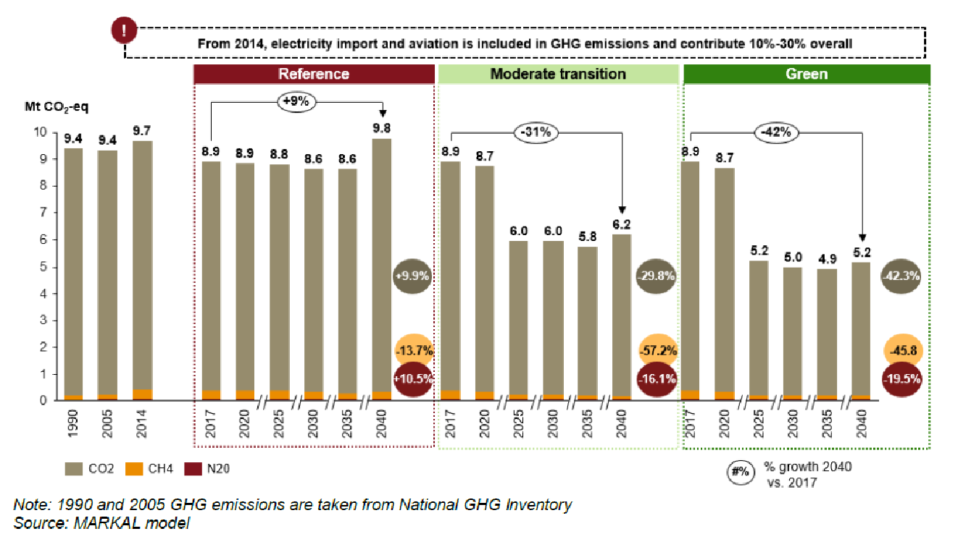
Source: Strategy for Energy Development in the Republic of North Macedonia until 2040, Ministry of Economy.

Risk Outlook

It is important to foresee potential risks that could arise in the period of implementation of the Growth Acceleration Plan. The Government will prepare mitigation measures and analysis for each of the risks mentioned below, such as:
- Macroeconomic Risk / Growing Macroeconomic Risks brought about by the COVID-19 pandemic affect the projects and activities across the GAP. We anticipate the risk connected to the planned growth scenarios.
- Political and Governance Risk
- Institutional Capacity Risk
- Fiduciary Risk
- Stakeholder Risk
- Technical Design and Procurement Risks.

Implementation Roadmap

The Growth Acceleration Plan aims to deliver ambitious results by 2026, and the first year of the Plan will be critical to establish the institutional and policy foundations to support Plan’s objectives.

Table 3. Implementation Roadmap

Pillar I - Institutional Set-Up
Action | Deadline | Description
Delivery Unit | 31st March 2022 | Prime Minister of the Government of the Republic of North Macedonia
Steering Committee | Established | Government of the Republic of North Macedonia
Monitoring Unit | 31st March 2022 | Office of the Deputy Prime Minister in charge of Economic Affairs, Coordination of Economic Departments and Investments
PIM Unit | 31st March 2022 | Ministry of Finance
Pillar II - Improving Investment Activity,
Innovation and Policy Improvement
Action | Deadline | Description
Enactment of the amendment to the Law on Development bank | 2021 | Guarantee Scheme
Enactment of the amendment to the Law on Development bank | 2021 | Fund for Research and Development
Enactment of the amendment to the Law on Development bank | 2021 | Energy Efficiency Fund
Enactment of the Law on Alternative Investment Funds | 2023 | It will govern the establishment of different types of alternative investment funds (Fund of Funds, Venture Capital Funds) managed by managers licensed in accordance with the European regulations and standards
Enactment of the Law on Alternative Investment Funds | 2023 | The competent authority to oversee the funds will be the Securities and Exchange Commission
Enactment of the Law on Alternative Investment Funds | 2023 | It will regulate the concept of limited partnership, i.e. the company that manages the funds will conclude limited partnership agreements with potential investors
Enactment of the amendments to the Law on Technological Development Zones | End-2021 | Competencies of the North Macedonia Free Zone Authority will be expanded in order to be able to establish and manage the funds.
Enactment of the amendments to Law on Balanced Regional Development | 2022 | Replacing the existing Bureau for Balanced Regional Development with a Fund for Local and Regional Development
 | 2022 | Supplementing the competencies of the Bureau due to the need to manage the Fund
 | 2022 | The sources for financing will be expanded, i.e. in addition to the budget funds for financing the Bureau, it will be able, with its transformation, to raise funds from other sources as well
Enactment of the amendments to the Law on Central Registry |  | Enactment of the amendments to the Law on Central Registry
Enactment of the amendments to the Law on Central Registry |  | Changes pertaining to the registration procedure, should there are be any legal obstacles for registration of the entities which will establish the Funds
Enactment of the amendments to the Law on Obligations | 2022 | Enactment of the amendments to the Law on Obligations
Enactment of the amendments to the Law on Obligations | 2022 | Changes pertaining to the type of contracts, for example, prescribing a new type of contract, such as limited partnership agreements
Enactment of the amendment to the Company Law | 2022 | Change pertaining to the type of legal forms provided by the Company Law, should there are any legal obstacles for registration of the entities which will establish the Funds
Enactment of the amendment to the Company Law | 2022 | Supplementing the list of companies (except micro, small and medium-sized) with new types
Enactment of the amendment to the Company Law | 2022 | Improved regulating and expanding the use of convertible debt and allowing institutional investors to make new investments even though there are failed companies in their portfolio.
Law on Concessions of Goods of General Interest | End-2021 | Law on Concessions of Goods of General Interest
Enactment of the amendment to National Bank Rulebook on Cross Border Payment Operations | 2022 | It will allow for and regulate cross-border transactions under the limited partnership in contractual form
Pillar III - Capacity Building
Action | Deadline | Description
Set up Capacity Building and Training Department committed to strengthening the governance and the institutional capacities | June 2022 | Institutional capacity building addresses capacity building beyond the provision of education and training of professionals. It aims to enhance the capacity of governments, business sector, non-governmental groups and communities to plan and manage the cost efficiently and effectively.
Pillar IV - Operationalisation of Instruments and Mechanisms
Action | Deadline | Implementation
Guarantee Scheme | End-2021 | Development Bank of North Macedonia
Energy Efficiency Fund | End-2022 | Development Bank of North Macedonia
Fund for Local and Regional Development | 2022 | Agency for Balanced Regional Development
Fund for Development | 2022 | Development Bank of North Macedonia;  Fund for Innovations and Technology Development
Hybrid Green and Digital Economy MSME Fund | 2022 | Fund for Innovations and Technology Development
Hybrid Strategic Green Investment Fund | 2022 | North Macedonia Free Zones Authority
Fund of Funds | 2023 | Different Funds - Securities and Exchange Commission
Venture Capital Funds | 2023 | Different Funds - Securities and Exchange Commission
Crowdfunding | 2022 | Macedonian Stock Exchange

References

https://ec.europa.eu/commission/presscorner/detail/en/IP_20_1811

https://www.consilium.europa.eu/en/policies/investment-plan/

https://www.consilium.europa.eu/en/policies/investment-plan/strategic-investments-fund/

https://ec.europa.eu/info/strategy/recovery-plan-europe_en#next-steps

https://www.worldbank.org/en/about/partners/maximizing-finance-for-development

https://thedocs.worldbank.org/en/doc/9385bfef1c330ed6ed972dd9e70d0fb7-0200022021/original/DC2021-0004-Green-Resilient-final.pdf

https://www.whitehouse.gov/build-back-better/

Appendix 1. Business Environment

First and foremost, the country outperforms regional peers at the World Bank's Doing Business Index. This index is based on an assessment of the regulatory environment in a country along 10 dimensions: Starting a Business, Dealing with construction permit, Getting electricity, Registering property, Getting credit, Protecting minority investors, Paying taxes, Trading across borders, Enforcing contracts and Resolving insolvency. While academic literature shows the positive impact of improved business regulations on productivity, growth and unemployment, data shows a positive correlation between the Foreign Direct Investments (FDI) and the Doing Business Performance North Macedonia ranked 17th globally in the 2020 edition, and the country has been in the top 20 since 2016. This performance is better than that of several G7 countries such as Germany (22nd, Canada (23rd), France (32nd) or Italy (58th). North Macedonia business environment attractiveness is in particular based on three indicators: Protecting Minority investors (12th rank globally), in particular thanks to very high disclosure standards, Dealing with construction permit (15th), in particular thanks to as reduced number of procedures and shorter processes, and Getting credit (25th), in particular thanks to the legal framework.

Recent reforms contributing to the improvement of the business environment in North Macedonia, as per the World Bank, include the simplification of the calculation of enforcement fees, and an effort to make the overall process less costly. Similarly, the country made the construction permitting process less costly by reducing the land development fees. Beyond the Doing Business score calculation, North Macedonia also implemented reform to ease employment, with labor regulations on probationary period, priority rules during redundancy dismissals, reemployment, and severance payments.

Figure 2. North Macedonia’s performance at the World Bank’s Doing Business Index
Doing Business Index score (2020) | Doing Business Index rank (2020)

North Macedonia: Scores - Doing Business 2019 & 2020
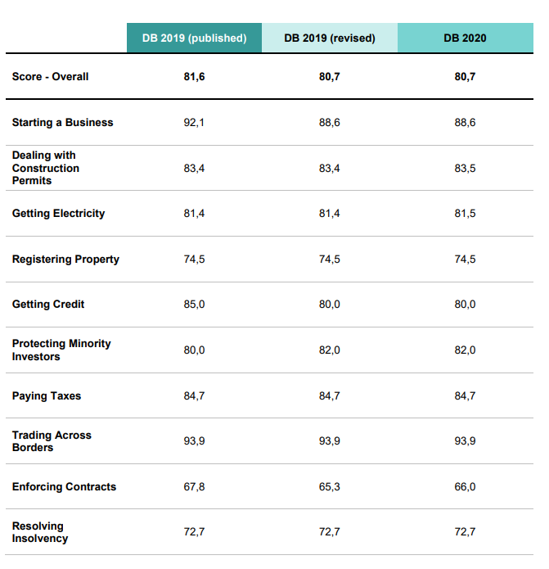

Rank per Indicator (2020)
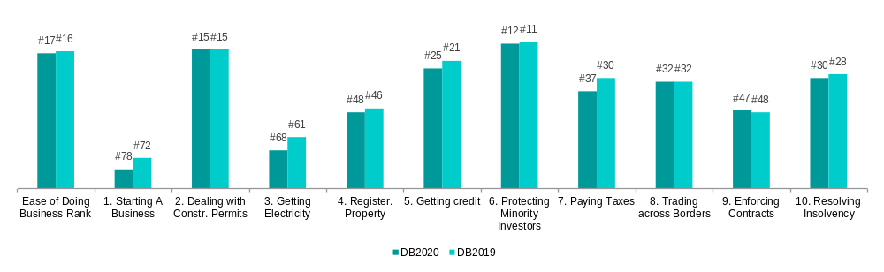
Source: World Bank

Another indicator demonstrates North Macedonia’s business friendly environment: the Index of economic freedom, from the Heritage Foundation. This index covers 12 mains aspect of economic freedom like property rights, government integrity, judicial effectiveness, government spending, tax burden, fiscal health, business freedom, labour freedom, monetary freedom, trade freedom, investment freedom, financial freedom. The country is getting the highest score in the region (68.6 out of 100) above neighboring EU countries such as Croatia (63.6).

Figure 3. Index of Economic freedom performance

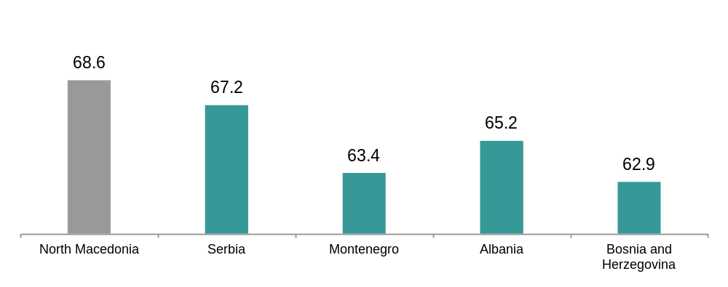
Source: Heritage Foundation

North Macedonia’s institutional setup is one of the strongest in the region. Several achievements over the past years have contributed to this achievement, starting with the Prespa Agreement in 2018 which put an end to the decade-long dispute with Greece over the country’s name and paved the way for further integration within Western Europe. Since then, the country officially joined NATO and waits to open chapters’ negotiations with the European Union. The latter provides a widely recognised anchor to support structural reforms, in particular related to the EU acquis.

The regional cooperation is another testament of North Macedonia’s institutional strengthening. It is characterised in particular by the Central European Free Trade Agreement (CEFTA), and most recently the progress made on the Open Balkans initiative, during the Summit in Skopje on July 29^{th,}, 2021.

The World Bank’s World Governance Indicators (WGI) also evidence it. The WGI defines governance holistically as “the traditions and institutions by which authority in a country is exercised, including the process by which governments are selected, monitored and replaced, the capacity of the government to effectively formulate and implement sound policies; and the respect of citizens and the state for the institutions that govern economic and social interactions among them.” It does not provide a single score rating, focusing instead on the 6 areas and allowing countries to be evaluated on each dimension. In four dimensions, North Macedonia is among regional top performers: Control of Corruption, Government effectiveness, Political stability and absence of violence and Regulatory quality. The average performance of the country is the second best in the Western Balkans, after Montenegro.

Figure 4. Performance of North Macedonia at WGI (2019 - percentile)

Control of Corruption | 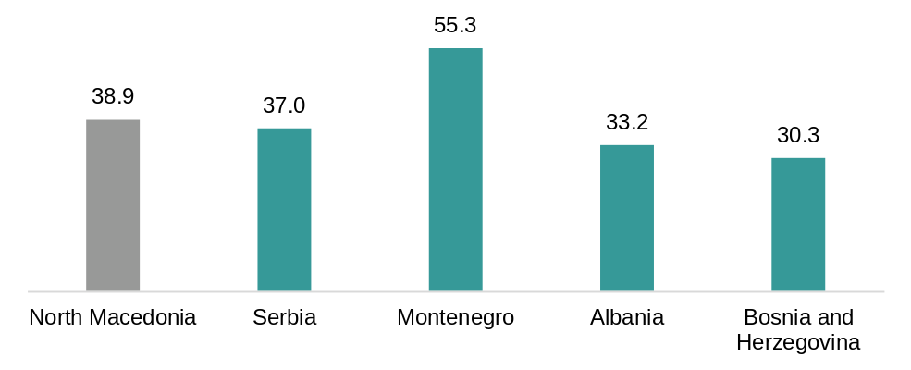
Government effectiveness |  | 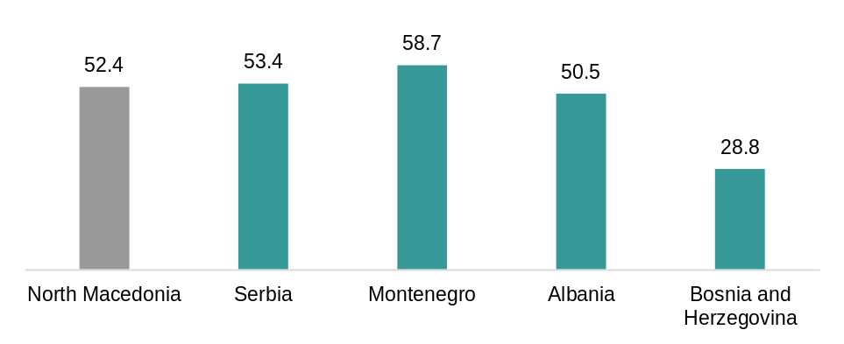
Political stability an absence of violence | 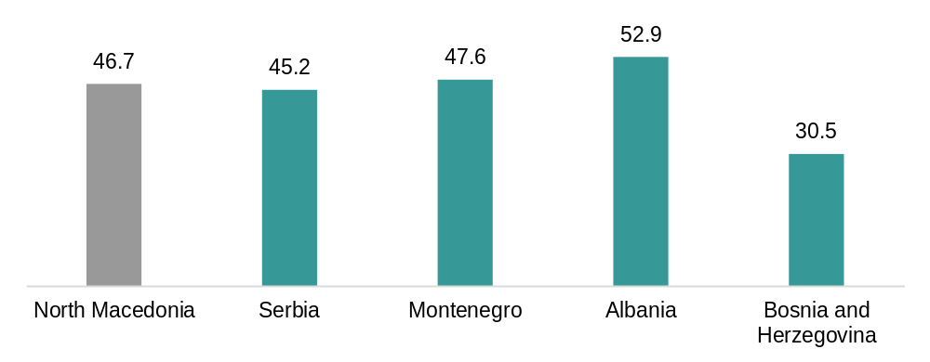
Regulatory quality | 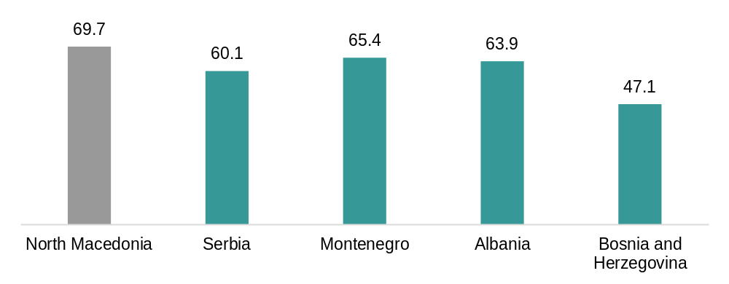
Source: World Bank

Special Economic Zones have been a key pillar of North Macedonia’s investment promotion strategy. The country has a total of 15 Special economic zones that play an increasingly active role in supporting the country’s economic activity, and currently account for nearly 50% of North Macedonia’s exports.

The Economic Zones are focused on sectors that provide long term benefits to the country’s growth as opposed to potential crowding out effects on local businesses. In particular, FDI in the agri-business and furniture sectors are not eligible to the Free Economic Zones to preserve North Macedonia’s domestic businesses and maximise the spillover effects of the zones.

The benefits provided to companies settling in the Zones are both fiscal and non-fiscal:

Fiscal and tax benefits
- Investors in economic zones are entitled to a 10-year profit tax exemption (versus a standard 10% profit tax rate)
- The zones offer a 100% reduction in personal income tax for 10 years - effective rate 0% (versus a standard 10% personal income tax rate)
- Investors are exempt from paying VAT on goods, raw materials and equipment in the zones (standard rate 18%)
- Exemption from customs duties on goods, raw materials, equipment and machinery (standard rates 5-20%)
- Investors are exempt from paying local utility fees or construction permit fees (standard property tax rates 0.1-0.2%, property transfer tax 3%)

Non-fiscal benefits
- Long-term lease of land in the zones for a period of up to 99 years
- Up to EUR 0.5 m cash grant for the cost of construction of facilities, depending on the number of new jobs and the amount of the investment
- Exemption from customs duties on equipment and spare parts used for the zone
- Access to high quality infrastructure (water supply, sewerage, etc.)
- Preferential / fast / priority services from the state: approvals for design and infrastructure, issuance of building and operation permits, customs administration, contacts with other state and local authorities and the like
- Equalisation of assistance to domestic and foreign investors.

Appendix 2. NIC Project List

NIC Project list

Appendix 3. Fund for Innovations and Technology Development (FITD)

Fund for Innovations and Technology Development (FITD) started with financing programmes with the first public call for financing in 2015. Since the beginning, FITD activities and the support instruments have been developed under the Project financed via World Bank loan: Skills Development and Innovation Support Project (SDIS), component no.3, while in 2017, FITD became the institution carrier of the 3rd pillar from the Government Plan for Economic Growth, under which several additional support instruments were developed.
- Total investment portfolio of FITD is based upon a model of co-financing and as of August 2021, the investment volume is the following:
Total volume of portfolio | 85,156,309.85 €
FITD co-financing | 47,740,734.94 €
Beneficiary's co-financing | 37,415,574.91 €
FITD total portfolio leverage ratio = 0.78.
- FITD leverage ratio per year:
Year | Leverage ratio per year:
2015 | 0.32
2016 | 0.18
2017 | 0.42
2018 | 0.74
2019 | 0.84
2020 | 0.64
2021 | 0.92

- Leverage ratio per support instrument:
Support instrument | Leverage ratio
Start-up & Spin-off | 0.29
Business Accelerators | 0.38
Improvement of innovation | 0.49
Commercialisation of innovation | 0.50
Technology development (COVID 19) | 0.64
Technology development for accelerated growth | 0.92
Technology extension | 1.39
Technology development | 2.55

As shown in the tables above, the leverage ratio depends on the type of support instrument since different instruments have different % of co-financing (it varies from maximum 85% FITD co-financing to a maximum of 30% FITD co-financing depending on the instrument).
In addition, although all instruments are co-financing grants, most of them have a model of return as royalty (as % from the sale of the product/service/process financed and developed via FITD project) or direct return (as % from the operative profit of the beneficiary company). Based on the models of return, FITD generates additional income.

- Measuring the economic performance of beneficiaries financed through FITD Programmes:
In an effort to assess the impact of the provided financial support to FITD beneficiaries, a set of economic performance indicators was derived by using official income statement data of selected companies, being provided by the Central Registry of North Macedonia (CRM). In order to establish a common reference point against which changes in the values of the indicators is measured (but also having in mind that the data from the income statements refer to annual values), it was decided that the starting values of the indicators are taken from the year prior to launching the public call, under which specific companies received financial support.
The analysis defines a set of indicators derived from the absolute values of the following income statement parameters: revenues оn the basis of sale (revenues in the following text); net profit; average number of employees for each year; average monthly salary for each year; employee benefits (including social and health insurance); tax on salary; and profit tax. By using the above-mentioned parameters, as for the analysis, the following indicators derived, at both, group and overall FITD portfolio level covering the period 2015 - 2019:

Indicator | Relative value
Аverage АNNUAL INCREASE IN THE OPERATING REVENUES of the overall portfolio of companies in the period 2015 – 2019 | 11%
Relative increase in the average annual amount of THE OPERATING REVENUES of the overall portfolio of companies in the period 2015-2019 in relation to the respective base years | 29%
Relative increase in the average annual amount of THE OPERATING REVENUES of the overall portfolio of companies in the period 2015-2019 in relation to the respective base years | 82%
Average ANNUAL INCREASE IN THE NUMBER OF COMPANIES GENERATING PROFIT at the level of the overall portfolio of companies in the period 2015 – 2019 | 19%
Average ANNUAL INCREASE OF THE PROFIT of the overall portfolio of companies in the period 2015 – 2019 | 71%
Average share of the PROFIT AS % OF THE OPERATING REVENUES of the overall portfolio of companies in the period 2015-2019 | 28%
Average share of the PROFIT AS % OF THE OPERATING REVENUES of the overall portfolio of companies in the period 2015 – 2019 | 6%
Average ANNUAL GROWTH OF MONTHLY SALARIES PER EMPLOYEE of the overall portfolio of companies in the period 2015 – 2019 | 10%
Average ANNUAL INCREASE OF THE PAYMENTS TOWARDS THE STATE of the overall portfolio of companies in the period 2015 – 2019 | 18%

In addition, in 2021, FITD Programmes were subject to external expert analyses performed by “Finance Think” (financially supported by the Norwegian Embassy in Belgrade and the Balkan Trust for Democracy of the German Marshal Fund of the US) named: “MEASURING ECONOMIC EFFECTS OF STATE AID GRANTED TO PRIVATE ENTERPRISES IN NORTH MACEDONIA - The case of the Government’s Plan for Economic Growth” (https://www.financethink.mk/wp-content/uploads/2021/04/Measuring-economic-effects-of-state-aid-granted-to-private-enterprises-in-North-Macedonia.pdf):
“The objective of this study was to measure the effects of state aid distributed to private enterprises in North Macedonia on efficiency and competition. Hence, two programmes were analysed – labelled as Law on Investment Support State Aid and FITD State Aid – executed during or at the end of 2018, for the purpose of being able to compare 2017 or 2018 (pre-support) and 2019 (post-support). The analysis relies on a rigorous impact evaluation method. First, we created comparison groups out of the pool of rejected applicants for the two programmes, because they best mimic the treatment group on unobservables: in both cases they had the same investment motive as they have also committed an investment (the FSIL case) or intended to make an investment (FITD case). Moreover, in the FITD case, we used the selection points to arrive at a more homogenous group of comparators. We pursued conditional matching on firms’ age, industry at three digit NACE Rev.2, location (distance from the capital) and firms’ size, by using the procedure of nearest neighbor or a caliper (searching for matches within a range of standard deviations). After the matching, we pursued a difference-in-differences calculation to isolate the effect of the state aid on a range of efficiency and competition indicators: growth in sales, investment, profit, employment, wages, productivity, cash, market share and competition perception. The FITD state aid – the third pillar of the Plan for Economic Growth 2018-2021 – proved considerably effective. Our findings suggest that due to the subsidy, recipients were able to increase their sales revenue and labor productivity. The cost of additional euro of sales generated, in gross terms, has been slightly over a euro. However, no more jobs or higher wages were created in recipients than in what has been observed among matching comparators non-recipients. Likewise, the FITD aid has been found responsible for the increase in investment in technology of non-tangible form, which was particularly important finding given: i) the definitional role of FITD aid to spur technological growth and innovation; and ii) the declining investment in non-tangible assets among non-recipients over the same period. Overall, these positive developments induced by the FITD state aid brought about a large increase in profits, far exceeding the profit growth in matching non-recipients. However, at the same time, FITD recipients were found under cash showers, which may suggest that excess profits were not exclusively driven by the increasing revenue, investment and productivity, but also by the extra generated cash in the company due to the grant. As a caution, though, we cannot exclude that cash accumulation from state aid disbursements has been a commitment for pursuing investment later, in the subsequent year, which we did not observe in our data.”

- Hybrid National Green and Digital MSME Fund for start-ups and innovative enterprises*:
The proposed Facility or Fund will contribute to the implementation of the access to finance pillar of the SME Strategy for a Sustainable and Digital Europe in the country, as well as the national Innovation Strategy and Law on Innovation Activity.

The rationale for government investment in venture and early growth equity funds rests on three pillars (Lerner 2010):
- the role of technological innovation in spurring economic growth;
- the role of entrepreneurship and venture capital in stimulating innovation and
- the role of governments in promoting entrepreneurship and venture capital.

Overall development objective:
- Diversify of the economy and exports towards more value-added sectors
- Improve productivity of existing firms
- Create better paid jobs for highly educated youth, thus preventing brain-drain and attracting talent
- Introduce non-bank financial instrument

Intermediate development objective:
Close the financing gap in venture and early growth equity and quasi-equity finance for green and digital start-ups and innovative SMEs through leveraging private investment.

Investment strategy:
Invest EUR 250 thousand – EUR 1.5 million in minority equity (75%) and quasi-equity (25%) stakes in green and digital start-ups and innovative SMEs, supporting their growth and entry on international markets.
Fund model considered for implementation:

Scenario B2: National Hybrid Investment Fund (30% public – 70% private) of EUR 27 million.

The model also allows it to grow into: Scenario C: Regional Hybrid Investment Fund (15% public – 85% private) of EUR 50 million.

Key characteristics of both scenarios:

 | Scenario B2:  National Hybrid Investment Fund | Scenario C2:  Regional Hybrid Investment Fund
Fund Size | €27 million | €50 million
Public – private investment ratio (where the private side includes international institutional investors) | 30% public (government) – 70% private (institutional investors and private arms of IFIs or bilateral financial institutions (to be raised by the fund manager) | 15% public (government) – 85% private (institutional investors and private arms of IFIs or bilateral financial institutions (to be raised by the fund manager)
Target investments | €19 million in 31 investments in domestic start-ups (10*€200K + 10*€500K + 10*€1mil + 1*€2 mil) | €39 million in total: €19 million in 31 investments in domestic start-ups (10*€200K + 10*€500K + 10*€1mil + 1*€2 mil) plus €20 million invested in two regional funds
FITD needs to establish a sponsoring company | Yes | Yes
Fund Manager selection | FITD owned sponsoring company competitively selects a private professional Fund manager licensed as a AIFM in a EU jurisdiction, who opens a local office | FITD owned sponsoring company competitively selects a private professional Fund manager licensed as a AIFM in an EU jurisdiction, who opens a local office
Fund registered with SEC | Yes | Yes
Feeder Fund registered in EU Jurisdiction | Yes | Yes
Investment decisions are made by | Investment Committee established by Advisory Committee (FITD and LPs (limited partners)), composed solely of independent experts from private sector | Investment Committee established by Advisory Committee (FITD and limited partners (LPs)), composed solely of independent experts from private sector
Costs for the Government | €10 million of which:  Through the Fund  - €5.5 mil as investment capital  - €0.75 mil for 2% Fund management fee (20%)  - €1 mil Fund operational costs (20%)  - €0.3 mil for investment by sponsoring company as GP (General Partner) in the Feeder Fund  - €0.3 Fund set-up costs (to be reimbursed after fund closing)  - €1.5 mil for GP (General Partner) /fund manager subsidy  - €0.7 mil for investment readiness TA | €9.2 million of which:  €8 mil as investment capital;  €0.7 mil for technical assistance to start-ups  €0.5 mil for GP (General Partner) fee for the Feeder Fund
Life span | 5 years investment period + 5 years de-investment period + 2 years extension subject to market conditions | 5 years investment period + 5 years de-investment period + 2 years extension subject to market conditions
Fund share classes | Class A: private investors: unlimited return  Class B: private arms of international financial institutions: capped return 8%  Class C: government  capped return 1% | Class A: private investors:  unlimited return  Class B: private arms of international financial institutions:  capped return 8%  Class C: government:  capped return 1%
Expected return to Government | 1% capped return | 1% capped return
Leveraged private investment and estimated net IRR to investors (after fees and taxes) | €21 million with estimated IRR of 13% | €42 million with estimated IRR of 10%
Multiplier effect at fund level | Large multiplier effect (1:2) | Very large multiplier effect (1:5)

The proposed legal and regulatory structure of the Fund is shown in Figure 1 below.

Figure 1: National MSME Fund Structure
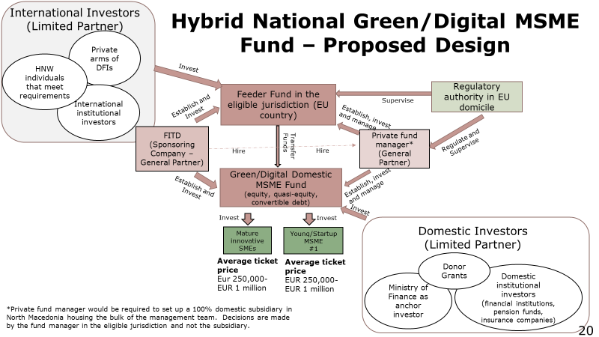

*The information provided in this section is based on the information and analyses conducted by the World Bank based on a technical assistance project with the FITD.

Appendix 4 “Greening Business” Facility (North Macedonia FZA)
- Establishment of “Greening Business” Facility via IPA III Annual Action Plan in favour of the Republic of North Macedonia for 2021, Action 06 - EU for Green Economy*:

The Action Plan will promote the sustainable economic development of Republic of North Macedonia. The EU funds will be geared towards greening, recovering, and modernising the economy through establishing the “Greening Business” Facility. The Action Plan will channel the EU funds to the private sector in support of the greening of the economy and enhancing the circular economy. At least 300 companies from the Republic of North Macedonia will be stimulated to innovate in a sustainable way, grow and create jobs in green businesses. The Action Plan will provide for over 180 companies to introduce quality and sustainability standards and to integrate in the EU and the regional value chains. The EU investments is expected to create 700 new (green) jobs. The advisory and financial mix will decrease the use of the natural resources by 20% and will increase the turnover of the supported companies by 10%.

Output 1: Established “Greening Business” Facility
Activity 1.1: Establishment of “Greening Business” Facility, involves:
- Expanding the body of knowledge on green financing in the Republic of North Macedonia, developing proposals for regulatory and tax incentives for green businesses, developing funding strategy;
- Advisory assistance for companies to achieve compliance with the EU Standards, to innovate, and become a part of the circular economy, to become a vector for reduction of pollution;
- Advisory assistance to the Fund for Innovations and Technology Development for designing the rules and procedures for selection of grant beneficiaries; assessing the proposed investments and consistency with the eligibility criteria, monitoring the funded operations, collecting data, and management and reporting.
- Promotion of the Green Business Facility and raising the awareness of the business communities on their environmental impact, as well as the ways to adopt environment-responsible and sustainable behaviour. Implementation of a communication plan by focusing the public attention on the need and the benefits of business greening.

Activity 1.2: Investing in green businesses
This activity refers to the operations of the “Greening Business” Facility, which will promote and stimulate the environmental responsibility among businesses. Facility is considered as an investment vehicle to encourage business to innovate their operations and decrease their environmental footprint.
Facility will provide grants, through a competitive procedure (targeted calls for proposals) to selected companies for their projects/initiatives.
Facility will stimulate the private companies’ investments in areas such as: industrial innovations and circular economy, green buildings, clean energy resources and sustainable mobility, sustainable land use and nature, and willingness to apply the EU Internal Market Standards.
Facility will be gender-sensitive as regards the beneficiaries, as well as with respect to the investments (all investments will be assessed for their gender impact).
Indicative budget:
Implementation modalities | EU contribution  (Amount in EUR) | Indicative third-party contribution, in currency identified
Output 1: Established Greening Business Facility, composed of | 20,000,000 | 7,000,000
Direct management (Grants)  (with Fund for Innovations and Technology Development) | 18,000,000 | 7,000,000
Direct management (Procurement) | 2,000,000

*This Facility is still subject to approval by the EU, not being active, nor approved at present. The information provided is extracted from the draft document.

North Macedonia Free Zones Authority

- Purpose
To provide the necessary financial resources to cover the extensive infrastructure and investment agenda within free-economic and industrial zones in the Republic of North Macedonia. Upon the piloting, the model can be extended to cover all such operations in the Republic of North Macedonia, without limitations.

- Current situation
Government provides all the financing for infrastructure and investments’ support to the free economic and industrial zones in the country. Current level of financing (annual) reaches up to EUR 23 million.
North Macedonia Free Zones Authority currently operates with approximately EUR 300 million of state-aid contracts, signed with existing investors. 40% of those have been executed, while approximately EUR 180 mil of incentives + exemptions remain to be materialised in the next 5 – 7 years=.
At present, with activities picking up in Q1/2021, North Macedonia Free Zones Authority mobilised 15+ Letters of Interest from existing and new investors, with total planned investments of EUR 250 million. This will add EUR 125 million to the existing balance, to be allocated in the State Budget over the next 5 - 7 years. In addition, North Macedonia Free Zones Authority is preparing PPP Agreement for Gevgelija Free Economic Zone, which is expected to bring up to EUR 500 million as investments over the period of 5 - 7 years. This will add EUR 250 million to the balance. These figures do not include additional needs related to new investors upon 1st April 2021 for free economic or industrial zones (except for Gevgelija).
Expected significant increase in funding needs justifies the effort and approach of the Ministry of Finance to seek for alternative sources (private, institutional) of financing of investors’ support programmes, including new initiatives of North Macedonia Free Zones Authority /Government.

- New approach to Government support to FDIs (and domestic investors) within the zones
New approach in analysing and preparing state aid scheme is now introduced, focusing on returns to the investment support provided by the Government. Individualised approach to investors, based on analysis of returns is expected to generate more “high-quality” investments versus those that rely heavily on cheap labour and Government subsidies. In the mid-term, it can be expected that Government support schemes to investments provide larger % of cash paid earlier in the process, with investors agreeing to accumulate assistance below limits of 50% of the eligible investment costs, applied within current (past) approach to policy for attracting FDIs.

Structure of the new initiatives
- North Macedonia Free Zones Authority, operating with the zones, introduces new pillars of new instruments to support investors, such as:
- Promoting green investments into North Macedonia, including the following components:
- Energy (new infrastructure within the zones + connecting lines to access points to main lines in the country)
- Transport (new infrastructure within the zones + connecting lines to access points to main road/rail lines in the country)
- Services (new infrastructure within and beyond zones, to allow for access to services needed – such as accommodation facilities for foreign and/or workers coming from within the country, education and primary health facilities)
- Other (specific for the need of investors, including construction and lease options for investors)

- SDP - Enhancing technological readiness of domestic companies to enter global value chains

Conservative analysis for these two main pillars are estimated to generate up to EUR 750 million in total investments covering the period 2025-2026.
With applied 25% rate of equity into financing (Budget + international financing instruments + private equity funds), the volume of funding of these Programmes via the Strategic Green Investment Fund should be calculated for up to EUR 150 million.

Rationale behind the model
In both cases – infrastructure and investment support, North Macedonia Free Zones Authority generates inflow of revenues that can be utilised to compensate for private financial investors’ contribution in the Strategic Green Investment Fund.
In addition, financial partners can be offered a voice in the decision to support specific investment project, which will be an added value to the Government efforts to bring-in and select “high-quality” investments.
Such financing model will lift pressure off investors to provide financial resources at the beginning phase of the investments. Investors will than focus on bringing know-how, new technologies, established markets and other inputs to successful business in the country This will ultimately contribute to greater interest, scaled up investments and much better quality of investors in the country.

Structure and returns (proposal)
- Government (North Macedonia Free Zones Authority), IFIs, private financial sector (banks, funds, individuals)
- The vehicle envisages issuance of shares to all holders, on the basis of contribution within the pool of funds
- Funding will be returned by means of lease, royalty, and another basis Private investors get priority shares i.e. get paid first, upon completion of the investment and the royalty payment period (during and after the completion)
- Private investors will get priority level of returns (50 to 75%). Once this level is reached, the returns are split according to % of contribution (shares) in the vehicle.

Financing model
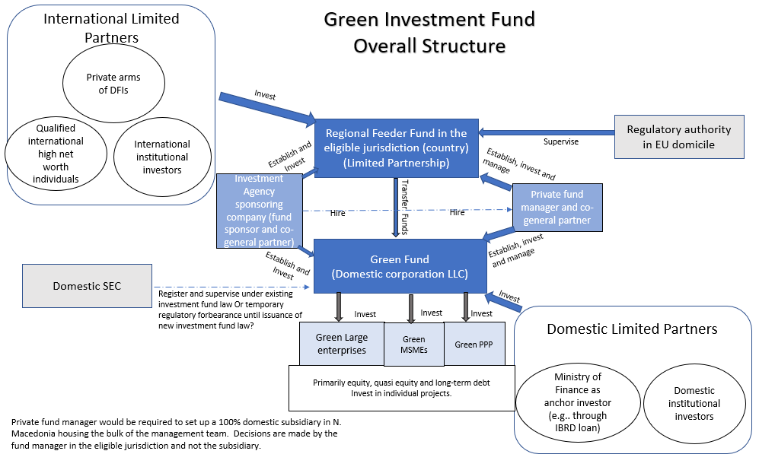

Оverall development objective of the Fund is to implement the EGD (EU Green Deal) in the Republic of North Macedonia, with the option for enlarging the operations in the Western Balkans Region. The intermediate development objective is to crowd-in private investors in the financing of enterprises and infrastructure PPP investments.

Appendix 5. Development Bank of North Macedonia
I. Current instruments
1. Loans
Development Bank (the Bank) disburses loans through banks and saving houses, as well as directly to SMEs. The loans are disbursed on behalf of and for the account of the Bank itself, or on behalf of and for the account of the state (as an agent). Activities that DBNM can perform as an agent of the state are determined within the Law on the Development Bank of North Macedonia.
Funding sources for the loans are: Bank’s own funds, loans from international institutions (KfW, EIB) and when acting as an agent of the state – funds from the Budget.
The multiplier of the loans varies –from 0 to 50 and above, depending on the credit line. It is common that the loans require at least 20-30% participating funds from the final borrower.
DBNM administers a credit portfolio of around EUR 60 million as an agent of the state (Self-employment, ACDF - Agricultural Credit Discount Fund, Special Loan Fund (SLF), Compensation Funds for Production, Processing and Export of Agricultural Products, Fund for Micro and Small-Sized Enterprises, Fund for Financing Liquidity of Enterprises).
2. Credit Insurance (short-term)
For the purpose of supporting Macedonian companies, which sale on credit, the Development Bank of North Macedonia provides short-term insurance of receivables against commercial and political risks. Since DBNM bares the risks of the buyers, the Bank reinsures the insurance policy..
In today’s trade, the most often pre-condition for realisation of an agreement is to sell on open account. Thus, a credit relation is created between the seller and its buyer, causing additional costs and risks for the seller. Besides the fact that the seller will wait longer to collect the receivables, the very value of the receivables will reduce gradually each day. Trade competition, especially on the international market is far too uncertain, and the implementation of the projects incurs a lot of risk. The risk may be reduced by appropriate insurance instruments.
Commercial risk denotes default of payment by the buyer due to insolvency or bankruptcy.
Political risk denotes default of payment by the buyer due to events in the country such as war, riots, occupation, revolution, as well as cancellation of licenses, non-observance of an agreement, moratorium.
Beneficiaries of credit insurance may be companies registered in the Republic of North Macedonia, which sell goods and services with deferred payment not exceeding 360 days.
The products that DBNM offers under this instrument are:
- Post-shipment and pre-shipment insurance of export receivables; and
- Post-shipment and pre-shipment insurance of domestic receivables.
In 2020, the Bank has insured receivables in the amount of around EUR 70 million (33% increase compared to 2019). During 2021, as of July inclusive, the Bank has insured receivables in the amount of around EUR 88 million (118% increase in the average monthly amount compared to the average monthly amount in 2020).
3. Factoring
Factoring is a service, which enables sale of goods and services with deferred payment, while part of the invoice value is received in advance. Factoring is a combination of credit protection, register of receivables, debt collection and financing of companies, which sell goods and services with deferred payment not exceeding 360 days. DBNM purchase invoices and makes an advance payment of 80% of the invoice value.
Advance payment is offered with an interest rate calculated up to the date of invoice payment by the buyer. The invoices of realised sale of goods and services between the seller and the buyer serve as a guarantee, as well as the insurance of receivables and the bill of exchange. Prior to payment, each invoice related to factoring has to be insured against commercial risk with DBNM. Thus, inflows on the basis of receivables, are insured.
In 2020, the Bank has purchased invoices in the amount of EUR 5.3 million (29% increase compared to 2019) and up to July 2021, the Bank has purchased invoices in the amount of EUR 4.2 million (38% increase in the average monthly purchased invoices compared to 2020). Since 2020, the Bank has also offered domestic factoring, i.e. purchase of receivables
4. Guarantees
During 2020, DBNM undertook a series of activities to include guarantees in its daily operations. The Government increased the capital of the Bank by EUR 3 million, so as to increase the Banks’s potential for undertaking risk. At the beginning of 2021, in its own account and in its own name, the Bank has introduced customs guarantee.
As an agent of the state, in the name and for the account of the state, in line with the Law on Development Bank, the Bank introduced Guarantee Fund to the end of providing a credit-guarantee scheme as support to the companies in the country. Two products are introduced under the Guarantee Fund: portfolio guarantees towards banks and saving houses for micro, small- and medium-sized companies and individual guarantees for large exporting traders.
4.1. Customs Guarantee
Comprehensive guarantees for securing customs debt in inward processing. The guarantee covers 100%of the amount of the customs debt on the basis of inward processing. The beneficiaries of the p customs guarantee are companies, which import goods in order to undergo inward processing operations and re-export the processed goods. The Development Bank provides higher amounts of customs guarantee for the companies in processing industry.
As of July 2021, the Bank has issued 6 customs guarantee in the amount of EUR 570 thousand. Considering that the Bank is required not to be competition to commercial banks, it does not market the product against banks, but it rather fills the gap on the market in order to provide more favorable conditions for the exporting companies.
4.2. Credit-Guarantee Scheme (Guarantee Fund)
By establishing a Guarantee Fund (state-funded), two products are introduced in the country:
- Portfolio guarantees towards banks and saving houses for eligible borrowers (guarantees of up to 50% for fixed asset loans, and up to 80% for working capital loans);
- Individual guarantees for big exporting companies (companies, wherein export revenues account for at least 30% of total generated revenues) with а guarantee of up to 50% of the loan amount.
The initial amount set in the Fund is EUR 10 million, with additional EUR 5 million budgeted for 2021. The Law ensures that the loans supported via guarantee from the Guarantee Fund can not exceed 10 times the amount of the funds in the Guarantee Fund, thus limiting the multiplier at 10.
The state is аssuming the risk with respect to the Credit Guarantee Scheme, as per best practices when such schemes are established under the development banks. The Guarantee Fund is established as a separate organisational unit, Guarantee Fund Unit in the Bank. Activities for implementing new software solutions are undertaken for the purpose of its easier operationalisation.
4.2.1. Portfolio Guarantees
Portfolio guarantees are provided to banks and saving houses, having concluded Agreement with the Development Bank, pertaining to portfolio guarantee issuance, for clients meeting the criteria set in the Agreement for Issuing Guarantees from the Guarantee Fund, organised by the Development Bank, requesting loan, lacking sufficient collateral. The loan secured with portfolio guarantee should be between Denar 300,000 – Denar 30,750,000, with minimum repayment period of 1 year and maximum repayment period of up to 8 years for a loan for fixed assets, i.e. up to 3 years for working capital. The Bank has issued six portfolio guarantee as of September 2021 inclusive.
4.2.2. Individual Guarantees
Individual guarantees are intended for big exporting companies (at least 30% of their total generated revenues come from export). DBNM directly processes the individual guarantee requests. The loan secured with the individual guarantee should range between Denar 3,075,000 – Denar 30,000,000, whereby the amount of the guarantee should not exceed 15% of the total revenues of the company.
Individual guarantees must not exceed 40% of the resources of the Guarantee Fund.
In order to be sustainable, a fee for the guarantees will be charged for the Guarantee Fund, starting 2023. Moreover, the state, as is the case with the best practices in other countries, can decide on providing additional funds to the Fund. Additionally, the Guarantee Fund uses mechanism upon the examples of other credit - guarantee shames, with the payment cap being set at 30% at portfolio level.

II. Instruments to be implemented
- Loans
Energy Efficiency Fund (World Bank funded EUR 5 million)
This Fund is based on the third component of the Energy Efficiency in the Public Sector Project funded with a loan from the World Bank (EUR 25 million). The Project is implemented by MSIP in MoF. Project consists of 3 components:
- Component 1: Investments for energy efficiency in the public sector - EUR 18 million for implementing energy efficient projects and certain investments in renewable energy in public facilities (municipal buildings, central government buildings and public lightning);
- Component 2: Technical assistance and support for implementation of the Project - EUR 2 million as technical assistance and implementation of the Project, as well as for establishing the Energy Efficiency Fund;
- Component 3: Initial Capital for the Energy Efficiency Fund - EUR 5 million for establishing the Energy Efficiency Fund.
Since the Fund should be established following the findings and recommendations of the consultants under Component 2, it is assumed that the Fund will be established between 6 and 18 months.
The multiplier effect of the Fund should come out of the analysis and the reports of the consultants. It is the Bank’s assumption that it will be roughly 1.3, assuming at least 30% participation from the beneficiaries.

- Insurance and Guarantees
2.1. Fund for Support of Export - Oriented Companies
By introducing the Law on Export Insurance and Financing, legal framework will be created for the Development Bank of the Republic of North Macedonia AD Skopje, Ministry of Finance and Inter-Sectoral Commission for Export Promotion (representatives from the ministries, chambers of commerce, the Development Bank and/or others), all to the end of establishing the export insurance system in the Republic of North Macedonia at state level.

Appendix 6 Invest North Macedonia
In 2018, Invest North Macedonia, became, through the Law on Financial Support of Investments ("Official Gazette of the Republic of Macedonia", no. 83/2018 and "Official Gazette of the Republic of North Macedonia", nos. 98/2019, 124/2019 and 178/2021), part of the 1st and 2nd pillar of the Plan for Economic Growth adopted by the Government of the Republic of North Macedonia. As for investment projects outside the technological industrial development zones and the industrial zones managed by North Macedonia Free Zones Authority, the business entities submit applications for use of financial support to Invest North Macedonia.
As an aid scheme in accordance with the regulations governing the control of state aid, the Law on Financial Support of Investments is part of the industrial policy measures (Industrial Strategy of the Republic of North Macedonia 2018-2027, with Action Plan - Ministry of Economy of the Republic of North Macedonia), wherein the state is directly involved and contributes to encouraging economic growth and development in the Republic of North Macedonia, thus providing for an equal framework and opportunity under certain conditions, for the business entities to receive financial support that will boost their economic growth, and which will subsequently contribute to increased overall economic growth and development of the economy of the Republic of North Macedonia.
Law on Financial Support of Investments provides financial support for domestic and foreign companies making productive initial investment within their business investment plans for a period of 5 (five) years.
The Law includes 7 (seven) measures for providing financial support:
      - Support for new employments ( 20% financial support for a business entity, which will pay monthly net salary , being by 50% higher than minimum net salary);
      - Support for establishing and promoting cooperation with suppliers from the Republic of North Macedonia (10% financial support from the value of the total performed procurements of products from suppliers);
      - Support for the establishment of organisational forms for technological development and research (50% financial support of the total eligible investment costs for industrial research);
      - Support for investment projects of significant economic interest:
- Payment of funds in the amount of paid personal income tax by new employees;
- Payment of funds in the amount of paid profit tax within the project;
- 10% of the eligible investment costs;
- Payment for each newly employed person, to whom a net salary is continuously paid higher by 50% of the minimum net salary;
      - Support for growth of capital investments and revenues (10% of the eligible investment costs);
      - Support for taking over business entities facing difficulties, (10% of the costs for taking over the business entity), and
      - Support for increasing market competitiveness (10% of eligible investment costs).
Total financial support that can be paid in accordance with the Law on Financial Support of Investments can not exceed 50% of the amount of realised eligible investment costs. As for major investment projects, the amount of financial support is: - up to 50% of the eligible investment costs for an investment project of up to EUR 50,000,000; - up to 25% for the part of the eligible investment costs for investment project from EUR 50,000,000 to EUR 100,000,000 and - up to 17% for the part of the eligible investment costs for investment project exceeding EUR 100,000,000.
The maximum intensity of financial support does not refer to the financial support that is granted and paid for the establishment of organisational forms for technological development and research.
Law on Financial Support of Investments contributes to balanced regional development, the beneficiaries of financial support will receive additional financial support depending on the planning region, where the productive initial investment is realised. The additional financial support will be calculated as a percentage difference between the planning region with the highest value of GDP per capita and the value of GDP per capita of the planning region, wherein the productive initial investment is realised.
For productive initial investments of business entities established by citizens of the Republic of North Macedonia, who have or have had a regular permanent or temporary residence abroad, i.e. outside the Republic of North Macedonia for a period of at least five years, until the day of submitting the application, the amount of financial support is increased by 15% of the eligible investment costs.
The financial support granted to the business entities is realised on annual basis with direct payment to the beneficiary's account. The provider of financial support is the Government of the Republic of North Macedonia, and the funds for payment are provided from the Budget of the Republic of North Macedonia.

The other two being Voice and accountability and Rule of Law
Calculated as the simple average of the percentile rank of each country. North Macedonia is on average at 49.8, while Montenegro is at 55.1 and Serbia at 48.6.
As for all scenarios, additional multiplier effect will be achieved at project level where private arms of IFIs and private investors invest in individual start-ups and MSME

