**To run these example, MATLABR2022b, Deep Learning Toolbox, Mapping Toolbox, Matlab Report Generator, Statistic and Machine Learning Toolbox, and the EnergyPlus Version 8.7 are required.**

1. **Example 1 Brazil**

Zoning the state of Rio Grande do Sul, in Brazil.

All settings are included in the file BRA_RGS.zon.

1. **Files required**

|  |  |  |
| --- | --- | --- |
|  | **File** | **Location** |
| 1. Input file | BRA_RGS.zon | simzoning\ |
| 1. Shape file of the States of Florida, Georgia, and Tennessee | BRA_RGS.shp | simzoning\GISfiles\AreaOfStudy\ |
| 1. Weather files of the area of study and surroundings | 35 .EPW files | simzoning\Weatherfiles\ |
| 1. Idf files | ModelHVAC.idf  ModelNV.idf | simzoning\IDFs\BRAZIL_IDFS\ |
| 1. EnergyPlus Version | 8-7-0 |  |
| 1. Alternative method for comparison | DegreeDays_Brazil.shp  GT_Brazil.shp | simzoning\GISfiles\CZ_Methods_Comparison\ |
| 1. File containing coordinates of Brazilian municipalities | MunicipiosBrasil.csv | simzoning\ |

1. **Steps**
2. Create a folder C:/simzoning to unzip simzoning files.
3. Confirm the path of EnergyPlus Version 8.7 installed in the computer. If necessary, rewrite the path in the BRA_RGS.zon file used as input data to run this example. 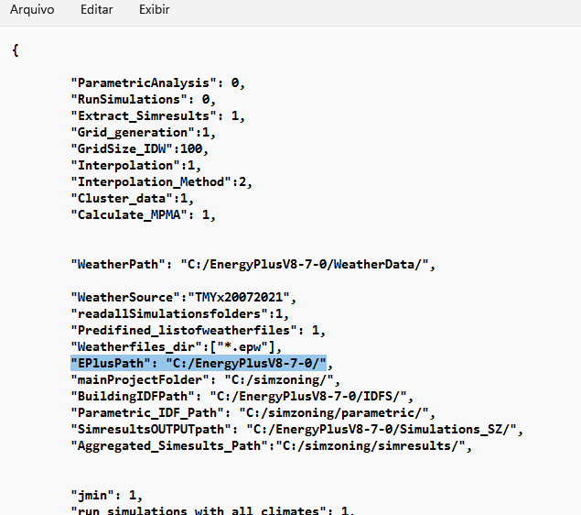

Figure 1 Input data file BRA_RGS.zon

1. Call simzoning from MATLAB with the BRA_RGS.zon file as input data.

|  |  |
| --- | --- |
| Case study summary | |
|  | 35 Epws |
| 2 models  5 Performance indicators  No Macrozones  4 Zones  Time estimation 1 hour |

1. **Expected results**

A Region with 4 Zones considering 3 Zoning resolution. A) Clustering based on points, b) clustering based on municipalities and c) clustering based on interpolated data.

Figure 2 Clustering based on isolated locations

Figure 3 Isolated locations zoning boxplot

Figure 4 Clustering based on municipalities

Figure 5 Zoning based on municipalities boxplot

Figure 6 Clustering based on a regular grid of interpolated data (ANN interpolation method)

Figure 7 Zoning based on a regular grid boxplot

Figure 8 MPMA of clustering results compared to the Degreedays zoning and the GT zoning for the area under study

See PDF file Rio Grande do Sul_ANN_Report.pdf in the output folder: simzoning/Outputs/ Rio_Grande_do_Sul_CaseStudy /, for further details about expected results.