**To run these example, MATLABR2022b, Deep Learning Toolbox, Mapping Toolbox, Matlab Report Generator, Statistic and Machine Learning Toolbox, and the EnergyPlus Version 8.3 are required.**

1. **Example 1 USA**

Zoning the states of Florida, Georgia, and Tennessee.

All settings are included in the file **USA.zon**.

1. **Files required:**

|  |  |  |
| --- | --- | --- |
|  | **File** | **Location** |
| 1. Input file | USA.zon | simzoning\ |
| 1. Shape file of the States of Florida, Georgia, and Tennessee | USA_States.shp | simzoning\GISfiles\AreaOfStudy\ |
| 1. Weather files of the area of study and surroundings | 87 .EPW files | simzoning\Weatherfiles\ |
| 1. Idf. files | AptMidRise1A.idf  AptMidRise2A.idf  AptMidRise3A.idf  AptMidRise4A.idf | simzoning\IDFs\USA_IDFS |
| 1. EnergyPlus Version | 8-3-0 |  |
| 1. Alternative method for comparison | DegreeDays_USA.SHP | simzoning\GISfiles\CZ_Methods_Comparison\ |

1. **Steps**

* Create a folder C:/simzoning to unzip simzoning files.
* Confirm the path of EnergyPlus Version 8.3 installed in the computer. If necessary, rewrite the path in the USA.zon file used as input data to run this example.
* Call simzoning with the USA.zon file as input data from MATLAB.

|  |  |
| --- | --- |
| Case study summary | |
|  | 87 Epws |
| 4 models  2 Performance indicators  (Annual energy demand for cooling and heating.)  4 Zones  Number of processors: 4  Time estimation 6 hours |

1. **Expected results**

A Region with 4 Zones considering 2 Zoning resolution. A) Clustering based on points, b) clustering based on interpolated data.

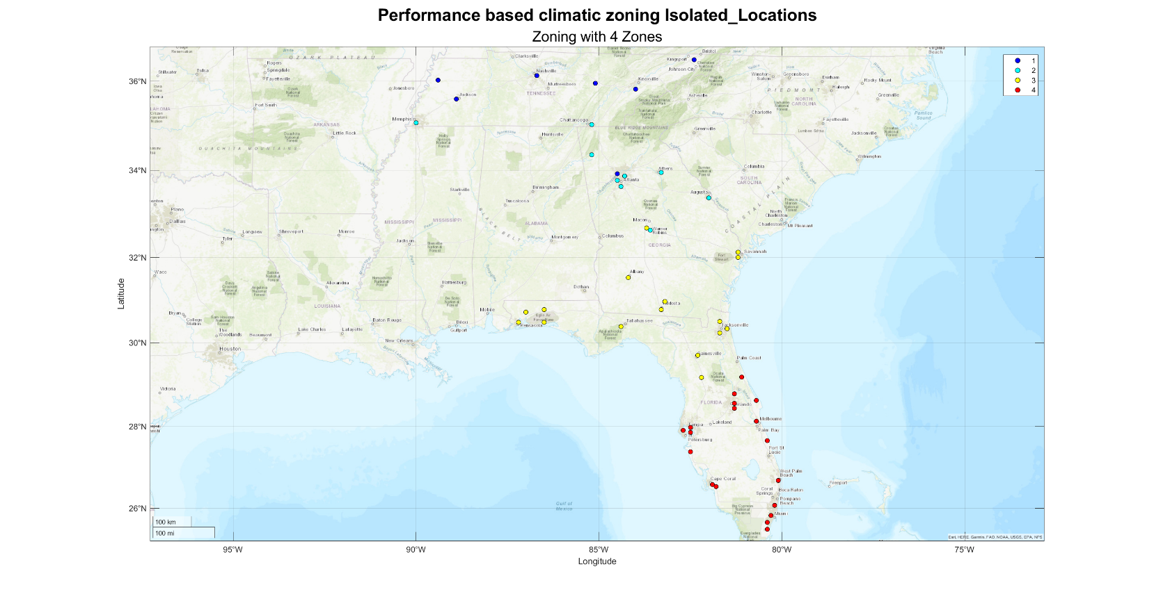

Figure 1 Clustering considering points and interpolated data.

Figure 2 Cooling and heating variation per zone of a random model

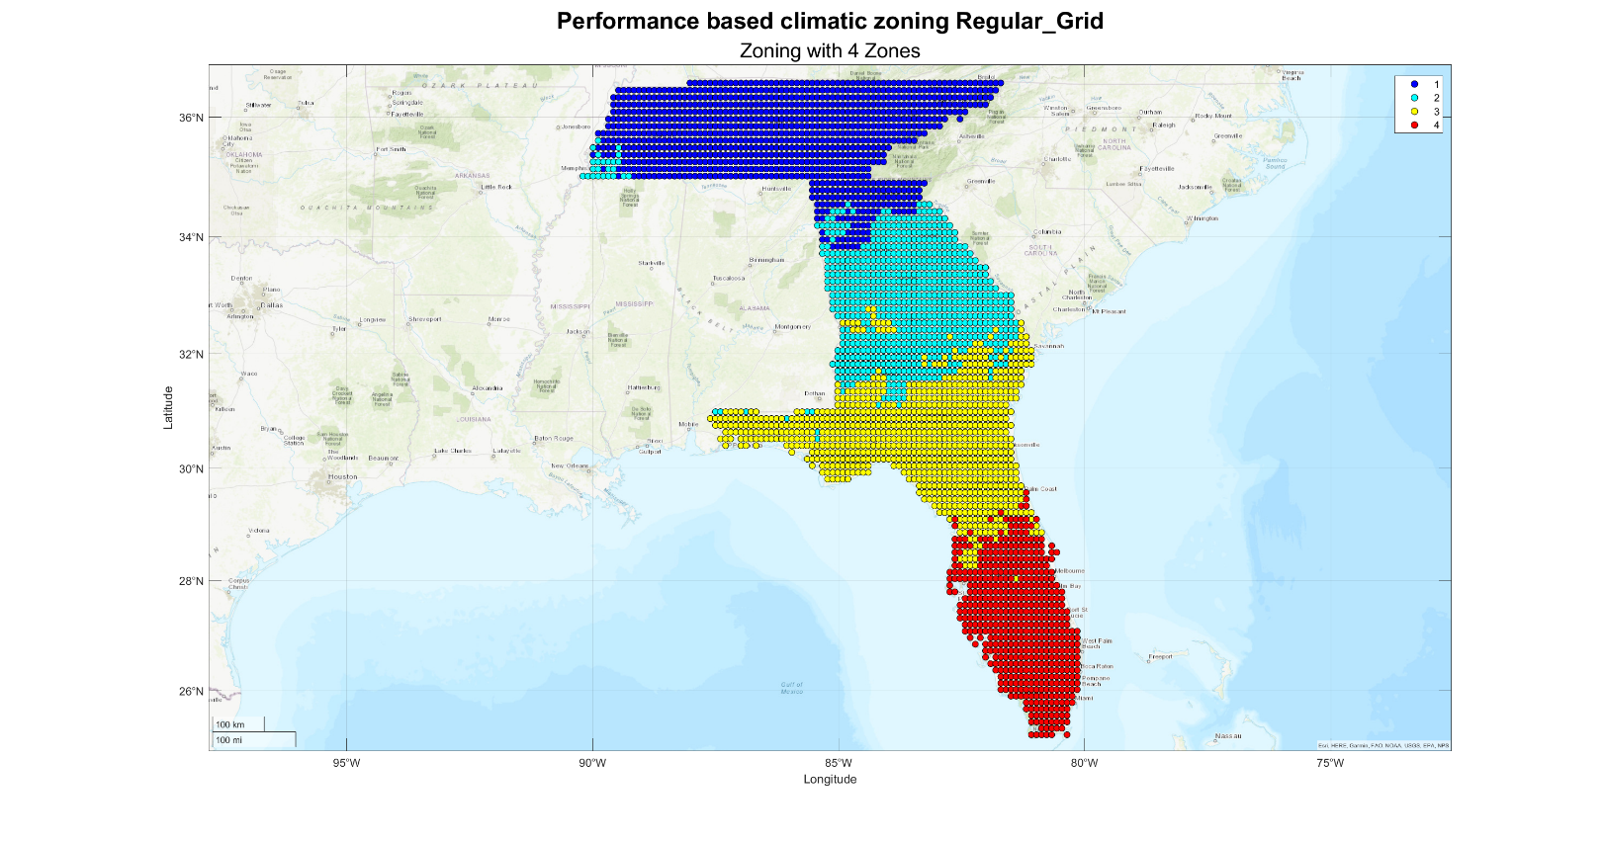

Figure 3 Clustering based on a regular grid of interpolated data (Altitude, latitude, and longitude interpolation method)

Figure 4 Cooling and heating variation per zone of a random model

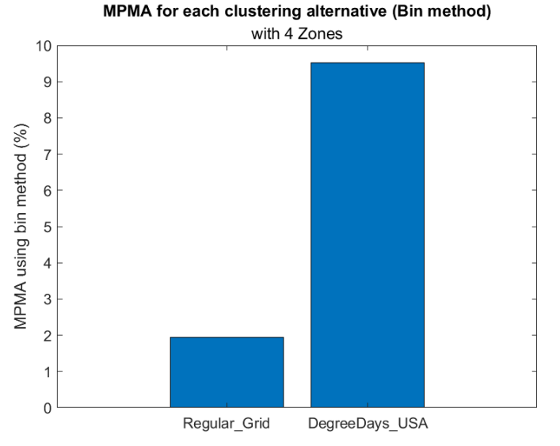

Figure 5 MPMA of clustering results compared to the degree days zoning for the region under analysis.

See PDF file Florida Georgia and Tennessee_AltLatLon_Report.pdf in the output folder.

simzoning/Outputs/Florida Georgia and Tennessee_CaseStudy/ for further details about expected results.