To run these example, MATLABR2022b, Deep Learning Toolbox, Mapping Toolbox, Matlab Report Generator, Statistic and Machine Learning Toolbox, and the EnergyPlus Version 8.3 are required.

1. **Example 2 Brazil**

Zoning of Brazil.

All settings are included in the file BRA_Brazil.zon.

**Files required:**

|  |  |  |
| --- | --- | --- |
|  | **File** | **Location** |
| 1. Input file | BRA_Brazil.zon | simzoning\ |
| 1. Shape file of the States of Florida, Georgia, and Tennessee | BRAlimits.shp | simzoning\GISfiles\AreaOfStudy\ |
| 1. Weather files of the area of study | 279 .EPW files | simzoning\Weatherfiles\ |
| 1. Idf files | ModelHVAC.idf  ModelNV.idf | simzoning\IDFs\BRAZIL_IDFS |
| 1. EnergyPlus Version | 8-7-0 |  |
| 1. Alternative method for comparison | DegreeDays_Brazil.shp  GT_Brazil.shp | simzoning\GISfiles\CZ_Methods_Comparison\ |
| 1. File containing coordinates of Brazilian municipalities | MunicipiosBrasil.csv | simzoning\ |

1. **Steps**
2. Create a folder C:/simzoning to unzip simzoning files.
3. Confirm the path of EnergyPlus Version 8.7 installed in the computer. If necessary, rewrite the path in the BRA_Brazil.zon file used as input data to run this example. 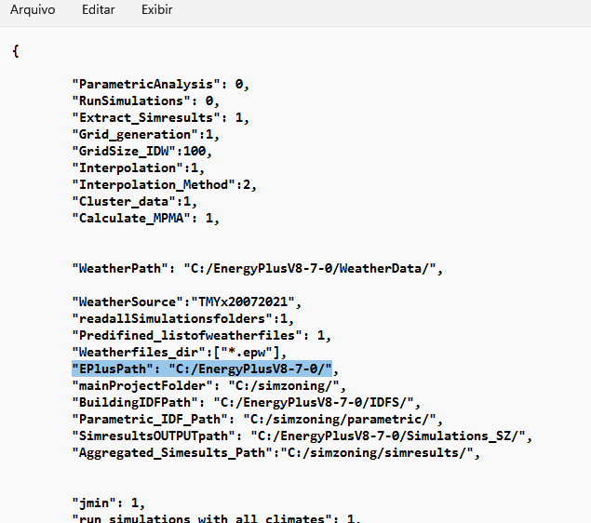

Figure 1 Input data file BRA_Brazil.zon

1. Call simzoning from MATLAB with the BRA_Brazil.zon file as input data.

|  |  |
| --- | --- |
| Case study summary | |
|  | 279 Epws |
| 2 models  5 Performance indicators  Macrozones  2 Cold Zones + 8 Hot zones  Time estimation 5 hours |

1. **Expected results**

A Region with 10 Zones considering 3 Zoning resolution. A) Clustering based on points, b) clustering based on municipalities and c) clustering based on interpolated data.

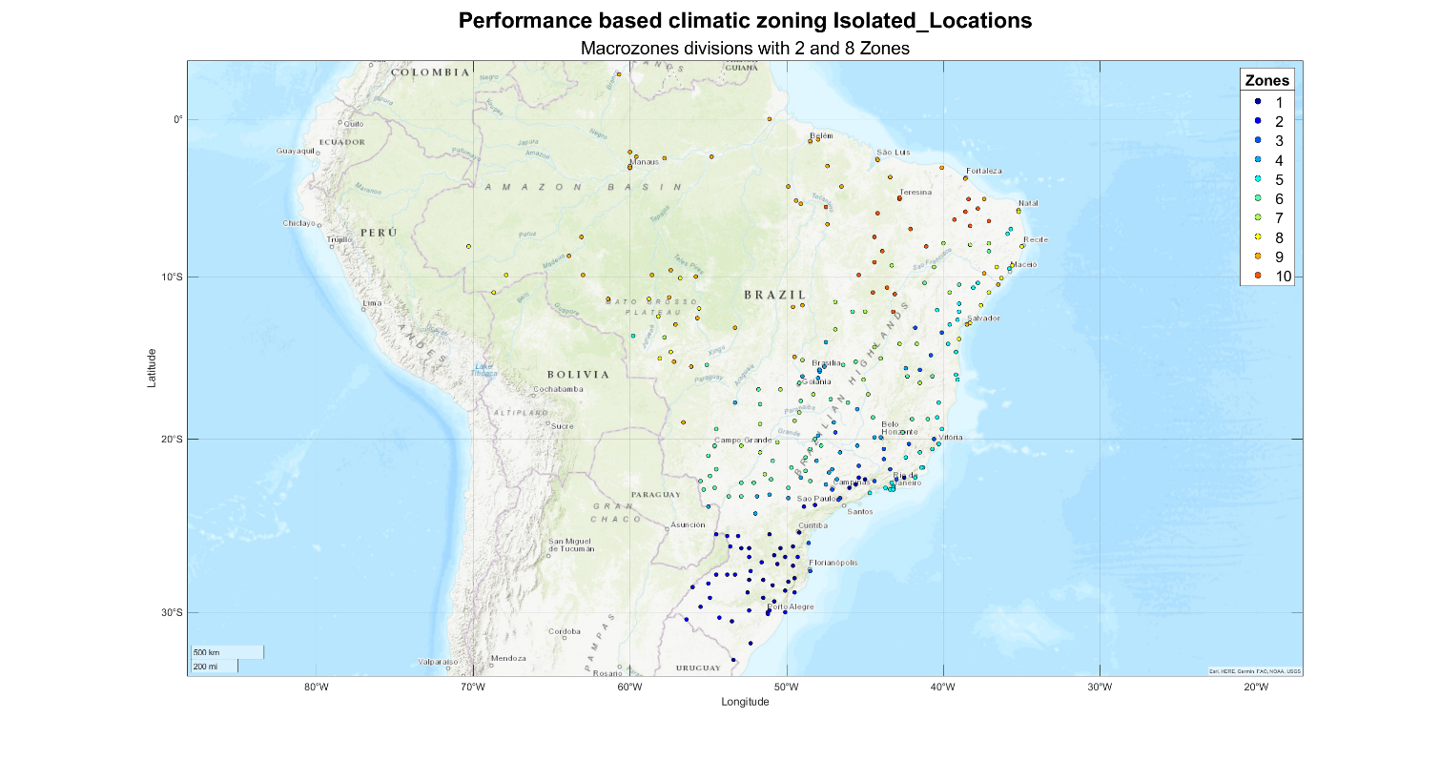

Figure 2 Clustering considering isolated locations

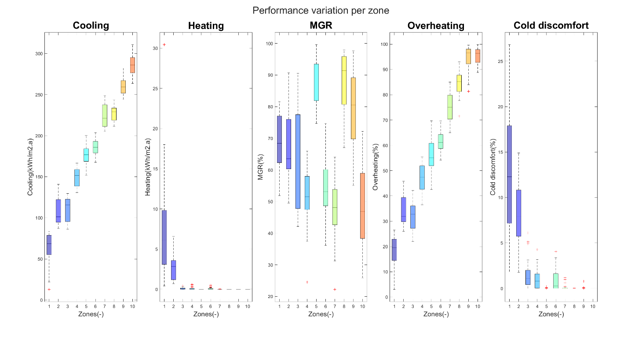

Figure 3 Performance variation of zoning based on isolated locations

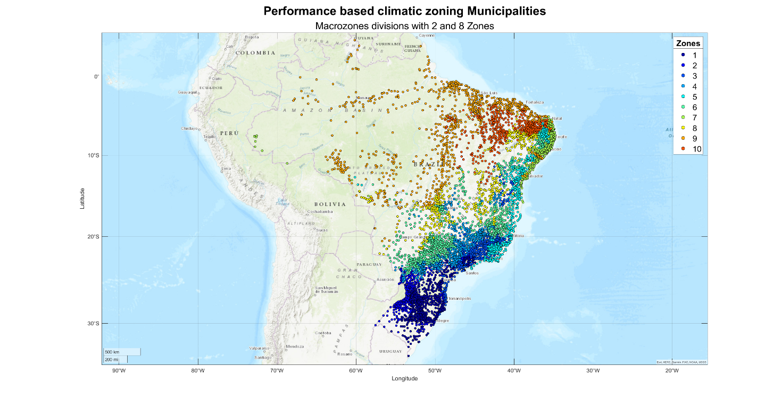

Figure 4 Clustering based on municipalities

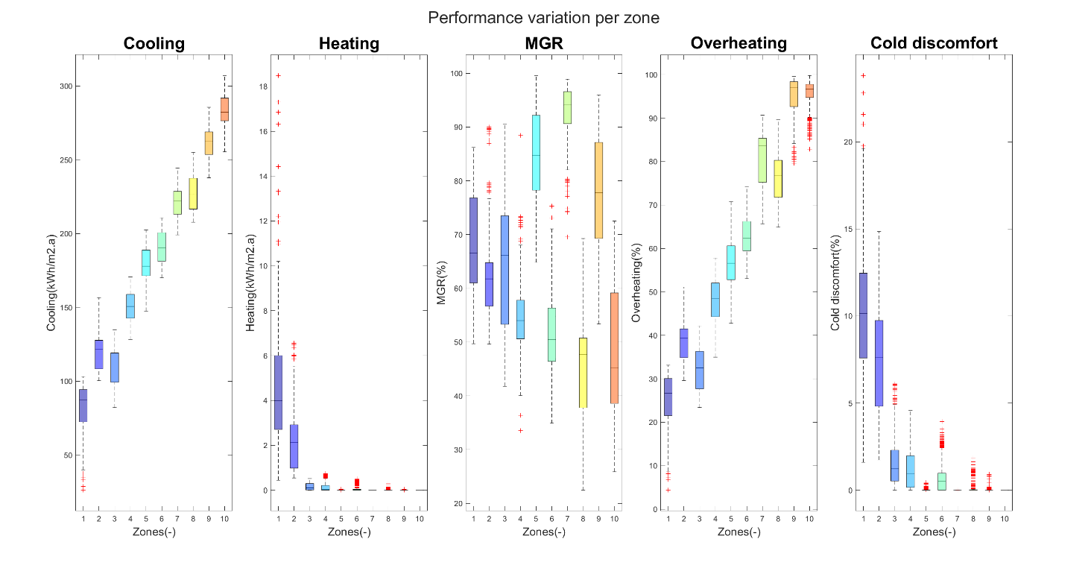

Figure 5 Performance variation of zoning based on municipalities

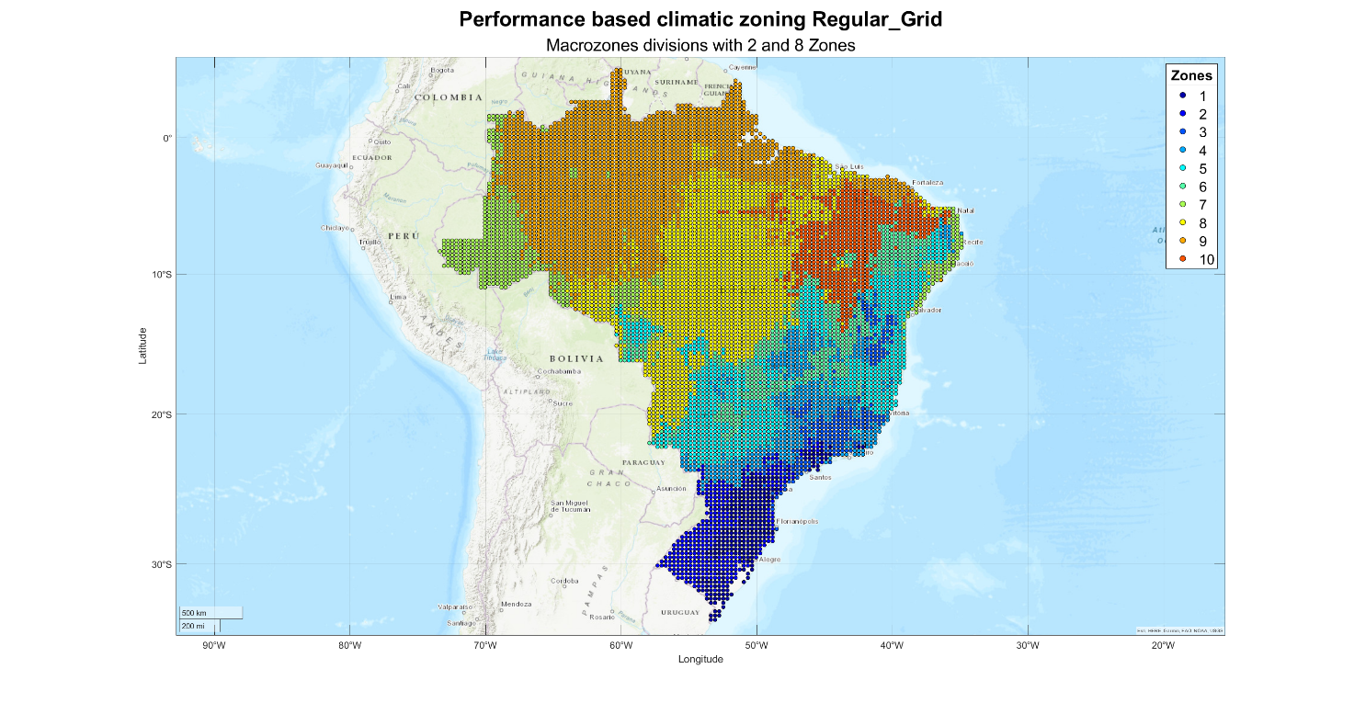

Figure 6 Clustering based on a regular grid of interpolated data (Altitude, latitude, and longitude method)

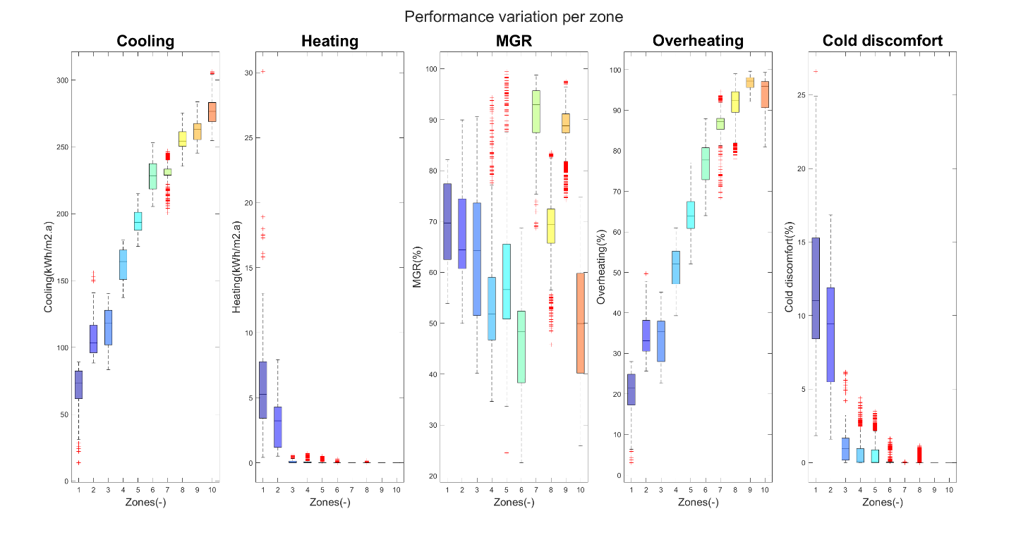

Figure 7 Regular grid zoning boxplot

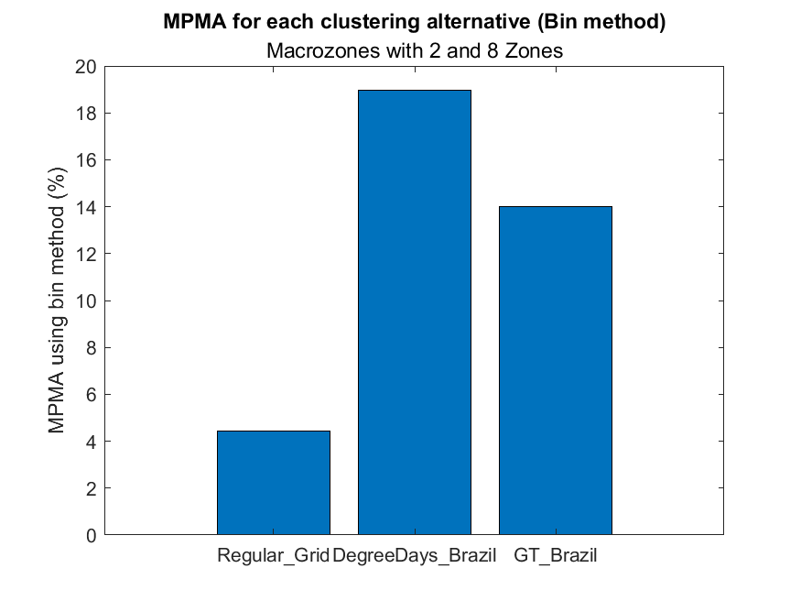

Figure 8 MPMA of clustering results compared to Degree-days and GT-zoning for that region.

See the Brazilian case study_AltLatLon_MacrZ_Report.pdf in the C:\simzoning\Outputs\Brazilian case study_CaseStudy folder for further details of expected results.