**Experiments:**

**(a)**

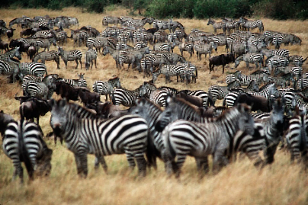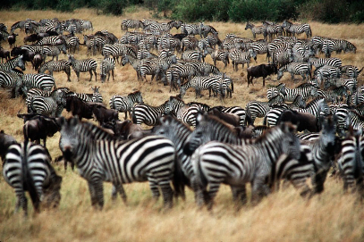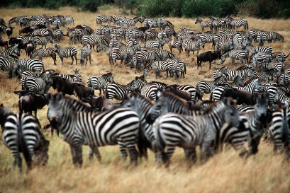

Fig1. Two images Fig2. Four images Fig3. Six images

More images can increase the quality. By comparing the image using two images and six images, we can easily find that stripes in six images is more clear than that in two images.

**(b)**

**(c)**

**Free study:**

**(1)**

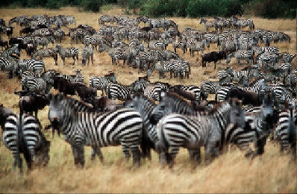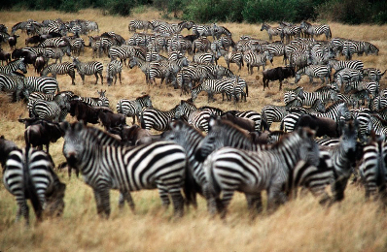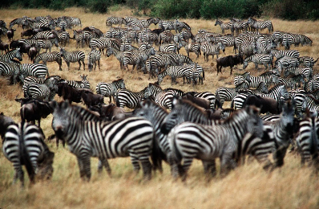

(a) N=5 (b) N=13 (c) N=21

When N become bigger, the stripes of the zebras are more clear.

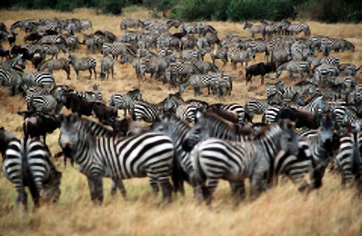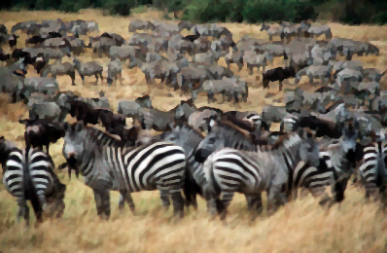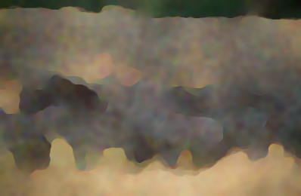

1. Lambda = 0.01 (b) Lambda = 0.1 (c) Lambda = 1

As the lambda become larger, the style of the image become like cartoon.

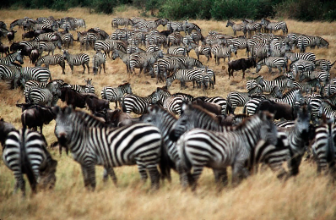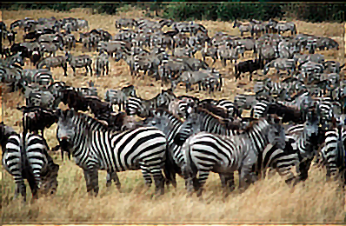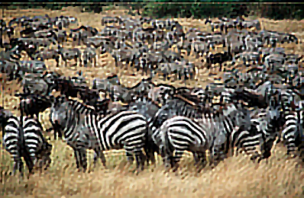

1. std = 1.5 (b) std = 3 (c) std = 5

When the Gaussian std become larger, the image become blurred and lose more details.

**(2)**