**Review the below suggestions for a possible upgrade in CLIMSOFT**

1. **Humidity Calculator**

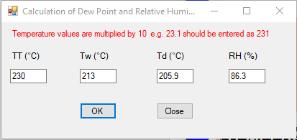

1. Include computations for ***Vapor Pressure*** and ***Mean Sea Level Pressure*** to ensure standardization of figures.
2. Add ***CLEAR Button*** to reset the calculator.
3. Dew Point returns 4 digits in decimal instead of 3 non-decimal digits.
4. RH returns a decimal value instead of a whole number.

There should be consistency in the presentation of the values computed by the calculator.

1. **Hourly Data for Sunshine**

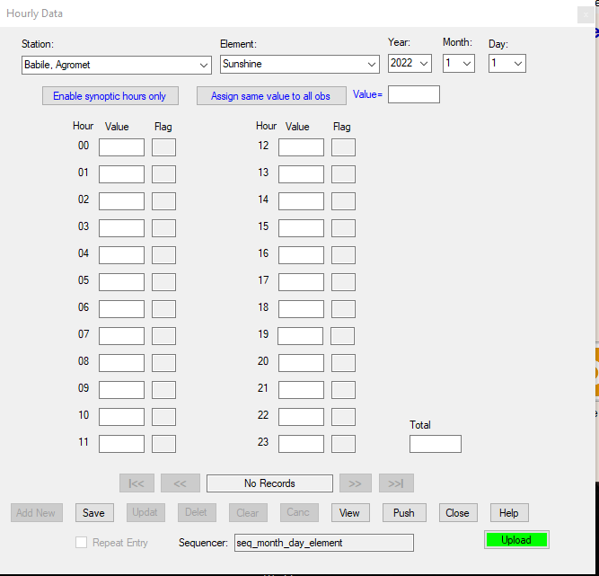

1. Sunshine occurs within 05:00 hrs and 19:00 hrs. The other hours should be disabled when the form is the selected option. There is the temptation to start entering values from the top fields since they are all enabled for the form.
2. **Windows Resizing**

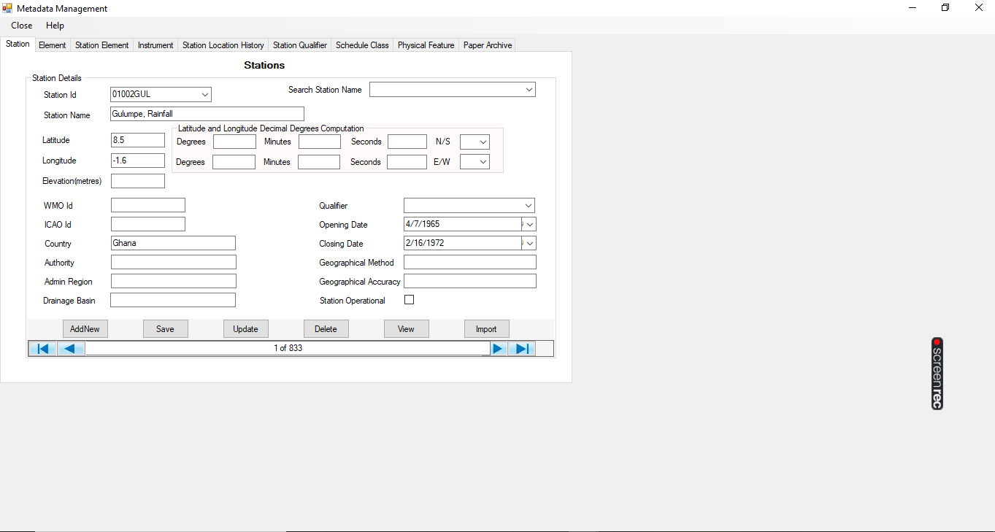

1. Implement responsive resizing of forms when the windows are maximized and minimized. Users with weak eyesight may have challenges with the small form views.

1. **SYNOPTIC DATA FORM**

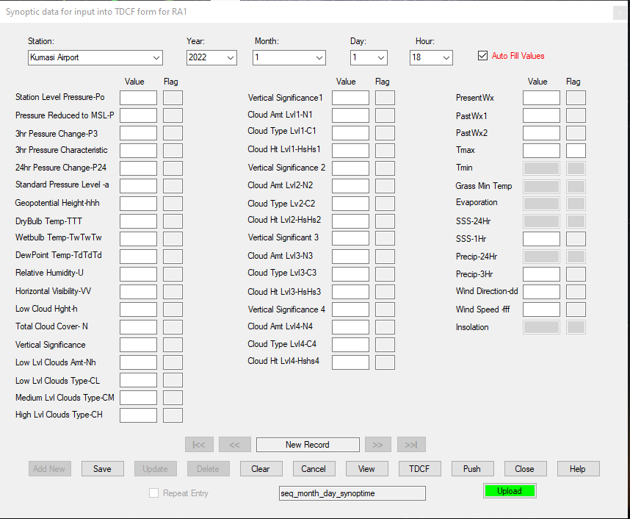

1. Enable Tmin at 0600 and 0900 hrs. Records of the element are taken at these hrs as well.
2. Enable 24hr Precipitation at 0600 hrs
3. We do also report 24hr Precipitation at 0900hrs. Can it be enabled as well?
4. Add 30 cm, 50 cm, and 120 cm soil temps to the list.
5. **The Form Hourly Wind Data**

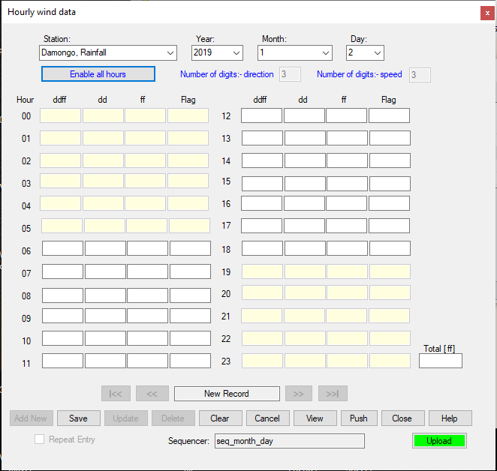

1. Review synoptic hours for the above form. The Synoptic hours are: 0000, 0300, 0600, 0900, 1200, 1500, 1800 and 2100. The form enables other hours as synoptic hours.
2. **Paper Archive**

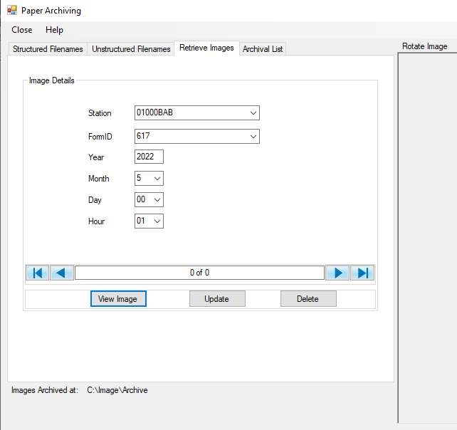

1. The “Day” drop list under the Retrieve Images dialog returns hourly values instead of days.

Take note for the necessary corrections.

1. **Setting Upper and Lower control limits**

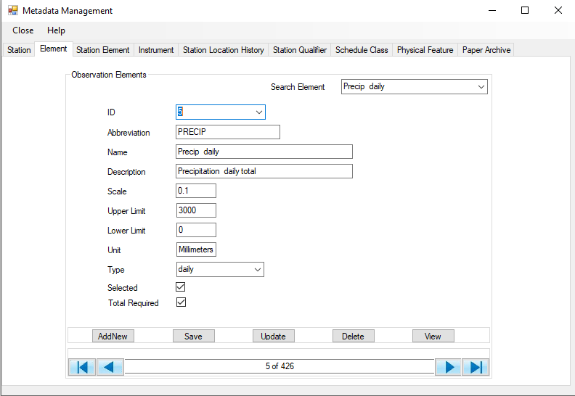

1. Create two additional fields: Station ID and Station Name as suggested in the image above. In this case, the settings would be applied to the selected station. Although it would be much work, once it is done that’s it.
2. Instead of having a general limit for all the stations per element, let’s have station-specific control limits. This should better check for outliers that may be recorded for the station.