**Application for Gene Curation Expert Panel Status** 

**Submitter Information:**

**Full Name of Submitting Source:**

**Short name or acronym for ClinGen website data display:**

**Expert Panel Member responsible for submission:**

**Email address:**

**Phone:**

**Expert Panel Coordinator name:**

**Expert Panel Coordinator email:**

**Gene Curation Expert Panel (GCEP) applicants** should compose their Expert Panel and complete their application in a stepwise manner, in accordance with the timeline shown below. Groups must submit their Step 1 application to the CDWG Oversight Committee for approval prior to initiating Step 2.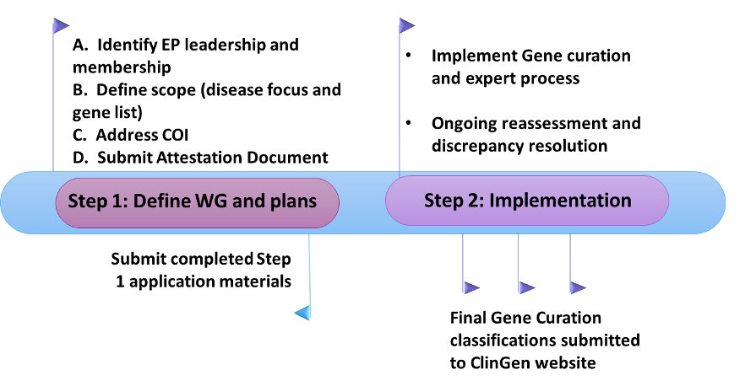

**Expert Panel Submission Details**

1. **Composition of Expert Panel**

Expert Panels are expected to represent the diversity of expertise in the field, including all major areas of expertise (clinical, diagnostic laboratory, and basic research). Membership should include representation from three or more institutions and will encompass disease/gene expert members as well as biocurators. Biocurators do not have to be gene/disease experts and will be primarily responsible for assembling the available evidence for subsequent expert member review. For role, suggested examples include: primary biocurator, expert reviewer, etc.

|  |  |  |  |
| --- | --- | --- | --- |
| **Member List** | | | |
| **Name** | **Institution** | **Area and Type of Expertise** | **Role**  **(Coordinator, Expert, Biocurator, etc)** |
|  |  |  |  |
|  |  |  |  |
|  |  |  |  |
|  |  |  |  |
|  |  |  |  |
|  |  |  |  |
|  |  |  |  |
|  |  |  |  |
|  |  |  |  |
|  |  |  |  |
|  |  |  |  |
|  |  |  |  |
|  |  |  |  |
|  |  |  |  |
|  |  |  |  |

1. **Scope of Work**

Describe the scope of work of the Expert Panel: disease area(s) of focus and gene list being addressed.

*It is expected that the expert panel will utilize* [*ClinGen Lumping and Splitting guidance*](https://clinicalgenome.org/working-groups/lumping-and-splitting/) *during pre-curation and should use the* [*Gene Tracker*](https://gene-tracker.clinicalgenome.org) *to enter their precuration information. Focus should be on the canonical disease, and splitting into multiple phenotypes should be avoided. The precurations will be published to the clinicalgenome.org website.*

*Enter Text:*

1. **Conflict of Interest (COI) Management**

Expert Panels are expected to represent the diversity of expertise in the field and should be composed of a sufficient number of eligible expert reviewers to address academic and financial conflicts of interest that may arise.

* Academic COI: Authors of literature about relevant variants may serve on the Expert Panel and are welcome to voice their opinion, but should not be the major arbiter of a variant classification when there is limited data available and it was provided by that individual or the individual’s lab group.
* Financial COI: Commercial entities may participate on the Expert Panel, but should not be the major arbiter of a variant classification when there is limited data available and it was provided by that entity.
* No special measures are needed if there is group consensus on a variant classification; however, if a vote is needed, those with relevant conflicts of interest should recuse themselves.
* All conflicts will be declared publicly on the clinicalgenome.org website and reported in publications as appropriate.

COI was discussed on a GCEP call (date: enter here)

All members of the GCEP have completed and submitted a ClinGen COI survey

**Describe any other specific processes for managing potential conflicts of interest, if any:**

1. **Attestation Document**

***The Gene Curation Expert Panel (GCEP) leaders(s) will complete the checkbox attestations document below on behalf of the GCEP.***

This GCEP will utilize the ClinGen [Gene Tracker](https://gene-tracker.clinicalgenome.org) for documentation of all precuration information, consistent with the current [Lumping and Splitting working group guidance](https://clinicalgenome.org/working-groups/lumping-and-splitting/), for gene-disease relationships.

This GCEP will utilize the ClinGen Gene Curation Interface for documentation of all gene-disease validity classifications.

All curations completed by this group will be made publicly available through the ClinGen website immediately upon completion.

[The ClinGen publication policy](https://clinicalgenome.org/site/assets/files/3752/clingen_publication_policy_apr2019.pdf) has been reviewed and a manuscript concept sheet will be submitted to the NHGRI and ClinGen Steering Committee before the group prepares a publication for submission.

Draft manuscripts will be submitted to the ClinGen Gene Curation WG for review prior to submission. Email: genecuration@clinicalgenome.org

The ClinGen Gene-Disease Validity Recuration process has been reviewed, link found [here](https://clinicalgenome.org/site/assets/files/2164/clingen_standard_gene-disease_validity_recuration_procedures_v1.pdf).

*Three examples of ClinGen-approved curation and review protocols are below (additional details may be requested from the CDWG Oversight Committee). Check or describe the curation and review protocol that this Expert Panel will use.*

Single biocurator curation with comprehensive GCEP review (presentation of all data on calls with GCEP votes). Note: definitive genes may be expedited with brief summaries.

Paired review (biocurator & domain expert) with expedited GCEP review. Expert works closely with a curator on the initial summation of the information for expedited GCEP review (brief summary on a call with GCEP voting and/or electronic voting by GCEP). Definitive genes can move directly from biocurator to expedited GCEP review.

Dual biocurator review with expedited GCEP review for concordant genes and full review for discordant genes.

Other: *Describe method here*

*Biocurators are expected to become familiar with the ClinGen training materials located on the clinicalgenome.org website. Biocurators are requested to join the mailing list for ClinGen Biocurator Working Group WG, and expected to attend those calls that focus on gene curation SOP and/or framework updates.*

Biocurator have received all appropriate training.

Biocurators are trained on the use of the Gene Curation Interface (GCI). (date: enter here)

Biocurators have joined the Biocurator WG mailing list.

The calls occur on the 2nd and 4th Thursdays from 12-1pm.

1. **NHGRI Data Availability**

*Curated genes and variants are expected to be approved and posted for the community as soon as possible and should not wait for the publication of a manuscript.*

Please check box to confirm your understanding that once a gene is approved in the GCI, the group should utilize the “publish” functionality within the GCI to make the curation publicly available on the ClinGen website (https://clinicalgenome.org/). They should not be held for publication.

*It is expected that, whenever possible, Expert Panel manuscripts will be pre-published (e.g. medRXiv). If the authors do not anticipate submitting their manuscript to a prepublication resource they must provide a written justification.*

Please check box to confirm plans to pre-publish or provide justification for not posting pre-print.

**Date of Submission:** enter here

After completing Application items A-E, please submit your draft Expert Panel application to the ClinGen Clinical Domain WG Oversight Committee for review at [cdwg_oversightcommittee@clinicalgenome.org](mailto:cdwg_oversightcommittee@clinicalgenome.org).

**ClinGen Contacts and Resources**

|  |  |
| --- | --- |
| Expert Panel Application help | cdwg_oversightcommittee@clinicalgenome.org |
| Gene Curation help | genecuration@clinicalgenome.org |
| Biocurator Working Group | biocurator@clinicalgenome.org |
| Gene Curation Interface (GCI) help | clingen-helpdesk@lists.stanford.edu |
| Gene Tracker Help | clingentrackerhelp@unc.edu |