dNBS

Reference Manual for dNBS (v1.0)

1. November 2020

Table of Contents

1 Preface 2

2 How to use dNBS 3

2.1 Installation 3

2.2 Start dNBS 4

3 Threshold Settings 5

3.1 Single Threshold 5

3.2 Threshold range 6

4 Result folder for testing with threshold range 7

4.1 Adjacency matrix network binary 9

4.2 Adjacency matrix network weighted 9

4.3 NBS network jpeg 10

4.4 Network weighted 10

4.5 test stat 11

# Preface

This is the manual for directed network-based statistics (dNBS, version 1.0).

dNBS is a software package written for Matlab that allows testing hypotheses about the human connectome.

For those who prefer learning by example, dNBS comes preinstalled with a sample data set. This sample data set is loaded by default when the software is opened for the ﬁrst time.

Please note that this manual only shows the differences between dNBS v1.0 and NBS v1.2. If you want to learn more about functionality and settings of dNBS for NBS, please consult the manual of NBS v1.2 (<https://www.nitrc.org/frs/download.php/5331/Reference_Manual_NBS_v1.2.pdf> ).

# **How** to use dNBS

## Installation

dNBS is quiet easy to install. Download and unzip the folder named

NBSDirected1.0.zip.

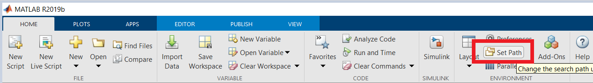

Figure 1 Set Path

After starting Matlab, go to “Set Path”. This function is contained in the “Home” tab “Figure 1”.

Click on “Add with Subfolders” and navigate to the location where you previously safed the unzipped dNBS tool.

## Start dNBS

Navigate via the folder search in Matlab to the storage location of dNBS. Then start dNBS by typing "**dNBS**" in the Matlab Command Window.

This command will open the graphical user interface of dNBS. «Figure 2 »

When you start dNBS for the first time, all input fields are filled automatically, so you can run a demo with the preinstalled data to get familiar with the handling of dNBS.

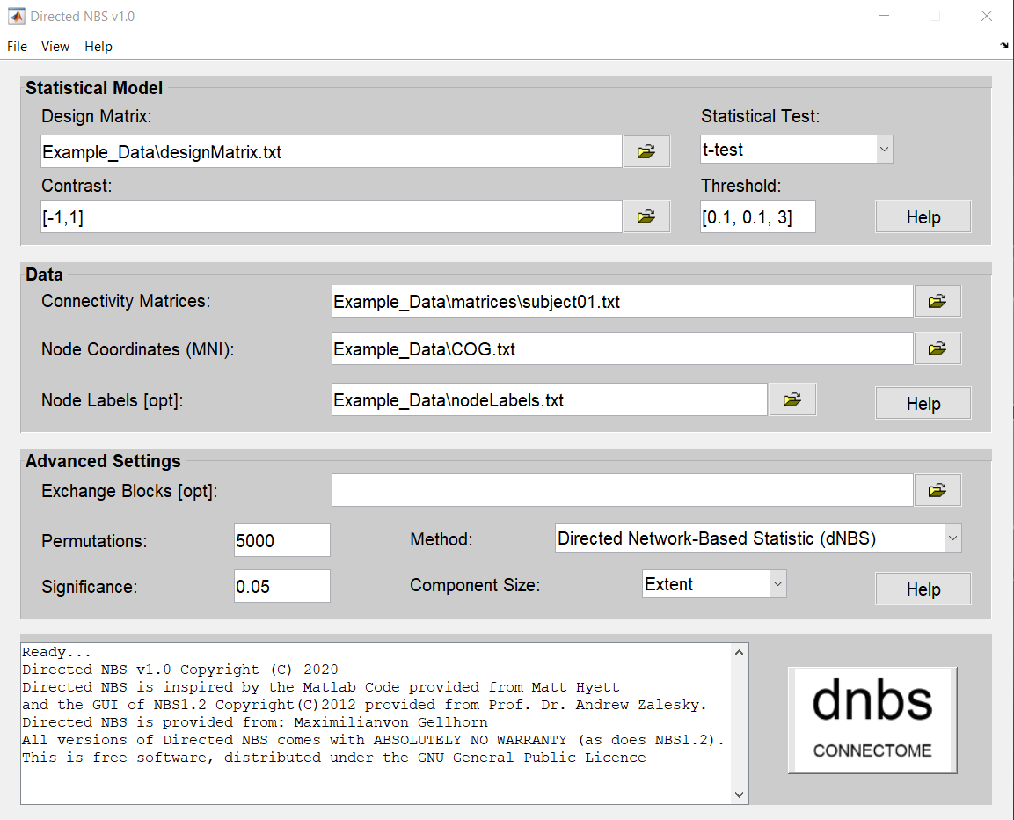

Figure 2 dNBS GUI

# Threshold Settings

With dNBS you have the possibility to enter a single threshold or a threshold range.

## Single Threshold

If you want to analyze a single threshold only, insert the threshold value of choice, in this case 2.7 as shown in “Figure 3” in the threshold field.

When you start dNBS, an analysis of the afore chosen threshold is performed.

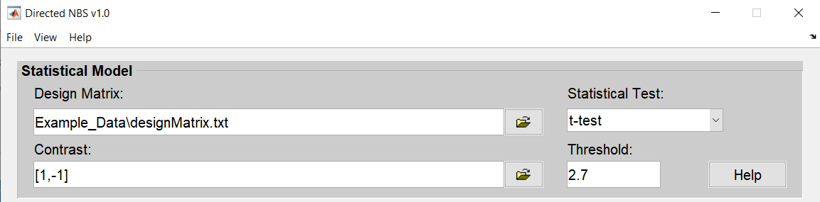

Figure 3: Single Threshold

If detected, a significant network will show up with the corresponding values, after running dNBS .

## Threshold range

The opportunity to insert a threshold range instead of a single threshold only, was implemented because choosing a threshold that best fits your analysis is a matter of experimentation, as already stated in the NBS v1.2 manual (Chapter 2.7):

*«Choosing the test statistic threshold (i.e. primary threshold) is ultimately a*

*matter of experimentation. Fortunately, it is the only parameter associated with*

*the NBS that requires tuning.»*

If you want to run dNBS for a predefined range of thresholds, the threshold range is constructed as shown in “Figure 4” and inserted to the GUI as shown “Figure 5”.

Inital Threshold

Increment of the Threshold

Final Threshold

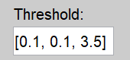

Figure 4 Explanation Threshold range

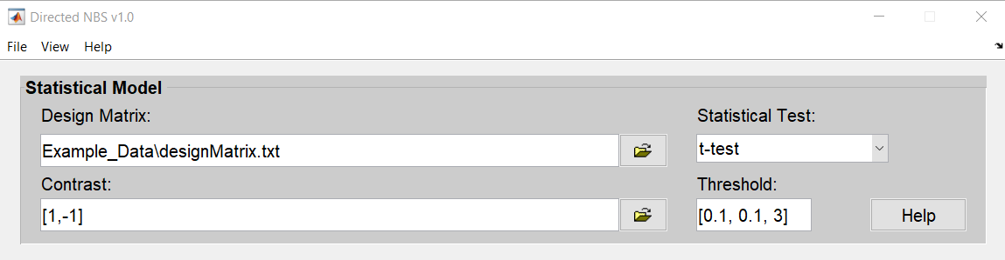

Figure 5: Threshold range

# Result folder for testing with threshold range

If the tested threshold range shows a significant result, the network is displayed for two seconds.

After all thresholds are processed, you find the results in the "**Result**" folder.

The results folder “Figure 6” located in the NBSDirected folder that you that you find in the unzipped files files (see Chapter Installation for more details).

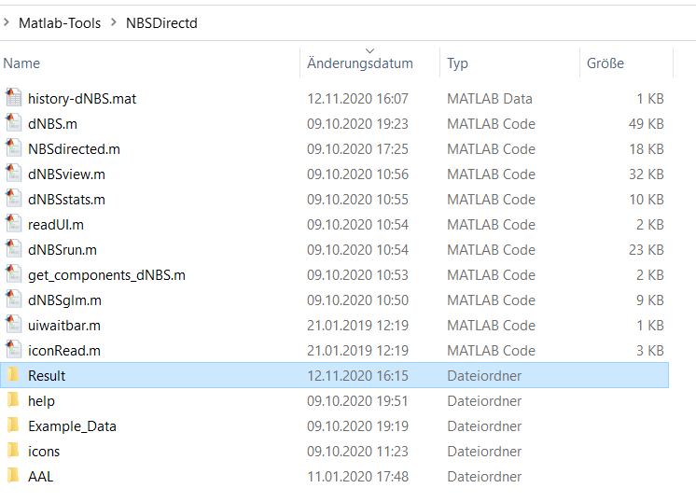

Figure 6 Result folder

In the Result folder a subfolder is automatically created with the actual test date. There, connectivity matrixes corresponding to the thresholds are stored in discrete folders.

Each folder contains the significant results for the corresponding threshold.

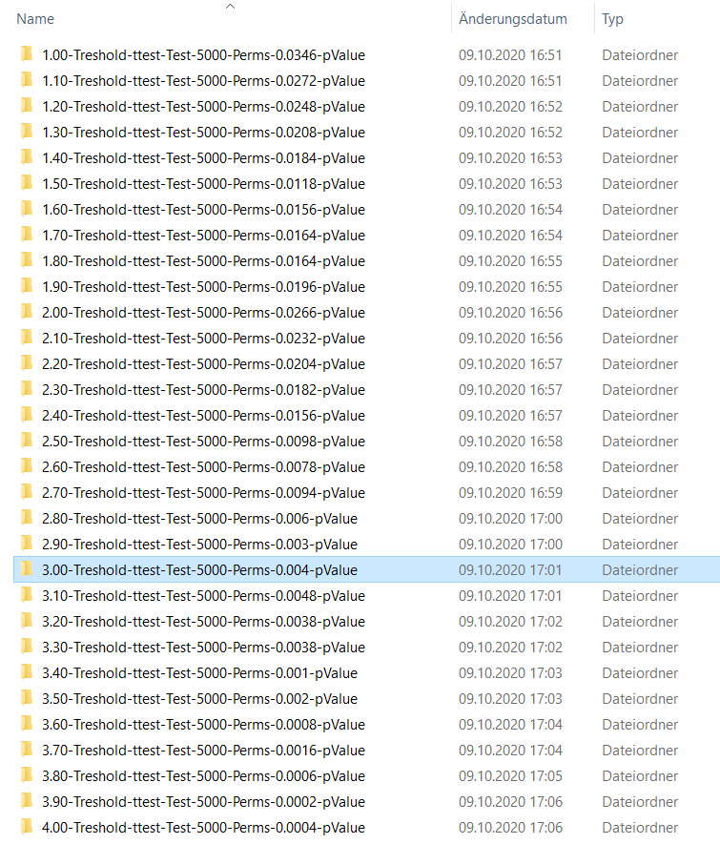

Figure 7: Result Folder view

The folders of the discrete runs are created according to the following schema (the folder for the threshold 3.0 serves as an example):



|  |  |  |  |
| --- | --- | --- | --- |
| Threshold | Test Type | Amount of Permutation | p-value |
| 3.00-Treshold- | ttest-Test- | 5000-Perms- | 0.004-pValue |

In each result folder you find the files that are depicted in Figure 8. For each significant network, a set of 5 files is created, which are explained below. Those are marked by enumerated numbers at the end of each file.

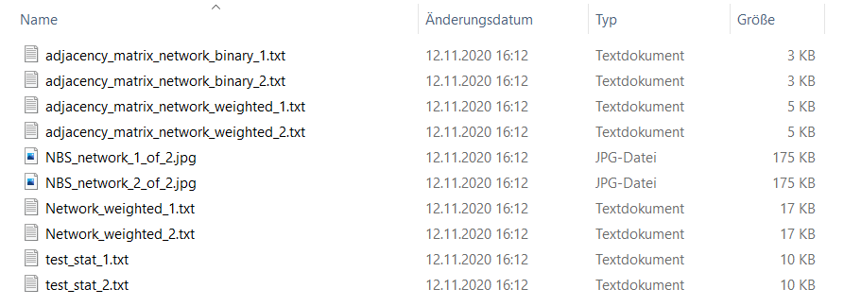

Figure 8 Result files

## Adjacency matrix network binary

The binary adjacency matrix of the network is a matrix that stores which nodes of the graph are connected by an edge. The matrix should contain one row and one column for each node, which results in an n x n matrix for n nodes. It should be saved as a binary format, containing 0 and 1 only.

|  |  |  |  |  |
| --- | --- | --- | --- | --- |
| 0 | 0 | 0 | 0 | 1 |
| 0 | 0 | 0 | 0 | 0 |
| 0 | 0 | 0 | 0 | 0 |
| 0 | 0 | 0 | 0 | 0 |
| 1 | 0 | 0 | 0 | 0 |

## Adjacency matrix network weighted

The weighted adjacency matrix of the network is a matrix that stores which nodes of the graph are connected by an edge. It has one row and one column for each node, resulting in an n x n matrix for n nodes. The values for the edges correspond to the test stat values calculated by dNBS.

|  |  |  |  |  |
| --- | --- | --- | --- | --- |
| 0 | 0 | 0 | 0 | -3.42E+00 |
| 0 | 0 | 0 | 0 | 0 |
| 0 | 0 | 0 | 0 | 0 |
| 0 | 0 | 0 | 0 | 0 |
| -4.26E+00 | 0 | 0 | 0 | 0 |

## NBS network jpeg

Example image of a significant network drawn by dNBS.

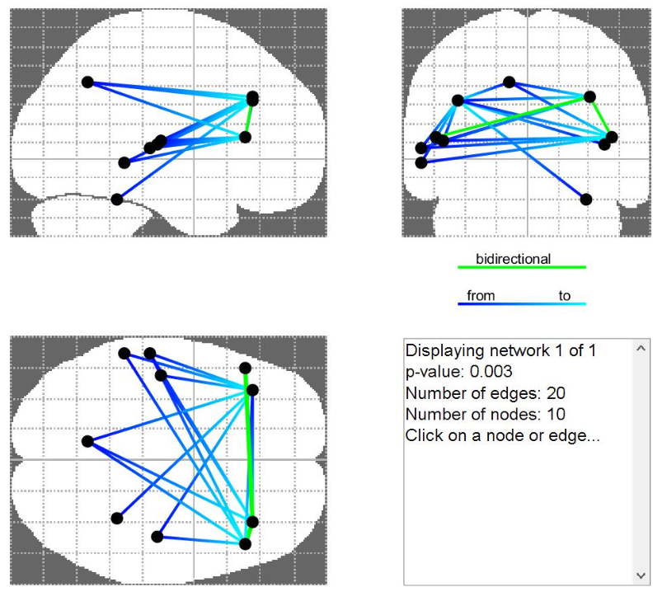

Figure 9 NBSview

## Network weighted

The matrix of the weighted network contains all calculated test stats, whereby each edge represents the corresponding test stat.

|  |  |  |  |  |
| --- | --- | --- | --- | --- |
| 0 | -7.05E-01 | 7.46E+00 | 3.62E+00 | -3.42E+00 |
| 5.99E+00 | 0 | 3.88E+00 | 3.26E+00 | 1.06E+00 |
| 6.61E+00 | 1.10E+00 | 0 | -5.43E-01 | 4.39E-01 |
| 8.23E+00 | 1.17E+00 | 6.49E-02 | 0 | 1.79E-01 |
| -4.26E+00 | 9.82E-01 | 8.72E-01 | -1.33E+00 | 0 |

## test stat

This file lists all significant connections with corresponding node names and test stats.

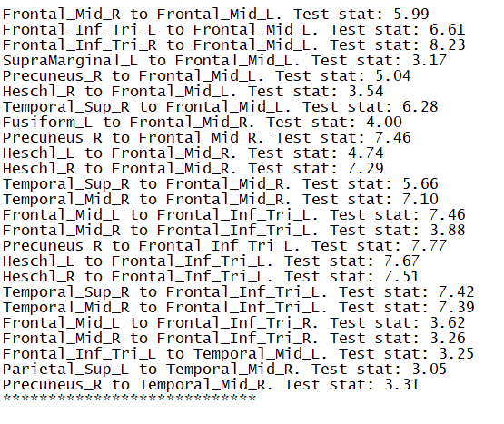

Figure 10 test stat