DENTAL CLINIC



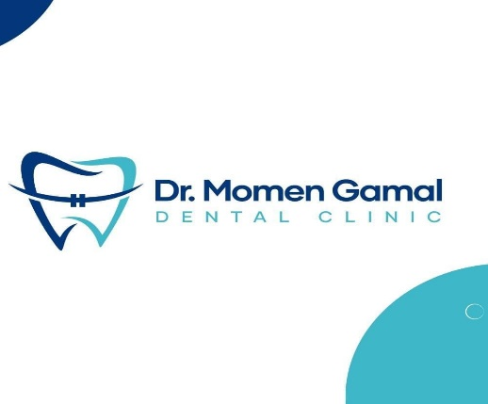

**Presented to:** Dr. Sahar Ali Fawzy

**BMD302: Clinical Informatics**

**Presented by:**

**.** **Reem Fayez_202001603  
 . Mohamed eltewaey_202001764**

**. Hagar Gamal_19105329  
 . omar mohamed_ 202003009  
 . Abdelrhman abdelrhman_202002162  
 . Saifeldin Mohamed kedwany_ 202002233**

**The scope:**

In today's fast-paced world, efficient and reliable systems are crucial for businesses to thrive. In the realm of healthcare, orthodontic clinics play a vital role in providing specialized dental care to patients. These clinics heavily rely on their internal systems to manage appointments, maintain patient records, and streamline their operations. However, like any other technology-driven system, orthodontic clinics can encounter issues that disrupt their daily workflow and hinder the delivery of quality patient care.

**Problem definition:**

Recently, an orthodontic clinic has found itself facing a significant challenge with its system. This clinic, which has been diligently serving its community for years, suddenly experienced unexpected malfunctions and inefficiencies within its internal infrastructure. The system, designed to enhance the clinic's productivity and patient management, began exhibiting erratic behavior, causing frustration among the staff and potential disruptions to the clinic's operations.

The clinic's system problem surfaced as a significant concern due to its impact on various facets of their practice. Scheduling appointments became a struggle as the system intermittently failed to update calendars and synchronize with patient information. This led to confusion, missed appointments, and an overall decline in patient satisfaction. Additionally, accessing patient records and treatment histories became a laborious task, negatively affecting the clinic's ability to provide personalized care and make informed treatment decisions.

The clinic's staff, including orthodontists, dental assistants, and administrative personnel, found themselves grappling with the system's unreliability, wasting valuable time and resources on troubleshooting and manual workarounds. The situation not only disrupted their daily routines but also impeded their ability to focus on their core mission of delivering exceptional orthodontic care.

**Solution:**

Recognizing the urgency and importance of resolving the system issues, the clinic's management has taken proactive steps to address the problem. They have sought external expertise from IT professionals and software developers to identify the root cause of the system malfunction and implement effective solutions.

The dental clinic requires an automated appointment scheduling system that optimizes the allocation of appointments, improves communication among staff members, considers patient preferences and constraints, efficiently allocates resources, and effectively handles emergency and urgent cases. The system should integrate with the clinic's existing infrastructure, be user-friendly, and provide real-time visibility of appointment schedules and resource availability. By addressing these challenges, the clinic aims to enhance patient satisfaction, increase operational efficiency, and maximize the utilization of dental resources.

For example

_ Appointment Scheduling Software: This digital solution eliminates errors such as double-booking and lost schedules, ensuring efficient management of patient appointments. Automated reminders can be sent to patients, it also enables real-time updates, allowing for quick rescheduling and adjustments, ultimately improving patient satisfaction, and optimizing clinic workflow.

_Billing Automation: Implementing a digital billing system automates the calculation of bills, deducts doctors' late attendance fees, and manages clinic charges. This streamlines the billing process, reduces errors, and improves financial management.

**Methodology :**

The goal of this project is to develop a comprehensive, user-friendly, and complex system that will optimize workflows in a hospital setting. With the use of a thorough methodology that Use unified Modelling Language (UML), and Wireframes, the project seeks to design a solution that balances the complexities of medical treatment, administrative procedures, and technology improvements. The Clinic Management System aims to transform clinics' management of patient data, appointments, treatments, and general operational efficiency by combining a variety of approaches and visual aids. This will eventually improve the quality of care that patients get.

**UML**

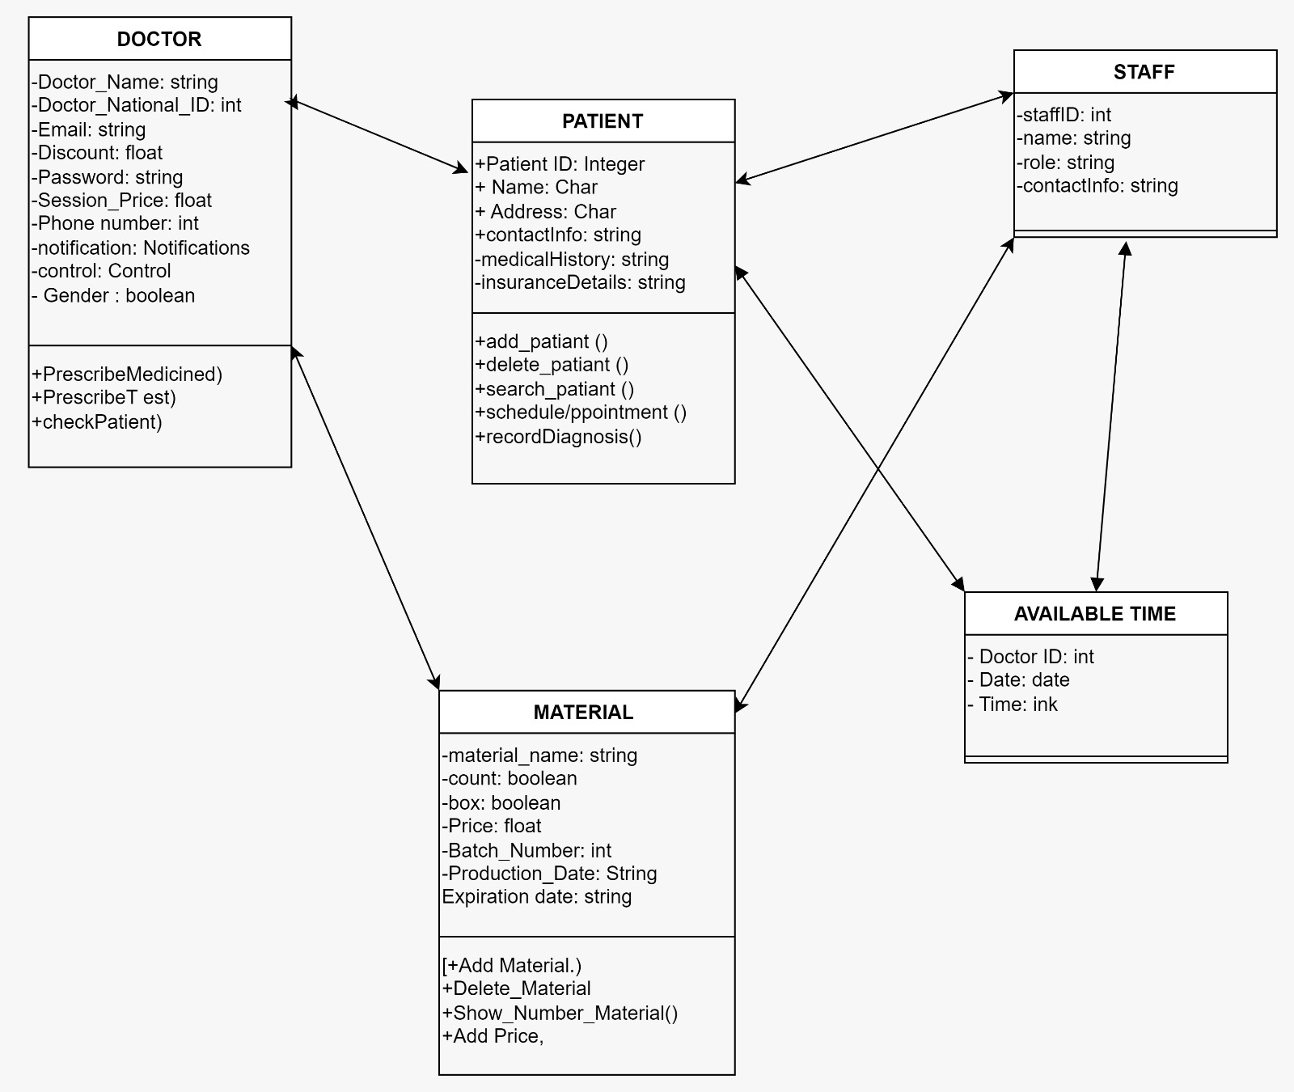

**Key Features**

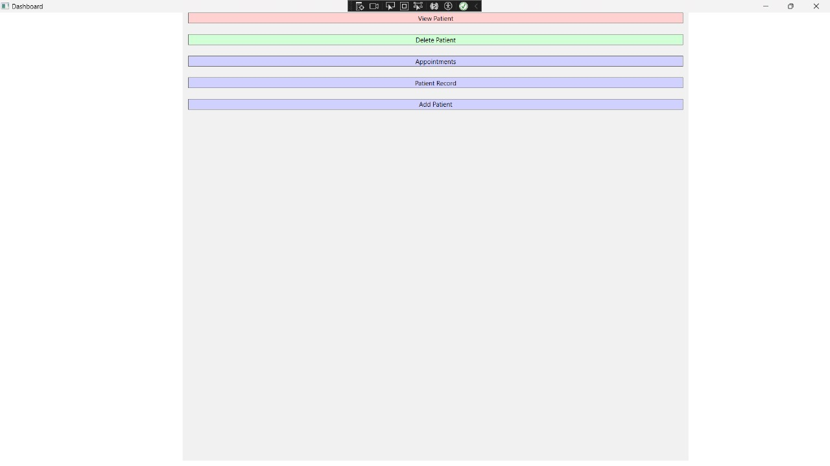

Doctor Features:

- Patient Profile Management and Medical Records

- Schedule and Appointments

- Diagnostic and Treatment Management

- Report Page

Available Schedule:

-available appointment slots.

-view the schedule.

-display real-time information to avoid double-bookings and provide an accurate representation of available slots.

Staff Features:

- Appointment Management

- Waiting Lists

- Patient Registration

- Check-In and Check-Out

- Billing and Payments

Patient Features:

-Name

-Cell phone

-Patient Registration

-Treatment Records

Material features:

- Cost

-Ordering and Restocking

Note: these patient and material features into the orthodontic clinic system, the clinic can enhance patient experience, streamline operations, improve communication, and ensure efficient management of materials, ultimately leading to better treatment outcomes and overall clinic efficiency.

**Use case:**

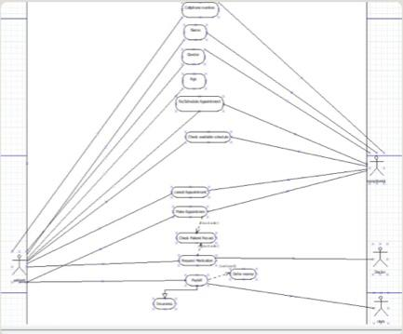

**Wire Frame**

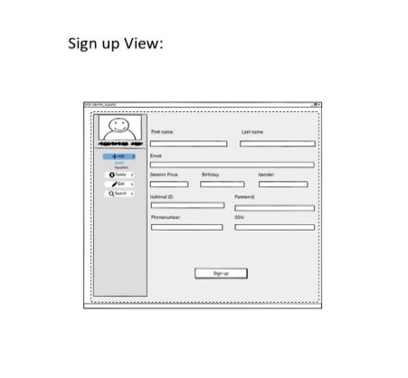

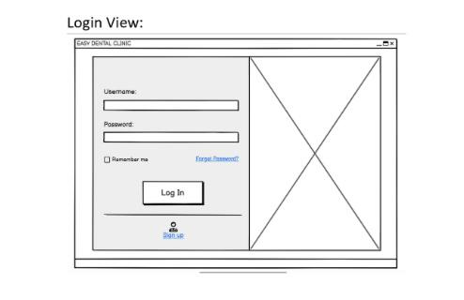

**Front end**

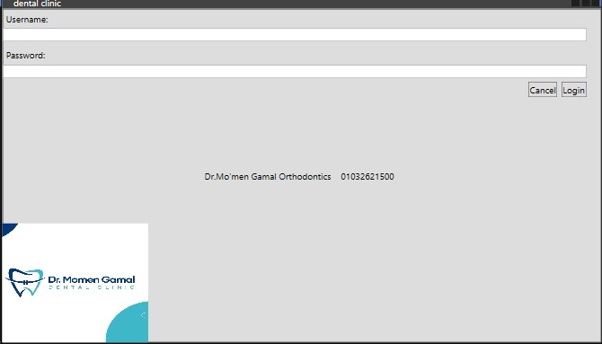

A screenshot of a computer

Description generated with very high confidence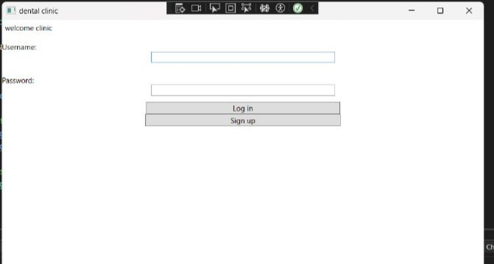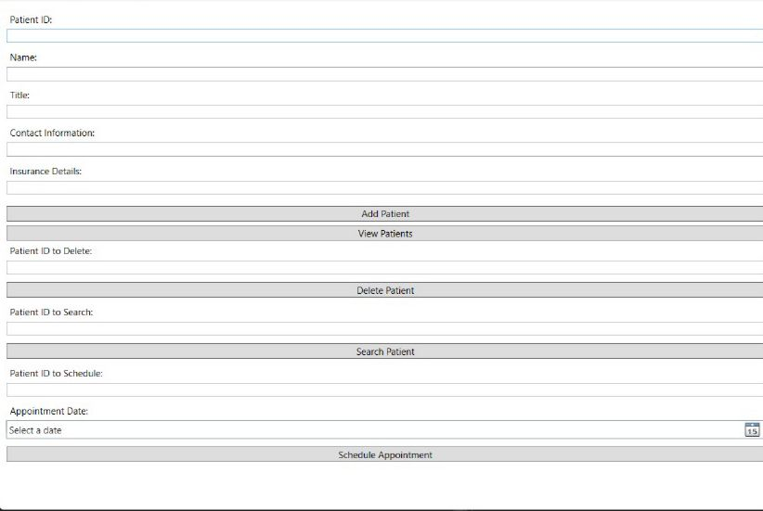  
  
  
  
A screenshot of a computer

Description generated with very high confidence

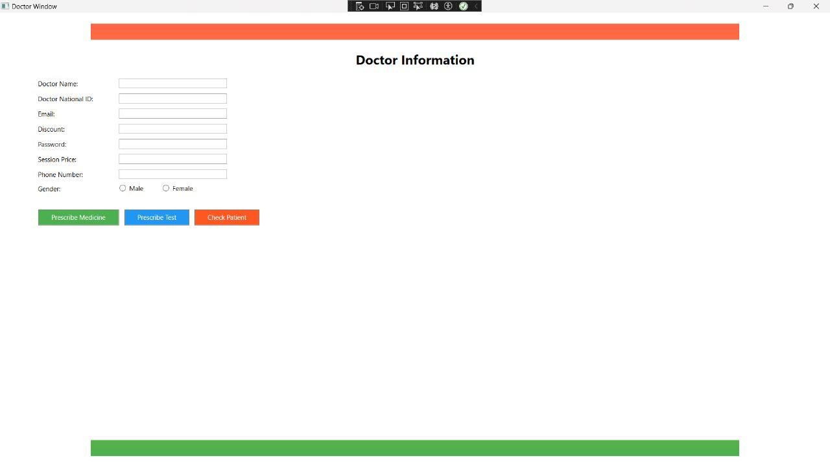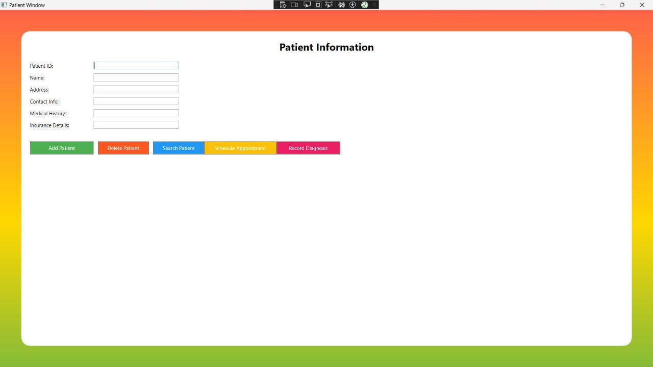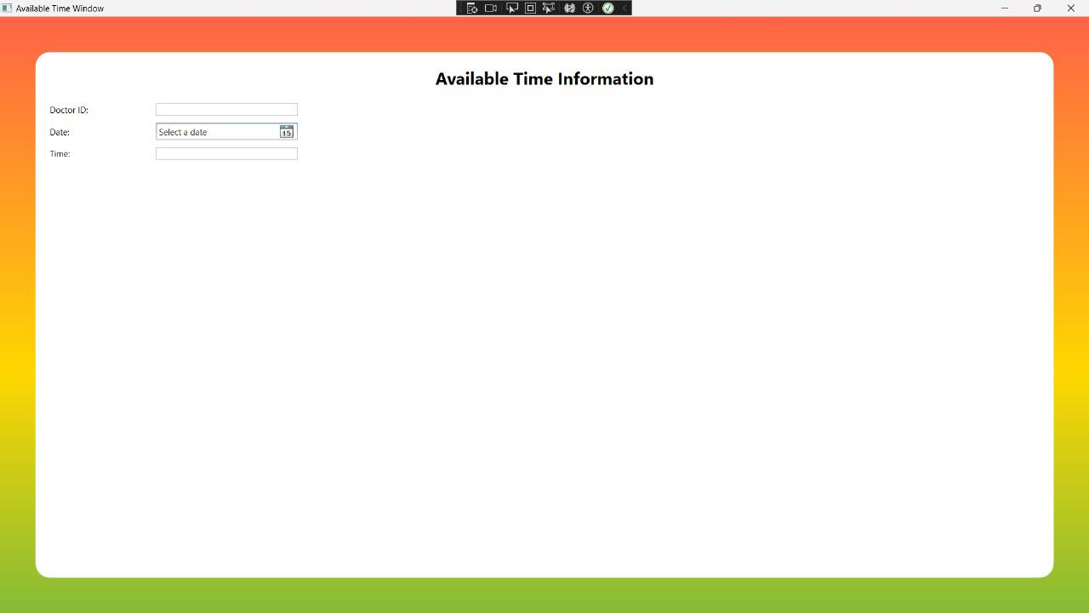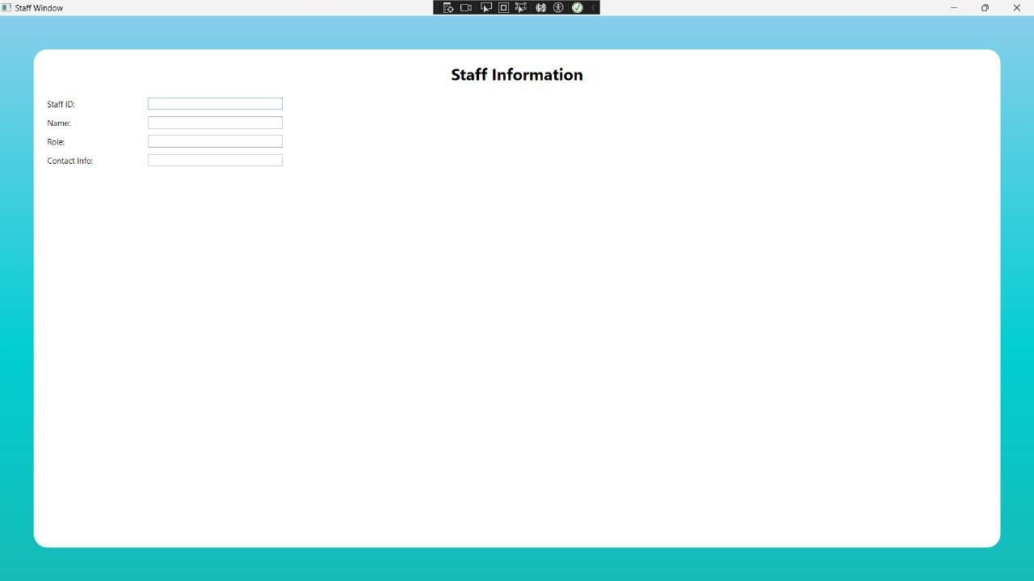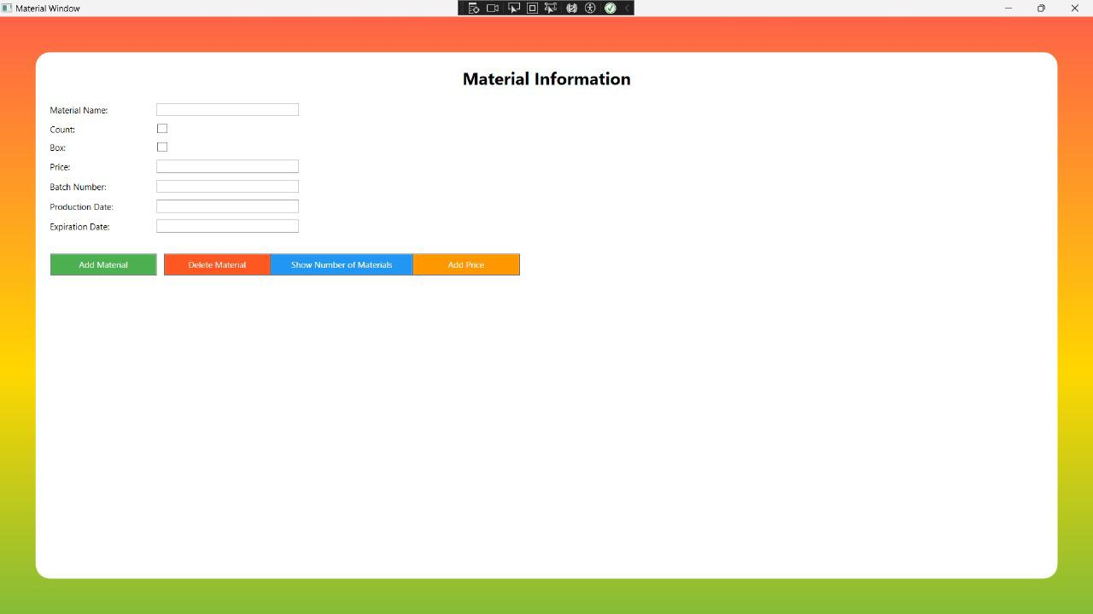

Github milestones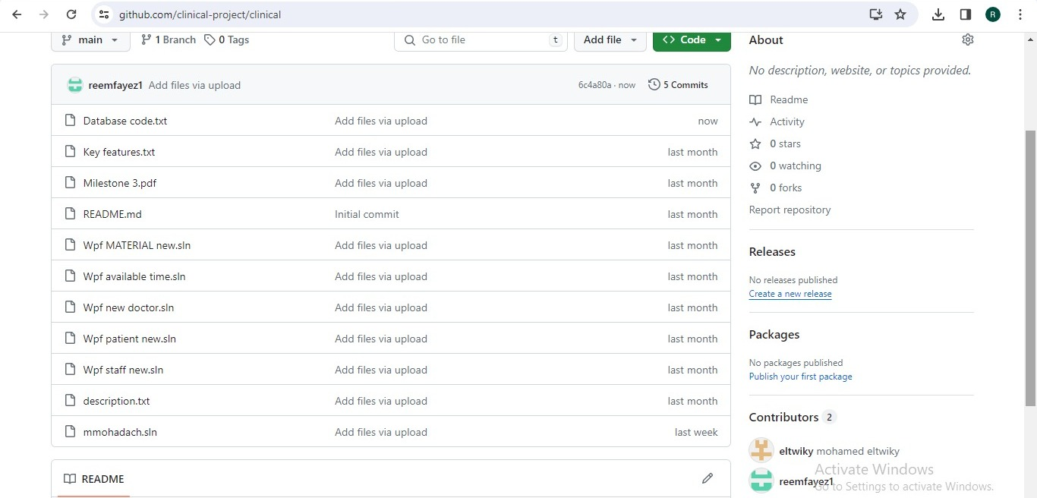

<https://github.com/clinical-project/clinical>